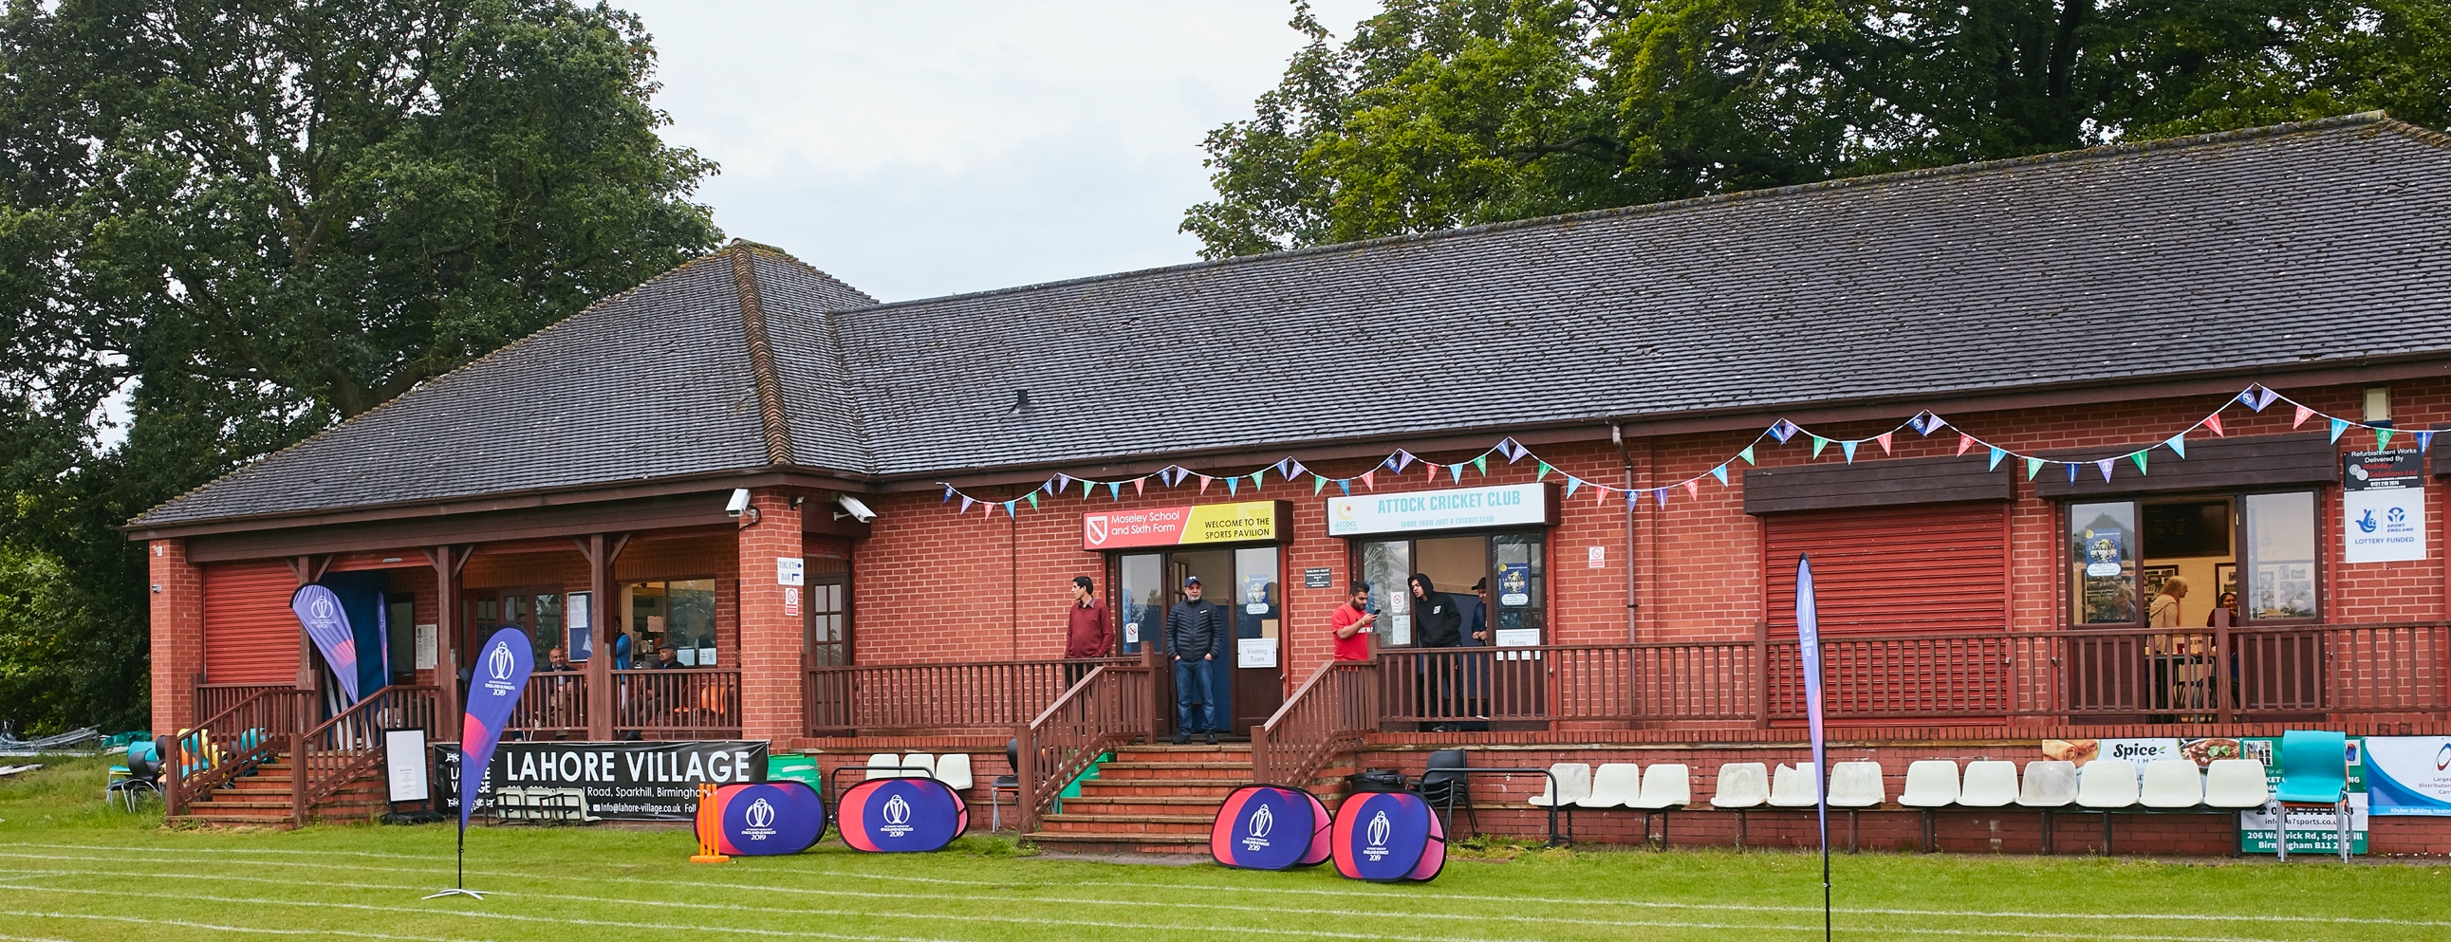

RISK ASSESSMENT TEMPLATE FOR CLUBS PREPARING TO OPEN THEIR CLUBHOUSE

2021 Risk Assessment Template for SHREWSBURY CRICKET CLUB
As a facility provider, you should complete your own COVID-19 Risk Assessment and publish this to your users.

If you are not the facility provider, then you should consider which sections will apply to your clubs individual situation upon returning to play and complete a risk assessment based on your activity, including (but not limited to) people management and communication, hygiene and first aid. You may still wish to record that you have assessed facility risks through enquiries made with your facility provider.

We have provided an example risk assessment below, which is for illustrative purposes only, and includes some examples of things to consider. Consider how this will apply to each aspect of your operation and identify the controls you require to meet Government guidance regarding health, social distancing and hygiene etc. Remember that you must review your other Health and Safety, and Safeguarding, risk assessments for other hazards such as fire, first aid etc.

What are the hazards? |  | Transmission of COVID-19
Who might be harmed? |  | Facility users, staff, volunteers, visitors and the wider community
No | Controls required |  | Action Taken by the Club
People Management and Communication
 | Self-screening of individuals before they arrive at the venue to ensure individuals displaying COVID-19 symptoms or those who should be shielding do not travel or attend. |  | No player/scorer/umpire will be coerced into traveling/playing if they believe they should self- isolate or believe they have symptoms of Covid-19.
 | An assessment of user numbers, space capacities, venue circulation and layout planning to maintain social distancing. |  | Undertaken by the club Chairman and Clubhouse Manager.
 | A plan for where parents and players will sit whilst watching cricket activities. |  | Parents/Spectators and players will have separated outside areas to congregate.
 | Signage and communication so that all participants and visitors are aware of the control measures in place and how to act appropriately to minimise the risk of transmission of COVID-19. |  | Signs are erected on and within the clubhouse as required by the Government guidelines.  Home team players will be permitted to utilize the home team changing room toilet.  Away team players will be permitted to utilize the away team changing room toilet
 | Staff and volunteer training to support the implementation of the plan, with suitable training records. |  | The General Committee of the club will ensure all staff & volunteers are aware of the Government guidelines and adhere to the control measures in place.
Buildings
 | Assess ventilation in your building (natural and mechanical) and take appropriate measures to maximise ventilation and minimise risk of transmission. |  | Windows and doors will remain open were possible to aid the flow of air through the clubhouse.
 | Assess the maximum occupancy of your rooms at 2m social distancing (or 1m with risk mitigation where 2m is not possible) and establish a suitable circulation system/one-way system. Use signage and floor markings to communicate this. |  | The clubhouse can accommodate 16no sitting individuals maintaining safe distancing whilst the circulation system is in place.  A one-way system is clearly marked within the clubhouse to the bar and toilets. Separate entrance and exit to the clubhouse is signed. Entry must be via the doors on the playing field side of the clubhouse with exit being via the car park side.
 | Assess the arrangement of seating areas to maintain social distancing and minimise the risk of transmission. |  | Seating area will be separated from individuals who are accessing the bar area and toilets.
 | Consider your wet weather plans and describe what actions you will take to maintain social distancing in wet weather. |  | A maximum of 20no can be accommodated in the clubhouse. Small gazebos will be available for shelter with all remaining required to shelter in their cars as they are parked in close proximity to the playing area.
Social and Hospitality Areas
 | Plan to solicit and maintain records of your member attendance, customers and visitors - to be maintained for 21 days and then destroyed. |  | Team sheets will be collected for reference at each game.  Contact details of all non-members who enter the clubhouse will be recorded.
 | Identification of suitable areas for outdoor service that don’t overlap with cricket activity. |  | N/A
 | Steps taken to minimise time and the number of people at the bar. |  | Maximum of one person permitted at the bar to order and collect drinks whilst maintaining a safe distance.
 | Steps taken to minimise contact points at payment or around the hospitality space. |  | Only one card machine and cash register in use.
 | Suitable PPE provision and training for staff and volunteers. |  | PPE equipment will be used supplied via the Natwest Cricket Force in addition to that acquired by the club. The staff will be required to follow Government guidelines on its use.
 | Strategy for the safe serving, clearing and cleaning of glassware and tableware. |  | All drinks will be served via bottles or cans.  No glasses will be used as the club will use plastic “glasses”.  All customers will be asked to deposit their empties and plastic glasses directly into waste bins.
 | Deep cleaning strategy to minimise COVID-19 transmission risk |  | All clubhouse and its facilities will be deep cleaned prior to fully opening.
 | Daily cleaning strategy to minimise COVID-19 transmission risk. |  | The clubhouse will be cleaned with the appropriate cleansing materials following each time it is used.
 | High-frequency touchpoint cleaning strategy to minimise COVID-19 transmission risk and how you will keep records. |  | The Clubhouse manager will ensure these areas are frequently cleaned during each game/practice session and will maintain a record of when undertaken.
Hygiene and Cleaning
 | Materials, PPE and training that you have provided to your staff for effective cleaning. |  | PPE equipment will be used supplied via the Natwest Cricket Force in addition to that acquired by the club. The staff will be required to follow Government guidelines on its use.
 | Provision of hand washing facilities with warm water, soap, disposable towels and bin. |  | Hand washing facilities are available within the toilets.
 | Provision of suitable hand sanitiser in locations around the facility to maintain frequent hand sanitisation. |  | In addition hand sanitizers are sited at the clubhouse entrance, toilet entrances and throughout the clubhouse.
 | Provision of suitable wipes and hand sanitiser on the field for hygiene breaks. |  | All players will be required to provide their own sanitizer/wipes as stated in the ECB guidance.
 | What are the hazards? | Other venue hazards to be considered after temporary closure such as Legionnaire’s Disease, fire, electrical safety etc.
 | Who might be harmed? | Facility users, staff, volunteers and visitors
 | Controls required |  | Action Taken by the Club
Preparing Your Buildings
 | Consider the risk of Legionnaire’s disease and carry out necessary work to make your water supply safe for users. Refer to the specific guidance in the document above. |  | Water within the clubhouse has been in constant use since the end of last season.
 | Check that routine maintenance has not been missed and certification is up to date (e.g. Gas safety, Electrical Safety and Portable Appliance Testing, Fire Safety, Lifts and Heating – Ventilation and Air Conditioning). |  | All appliances are certified and checked.
 | Check that your ground is ready and safe to play. Look at what work is required and how this can be done safely at a social distance. |  | Ground is ready and has been since early April.
 | What are the hazards? | Vital first aid equipment is not available when needed. First aiders do not have adequate PPE to carry out first aid when required.
 | Who might be harmed? | First aiders, facility users, staff, volunteers and visitors
 | Controls required |  | Action Taken by the Club
First Aid
 | Check that your first aid kits are stocked and accessible during all activity. |  | First aid kits will be sited in full view and accessible within the clubhouse.  The kit is new and well stocked.
 | What steps have you taken to improve your first aiders’ understanding of first aid provision under COVID-19? |  | First aiders will be supplied with gloves and face mask which will be sited adjacent to the first aid kit.
 | If you have an AED then check that it is in working order, service is up to date and that it is available during all activity. |  | AED is new and easily accessible within the clubhouse.
 | What are the hazards? | Pitches or outfield are unsafe to play on
 | Who might be harmed? | Players, officials, ground staff
 | Controls required |  | Action Taken by the Club
Preparing your Grounds
 | Safety checks on machinery, sightscreens and covers. |  | All continually checked and machinery has been used extensively since March.
 | Check and repair of any damage to pitches and outfields. |  | All well maintained and ready for use.
 | Surfaces checked and watering regime adjusted based on lack of rainfall. |  | All well maintained and ready for use.
 | What are the hazards? | Use this space to identify hazards at your venue
 | Who might be harmed? | Use this space to identify who might be harmed
 | Controls required |  | Action Taken by the Club
 | Identify your own control measures required. |  | All potential hazards and their controls have been identified within the clubs Risk Assessments for use of the clubhouse & ground during normal circumstances.  These are available for viewing within the clubhouse.

