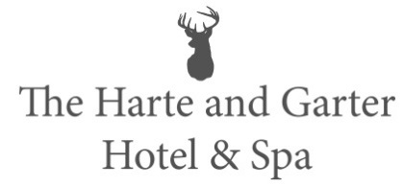

Starters

Arrosto (v)
goats cheese & baked beetroot, Mediterranean vegetables, olives & focaccia

Prawn Skewers
marinated in dill & lime with mixed leaves, sweet chilli sauce & garlic aioli

Bruschetta
peach, prosciutto and ricotta on jalapeño cheddar bread, onion chutney & salad leaves

Main Courses

Twice Cooked Blade of Beef
creamed potatoes, confit cherry tomatoes & red wine sauce

Seafood Chowder
creamy cheese broth with sweetcorn, salmon, haddock, seafood and mashed potato

Baked Portobello (v)
roasted vegetables, grated parmesan, focaccia & confit cherry tomato

Desserts

Oreo Cheesecake
chocolate earth & pistachio ice cream

Eton Mess
forest fruit, physalis and segment of orange

Passion Fruit Crème Brulee
Chantilly cream & shortbread biscuit

