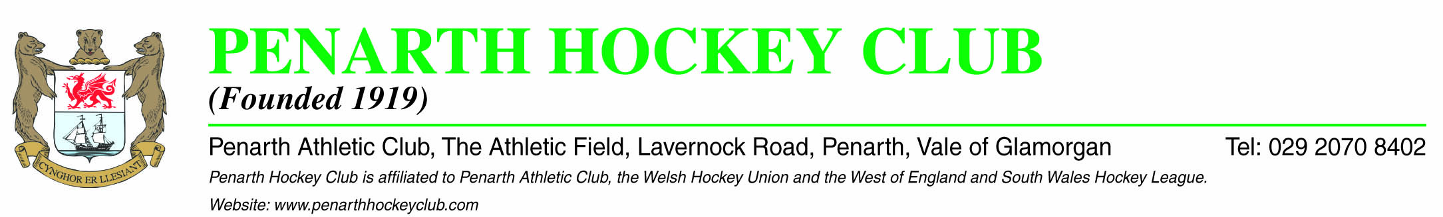
Dear Member,

In an effort to improve cash flow and admin for both the club and club members we are offering a new payment option for annual subscriptions.
For Senior Members this will be £5 per month and should be set up by Monthly Standing Order at your own bank. (See proforma attached.) If you intend to settle your annual subscriptions in this manner would you please confirm to me, activation of your Standing Order by e-mail (stevens anthony1@sky.com ).

Many thanks for your support

Yours faithfully

Tony Stevens
Penarth Hockey Club Treasurer
Tel: 02920708509 / Mobile 07588039696
8<------------------------------------------------------------------------------------------------------------------8
PENARTH HOCKEY CLUB ____ STANDING ORDER FORM
To: The Manager
Your Bank Name: __________________________ Your Name: ___________________
Your Bank Address:________________________ Your Address: __________________ _________________________ _____________________________ _________________________ _____________________________ Post Code: _________________ Post Code: ____________________
Sort Code: _______________ Your Account No: _______________
Dear Sir,

I would be grateful if you would arrange to set up a Banker’s Standing Order for the sum of £5.00 (Five pounds only) payable to Penarth Hockey Club.
Payment is to be made on or before the (________________and each subsequent month (12 payments p/a) until further notice and credited to:-
Bank : Barclays Bank Cardiff Business Centre
1-3 St. Davids Way,
St. Davids Centre
Cardiff, South Glam
CF10 2DP
Sorting Code: 20-18-15
Account Number: 50636967
Account Name: Penarth Hockey Club
Reference: __________________ (“Your initials/surname – PHC RF”)

Yours faithfully
Signature _______________________________________

