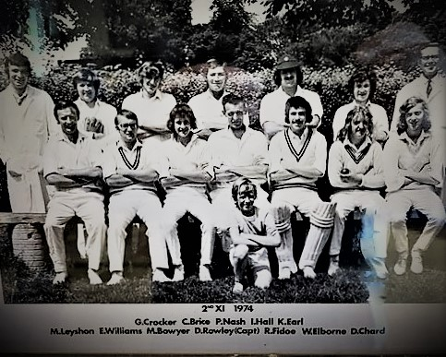
It is with a heavy heart we announce the sad passing of Dave “Oscar” Rowley who passed away on Christmas Day 2021 aged 91.
The term “legend” is used far too often these days, but in Dave’s case at Shirehampton Cricket Club it was certainly appropriate.
A gifted all-round sportsman who not only excelled at cricket but was also a talented goalkeeper in an era where the goalie was fair game to any abrasive center half.
With his 6foot 5inch frame Dave was a formidable middle order batsman, clearing the ropes with ease with his long levers.
Using his goalkeeping talent he specialized fielding at backward point/gully position. Some 35 years ago, we recall a particular match where we trudged off down to Trowbridge for a 20 over midweek cup game. Fielding first, a young naive bowler trotted in and bowled the shortest widest long hop ever, the batsman was smiling as he wound up to treat the ball with all the contempt it deserved and smashed it through the backward point region. In a split-second Dave dived to his left and caught the ball one handed 6 inches off the ground. The batsman was as amazed as the rest of us. Dave came bounding over, “well done lad, I knew that would get him.” Dave would have been in his late 50s when he took that incredible catch.
That basically summed the man up, always supportive to the younger players, never critical and fiercely competitive.
This continued after his playing days were done following the 1st team to home and away matches with loyal wife/partner in crime Peggy by his side, encouraging, applauding and even when the game wasn’t going Shire’s way and the weather was not for the faint hearted, he was there.
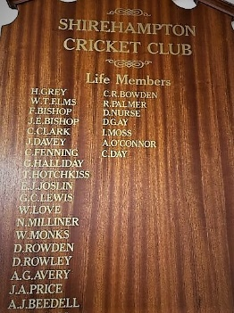
As Forman of the Wednesday gang Dave would organize the work parties prioritizing duties and “motivating” the team in their efforts. He did this for many years and with his invaluable experience gained as the dock’s resident Engineer ensured the clubhouse and ground was the envy of all the other clubs.
Dave was the quintessential gentleman of Shirehampton Cricket Club, a life member, dedicated clubman, loyal supporter to all and a good old fashioned no nonsense great fella who will be greatly missed by the Shire CC family.
May we offer our condolences to the Rowley family, our thoughts and prayers are with you all at this incredibly sad time.

Dave’s funeral will be held at Canford crematorium on 25th January at 12:45hrs, returning to Shirehampton Cricket Club after.

