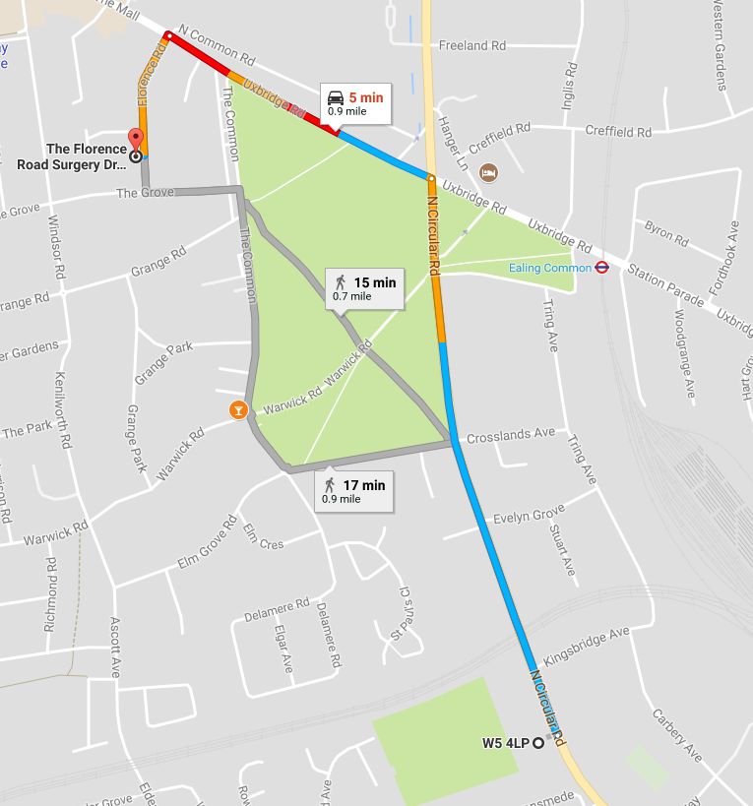
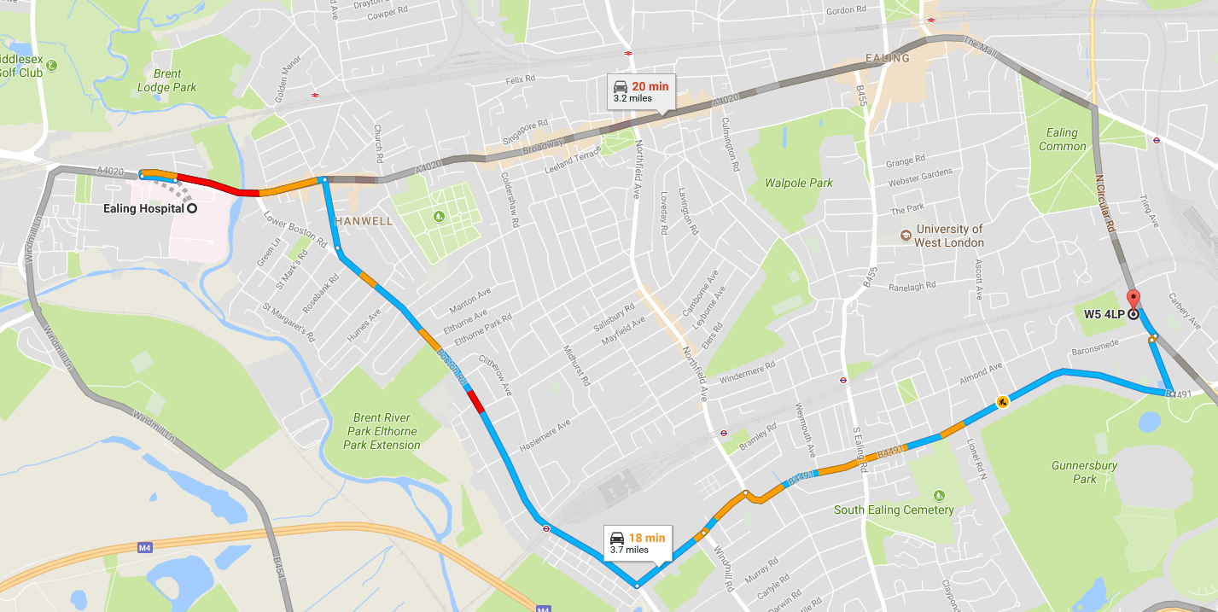
DOCTOR’S SURGERY AND EALING HOSPITAL (FIRST AID KITS are available from the Kitchen)
Doctor’s Surgery (Florence Road Surgery W5 3TU)
Turn left out of Popesfield Sports Ground and Head north on N Circular Rd towards Kingsbridge Ave (0.5 mi). Turn left onto Uxbridge Rd/A4020 and continue to follow A4020 for 0.3 mi. Turn left onto Florence Rd, The surgery will be on the right,
020 8567 2111
Directions to Ealing Hospital, Uxbridge Road UB1 3HW
Turn right out of Popesfield Sports Ground and Head south-east on N Circular Rd. Turn right onto Gunnersbury Drive. Turn right onto Popes Ln/B4491. Continue to follow B4491. Turn left onto Windmill Rd/B452. At the roundabout, take the 2nd exit and stay on Windmill Rd/B452. Continue onto Swyncombe Ave. At the roundabout, take the 2nd exit onto Boston Manor Rd/A3002. Continue to follow A3002. Turn left onto Uxbridge Rd/A4020
020 8967 5000

