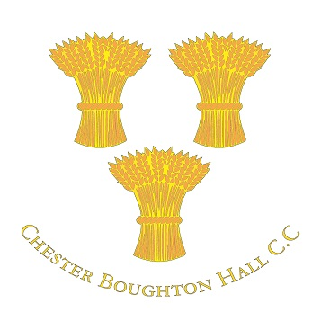
2015 Membership Subscriptions
(Due by 31 May 2015)
Paying by online transfer is by far the simplest method to pay and we are encouraging everyone to use this method from this season onwards. It cuts out significant administration effort and is more secure.
CBHCC account details:
Sort code: 60 40 08
Account number: 33100942
In the payment reference field, please use the following format:
Subs Surname Forename (e.g. Subs Gilson Jim)
If your name is too long to fit into the reference field please enter as much as possible – the purpose of this reference is so we can identify who has paid, for what.
If you wish you can send a follow up email to Ian Thistlewood (ianthistlewood@hotmail.com) to confirm your transfer – please include amount, date, payment reference, and who the payment is for. This helps to ensure your payment is logged and marked as ‘done’.
If you are paying for more than one person, please make separate payments so these can be tracked accurately. For example, if you are paying 2015 playing subs for yourself, and also your partner's yearly subs, please make two separate payments. Or, if you are a parent paying for more than one child please make a separate payment for each child.
On an exceptional basis we can accept cheques. As a reminder, this method of payment adds effort for your fellow club members to collect, go to the bank, and then separately record the deposit.
Please send a cheque or cheques to:
FAO Jim Gilson (subs 2015)
Chester Boughton Hall Cricket Club
Filkins Lane
Chester CH3 5EJ
Please ensure cheques are made payable to ‘Boughton Hall Cricket Club’.
Please include on the reverse of the cheque the same reference information as for an online transfer. Again, if you are paying for more than one person, please send separate cheques.

2015 Membership Subscriptions
Playing - Senior men - £120
Playing - Ladies - £65
Playing - Junior - School years 1-2 - £5
Playing - Junior - School years 3-6 - £70
Playing - Junior - School years 7-13 - £80
Playing - Junior - University - £50
Playing - Over 40s* (Blazers) - £50
Vice-presidents** - £40
Social members - £20
Partner members*** - £10

*What if I play over 40s and also in another senior side?
You pay the highest of the two categories, but you don’t have to pay both. For example: Jim Gilson is over 40 and so may turn out midweek for Dave Atkin’s Blazers in his specialist format of T20. But Jim may also be drafted into the 1’s as a ringer to show the youngsters how it’s done. In this example Jim’s subs are £120 as he falls into the higher category of ‘playing – senior men’. If however he only played over 40 cricket he would pay £50.
**Vice-president subs are in addition to any playing subs you may owe.[/i]
***For the partner of an existing member.
There will be a levy of £5 per player for each senior match (£3 for 20 over matches). The levy for junior matches is £2 per player. These fees are in addition to tea money, which is payable by all players.

