RECALL NOTICE
GO AHEAD! NUTTY CRUNCH HAZELNUT BARS

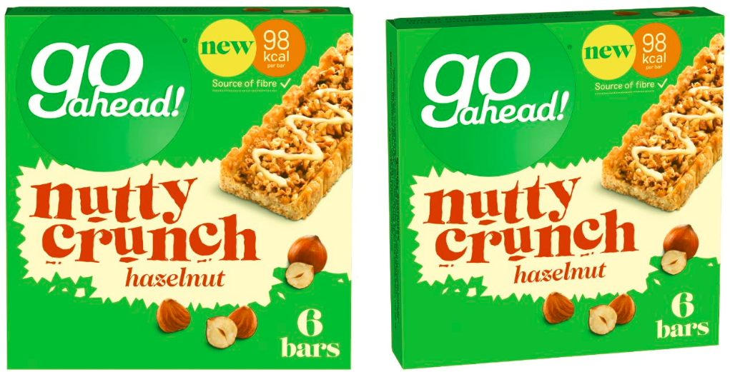

As a precautionary measure we are recalling one batch of go ahead! Nutty Crunch Hazelnut bars.
We have identified that a batch incorrectly include peanuts in the recipe. The allergy information on the packaging already warns consumers that the bars may contain peanuts, so consumers with a peanut allergy are already advised not to consume this product.
However, the safety and quality of our products is paramount and are therefore recalling one batch with best before date of 01/10/2019, and Lot Code of 078X. No other products or date codes are affected.
We apologise for any inconvenience caused and ask consumers who have bought the product return it to the store or to please contact our consumer helpline on ubconsumerservices@pladisglobal.com or 0800 456 1372 for a refund.

