Interim Financial Report

First World Hybrid Real Estate Plc

For the 6 month period ended 28 February 2026

CONTENTS PAGE

Fund Information 1

Management Report 2- 7

Interim Consolidated Statement of Comprehensive Income 8

Interim Consolidated Statement of Financial Position 9

Interim Consolidated Statement of Changes in Equity 10

Interim Consolidated Cash Flow Statement 11

Notes to the Financial Statements 12-19

Directors
Beth Greenhalgh
Craig Ewin
David Elliott
Duggan Matthews
Mark Grace
Philip Scales
Russell Collister

Registered Office
55 Athol Street
Douglas
Isle of Man
IM1 1LA

Administrator, Registrar, Registered Agent, Asset Manager, Property Manager and Promoter
FIM Capital Limited
55 Athol Street
Douglas
Isle of Man
IM1 1LA

Custodian
EFG Fund Services
44 Esplanade
St Helier
Jersey
JE1 3FG

Auditor
KPMG Audit LLC
Heritage Court
41 Athol Street
Douglas
Isle of Man
IM1 1LA

Listing Sponsor

Equiom (Isle of Man) Limited
Jubilee Buildings
Victoria Street
Douglas
IM1 2SH

UK Property Market
Against the backdrop of global geopolitical and trade uncertainty, the UK commercial property market gathered good momentum during the six months ending February 2026 and the consensus is that the next upward phase of the property cycle has commenced.
Occupational demand, especially distribution warehousing, has been encouraging with rental growth continuing, albeit moderating off the exceptional levels of prior years, and supported by good demand for space and relatively constrained and low new supply coming to the market. Retail warehousing demand, including food stores, remains robust with successful value chains seeking to roll out further stores. The demand for offices continues to be somewhat subdued although there is increasing narrative of this improving.
The investment demand for quality assets continues to pick up and transaction volumes have increased. Valuation yields have been largely stable with rental growth underpinning valuation growth but with the prospect of some downward yield compression and pricing appreciation.
This improving property environment was supported by lower inflation and the downward trajectory of interest rates, with the base rate having now been cut no less than six times, to 3.75% since July 2024. The expectation is for interest rates to continue to trend down over the longer term.
However, the Middle East conflict which escalated in March this year has increased global uncertainty and investment markets have been volatile with equity prices falling sharply. Listed REITs, which are highly liquid and have a strong correlation to bond yields, have not been spared and have been sold down.
Physical property, however, has specific benefits and proven resilience in times of investment uncertainty. Unlike paper assets, it has intrinsic value and remains a physical necessity for logistics, retailing etc notwithstanding economic shocks. Property also offers income stability in that rent is contractually secured by lease arrangements and the more predictable that rental is due to the financial strength of tenants and the length of remaining lease terms, the more protection it offers investors. At the same time, escalating rentals support income growth and property valuation upside.

Overall, the type of property that the Fund is invested in is expected to generate solid net rental, rental growth and this will continue to be supportive of valuation growth.

Investment Objective of the Fund
The Investment Objectives of the Fund as stated in the Offering document, is to generate a reliable, predictable, and growing income by combining direct and listed real estate. A fundamental part of the FWHRE offering is to provide investors with better liquidity and pricing certainty than a direct property investment and with lower volatility than publicly quoted property. This with the benefit of a Regulated structure. The Fund is delivering on these objectives.

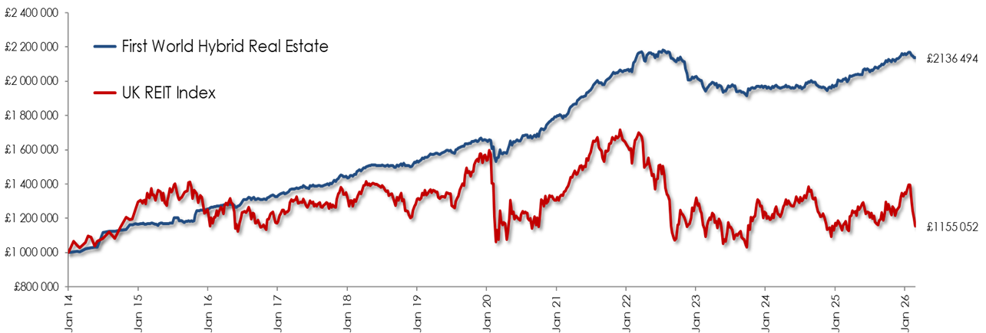

Source data: Bloomberg and Marriott Asset Management (Pty) Ltd.

The graph above is compelling and demonstrates the performance of the Fund since inception relative to UK REITs. The Fund now has a 10-year plus track record and has produced solid growth with low volatility, whereas the volatility and weaker return of the UK REIT index is clear. No doubt the type of property that the Fund has chosen to invest in has contributed to this favourable return outcome.

The Direct Property Portfolio
The value of the direct property portfolio at 28 February 2026 was £182.9m (31 August 2025: £186.6m and 29 February 2025: £182.4m).
There were no acquisitions during the six-month period under review. The sale of the Booker property was completed on 5 November 2025 at a selling price of £4.05m. The property was purchased in 2015 for £3.6m. The selling price was £200k (5.2%) above the last independent valuation received in May 2025, of £3.85m.
The sector weighting and lease expiry profile of the property portfolio on 28 February 2026 is set out below.
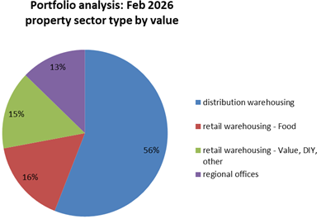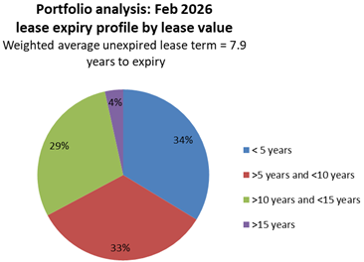
The portfolio remains distribution warehousing dominant at 56%, with 16% and 15% weightings to food stores and retail warehousing respectively, and with a relatively low exposure to offices at 13%.
During the six-month reporting period there were 18 property valuations. The net upward adjustment for the six months under review was £0.2m (£1.8m upward adjustment in the comparable six months period last year) which equates to approximately 0.1% of opening portfolio value. While the trend of stable yields and valuation upside being driven by rental growth and lease extensions remains very much intact, there were three office properties that were adjusted downwards. The valuation outlook is positive with some further valuation increases brought to book after 28 February 2026.
Apart from a small retail shop (1,520 square foot) in Marina Quay, where the tenant has ceased trading, the portfolio is fully tenanted and occupied. This space is being actively marketed for let.
The lease expiry profile remains well spread. The portfolio WAULT is 7.9 years (31 August 2025: 8.5 years and 28 February 2025: 9.1 years).
There have been several positive rent reviews and leasing outcomes during the past six months.
- Bidfoods Cannock - open market rent review concluded - 35% increase on previous rent
- FPE Seals Darlington – fixed rent review – 13% increase on previous rent
- DHL Doncaster – fixed rent review – 10% increase on previous rent
- B&M Marina Quay – open market rent review – agreed at previous passing
- Wickes Grimsby – removal of tenant break concluded – extending certain term by 5 years, rent review agreed at previous passing
- Vanquis Bank Chatham – removal of tenant break concluded - extending certain term by 5 years, rent increased by 6% over previous passing
There are four rent reviews coming up during the remainder of 2026 calendar year, two being RPI linked and two open market rent reviews. These represent 14% of the portfolio rental. Approximately 15% rental upside on these (after provision for incentives) is estimated. Across the entire portfolio it is estimated that there is approximately 7% current inherent rental upside above passing rent. This is positive.
There are also negotiations currently taking place with no less than eight tenants regarding the extension of their leases.

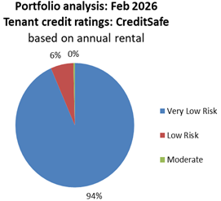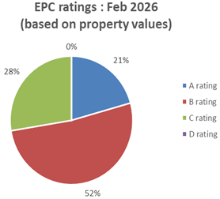
The credit rating of the portfolio remains very strong. Updates from CreditSafe on in-situ tenants are obtained routinely. During the period under review, credit ratings have generally remained stable or improved.
EPC ratings is a particular aspect where environmental considerations can be measured and tracked. The Fund’s property portfolio rating is depicted in the EPC pie chart above. The property portfolio is generally well positioned from an EPC perspective in terms of its overall ratings but also importantly in terms of the regulatory targets which are purported to become effective in April 2027. Ongoing attention is being given to early reviews of ratings and ways in which they can be cost effectively improved, and good progress has been made in this regard with 73% of the portfolio by value now having either A or B ratings and importantly there being no properties D or worse. The nature of tenant’s operations is also considered as part of sensible acquisition filter risk but also in line with ESG considerations.

The REIT portfolio
The Fund has a portfolio of seven UK REITS, namely London Metric, Segro, Tritax Big Box, Big Yellow, British Land, Land Securities and Primary Healthcare Properties. The portfolio now has greater diversification and a weighting to other property sectors while maintaining an emphasis in distribution warehousing.

REIT pricing is volatile and is highly sensitive to bond yield movement and interest rate sentiment. REIT prices showed strong appreciation during the six months ending 28 February 2026.
The value of these REITs at 28 February 2026 was £23.3m (31 August 2025: £19.1m and 28 February 2025: £22.1m). The net realised and unrealised gain from the REITs during the six months ended 28 February 2026 is £4.0m (year ended 31 August 2025: £3.9m loss; six months ended 28 February 2025: £3.6m loss).

The REIT portfolio is an integral holding of the Fund, to provide liquidity. Having contributed positively to the Fund’s return performance during the reporting period, REIT prices have disappointingly come off sharply in March 2026 but we take comfort that the REITs selected for the Fund have performed well relatively and seem well placed for recovery based on historic yields and the discounts to net asset value that they are currently traded at.

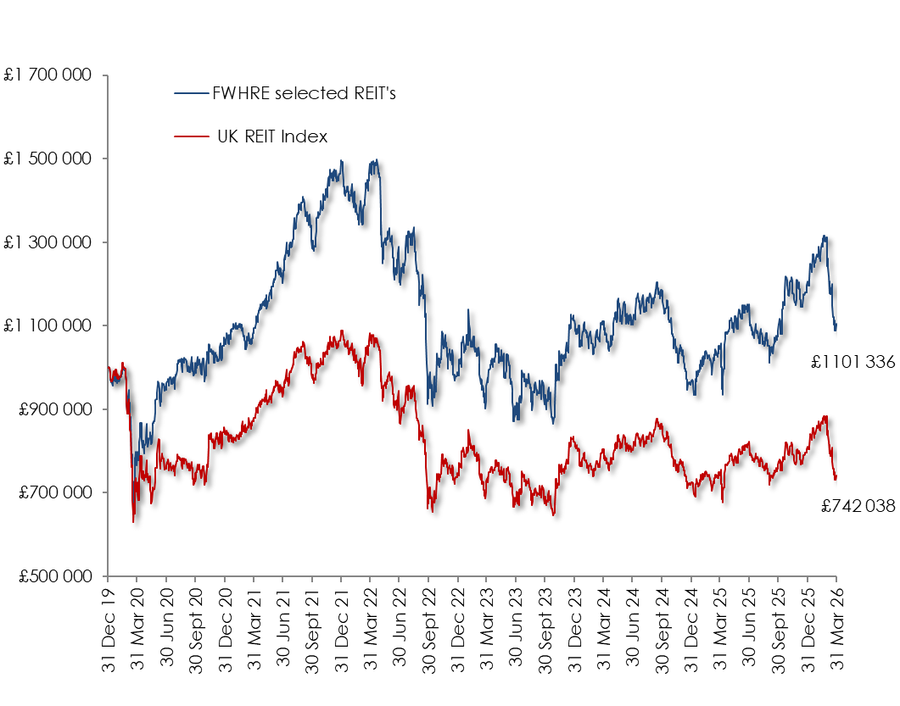
Source data: Bloomberg and Marriott Asset Management (Pty) Ltd.

Debt Funding
Historically each property acquisition was funded with 50% debt finance but more recently the Fund has targeted an LTV ratio of 35% to 45% with between 50% and 75% of the debt being hedged by way of a spread of interest rate swaps.
On 28 February 2026, the portfolio LTV rate was circa 46%; a lower 39% on a Fund basis when including the REITs. Some 72% of the term debt has been hedged by way of five interest rate swaps with a weighted average remaining term of 3.1 years. The largest of these swaps (£25m or 48% of the hedging) is at an attractive low fixed rate of 1.05% and still has almost 6 years to maturity (December 2031) and therefore provides good interest rate protection against higher rates. The remaining four swaps have shorter terms to expiry but are at fixed rates which are generally not dissimilar to the current base rate meaning that the risk to higher debt funding costs upon their expiry is limited.
The existing fixes remain well in the money with a fair value on 28 February 2026 of circa £3.4m (31 August 2025: £4.2m, 28 February 2025: £4.6m). During the period under review, the value of the swap has decreased and given rise to a fair value downward adjustment of £0.8m (year ended 31 August 2025: fair value loss of £0.8m; six months ended 28 February 2025: fair value loss of £0.3m).
There were two further interest rate cuts of 25 bps each during the six months ending February 2026 and the base rate is now 3.75%. There has now been a total of six cuts in this downward interest rate cycle and at the end of the reporting period it was expected that a further cut was imminent and that rates would continue to trend downwards. However, the impact of the Middle East conflict is likely to see this trend paused while the inflationary impact of higher oil prices is assessed.
There are no concerns with bank covenants where there are good levels of headroom.

Subscription, redemptions, and liquidity
New subscriptions for the six-month interim period ending 28 February 2026 were £4.8m (12 months ended 31 August 2025: £4.7m, six months ended 28 February 2025: £2.5m). Redemptions for the six months total £8.8m (31 August 2025: £25.1m, 28 February 2025: £13.9m). Redemptions for the six months under review were 7.0% of average NAV over the period (12 months ended 31 August 2025: 18.7%, six months ended 28 February 2025: 10.2%).
The Fund seeks to provide investors with known pricing and reasonable liquidity. Liquidity to meet redemptions is facilitated by the Fund including REITs as part of its investments. To this end, a Liquidity Level of 25% (of net asset value) is targeted with a Red-line Minimum Liquidity level of 15%. The liquidity level at 28 February 2026 was 19% (31 August 2025: 15%, 28 February 2025: 17%). These percentages exclude any unutilised RCF which may be available should the need arise.
Fund Performance

The Fund’s total return for the six months ending 28 February 2026 (based on the latest pricings as at the respective period ends) is a positive 4.1%. The 2.3p per share distribution for six months represents an annualised 4.1% on the opening share price (A class) of 112.12p.
The longer-term performance of the Fund is set out in the table below. It is evident that the income return has been consistent and meaningful and furthermore that the return for the last 12 months is a credible 8.4%, with a capital price appreciation of 4.0%. Longer term returns have been impacted by a difficult three-year period (2022 to 2024) for property when interest rates spiked from 0.25% to 5.25%, impacting negatively on capital values.
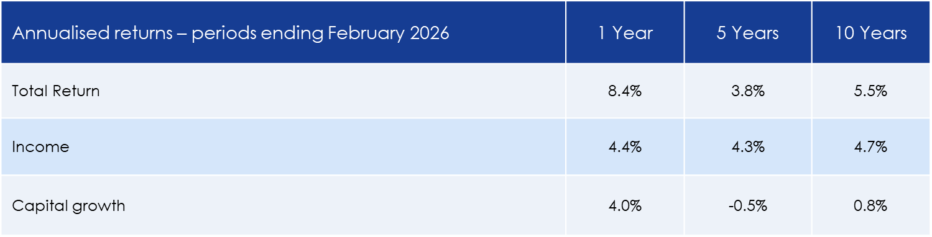
Source data: Bloomberg and Marriott Asset Management (Pty) Ltd, based on last published price for period.

Note: The annualised returns are based on the last pricing available at the end of the respective periods and will differ to the IFRS interim financial statements.
The table below compares the Fund’s returns to UK REITs and UK Equities. While the Fund produced a decent, predictable return over the last year, listed counters ran hard. However, over the longer term the Fund has compared comparatively well, especially relative to UK REITs.
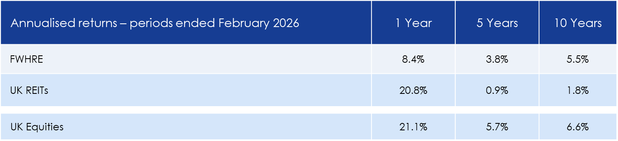
Source data: Bloomberg and Marriott Asset Management (Pty) Ltd, based on last published price for period.

Outlook
The Fund’s properties continue to perform well with excellent occupancy and rent collections. Increased rental is being achieved when rental levels are reset, and leases are being extended. These are the underlying drivers underpinning positive property fundamentals and which result in increased income from the property portfolio. Similarly, the REITs which the Fund has invested in have reported strong results and growth in their dividends.
Interest rates have fallen and are likely to continue to do so although this downward trend may be paused while the wider impact of the Middle East conflict is assessed. Consequently, the cost of debt on the Fund’s unhedged debt has reduced and those interest rate swaps maturing in the short term will not impact negatively but are expected to be slightly earnings accretive at the current 3.75% base rate.
Against this background and earnings growth being evidenced by the Fund, the Board approved a 4.3% increase in the quarterly dividend which was declared in March and paid during April 2026.
Growth in rental is the fundamental driver of property valuation growth over time. Furthermore, when the war in the Middle East is resolved and oil supplies start to flow freely again, there is good potential for a strong rebound in REIT pricing.
The occupational demand and broader fundamentals for the type of property that the Fund has invested in remains sound and supports the view that given the robust income generated by the Fund and the expectation of income growth, off these pricing levels a total return guidance of 7% per annum is a reasonable expectation.

 | Note | 6 months ended  28 Feb 2026 | Year ended  31 Aug 2025 | 6 months ended  28 Feb 2025
 |  | (Unaudited) | (Audited) | (Unaudited)
 |  | £000 | £000 | £000
Revenue
Rental income | 5 | 5,967 | 11,912 | 5,835
Other income | 6 | - | 130 | 130
Net gain/(loss) on financial assets and liabilities at fair value through profit or loss | 4 | 3,175 | (4,606) | (3,914)
Net fair value gain on investment properties | 5 | 164 | 5,226 | 1,762
Dividend income |  | 421 | 1,319 | 414
 |  | 9,727 | 13,981 | 4,227
Expenses
Finance expense | 7 | (2,079) | (4,269) | (1,846)
Property expenses |  | (457) | (1,037) | (497)
Management expenses | 11 | (345) | (679) | (342)
Custodian fees |  | (78) | (162) | (81)
Other expenses |  | (144) | (240) | (132)
 |  | (3,103) | (6,387) | (2,898)
Profit before tax |  | 6,624 | 7,594 | 1,329
Taxation |  | (1,072) | (1,951) | (1,043)
Profit for the period/year |  | 5,552 | 5,643 | 286
Total comprehensive profit for the period/year |  | 5,552 | 5,643 | 286

The Directors consider that all results derive from continuing activities.

The accompanying notes on pages 12 to 19 form an integral part of these interim financial statements.

 | Note | As at  28 Feb 2026 | As at  31 Aug 2025 | As at  28 Feb 2025
 |  | (Unaudited) | (Audited) | (Unaudited)
 |  | £000 | £000 | £000
Non-current assets
Investment property | 5 | 182,855 | 186,575 | 182,363
Financial assets at fair value through profit or loss - swap | 7 | 3,440 | 4,189 | 4,505
 |  | 186,295 | 190,764 | 186,868
Current assets
Cash and cash equivalents |  | 59 | 148 | 300
Trade and other receivables |  | 3,877 | 3,242 | 3,000
Interest receivable | 7 | 75 | 104 | 169
Tax asset |  | 166 | 311 | 632
Financial assets at fair value through profit or loss - equities |  | 23,313 | 19,063 | 22,110
Financial assets at fair value through profit or loss - swap |  | 40 | 7 | 152
 |  | 27,530 | 22,875 | 26,363
Total assets |  | 213,825 | 213,639 | 213,231
Liabilities
Non-current liabilities
Borrowings | 7 | 82,773 | 83,467 | 78,657
Financial liabilities at fair value through profit or loss - swap |  | 75 | - | -
 |  | 82,848 | 83,467 | 78,657
Current liabilities
Trade and other payables |  | 944 | 863 | 878
Interest payable | 7 | 483 | 560 | 530
Deferred income | 5 | 3,498 | 3,301 | 3,157
Financial liabilities at fair value through profit or loss - swap |  | 5 | - | -
 |  | 4,930 | 4,724 | 4,565
Total liabilities |  | 87,778 | 88,191 | 83,222
Net assets |  | 126,047 | 125,448 | 130,009
Equity
Participating Share capital | 8 | 954 | 981 | 1,051
Share premium | 8 | 105,172 | 109,182 | 118,080
Retained earnings |  | 19,921 | 15,285 | 10,878
Total Equity |  | 126,047 | 125,448 | 130,009
NAV per Share | 9 | £1.32 | £1.28 | £1.24

These interim financial statements on pages 12 to 19 were approved and authorised for issue by the Board of Directors on 23 April 2026 and signed on its behalf by:

Russell Collister Craig Ewin
Director Director

 | Participating Share capital |  | Share premium |  | Retained earnings |  | Total Equity
 | £000 |  | £000 |  | £000 |  | £000
Balance at 1 September 2024 | 1,143 |  | 129,400 |  | 11,692 |  | 142,235
Loss for the period | - |  | - |  | 286 |  | 286
Total comprehensive loss for the period | - |  | - |  | 286 |  | 286
Transactions with Shareholders
Distributions to Shareholders | - |  | - |  | (1,100) |  | (1,100)
Participating Share issuances | 19 |  | 2,492 |  | - |  | 2,511
Participating Share redemptions | (111) |  | (13,812) |  | - |  | (13,923)
Total transactions with Shareholders | (92) |  | (11,320) |  | (1,100) |  | (12,512)
Balance at 28 February 2025 (Unaudited) | 1,051 |  | 118,080 |  | 10,878 |  | 130,009
Balance at 1 September 2024 | 1,143 |  | 129,400 |  | 11,692 |  | 142,235
Loss for the year | - |  | - |  | 5,643 |  | 5,643
Total comprehensive profit for the year | - |  | - |  | 5,643 |  | 5,643
Distributions to Shareholders | - |  | - |  | (2,050) |  | (2,050)
Participating Share issuances | 36 |  | 4,659 |  | - |  | 4,695
Participating Share redemptions | (198)  98) |  | (24,877) |  | - |  | (25,075)
Total transactions with Shareholders | (162) |  | (20,218) |  | (2,050) |  | (22,430)
Balance at 31 August 2025 (Audited) | 981 |  | 109,182 |  | 15,285 |  | 125,448
Balance at 1 September 2025 | 981 |  | 109,182 |  | 15,285 |  | 125,448
Profit for the period | - |  | - |  | 5,552 |  | 5,552
Total comprehensive gain for the period | - |  | - |  | 5,552 |  | 5,552
Transactions with Shareholders
Distributions to Shareholders | - |  | - |  | (916) |  | (916)
Participating Share issuances | 37 |  | 4,761 |  | - |  | 4,798
Participating Share redemptions | (64) |  | (8,771) |  | - |  | (8,835)
Total transactions with Shareholders | (27) |  | (4,010) |  | (916) |  | (4,953)
Balance at 28 February 2026 (Unaudited) | 954 |  | 105,172 |  | 19,921 |  | 126,047

The accompanying notes on pages 12 to 19 form an integral part of these interim financial statements.
 | Note | 6 months  ended  28 Feb 2026 |  | Year ended  31 Aug 2025 |  | 6 months ended  28 Feb 2025
 |  | (Unaudited) |  | (Audited) |  | (Unaudited)
 |  | £000 |  | £000 |  | £000
Cash flows from operating activities
Profit before tax |  | 6,624 |  | 7,594 |  | 1,329
Adjustments to reconcile profit before tax to net cash flows
Interest expense | 7 | 1,952 |  | 3,643 |  | 1,696
Revolving Credit Facility commitment fees | 7 | 10 |  | 23 |  | 13
Amortisation of borrowing arrangement fees | 7 | 117 |  | 603 |  | 137
Net unrealised (gain) on investment property | 5 | (153) |  | (5,206) |  | (1,742)
Realised (gain)/loss on investment property | 5 | (11) |  | (20) |  | (20)
Net (gain)/loss in financial assets and liabilities at fair value through profit or loss | 4 | (3,175) |  | 4,606 |  | 3,914
Movement in concession rent debtor adjustment | 5 | (96) |  | (1,380) |  | (643)
Working capital adjustments:
(Increase)/decrease in trade and other receivables |  | (767) |  | (2,468) |  | (2,411)
Increase in trade and other payables |  | 277 |  | 2,617 |  | 2,487
 |  | 4,778 |  | 10,012 |  | 4,760
Dividends paid |  | (421) |  | (1,319) |  | (414)
Interest paid |  | (2,009) |  | (3,650) |  | (1,786)
Tax paid |  | (927) |  | (1,117) |  | (531)
Net cash inflow from operating activities |  | 1,421 |  | 3,926 |  | 2,029
Cash flows from financing activities
Issue of redeemable participating preference Shares |  | 4,798 |  | 4,695 |  | 2,511
Redemption of redeemable participating preference Shares |  | (8,835) |  | (25,075) |  | (13,923)
Repayment of term loans | 5 | (1,811) |  | (7,934) |  | (7,934)
Utilisation of Revolving Credit Facility |  | 1,000 |  | 10,000 |  | 5,000
Borrowing arrangement fees |  | - |  | (656) |  | -
Distributions paid to shareholders | 10 | (916) |  | (2,050) |  | (1,100)
Net cash outflow from financing activities |  | (5,764) |  | (21,020) |  | (15,446)
Cash flows from investing activities

Purchase of investment properties | 5 | - |  | (24) |  | (14)
Sale of investment properties | 5 | 3,981 |  | 8,220 |  | 8,220
Purchase of investments at fair value |  | (6,324) |  | (12,969) |  | (302)
Sale of investments at fair value |  | 6,044 |  | 20,350 |  | 4,868
Dividend received |  | 553 |  | 1,358 |  | 638
Net cash inflow from investing activities |  | 4,254 |  | 16,935 |  | 13,410
Net (decrease)/increase in cash and cash equivalents |  | (89) |  | (159) |  | (7)
Cash and cash equivalents at the beginning of the year |  | 148 |  | 307 |  | 307
Cash and cash equivalents at the end of the year |  | 59 |  | 148 |  | 300

The accompanying notes on pages 12 to 19 form an integral part of these interim financial statements.

- General Information

First World Hybrid Real Estate plc (the “Fund”) was incorporated in the Isle of Man on 1 August 2013 under the Isle of Man Companies Act 2006. The Fund became a Regulated Fund in the Isle of Man on 26 February 2015, and it is subject to the Isle of Man Collective Investment Schemes Regulations.
The Fund invests primarily in UK commercial real estate. The Fund has two wholly owned subsidiaries FWRE Holdings Limited and FWRE Holdings Two Limited, which in turn hold wholly owned operating subsidiaries FWRE Limited (“FWRE”) and FWRE Two Limited (“FWRE Two”) respectively (collectively the “Group”).

- Summary of significant accounting policies
  - Basis of preparation

These interim financial statements have been prepared in accordance with IAS 34 Interim Financial Reporting and should be read in conjunction with the Fund’s last annual consolidated financial statements for the year ended 31 August 2025. They do not include all the information required for a complete set of IFRS financial statements. However, selected explanatory notes are included to explain events and transactions that are significant to an understanding of the changes in the Group’s financial position and performance since the last annual financial statements.
The principal accounting policies applied in the preparation of these financial statements are unchanged from those applicable to the annual financial report as at 31 August 2025. Where applicable, comparatives have been changed to accord with the presentation in the current period. There were no significant presentational changes arising from this.

  - Standards and amendments which are first effective for the period beginning 1 September 2025
Management has assessed the IAS 21 ‘Lack of Exchangeability’ amendments, effective for the current annual period, and determined that no changes in accounting treatment or disclosures were required. No new principal accounting policies applied in the preparation of these financial statements.
  - New standards, amendments and interpretations issued but not yet effective and not early adopted
The following new standards, amendments and interpretations are effective for annual periods beginning after 1 September 2025. Early application is permitted; but not elected by the Group. The Directors are assessing the impact on the Group’s financial statements, and this assessment will be completed before the standards/amendments are effective.

Description | Effective date
Annual Improvements to IFRS Accounting Standards | 1 January 2026
Amendments to the Classification and Measurement of Financial Instruments – Amendments to IFRS 9 Financial Instruments and IFRS 7 Financial Instruments: Disclosures | 1 January 2026
IFRS 18 Presentation and Disclosure in Financial Statements | 1 January 2027
IFRS 19 Subsidiaries without Public Accountability: Disclosures | 1 January 2027
IFRS for SMES third edition | 1 January 2027

IFRS 18 Presentation and Disclosure in Financial Statements
IFRS 18 will replace IAS 1 Presentation of Financial Statements and applies for annual reporting periods beginning on or after 1 January 2027. The new accounting standard introduces the following new requirements.
- Entities are required to classify all income and expenses into five categories in the statement of profit or loss, namely operating, investing, financing, discontinued operations, and income tax categories. Entities are also required to present a newly defined operating profit subtotal. Entities’ net profit will not change.
- Management-defined performance measures (“MPMs”) are disclosed in a single note in the financial statements.
- Enhanced guidance is provided on how to group information in the financial statements.

In addition, all entities are required use the operating profit subtotal as the starting point for the statement of cash flows when presenting the operating cash flows under the indirect method.

The Group is still in the process of assessing the impact of the new accounting standard, particularly with respect to the structure of the Group’s statement of profit or loss, the statement of cash flows and the additional disclosures required by the MPMs. The Group is also assessing the impact on how information is grouped in the financial statements, including for items currently labelled as ‘other’.

- Significant accounting judgements, estimates and assumptions

In preparing these interim financial statements, management has made judgements and estimates that affect the application of accounting policies and the reported amounts of assets and liabilities, income, and expense. Actual results may differ from these estimates.
The significant judgements made by management in applying the Group’s accounting policies and key sources of estimation and uncertainty were the same as those described in the last annual financial statements.

- Financial assets and liabilities at fair value through profit or loss (“FVTPL”)

 | 6 months ended  28 Feb 2026 | Year ended  31 Aug 2025 | 6 months ended 28 Feb 2025
 | (Unaudited) | (Audited) | (Unaudited)
 | £000 | £000 | £000
Net gain/(loss) on investments | 3,971 | (3,853) | (3,621)
Net unrealised loss on swaps | (796) | (753) | (293)
Net gain/(loss) on financial assets at FVTPL | 3,175 | (4,606) | (3,914)

- Investment property
 | As at  28 Feb 2026 | As at  31 Aug 2025 | As at  28 Feb 2025
 | (Unaudited) | (Audited) | (Unaudited)
 | £000 | £000 | £000
Investment property | 181,101 | 184,799 | 181,324
Concession rent debtor adjustment | 1,753 | 1,776 | 1,039
Closing balance | 182,855 | 186,575 | 182,363

 | 6 months ended  28 Feb 2026 | Year ended  31 Aug 2025 | 6 months ended 28 Feb 2025
Investment property fair value movement | (Unaudited) | (Audited) | (Unaudited)
 | £000 | £000 | £000
Unrealised gain on investment property  Realis | 153 | 5,206 | 1,742
Realised gain on investment property | 11 | 20 | 20
Net fair value gain on investment properties | 164 | 5,226 | 1,762

Properties are initially valued at cost which comprises their purchase price and directly attributable expenditure. Directly attributable expenditure includes professional fees for legal services and stamp duty land tax. Subsequently, valuations are performed by externally accredited independent valuers every 6 months based on the acquisition date of that property into the portfolio.

On 5 November 2025, the Group completed on the disposal of the property known as Booker, 164 Sadler Road, Lincoln (“Booker, Lincoln”). The property was purchased for £3,600,000 in 2015 and sold for £4,050,000 which was paid on completion. The property was partly funded by debt of £1,811,000, which was repaid upon completion.

Rental income earned and received from the investment properties during the period was £5,967,000 (31 August 2025: £11,912,000 and 28 February 2025: £5,835,000). As at 28 February 2026 there was £3,498,000 deferred rental income (31 August 2025: £3,301,000 and 28 February 2025: £3,157,000) that had been received by the Fund which relates to the next financial period.

- Other income

During the financial period there was no other income. On 23 December 2024, the FWRE Limited signed a discharge agreement with the tenant of Unit 2, Deeside to discharge it from its lease liabilities upon vacating the property. A fee, net of legal costs of £130,000 was received from the tenant.

- Borrowings
 | As at  28 Feb 2026 | As at  31 Aug 2025 | As at  28 Feb 2025
 | (Unaudited) | (Audited) | (Unaudited)
Non-current borrowings | £000 | £000 | £000
Total loans before amortisation | 83,257 | 84,069 | 79,069
Less: amortised borrowing arrangement fees | (484) | (602) | (412)
Total | 82,773 | 83,467 | 78,657

For details of debt repayments made on the disposal of properties, refer to note 5.

The Group holds the following loans as at 28 February 2026, all with interest charged at compounded daily SONIA with a fixed margin of 1.75% per annum:

 | Term loan 1 | £5,000,000 RCF | Term loan 2 | £9,000,000 RCF
Counterparty | Barclays Bank Plc | Barclays Bank Plc | HSBC UK Bank Plc | HSBC UK Bank Plc
Borrower | FWRE Limited | FWRE Limited | FWRE Two Limited | FWRE Two Limited
Loan balance at period end £’000 | 56,035 | 3,000 | 16,223 | 8,000
Fair value of investment property held as security by Counterparty £’000* | 123,640 | 5,000 | 45,215 | 9,000
Agreement date | 16 June 2025 | 16 June 2025 | 14 May 2025  # | 14 May 2025
Termination date | 16 June 2028 | 16 June 2028 | 14 May 2028 | 14 May 2028

*The Barclays Bank Plc Term loan and Revolving Credit Facilities, including undrawn balances (combined loans of £61,035,000) are secured fully against the property portfolio of FWRE Limited (£128,640,000). The HSBC UK Bank Plc Term loan and Revolving Credit Facilities, including undrawn balances (combined loans of £25,223,000) are secured fully against the property portfolio of FWRE Two Limited (£54,215,000).

Interest is paid quarterly, and the loan capital becomes payable on expiry. Interest payable as at 28 February 2026 was £483,000 (31 August 2025: £560,000, 28 February 2025: £530,000). Interest receivable in relation to the swaps as at 28 February 2026 was £75,000 (31 August 2025: £104,000, 28 February 2025: £169,000).
Expenses directly attributable to arranging bank borrowings were initially included in the amortised cost of the loans and are being released to the Consolidated Statement of Comprehensive Income over the term of the loans.

 | 6 months ended  28 Feb 2026 | Year ended  31 Aug 2025 | 6 months ended  28 Feb 2025
 | (Unaudited) | (Audited) | (Unaudited)
Finance expense | £000 | £000 | £000
Interest expense | 1,952 | 3,643 | 1,696
Revolving Credit Facility commitment fees | 10 | 23 | 13
Borrowing arrangement fees amortisation | 117 | 603 | 137
Total | 2,079 | 4,269 | 1,846

The Fund holds five interest rate swaps as part of its investment strategy:
Barclays Bank Plc
Notional amount £’000 | 25,000 | 5,000 | 9,500
Effective date | 22 October 2021 | 7 April 2025 | 2 May 2025
Termination date | 2 December 2031 | 7 April 2027 | 2 May 2026
Interest paid on notional % per annum | 1.049 | 3.795 | 3.829
Interest received on notional %  per annum | Compounded daily SONIA +  0.109% per annum spread | Compounded  daily SONIA | Compounded  daily SONIA

HSBC UK Bank Plc
Notional amount £’000 | 2,300 | 10,000
Effective date | 11 February 2022 | 7 April 2025
Termination date | 11 February 2027 | 7 April 2027
Interest paid on notional % per annum | 1.75 | 3.8154
Interest received on notional % per annum | Compounded  daily SONIA | Compounded  daily SONIA
- Share Capital and Share Premium

Participating Shares

Details of the subscriptions and redemptions made during the financial period and comparative periods are given below:

6 month period ended  28 February 2026 (Unaudited) | Number of Participating Shares
6 month period ended  28 February 2026 (Unaudited) | A Shares |  | B Shares | C Shares | Total
Opening balance | 39,676,202 |  | 40,763,443 | 17,521,421 | 97,961,066
Subscriptions for the period | 2,271,645 |  | 1,324,688 | 124,046 | 3,720,379
Redemptions for the period | (2,248,097) |  | (2,268,812) | (1,887,641) | (6,404,550)
At 28 February 2026 | 39,699,750 |  | 39,819,319 | 15,757,826 | 95,276,895
Year ended  31 August 2025 (Audited) | Number of Participating Shares
Year ended  31 August 2025 (Audited) | A Shares |  | B Shares | C Shares | Total
Opening balance | 48,464,563 |  | 44,471,347 | 21,344,719 | 114,280,629
Subscriptions for the period | 1,263,849 |  | 809,275 | 1,510,193 | 3,583,317
Redemptions for the period | (9,671,739) |  | (4,609,930) | (5,536,744) | (19,818,413)
Share Class transfers for the period | (380,471) |  | 92,751 | 203,251 | (84,469)
At 31 August 2025 | 39,676,202 |  | 40,763,443 | 17,521,419 | 97,961,065
6 month period ended | Number of Participating Shares
28 February 2025 (Unaudited) | A Shares |  | B Shares | C Shares | Total
Opening balance | 48,464,563 |  | 44,471,347 | 21,344,718 | 114,280,628
Subscriptions for the period | 734,360 |  | 380,694 | 835,021 | 1,950,075
Redemptions for the period | (5,446,053) |  | (2,331,371) | (3,352,314) | (11,129,738)
Share Class transfers for the period | (348,462) |  | 123,917 | 146,072 | (78,473)
At 28 February 2025 | 43,404,408 |  | 42,644,587 | 18,973,497 | 105,022,492

6 month period ended  28 February 2026 (Unaudited) | Participating Share capital £000
6 month period ended  28 February 2026 (Unaudited) | A Shares |  | B Shares |  | C Shares |  | Total
Opening balance | 397 |  | 409 |  | 175 |  | 981
Subscriptions for the period | 23 |  | 13 |  | 1 |  | 37
Redemptions for the period | (22) |  | (23) |  | (18) |  | (64)
At 28 February 2026  28 February 2026 (Unaudited) | 398 |  | 399 |  | 158 |  | 954

Year ended 31 August 2025 (Audited) | Participating Share capital £000
Year ended 31 August 2025 (Audited) | A Shares |  | B Shares |  | C Shares |  | Total
Opening balance | 485 |  | 445 |  | 213 |  | 1,143
Subscriptions for the period | 13 |  | 8 |  | 15 |  | 36
Redemptions for the period | (97) |  | (46) |  | (55) |  | (198)
Share Class transfers for the period | (4) |  | 2 |  | 2 |  | -
As at 31 August 2025 | 397 |  | 409 |  | 175 |  | 981

6 month period ended  28 February 2025 (Unaudited) | Participating Share capital £000
6 month period ended  28 February 2025 (Unaudited) | A Shares | B Shares | C Shares | Total
Opening balance | 485 | 445 | 213 | 1,143
Subscriptions for the period | 7 | 4 | 8 | 19
Redemptions for the period | (54) | (23) | (34) | (111)
Share Class transfers for the period | (3) | 2 | 1 | -
At 28 February 2025 | 435 | 428 | 188 | 1,051

6 month period ended  28 February 2026 (Unaudited) | Share premium £000
6 month period ended  28 February 2026 (Unaudited) | A Shares | B Shares | C Shares | Total
Opening balance | 41,051 | 46,076 | 22,055 | 109,182
Subscriptions for the period | 2,549 | 2,032 | 180 | 4,761
Redemptions for the period | (2,528) | (3,470) | (2,773) | (8,771)
At 28 February 2026 | 41,072 | 44,638 | 19,462 | 105,172
Year ended  31 August 2025 (Audited) | Share premium £000
Year ended  31 August 2025 (Audited) | A Shares | B Shares | C Shares | Total
Opening balance | 50,594 | 51,442 | 27,364 | 129,400
Subscriptions for the period | 1,380 | 1,164 | 2,115 | 4,659
Redemptions for the period | (10,511) | (6,657) | (7,709) | (24,877)
Share Class transfers for the period | (412) | 127 | 285 | -
At 31 August 2025 | 41,051 | 46,076 | 22,055 | 109,182
6 month period ended | Share premium £000
28 February 2025 (Unaudited) | A Shares | B Shares | C Shares | Total
Opening balance | 50,594 | 51,442 | 27,364 | 129,400
Subscriptions for the period | 801 | 539 | 1,152 | 2,492
Redemptions for the period | (5,876) | (3,321) | (4,615) | (13,812)
Share Class transfers for the period | (377) | 174 | 203 | -
At 28 February 2025 | 45,142 | 48,834 | 24,104 | 118,080

Share premium represents the difference between the Participating Shares issue price determined on subscription at a relevant dealing date and the par value of £0.01.

- Net asset value (“NAV”) per share

The Fund’s Offering Document allows for the amortisation of expenses incurred in acquiring a property, whereas IFRS requires property acquisition costs to be expensed as incurred.

In accordance with IFRS, all rent free periods included within rental agreements are recognised in net fair value gains/(losses) on investment properties. For the determination of the Fund’s pricing, it is considered more appropriate to apply a rental income adjustment spread evenly over the period of the leases so as not to unfairly prejudice existing investors.

The differences in the treatments of property acquisition costs and rent free periods between IFRS and trading NAV calculations creates a difference between the IFRS NAV and the trading NAV at any point in time.

The following table shows the reconciliation of the Fund’s IFRS NAV to its trading net asset value:

 | As at 28 February 2026 (Unaudited)
 | A Shares | B Shares | C Shares | Total
IFRS NAV £000 | 43,421 | 59,829 | 22,797 | 126,047
Plus: Amortised property acquisition cost pricing adjustment £000 | 1,387 | 1,911 | 728 | 4,026
Plus: Concession rent adjustment £000 | 604 | 832 | 316 | 1,752
Trading NAV £000 | 45,412 | 62,572 | 23,841 | 131,825
Participating Shares in issue (number) | 39,699,750 | 39,819,319 | 15,757,826 | 95,276,895
Trading NAV per Participating Share (£) | 1.1438 | 1.5713 | 1.5130 | 1.3836
IFRS NAV per share (£) | 1.0937 | 1.5025 | 1.4467 | 1.3229

 | As at 31 August 2025 (Audited)
 | A Shares | B Shares | C Shares | Total
NAV per financial statements £000 | 42,430 | 58,674 | 24,344 | 125,448
Plus: Amortised property acquisition cost pricing adjustment £000 | 1,541 | 2,131 | 884 | 4,556
Concession rent adjustment | 601 | 831 | 344 | 1,776
Pricing NAV £000 | 44,572 | 61,636 | 25,572 | 131,780
Participating Shares in issue (number) | 39,676,202 | 40,763,443 | 17,521,419 | 97,961,064
Trading net asset value per Participating Share (£) | 1.1213 | 1.5092 | 1.4568 | 1.3427
IFRS NAV per share (£) | 1.0673 | 1.4366 | 1.3867 | 1.2781

 | As at 28 Feb 2025 (Unaudited)
 | A Shares | B Shares | C Shares | Total
NAV per financial statements £000 | 45,569 | 59,026 | 25,414 | 130,009
Plus: Amortised property acquisition cost pricing adjustment £000 | 1,792 | 2,320 | 999 | 5,111
Plus: Concession rent adjustment £000 | 364 | 472 | 203 | 1,039
Trading NAV £000 | 47,725 | 61,818 | 26,616 | 136,159
Participating Shares in issue (number) | 43,404,408 | 42,644,587 | 18,973,497 | 105,022,492
Trading net asset value per Participating Share (£) | 1.0995 | 1.4496 | 1.4027 | 1.2964
IFRS NAV per share (£) | 1.0498 | 1.3841 | 1.3394 | 1.2379

- Dividends paid

The following Class A dividends were approved by the Directors and paid during the period/year:

Date paid during period ended 28 February 2026 (Unaudited) | £000 | Dividend per shares in issue (pence per share)
20 October 2025 | 454 | 1.15
19 January 2026 | 462 | 1.15
 | 916

Date paid during year ended 31 August 2025 (Audited) | £000 | Dividend per shares in issue (pence per share)
21 October 2024 | 559 | 1.15
21 January 2025 | 541 | 1.15
21 April 2025 | 482 | 1.15
21 July 2025 | 468 | 1.15
 | 2,050

Date paid during period ended 28 February 2025 (Unaudited) | £000 | Dividend per shares in issue (pence per share)
21 October 2024 | 559 | 1.15
21 January 2025 | 541 | 1.15
 | 1,100

- Related party transactions

Individuals considered related parties are shown below:
Individual | Group Directorships | Related Party Directorships
Craig Ewin | First World Hybrid Real Estate Plc | FIM Holdings Limited
David Elliott and Duggan Matthews | First World Hybrid Real Estate Plc | Marriott Asset Management (Pty) Limited  Marriot Isle of Man Limited
Daniel Cadamy | FWRE Limited  FWRE Two Limited | FIM Capital Limited
Philip Scales | First World Hybrid Real Estate Plc | FIM Holdings Limited
Russell Collister | First World Hybrid Real Estate Plc  FWRE Holdings Two Limited  FWRE Holdings Two Limited  FWRE Limited  FWRE Two Limited | FIM Holdings Limited

FIM Capital Limited (“FIM”) is the Fund’s Asset Manager, FIM Holdings Limited is its ultimate parent. From 14 January 2026, the annual Management fee is 0.31% (previously 0.25%) of the Gross Asset Value (“GAV”) of the Fund subject to an annual minimum of £650,000. The current Maximum Permitted Level of the Management Charge is 1.5% of the Net Asset Value on an annualised basis. During the financial period, FIM charged fees for Management services of £345,000 (31 August 2025: £679,000 and 28 February 2025: £342,000), of which £136,000 remained outstanding at the period-end (31 August 2025: £119,000 and 28 February 2025: £116,000).

FIM is the Fund’s Property Manager. The Property Management fee is an annual fee of the GAV on the following sliding scale: 0.5% on the first £125 million; 0.3% on GAV between £125 million and £250 million; and 0.25% on GAV in excess of £250 million. During the financial period, FIM charged fees for Property Management services of £448,000 (31 August 2025: £898,000 and 28 February 2025: £448,000), of which £68,000 remained outstanding at the period-end (31 August 2025: £98,000 and 28 February 2025: £68,000).

Until 13 January 2026, FIM received an annual listing sponsor fee of £5,000. During the financial period £3,000 was expensed (31 August 2025: £5,000 and 28 February 2025: £3,000) and nil remained payable at the financial period end (31 August 2025: £1,000 and 29 February 2025: £1,000). From 14 January 2026, Equiom (Isle of Man) Limited (“Equiom”) was the Funds listing sponsor.

FIM are entitled to charge a portfolio management fee of up to 0.75% per annum on investments made into the Fund via an International Investment Portfolio, as detailed within the International Investment Mandate. Marriott Asset Management (Pty) Limited (“MAM”) will render intermediary and distribution services to FIM in respect of such investments and consequently are paid a maximum of 0.52% per annum, from the 0.75% portfolio management fee paid to FIM.

FIM Nominees Limited which holds 95,276,895 Participating Shares in a nominee capacity at the period-end representing 100% of the total Participating Shares in issue (as at 31 August 2025: 97,961,064 Shares representing 100% and 28 February 2025: 105,022,492 Shares representing 100%).

FIM Nominees Limited also owns 100% (200 shares) of the Management Shares in issue at 28 February 2026, 31 August 2025 and 28 February 2025.

MAM receive 50% of the gross Class C Management fee paid to FIM for distribution services for the Fund on behalf of FIM. MAM received a Promoter fee from FIM of £31,000 for the financial period (31 August 2025: £70,000 and 28 February 2025: £36,000).

Related parties had the following interests in the shares of the Fund either directly or indirectly:
Number of shares | As at  28 Feb 2026 | As at  31 Aug 2025 | As at  28 Feb 2025
 | (Unaudited) | (Audited) | (Unaudited)
Marriot Isle of Man Limited | A Shares: 955,437  B | A Shares: 955,437  B | A Shares: 955,437  B
 | C Shares: 9,218 | C Shares: 9,218 | C Shares: 9,218

- Directors’ interests
Directors had the following interests in the shares of the Fund either directly or indirectly:
Number of shares | As at  28 Feb 2026 | As at  31 Aug 2025 | As at  28 Feb 2025
 | (Unaudited) | (Audited) | (Unaudited)
Craig Ewin | A Shares:737,310  B | A Shares:723,297  B | A Shares:709,252  B
 | B Shares:103,101 | B Shares:103,101 | B Shares:103,101

Directors’ fees for the current and comparative periods are shown below:
 | 6 months ended  28 Feb 2026 | Year ended  31 Aug 2025 | 6 months ended 28 Feb 2025
 | (Unaudited) | (Audited) | (Unaudited)
 | £000 | £000 | £000
Craig Ewin | 12 | 25 | 12
Elizabeth Greenhalgh | 8 | 15 | 8
Mark Grace (including VAT) | 14 | 24 | 12
 | 34 | 64 | 32

On 14 January 2026 the annual fees of Elizabeth Greenhalgh and Mark Grace increased to £20,000 and £30,000 (+ VAT) respectively.

- Subsequent events

Distributions
On 25 March 2026, a dividend of 1.20 pence per share was announced to shareholders with a record date of 27 March 2026 and a payment date of 20 April 2026.

Share information
The trading NAV prices per share class as at 17 April 2026 were as follows:
- A (Income) Class GBP0.01 - £1.1335 per Share
- B (Accumulation) Class GBP0.01 Shares - £1.5739 per Share
- C (Accumulation) Class GBP0.01 Shares - £1.5145 per Share

Since 28 February 2026, up to the date these financial statements were signed, the Fund has received subscriptions of £1,192,000 and redemptions of £4,293,000 (these figures are gross for all share classes).

Property valuations
After the period end, eight properties were independently revalued in terms of the Fund’s valuation policy resulting in the value of the investment properties increasing by £860,000.

Net gain on investment properties per the financial statements of £164,000 (28 February 2025: £1,762,000 gain) comprises of £130,000 fair value gain on investment properties (28 February 2025: £2,385,000 gain), £11,000 realised gain on investment properties (28 February 2025: £20,000 realised gain) and IFRS adjustments of £23,000 write back rent-free debtors (28 February 2025: £643,000 write off).
Liquidity is calculated as liquid assets (cash and equities) as a percentage of net assets.

