
Henna Reflective Learning Log

The art of reflection
Throughout school, college and university you become increasingly responsible for your progress as an independent learner. When you start to pursue a new hobby you are on your own when it comes to developing your skills, knowledge and experience, unless you attend a formal teaching programme.
- At school: teachers closely monitor your progress and will coach you in order to help you reach basic standards and your potential. Classroom assistants and volunteers help you and the teachers. You have lots of people to tell you where to improve, and help you.
- At college: teachers monitor your progress and give you ideas about how to improve, and formal feedback, but expect you to go to them with problems and you to independently monitor your progress. The college will offer limited opportunities to improve.
- At University: teachers are aware of your process but expect you to be entirely responsible for your own progress as an independent learner.

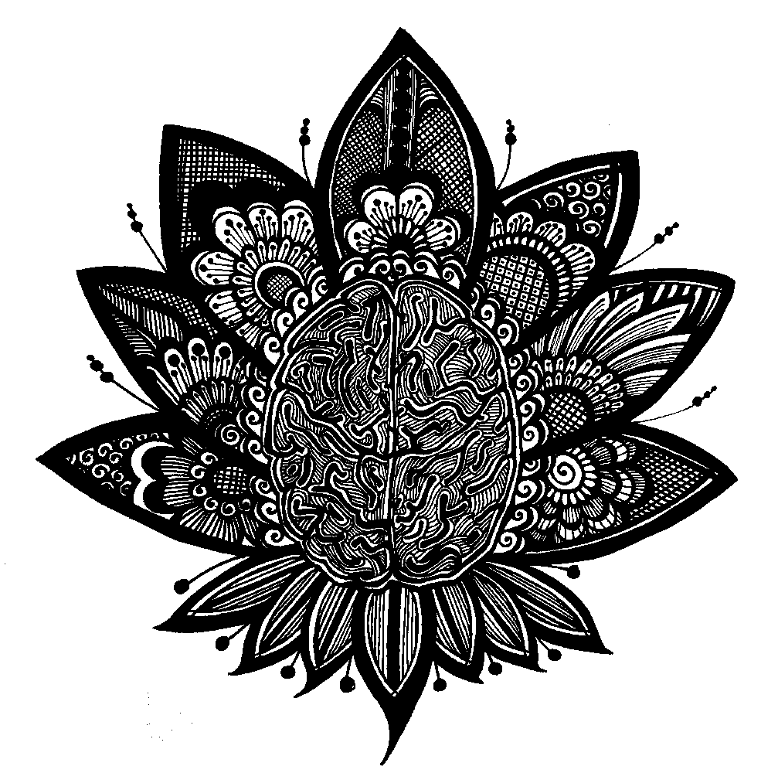
It is really important that you formally think about (or reflect on) your learning in order to develop and improve.

Reflective learners continually think about on:
- What they are learning
- How they are learning it
- How they are using what they are learning
- What their strengths and weaknesses in learning are
- What their learning priorities are
- How they can improve and build upon their learning process
- How well they are working towards their short-, medium- and long-term goals

Reflective learners consider:
- Their motivation
- Their attitudes and ideas, and changes in these
- The skills they need for different components of their study and learning
- What (if anything) is blocking their learning
- The gaps in their knowledge and skills, and how they might best work towards filling these

Why is reflection important?
- Thinking about your learning and writing things down helps to clarify your thoughts and emotions.
- Reflection also helps you to focus on your development as an effective independent learner, and on the strategies you use to work towards this.
Henna Body Art

Date | Text / activity | What happened / incident / issue? | What did you learn / find out / regret / realise? And what was the impact? | What will you do differently in the future? | What other learning needs did you identify | When will you address these | New learning completed
08.08.15 | EXAMPLE  Drawing Paisleys | A friend asked for a design with really big paisleys in it. | I found it really hard to draw a paisley on such a large scale. I had to clean it off and start again. | I will practice large paisleys until I can do them perfectly each time. | I should also come up with lots of ways to fill the large paisleys. | On Saturday, when I have two hours to practise. | Saturday. I did it!

