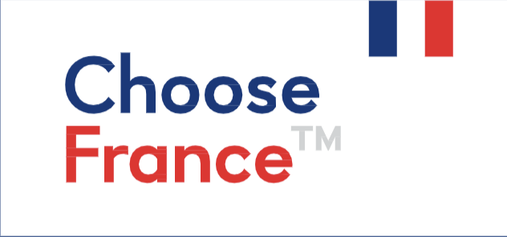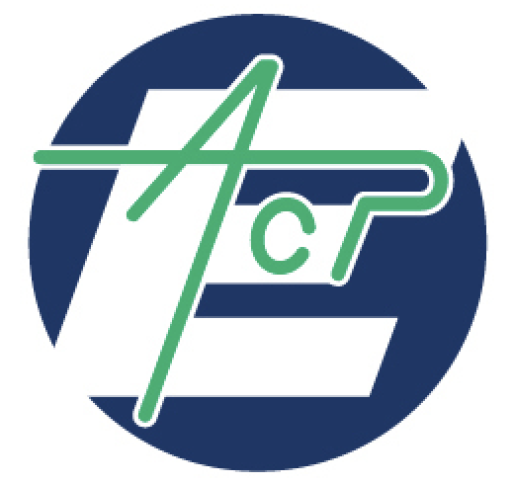

In partnership with

With the support of

**PURCHASE ORDER**

*Business Meetings Africa 2022 -*

*Mining & Related industries*

***Please return this document to*** [***contact@convergence.link***](mailto:contact@convergence.link)

**Your company**

Name:

Headquarters’ address:

Postal Code: City: Country:

CEO/COO/Managing Director (or anyone with Legal Responsibility/Accountability for the corporation's operations):

**Contact person**

Name / Surname: Job title/Position held at your company:

E-mail address:

Landline or work phone number: Mobile phone number:

**Billing address information (if it differs from your headquarters’ address)**

E-mail address:

Phone number:

Address: Postal Code:

City: Country:

**Registration options**

**Zoom mode :** Basic package including conferences and B2B meetings: eligible to attend on Tuesday 8th and Wednesday, November 9th 2022: **600**€ **/ 6,150 ₵ Excl. Taxes**

Registration for an additional person from the same company: **350€ / 3,650₵ Excl**. **Taxes** Number of additional people: Additional amount (HT):

**In person :** Basic package including conferences, B2B meetings, networking lunch and coffee breaks: eligible to attend on Tuesday 8th and Wednesday, November 9th 2022: **1,300**€ **/ 13,550 ₵ Excl. Taxes**

Registration for an additional person from the same company: **1,000€ / 10,400₵ Excl**. **Taxes** Number of additional people: Additional amount (HT):

Option 1: Hotel room in one of our partner’s in Abidjan or Accra, to attend the event in person: **300€ / 3,100 ₵ Excl. Taxes**

Partnership 1: “Simple” Visibility on Convergence networks and event communication: **2,000€ Excl. Taxes for big companies, 1,000€ Excl. Taxes for smaller ones**

Partnership 2: “Full” Visbility on Convergence networks and event communication. Intervention during a conference during the event : **4,000€ Excl. Taxes for big companies, 2,000€ Excl. Taxes for smaller ones**

**Terms of payment**

Via the event’s website: the invoice will be sent by email (Note: This payment method can only be used for payments related to the basic package. Any of the additional extras **must be paid separately**, once we have received your signed purchase order).

Bank transfer (once we have received your signed purchase order) to the following account:

**IBAN:** FR76 3006 6102 1100 0202 4370 178

**BIC:** CMCIFRPP

**Bank Address:** Convergence International SAS, CIC Agence Paris Tolbiac, 24 rue de Tolbiac 75013 Paris.

**Location:** 41, rue Barrault 75013 Paris.

*The undersigned agrees to the terms of this agreement on behalf of his or her organization or business* (ref. General Terms and Conditions of Sale – following pages)*.*

On behalf of: (Company Name)

Date:

Signature and company stamp or seal:

**GENERAL TERMS AND CONDITIONS OF SALE**

*Business Expedition Africa 2022*

**Article 1: Purpose and scope of application**

The present general sales conditions (GSC) constitute the basis of the commercial negotiation and are systematically sent or given to each buyer to enable him to place an order.

The general sales conditions described hereafter detail the rights and obligations of CONVERGENCE INTERNATIONAL SAS and its customer within the framework of the sale of the service " Business Expedition Africa 2022 " and its optional activities.

Any acceptance of the commercial proposal including the clause "I acknowledge having read and accepted the general conditions of sale attached" implies the buyer's unreserved adherence to these general conditions of sale.

**Article 2: Prices**

The prices of the sold goods are those in force at the day of the order taking. They are denominated in euros and calculated without taxes. Consequently, they will be increased by the rate of VAT applicable to the day of the order.

The company CONVERGENCE INTERNATIONAL SAS grants itself the right to modify its prices at any time. However, it makes a commitment to invoice the ordered goods at the prices indicated during the recording of the order.

**Article 3: Discounts and rebates**

The proposed prices include the discounts and rebates that CONVERGENCE INTERNATIONAL SAS would have to grant taking into account its results or the assumption of responsibility by the buyer of certain services.

**Article 4: Discount**

No discount will be granted in case of early payment.

**Article 5: Terms of payment**

The payment of the orders is carried out:

- Either by credit card (Weezevent website);

- Or by bank transfer;

- Or by check.

Payment by check is only possible for checks in euros drawn on a French bank. The check must be made out to CONVERGENCE INTERNATIONAL SAS and sent to the address below:

Convergence International

41, Rue Barrault

75013 PARIS - France

Payment must be made in full before the service is rendered, either in cash or by means of a schedule of payments fixed at the time of signing an annex to the sales contract with CONVERGENCE INTERNATIONAL SAS. To confirm the reservation, a deposit of 30% is required when pre-registering for the event.

**Article 6: Late payment**

In the event that full payment has not been received before the event (November 7, 2022) and regardless of the method selected, the participant will not be able to attend. CONVERGENCE INTERNATIONAL SAS will reimburse the full amount already paid by the participant, with the exception of the deposit and any expenses incurred outside of the Convergence services (such as airfare).

**Article 7: Cancellation**

In case of cancellation of his participation, the client must inform CONVERGENCE INTERNATIONAL SAS by letter with acknowledgement of receipt to the following address

Convergence International

41, Rue Barrault

75013 Paris - FRANCE

The following clauses are then applicable:

* In case of cancellation received more than 45 days before the event (i.e. until September 25, 2022), CONVERGENCE INTERNATIONAL SAS will reimburse 50% of the total amount paid (including pre-registration and options).
* In case of cancellation received between 45 and 30 days before the event (i.e. until October 7th 2022), CONVERGENCE INTERNATIONAL SAS will refund 25% of the total amount paid (pre-registration and options included).
* In case of cancellation received less than one month before the event (i.e. from October 7th, 2022), CONVERGENCE INTERNATIONAL SAS will not make any refund.

**Article 8: Date of realization**

The services purchased under the present conditions will be carried out by CONVERGENCE INTERNATIONAL SAS from 7 to 10 November 2022, during the " Business Expedition Africa 2022 " according to the selected options.

In addition to the participation in the "Business Expedition Africa 2022", the service purchased also includes a communication service and promotion on Convergence's communication media, which will extend episodically from the month preceding the event to the month following it.

**Article 9: “Force majeure” or strong constraint**

The responsibility of CONVERGENCE INTERNATIONAL SAS cannot be implemented if the non-execution or the delay in the execution of one of its obligations described in the present general sales conditions results from a case of force majeure (article 1148 of the French Civil Code) or another strong constraint.

In the case where CONVERGENCE INTERNATIONAL SAS would not be able to carry out the bought services, the company commits itself to refund the buyer completely.

**Article 10: Competent court**

Any dispute relating to the interpretation and the execution of the present general conditions of sale is subject to French law.

In the absence of amicable resolution, the dispute will be brought before the Commercial Court of Paris, the only competent court to decide.