**Book me wherever whenever 24/7.**

**My doors aren’t open 24/7 but my diary is**

Book your appointment directly in my calendar at a time of day that suits you.

**I’ll remind you in advance**

Life happens so I’ll send you a reminder 24 hours before your appointment. You can easily reschedule on the app too.

**Be the first to receive my promotions**

As my client you’ll receive special deals and you can even get them directly through the app.

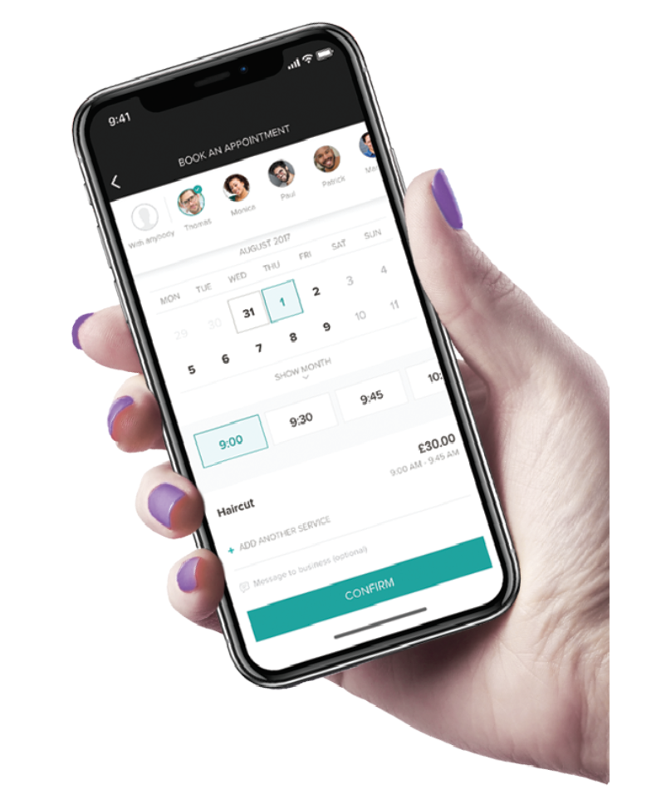

**Try it now:**

**1.** Download the app at booksy.com/download or use the QR code below

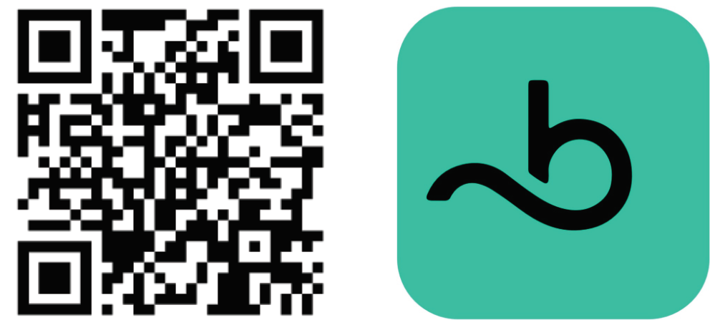

**2.** Find me there

**3.** Book your appointment

Don’t forget to review us after your appointment!