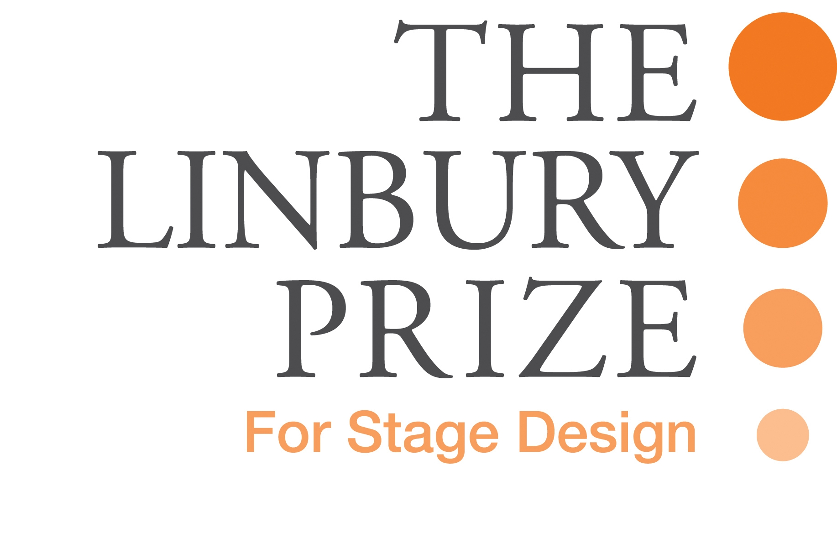
The Linbury Prize Committee is seeking expressions of interest from Opera, Theatre and Dance Companies to participate in the 2019 Prize.

BACKGROUND
The Prize is the only competition of its kind in the UK. Founded in 1987 by Anya Sainsbury CBE, the Prize has helped discover and launch the careers of over 200 talented young stage designers.
It offers an unparalleled opportunity for exposure and success at a crucial moment in their career.
In each biennial cycle the Prize:
- Gives 12 finalists the opportunity to showcase their work as part of an exhibition at the National Theatre;
- Gives each of the four winners a cash prize and, more importantly, a commission to work with a highly-regarded British company on an opera, theatre or dance production; and
- Works in partnership with four companies (the ‘Commissioning Companies’), each of which receives sponsorship towards the realised production.
The 2019 Prize is open to final year students in 2019 and graduates from 2018, from theatre design courses in the UK.
Participating companies for the 2017 Prize were;
The Lyric Hammersmith, Unicorn Theatre, Mercury Theatre, Colchester, Phoenix Dance Theatre
SPONSORSHIP
The Linbury Prize is funded entirely by the Linbury Trust. The National Theatre provides administrative support and generously makes space available for the exhibition.
In respect of each Commissioning Company, the following arrangements will apply:
- The 3 finalists working with the Company will each receive a stipend/contribution to living expenses / model materials for the period August – October of around £2,000.
- The Company will receive sponsorship of £12,000 towards the costs of the production. Of this, £4,500 is the design fee payable to the designer. The balance of £7,500 is intended to be supplemental to the Company’s normal production and design budget.
- The winning designer will receive a separate cash prize.

TIMETABLE (all exact dates subject to confirmation)
2019
Friday 8 March 2019 | Final receipt of applications from Companies
Monday 25 March 2019 | Commissioning Companies interview and selection (at the National Theatre, London)
Monday 12pm, 8 July 2019 | Deadline for receipt of applications by designer candidates
Monday 29 July 2019* | Directors of Commissioning Companies * each interview all short-listed candidates (around 20) and select 3 finalists
August – October 2019 | Companies work with their finalists on their chosen production
November 2019* | Final judging of designs at Exhibition*  Announcement of Winners and Private View
November – Jan 2020 | Linbury Stage Design Prize Exhibition at the National Theatre
2020 | Productions realised

* Attendance by Artistic Director / Choreographer / Director essential at these stages

NEXT STEPS
Companies wishing to apply will be asked by the Linbury Prize Committee to present outline details of the production they would like to offer as a commission to the potential winner.
Each Commissioning Company selected will be required to enter into a Memorandum of Understanding (MOU) with the Linbury Prize.

If you would like further details or an application form please visit www.linburyprize.org.uk

Or you can contact:
Róisín Devine
National Theatre
020 7452 3034
rdevine@nationaltheatre.org.uk

