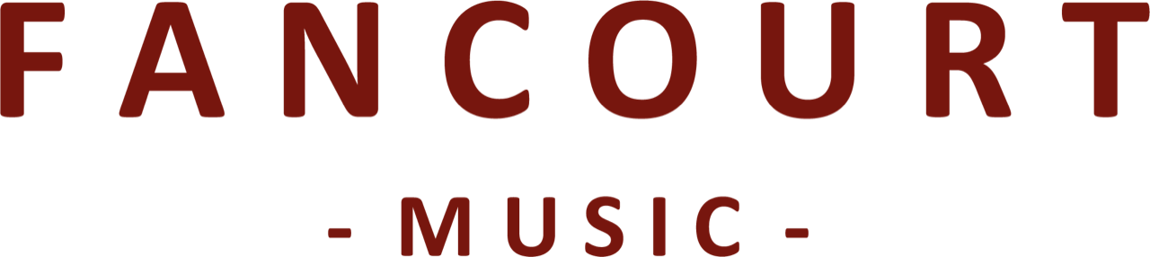
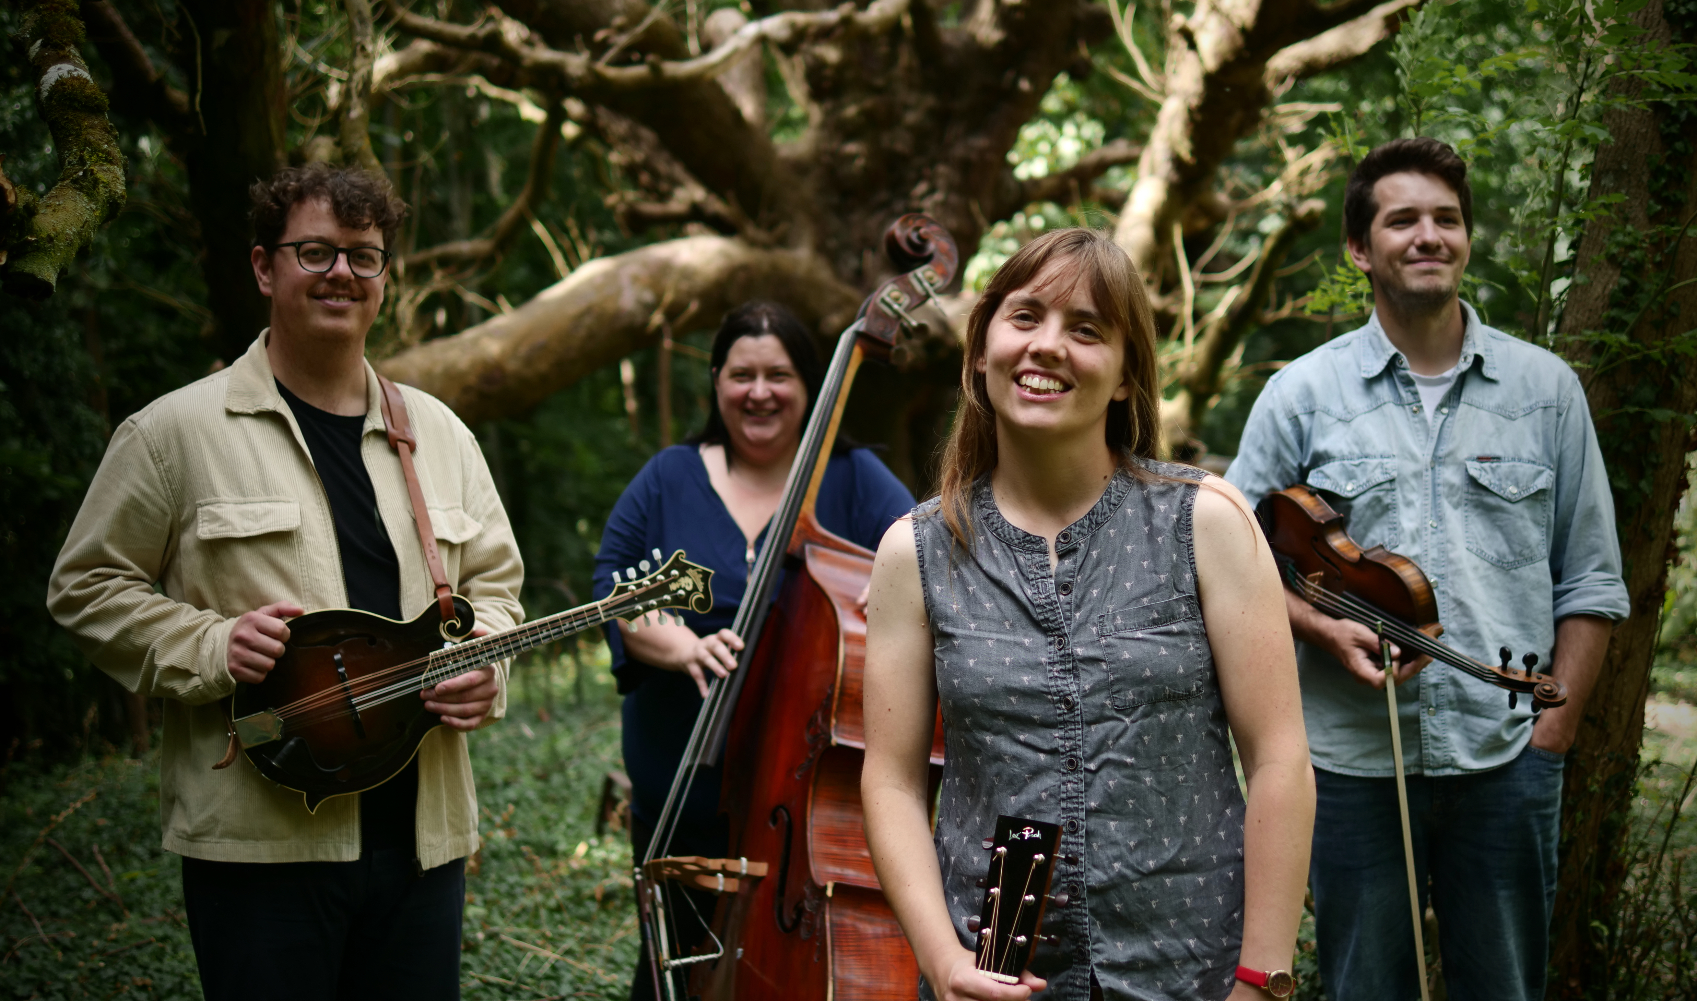
THE CHARLOTTE CARRIVICK BAND

FULL BIOGRAPHY

With a shared passion for modern bluegrass, The Charlotte Carrivick Band brings together four of the most exciting musicians in the UK today. Charlotte Carrivick is a flatpicking guitarist of international renown, sought for her inventive lead playing and regarded as an expert fiddle tune interpreter on the guitar.

Joining Charlotte is long time collaborator and in-demand fiddler, Kieran Towers (Pet Yeti); master of tone and taste, Evan Davies, on the mandolin (The Often Herd); and the firm hand of fellow Midnight Skyracer bassist, Eleanor Wilkie. Together, their music is at times joyous, poignant, dark, pensive or exuberant with virtuosic instrumentals and close harmony singing.

As a founding member of IBMA award nominated, Island Records signed bluegrass powerhouse band, Midnight Skyracer, and one half of the more folk infused and award winning duo The Carrivick Sisters, Charlotte’s taste covers the breadth of the genre as well as taking influence from old time and jazz. It was during the recording of her debut solo album, showcasing her guitar playing and tune writing, that the band was formed.

If you are lover of new acoustic music, bluegrass, old time and swing you won’t want to miss this band.

For further information, please contact Ant Miles at Fancourt Music ant.miles@fancourtmusic.com +44 7837 881941

