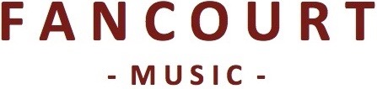

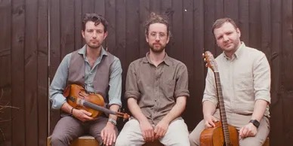

**TOBY SHAER, ARCHIE MOSS & JACK WARNOCK**

A brand-new trio formed by three seasoned session musicians, this collaboration between Toby Shaer, Archie Moss and Jack Warnock was born out of a shared love for traditional music from the UK, Ireland, and mainland Europe. Since meeting in 2019, the trio have established themselves not only as dynamic performers but also as sensitive re-interpreters of the tradition.

Each artist is well respected in their own right: Archie Moss (accordion) is a BBC award-winning musician, a celebrated composer, and one of the most in-demand button accordion players in the UK, has performed alongside Seth Lakeman, Sam Sweeney, and Eliza Carthy.

Toby Shaer (fiddle, flute, whistles, cittern) is a multi-instrumentalist, composer, andproducer from the south east of England. Over the past ten years, he has toured extensively across Europe, Australia, and China with revered artists such as Cara Dillon, McCusker, McGoldrick, Doyle, and, alongside Archie Moss, with Sam Kelly & the Lost Boys.

Jack Warnock (guitar, vocals) hails from Co. Derry in Ireland. An award-winning guitarist and singer, he is also an avid Gaeilgeoir (Irish speaker), performing songs in both Irish and English. His compositions and repertoire are steeped in storytelling as he embraces the lineage of folk music in its truest form.

This trio approach their craft and arrangements with delicacy and thought, drawing influence from a plethora of traditions. A collaboration of three like-minded musicians presenting folk music through a contemporary lens.

**Quotes**

**“*Jack Warnock's voice could entice the birds from the trees*”**Robert McMillen, The Irish News

**“*Archie Churchill-Moss - Great player, great tunes*”**Mark Radcliffe, BBC Radio 2

**Links**

shaermosswarnock.com

facebook.com/shaermosswarnock  
instagram.com/shaer_moss_warnock