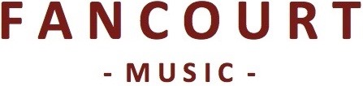

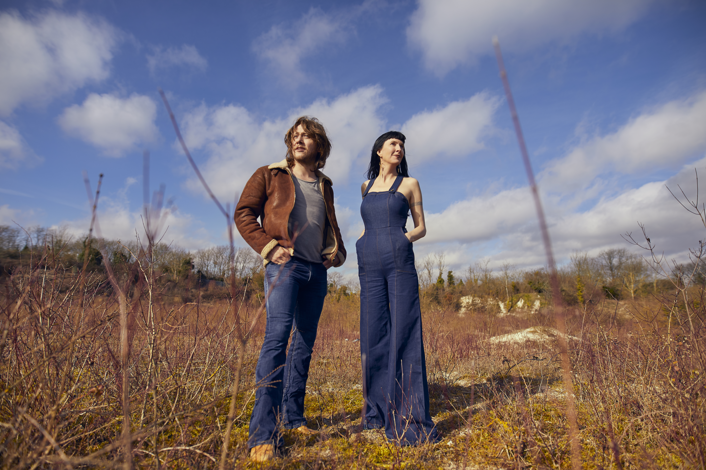

Hannah Sanders & Ben Savage release their fifth studio album The Strangers' Share on 17th October 2025; a record centred on dreams and the supernatural.

Following 2024's In The Dark We Grow band tour, and their 2023 collaborations with folk-rock legends Fairport Convention, the album sees Hannah & Ben return home to the intimate, pin-drop intimacy of the single microphone live shows that made their name five albums earlier. Every creak from their 80 year old vintage guitars is honestly captured; an intake of nervous breath before a heartbreaking ballad; the magic of live-in-the-studio duetting - this record takes you through the veil, deep into Hannah & Ben’s dreamy, soundscaped world - for 40 minutes, you’re in the room with them - sharing the magic.

Their 2022 Topic Records album Ink Of The Rosy Morning was included in MOJO's folk albums of the year, who declared it “as heartwarming as it is beguiling”; the record reached #3 in the Official UK Folk Album Charts.

Since emerging in 2016, Hannah & Ben have been defying all conventions of style, genre and compartmentalisation. A touch of ‘Americana’, yet quintessentially English. Traditional, yet contemporary, with their individual writing style. Playful and instinctive, they make music with such panache and natural chemistry it makes perfect sense.

Hannah Sanders has an alluring mystique and a voice of disarming purity that massages your senses. Ben Savage is a singular guitarist with a sound as distinctive as it is innovative. Together their harmonies and unique stage presence shimmer with an infectious enthusiasm and joy for the connection music offers.

Their intimate live show has captivated audiences across the UK, US, Canada & Asia, sharing the stage with the likes of Fairport Convention, Sarah Jarosz, Martin Simpson, Ralph McTell, Seth Lakeman and Gretchen Peters.

Links

hannahbenmusic.com
facebook.com/hannahbenmusic
twitter.com/hannahbenmusic
instagram.com/hannahbenmusic
youtube.com/channel/UCPa8Znbjkje6e0ehc01w4oA

Quotes

“Arrestingly beautiful” ★★★★★
Songlines

“As close to perfection as it's possible to be… A Pentangle for the 2020s?”
At The Barrier

“As heartwarming as it is beguiling”
MOJO

“An exquisite soundscape, which is the result of passion, precision and unbridled intimacy” ★★★★★
R2 Magazine

“Awesome… a supremely divine album.”
Americana UK

“This is folk music for everyone – a master-class in proficiency, an exercise in individuality and a declaration of love of the folk tradition from both sides of the Atlantic” ★★★★★
Spiral Earth

“A stream of brilliant music - they should be rated among the elite when it comes to UK folk”
Maverick

“Listening to this record is a form of meditation, with all its benefits. Sanders has a voice of such sparkling clarity that soars above and dips around Savage’s dobro and their harmonies are exquisite.”
No Depression

“I've loved Hannah Sanders' voice since first listen and Ben Savage is a master musician. they are both deep in to the soul of their music. I think this album is the best thing they've done.”
Mike Harding Folk Show

“Flawless”
The Guardian - Picks of the month

“Bewitching harmonies, tasteful twin guitars and a dreamy quality that lingers long after the music ends”
Daily Express

"Enchantingly beautiful music”
The Mirror

