
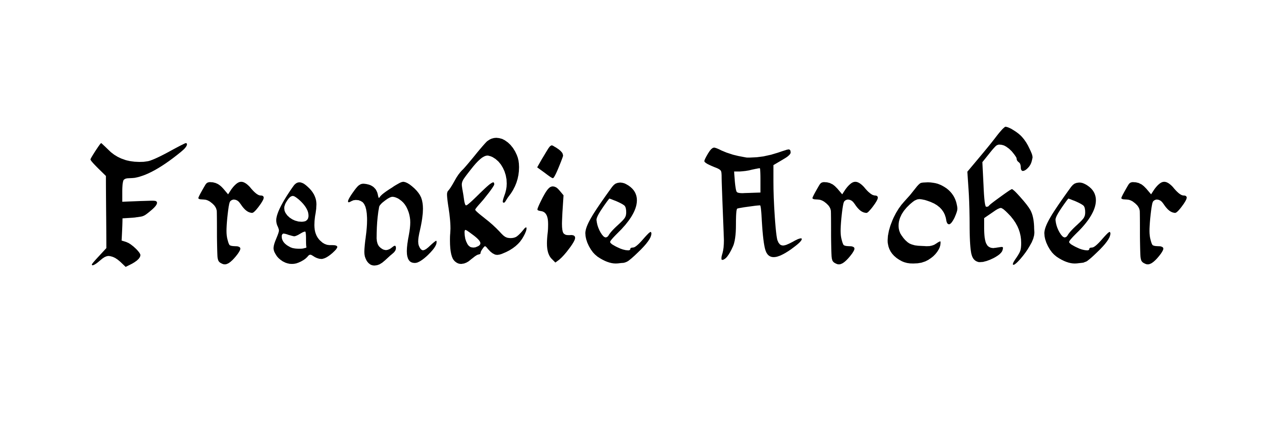

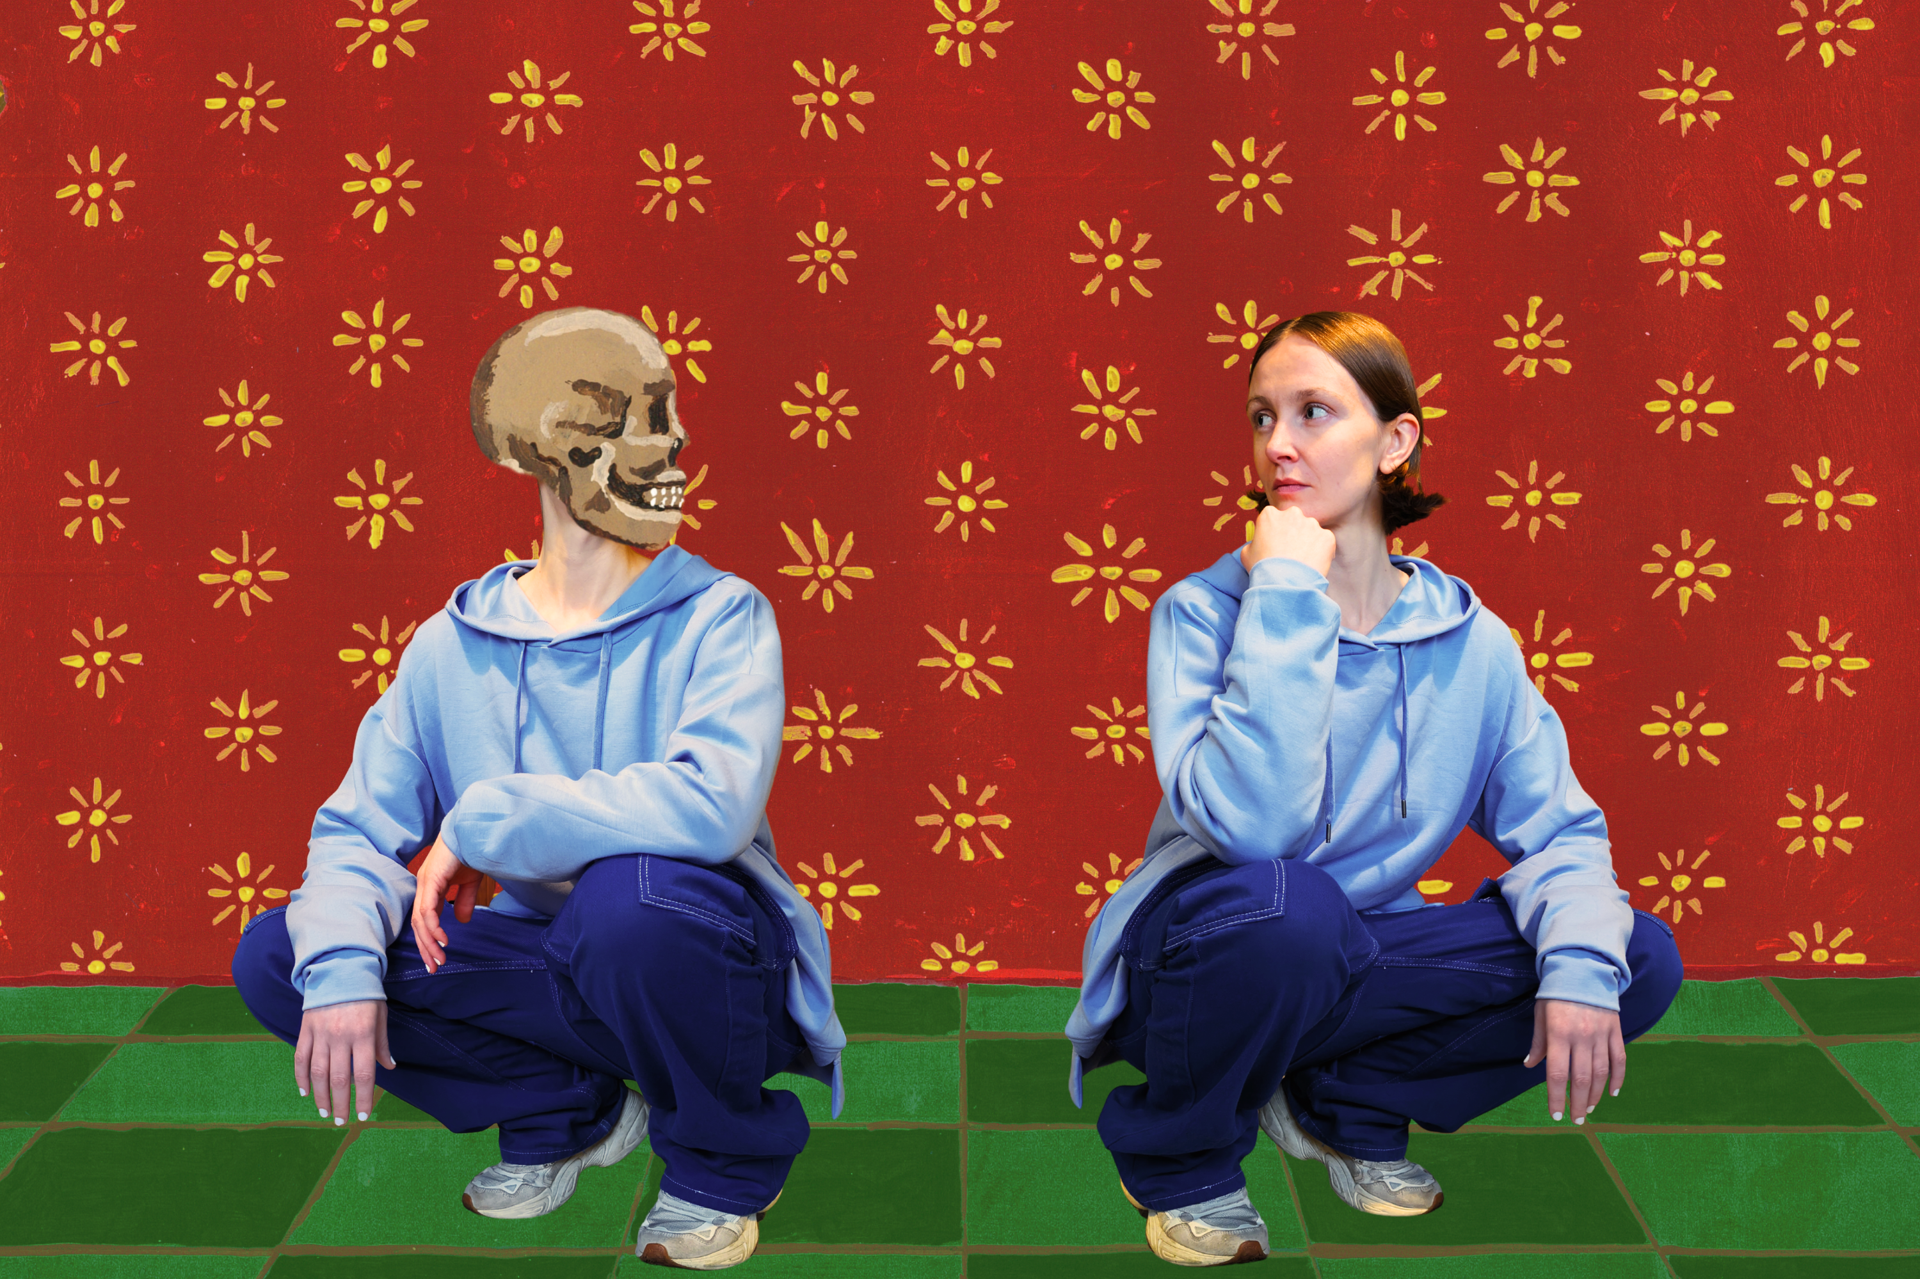

BIOGRAPHY
Frankie Archer presents a blistering nu-ancient trad bangers, telling tales and unfolding beliefs. Inspired in part by the medieval danse macabre and touching on mortality, grief and love, the album’s sound journeys through dreamy electronic to gnarly gristle and everything in between.
Jools Holland described her music as “extraordinary”.
Her unique, fresh sound has pricked up the ears of fans and press, being featured in The Guardian, Bandcamp Best Of, Amazing Radio Tips for 2024, NME New Bangers.
Winner of the Christian Raphael Prize, Frankie has been featured on ‘Later… With Jools Holland’, BBC Proms, BBC Glastonbury coverage, BBC Radio 4 Woman’s Hour, and championed by tastemakers at BBC Radio 2, 3 and 6Music.
She has supported the likes of The Futureheads and The Last Dinner Party. With her unique tech-infused live set turning heads wherever she goes, from Glastonbury to the BBC Proms, Frankie is tearing things up in the alternative space.

QUOTES

“One to Watch”
The Guardian

“Extraordinary”
Jools Holland

“Utterly Hypnotic”
The Quietus

"An utterly beguiling presence live”
Mark Radcliffe, BBC Radio 2

“Truly other-worldly…remarkable”
CLASH Magaine

“New Bangers”
NME

"Fascinating and intoxicating”
Mark Radcliffe, BBC Radio 2

"Nothing short of a revelation… the most exciting thing to have
happened in music; not just folk music, in the last 20 years”
Jen Taylor, At The Barrier

'She is thrilling… you simply cannot wrench your eyes, or ears,
away from the stage… the world is hers for the taking”
Gavin McNamara, Bristol 24/7

"She doesn't just push boundaries but smashes them out of the solar system”
Tony Birch, FATEA

LINKS

frankiearchermusic.com
facebook.com/frankiearchermusic
instagram.com/frankiearchermusic
youtube.com/@frankiearchermusic
tiktok.com/@frankiearchermusic

For further information, please contact Ant Miles at Fancourt Music
07837 881941 | ant.miles@fancourtmusic.com | fancourtmusic.com/frankiearcher

