


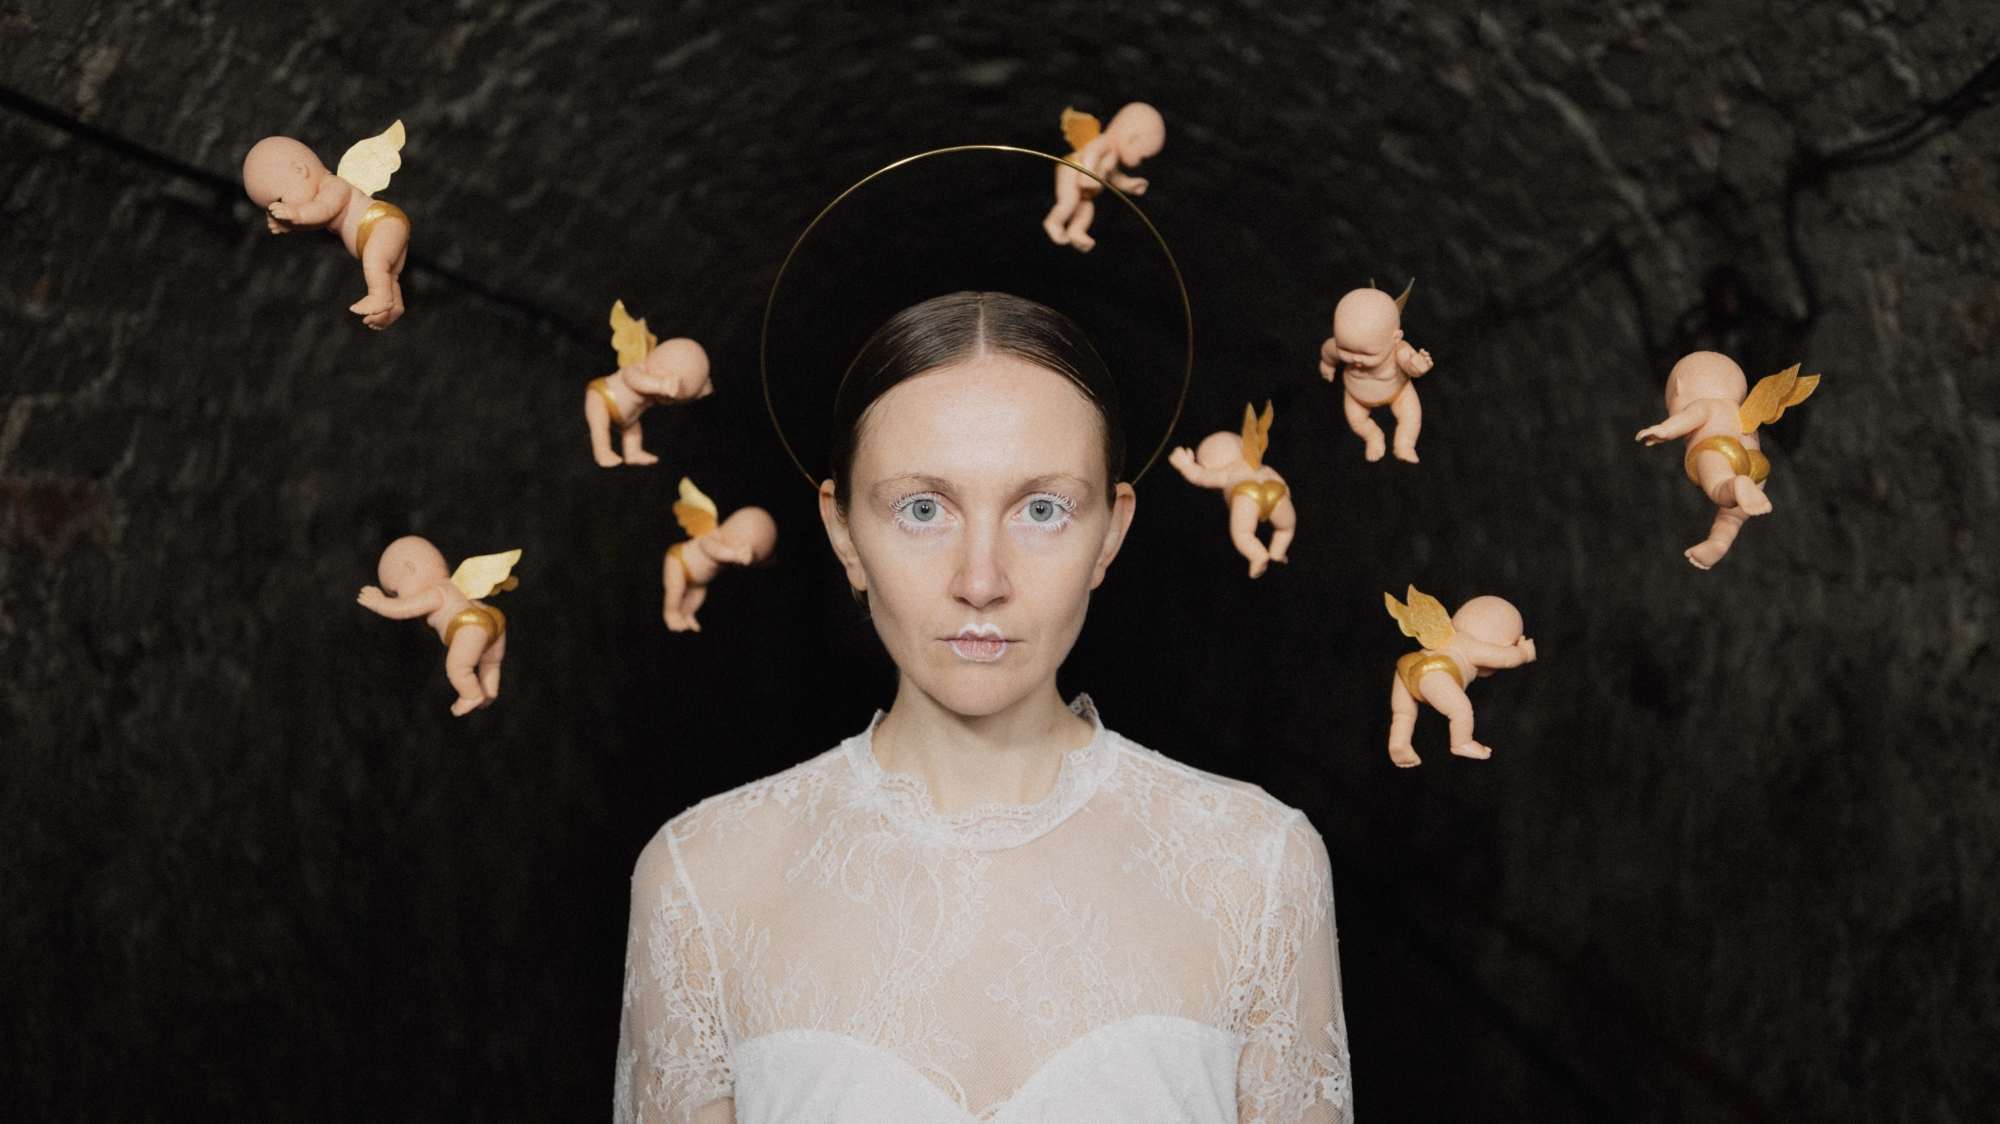

BIOGRAPHY

Frankie Archer’s imaginative and bold mash of electro alt-trad shows her deep love of electronic and experimental music and her Northumbrian roots. Mark Radcliffe (BBC Radio 2) described her music as “fascinating and intoxicating”.

Her unique, fresh sound has pricked up the ears of fans and press, being featured in The Guardian, Bandcamp Best Of, Amazing Radio Tips for 2024, NME New Bangers, earning wonderful reviews from Clash Magazine, Tradfolk and Fresh on the Net, and being chosen by Fatea for their Showcase Session.

Winner of the Christian Raphael Prize, Frankie has been featured on Later… With Jools Holland, BBC Proms, BBC Glastonbury coverage, BBC Radio 4 Woman’s Hour, and championed by tastemakers at BBC Radio 2, 3 and 6Music. She has supported the likes of The Futureheads and The Last Dinner Party. With her unique tech-infused live set turning heads wherever she goes, Frankie is quickly establishing herself as one to watch in the alternative space.

QUOTES

"An utterly beguiling presence live”
Mark Radcliffe, BBC Radio 2

“One to Watch”
The Guardian

“Extraordinary”
Jools Holland

“Utterly Hypnotic”
The Quietus

“Truly other-worldly…remarkable”
CLASH Magaine

“New Bangers”
NME

"Fascinating and intoxicating”
Mark Radcliffe, BBC Radio 2

"Nothing short of a revelation… the most exciting thing to have
happened in music; not just folk music, in the last 20 years”
Jen Taylor, At The Barrier

'She is thrilling… you simply cannot wrench your eyes, or ears,
away from the stage… the world is hers for the taking”
Gavin McNamara, Bristol 24/7

"She doesn't just push boundaries but smashes them out of the solar system”
Tony Birch, FATEA

LINKS

frankiearchermusic.com
facebook.com/frankiearchermusic
instagram.com/frankiearchermusic
youtube.com/@frankiearchermusic
tiktok.com/@frankiearchermusic

For further information, please contact Ant Miles at Fancourt Music
07837 881941 | ant.miles@fancourtmusic.com | fancourtmusic.com/filkinsdrift

