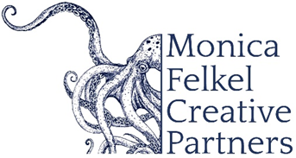

XAVIER FOLEY, double bass and composer

A trailblazing artist and recipient of the prestigious Avery Fisher Career Grant, Xavier Foley is redefining the role of the bassist in 21st-century music. A double bassist of staggering technical prowess and expressive depth, he is also a composer who brings his own voice to the stage, crafting works that showcase both his virtuosic playing and his distinct compositional language.

Xavier has composed five groundbreaking concerti for double bass, commissioned and performed by ensembles including the Atlanta Symphony Orchestra, the Sphinx Virtuosi in association with Carnegie Hall and the New World Symphony, and the Cabrillo Festival in association with the Mahler Foundation, as well as the Saint Paul Chamber Orchestra, Baltimore Symphony, Kansas City Symphony, Nashville Symphony, and the Mostly Mozart Festival Orchestra. He has collaborated with conductors including Mei-Ann Chen, Cristian Măcelaru, David Danzmayr, Michael Christie, Michael Stern, Carlos Kalmar, and Thomas Wilkins.

Xavier has captivated audiences with recital appearances at leading venues including the Kennedy Center, Shriver Hall, The Conrad Prebys Performing Arts Center, Isabella Stewart Gardner Museum, Davies Symphony Hall, and the National Gallery of Art.

He regularly performs his original solo works in recital, often alongside Bach transcriptions, positioning the double bass as a bold and expressive solo voice. Beyond the stage, he reaches over 123,000 followers on Instagram (@xavierfoleybass), where his content has helped redefine the double bass for a global audience.

Originally from Marietta, Georgia, Xavier Foley is a graduate of the Curtis Institute of Music, where he studied with Edgar Meyer and Hal Robinson. He won the 2016 Young Concert Artists International Auditions and is an alumnus of the Perlman Music Program.

7/2026 (short bio, ~265 words)
NOTE: Please discard previously dated materials and contact artist’s management before making any alterations or cuts. Please do not use previously dated materials.

