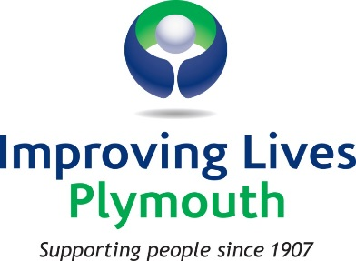

Data Protection Statement

In keeping with good practice and in compliance with data protection law, Improving Lives Plymouth will only collect and securely store information about you to enable us to provide you with the service(s) you have requested. The data will be collected to enable us to record the number of sessions we are delivering and to whom. This data will then be fed back to our funders to show we are achieving our outcomes.

We will treat the information you provide as confidential and will only share your information within Improving Lives Plymouth with your permission to help achieve the best outcome for you; however, we are also required by law to share your data with the relevant organisations in certain situations, e.g. in the case of a criminal investigation or where, in our opinion, you are putting yourself or others at risk.

You have the right to withdraw your consent at any time. Unless you ask us to erase the data, we will keep your information for three years, after which it will be destroyed. You can inform us at any time if some of your details have changed so that we can rectify the information we have. You have a right to access the data we hold by completing a Subject Access Request Form which you can obtain from reception.

