Student Handout
A. Objectives
This experiment is an introduction to cross-coupling reactions and features a modern twist. Specifically, this experiment involves the Ni-catalyzed Suzuki–Miyaura reaction to link aromatic fragments that contain heteroatoms, or ‘heterocycles’ (Figure S1). Additionally, the importance of ‘green’ and sustainable chemistry will be introduced in this laboratory experiment. NMR spectroscopy will be used to determine the outcome of the reaction, which should provide analytical training to the experimenter.
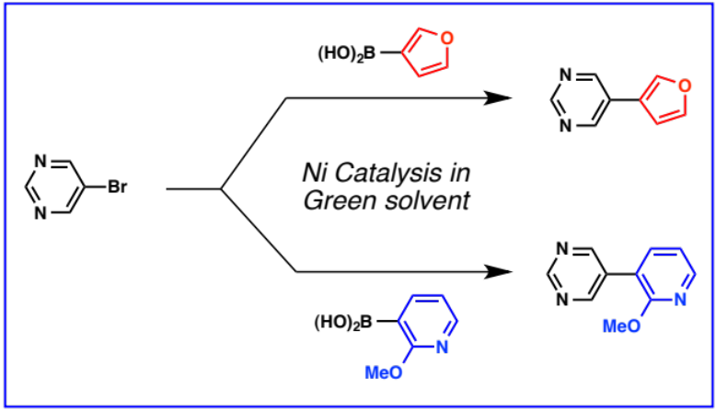
Figure S1. The nickel-catalyzed Suzuki–Miyaura cross-coupling
reactions performed in this undergraduate laboratory experiment.

B. Introduction
Cross Coupling Reactions
Cross-coupling reactions have become one of the most utilized tools to assemble carbon–carbon (C–C) and carbon–heteroatom bonds in chemistry. In fact, the 2010 Nobel Prize in Chemistry was awarded to Richard Heck, Ei-ichi Negishi, and Akira Suzuki for their pioneering work in Pd-catalyzed cross-coupling chemistry that is now used in a host of academic and industrial applications. Among these powerful transformations, the Suzuki–Miyaura cross-coupling, generally defined as the transition-metal-catalyzed cross-coupling between an organic halide and an organoboron compound, has become one of the most attractive approaches for the assembly of C–C bonds. Other types of important cross-coupling reactions include Stille couplings, Sonogashira Couplings, and Heck couplings to build C–C bonds, in addition to Buchwald–Hartwig couplings to build carbon–heteroatom bonds.

Nickel Catalysis, Heterocycles, and Green Chemistry
Although the use of palladium catalysis is most common in cross-coupling reactions, complementary approaches to achieve such couplings are highly sought after. One attractive alternative involves the use of nickel catalysts in place of palladium catalysts (Figure S2). Several aspects of nickel render it attractive: (a): nickel is readily available, as opposed to palladium, which is considered a ‘precious metal’; (b) nickel metal is considerably cheaper compared to palladium metal, as shown in Figure S2, although the overall price for a given chemical process will depend on a variety of factors; (c) nickel is considered less toxic compared to palladium; for example, greater amounts of trace nickel (roughly 2x) can remain in a final orally administered drug substance compared to palladium; (d) although not the focus of this laboratory experiment, nickel catalysis can be used to react several unconventional electrophiles in place of commonly used aryl halides; (e) nickel catalysis can be used to form linkages between two heterocyclic coupling fragments; heterocycle–heterocycle couplings are generally challenging for catalytic reactions because heteroatoms such as oxygen and nitrogen can bind to metals and ‘poison’ the catalysts. Heterocycles, or organic molecules that possess heteroatoms such as nitrogen and oxygen, are prevalent in polymers, materials, ligands, bioactive compounds, and natural products. Methods to link heterocycles together are important, as the resulting products called bis(heterocycles) are also important classes of compounds (see Figure S3).

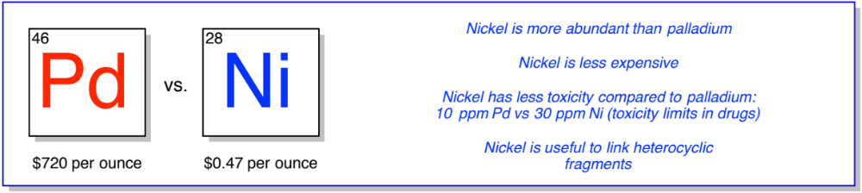
Figure S2. Nickel as an attractive alternative to palladium.

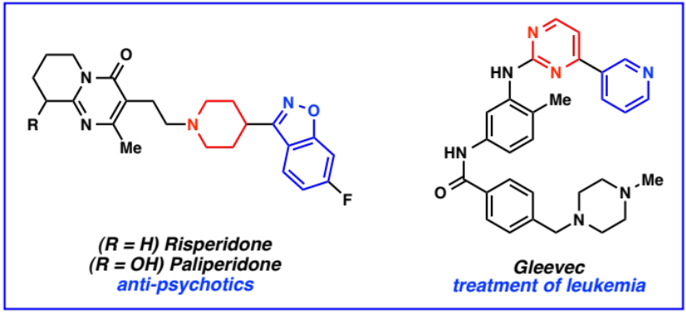
Figure S3. Examples of top selling drugs which contain bis(heterocycle) motifs.

By shifting from palladium to nickel, there are also opportunities in the realm of ‘green chemistry’. ‘Green chemistry’, or the design of chemical processes that reduce or eliminate the use of hazardous and environmentally unfriendly substances, is one of the most important modern initiatives in the chemical sciences. For instance, the pharmaceutical sector is readily embracing more ‘green’ processes to circumvent many unfavorable aspects of drug production, including the use of unrecoverable starting materials, excessive use of environmentally unfriendly organic solvents for separation and purification, and use of toxic reagents. It is estimated that 25–100 kg of waste is produced per kg of drug produced in a 6–8 step industrial drug manufacturing process. Of this waste, 85% consists of organic solvent.⁶ Therefore, the ability to efficiently carry out cross-coupling reactions in more environmentally friendly solvents,, such as alcohols (e.g., tert-amyl alcohol) remains a challenge and important goal of green chemistry research.

Mechanism of the Suzuki–Miyaura Coupling
The general mechanism of the Suzuki–Miyaura cross-coupling reaction, catalyzed by the nickel catalyst used in this laboratory, is outlined in Figure S4.^{2d} The first step of the proposed mechanism is to generate an active Ni(0) catalyst. This is achieved by the boronic acid, which reduces the starting Ni(II) pre-catalyst to a related Ni(0) complex. The complex then inserts into the carbon–bromide bond through a process called oxidative addition, where the nickel changes to the +2 oxidation state. The oxidative addition intermediate then undergoes transmetallation, where the organic fragment attached to boron is transferred to the nickel center. This is facilitated by the presence of base. In the final step, reductive elimination forms the key C–C bond and regenerates the active Ni(0) catalyst, which, in turn, can re-enter the catalyst cycle.
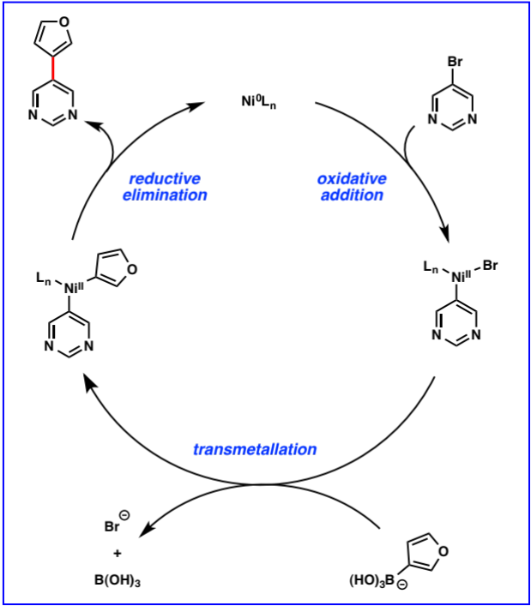
Figure S4. Proposed reasonable mechanism of the nickel-catalyzed Suzuki–Miyaura coupling.
C. Experimental
Safety Hazards and Considerations
Closed-toed shoes, long pants, safety glasses, gloves, and flame-resistant laboratory coats should be worn at all times. All hazardous materials should be handled and disposed of in accordance with the recommendation of the materials’ safety data sheet and EH&S. Bis(tricyclohexylphosphine)nickel(II) dichloride (NiCl₂(PCy₃)₂) and heterocyclic boronic acids may be harmful if inhaled, swallowed, or absorbed through skin. 5-Bromopyrimidine and potassium phosphate are irritants and may be harmful if inhaled, swallowed, or absorbed through skin. Tert-amyl alcohol is an irritant and may therefore cause skin and eye irritation; it is also flammable and may be harmful if inhaled, swallowed, or absorbed through skin. Hydrochloric acid and sodium hydroxide are corrosive and can cause burns to skin, eyes, and respiratory tract. Stock solutions of 1 M aqueous hydrochloric acid (HCl) and sodium hydroxide (NaOH) should be used and prepared in a fume hood. Ethyl acetate and hexanes are flammable and volatile organic solvents. The n-hexane in hexanes is a neurotoxin. CDCl₃ is toxic and a cancer suspect agent. The products of the coupling are not considered harmful, but care should be taken to avoid inhalation or contact with skin. Stirring-hotplates should be used inside the fume hood and kept away from flammable solvents. When the reaction is quenched with HCl, the reaction mixture should be at room temperature (see page S11).
Experimental Procedures
Note: students will be randomly assigned one of two heterocyclic boronic acids (see Figure S5). After completing the experiment, purification, and NMR analysis, students will determine which boronic acid they were given and the structure of the cross-coupled product. Students must support their structural assignment based on their collected NMR data.

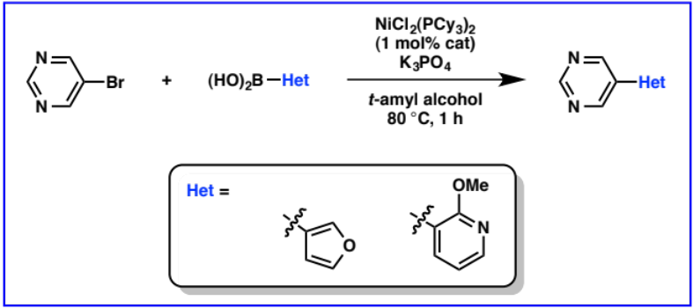
Figure S5. Cross-coupling reaction between 5-bromopyrimidine and a heterocyclic boronic acid.

Add 5-bromopyrimidine (100.00 mg, 0.63 mmol, 1.00 equiv), NiCl₂(PCy₃)₂ (4.40 mg, 0.0063 mmol, 0.01 equiv), unknown heterocyclic boronic acid (1.58 mmol, 2.50 equiv), and K₃PO₄ (603.00 mg, 2.84 mmol, 4.50 equiv) to a 4 mL glass vial (1 dram).
For unknown boronic acid # 1, add 176 mg.
For unknown boronic acid # 2, add 240 mg.

After adding all of the solids, add a stir bar and t-amyl alcohol (2.10 mL). Cap the vial tightly with a green thermoset screw cap. Seal the green cap with Teflon tape and then wrap the vial with parafilm to prevent the risk of solvent leaking. Please ask your instructor or teaching assistant if you need help with this or any other part of the experimental protocol. Allow the heterogeneous mixture to stir at 23 °C for 30 min, and then heat the mixture to 80 °C for 1 h. Remove the reaction vessel from the heat source and set the vessel aside in the fume hood for 5-10 min for cooling. Alternatively, upon completion of the reaction, the temperature of the heat source can be adjusted to 23 °C and the vessel can be removed once the temperature reaches 23 °C. Quench the reaction by adding 1 M aqueous HCl (3 mL) dropwise.
Separate the organic and aqueous layers using a separatory funnel. Extract the aqueous layer with EtOAc (3 x 4 mL). Wash the combined organic layers with 1 M aqueous NaOH (4 mL), brine (4 mL), dry the organic layer over magnesium sulfate (MgSO₄), and filter the mixture to remove MgSO₄. Perform thin layer chromatography (TLC) (recommended solvent mixture is 3:1 Hexanes:EtOAc) and record your observation. Remove the solvent using a rotary evaporator.
Purify the crude residue by silica gel flash chromatography (recommended solvent mixture is 3:1 Hexanes:EtOAc). Collect the fractions in test tubes and then transfer the product-containing fractions to a round bottom flask. Wash the test tubes with a small quantity of EtOAc and combine the washing solvent to the round bottom flask. Remove the solvent using a rotary evaporator to yield the desired cross-coupled product.
Weigh the coupling product and calculate the isolated and percent yield. Prepare a sample for NMR analysis: measure about 50 mg of the product into a test tube and dissolve the product in roughly 1 mL of CDCl₃ and then transfer the resulting solution to an NMR tube by pipette. Acquire ¹H and ¹³C NMR spectra. Analyze your NMR data, along with the attached NMR data for 5-bromopyrimidine, to identify the unknown boronic acid and the cross-coupled product.

Pre-Lab Handout
1. Provide a brief description of the Suzuki–Miyaura cross-coupling reaction.

2. Suzuki–Miyaura cross-couplings use organoboron reagents as coupling partners, as opposed to Stille couplings, which use organotin reagents. List two desirable characteristics of organoboron reagents that render Suzuki–Miyaura cross-couplings especially attractive.

3. Define the term ‘green chemistry’.

4. Anastas and Warner popularized the concept ‘12 principles of green chemistry’. List 6 of these key ideas.

5. For the experiment you will perform, you will be given one of two possible boronic acids as the nucleophilic coupling partner. The other reagent ingredients are consistent regardless of which boronic acid is used. Draw chemical structures of the electrophile, catalyst, base, and solvent you will be using.

Electrophile | Catalyst | Base | Solvent

6. Briefly explain the role of the base in the reaction.

7. Safety is a paramount concern when conducting any laboratory experiment. Describe three safety concerns you have about performing this particular experiment and any precautions you will take to meet these concerns.

8. Considering the ‘12 Principles of Green Chemistry’, briefly describe two ways in which the reaction you are performing is considered ‘green’.

Postlab Worksheet
1. Provide a sketch of your TLC plate and indicate how you visualized compounds on the plate. Calculate the R_{f} value of the coupling product. Be sure to indicate the solvent system you used for TLC.

2. Describe the physical appearance of the coupling product you obtained after chromatography and isolation.

3. Attach ¹H and ¹³C NMR spectra of the coupling product and answer questions (a) and (b).

(a) Consider the ¹HNMR spectrum. For all peaks that correlate to the boronic acid fragment in the product, list the chemical shift, multiplicity, and integration.

(b) Consider the ¹³CNMR spectrum. For all peaks that correlate to the boronic acid fragment in the product, list the chemical shift.

4. Based on inspection of your NMR data, the ¹HNMR and ¹³CNMR data for the bromopyrimidine substrate provided, and the two possible structures shown in the laboratory handout, provide chemical structures for the ‘unknown’ boronic acid and the resulting product you isolated.

Unknown # ____ | Coupling product

5. Provide the mass of isolated product you obtained and calculate the percent yield for the reaction.

6. You can measure catalyst efficiency by calculating the catalyst turnover number (TON), which is defined as the amount of reactant (moles) divided by the amount of catalyst (moles) times the % yield of product. A large TON (typically 10³ or greater) indicates a stable, long-lived catalyst. Based on the resulting experimental yield, calculate the corresponding TON for the nickel catalyst used.

7. Do you observe any impurities by ¹H NMR analysis? ____________. If impurities are observed, speculate as to what the impurities may be. You may choose among the options listed below. If you observe residual solvent(s), provide the structures for the solvent(s) and speculate as to the source of the solvent(s) in the NMR spectrum.

- Bromide substrate
- Boronic acid substrate
- Nickel catalyst
- Solvent

8. Suggest two modifications of this experimental protocol that would make it ‘greener’.

(a) Metal-Catalyzed Cross-Coupling Reactions; de Meijere, A.; Diederich, F., Eds.; Wiley-VCH: Weinheim, 2004. (b) Hassan, J.; Sévignon, M.; Gozzi, C.; Schulz, E.; Lemaire, M. Chem. Rev. 2002, 102, 1359–1469. (c) Topics in Current Chemistry, Vol. 219; Miyaura, N., Ed.; Springer-Verlag: New York, 2002. (d) Corbet, J.-P.; Mignani, G. Chem. Rev. 2006, 106, 2651–2710. (e) Negishi, E. Bull. Chem. Soc. Jpn. 2007, 80, 233–257. (f) Application of Transition Metal Catalysis in Drug Discovery and Development: An Industrial Perspective; Shen, H. C.; Crawley, M. L.; Trost, B. M., Eds.; John Wiley & Sons, Inc.: Hoboken, 2012. (g) Magano, J.; Dunetz, J. R. Chem. Rev. 2011, 111, 2177–2250.
For reviews on Suzuki–Miyaura cross-coupling reactions, see: (a) Miyaura, N.; Suzuki, A. Chem. Rev. 1995, 95, 2457–2483. (b) Suzuki, A. J. Organomet. Chem. 1999, 576, 147–168. (c) Metal-Catalyzed Cross-Coupling Reactions; Diederich, F.; Stang, P. J., Eds.; Wiley-VCH: New York, 1998. (d) Han, F.-S. Chem. Soc. Rev. 2013, 42, 5270–5298.
For reviews on Ni-catalyzed cross-coupling reactions of phenolic derivatives, see: (a) Rosen, B. M.; Quasdorf, K. W.; Wilson, D. Z.; Zhang, N.; Resmerita, A.-N.; Garg, N. K.; Percec, V. Chem. Rev. 2011, 111, 1346–1416. (b) Mesganaw, T.; Garg, N. K. Org. Process Res. Dev. 2013, 17, 29–39.
For Ni-catalyzed couplings to build bis(heterocycles), see: (a) Ramgren, S. D.; Hie, L.; Ye, Y.; Garg, N. K. Org. Lett. 2013, 15, 3950–3953. (b) Ge, S.; Hartwig, J. F. Angew. Chem. Int. Ed. 2012, 51, 12837–12841.
Green Chemistry: Theory and Practice: Anastas, P. T.; Warner, J. C. Oxford University Press: New York, 2000.
Fortunak, J. M. Future Med. Chem. 2009, 1, 571–575.
For solvent selection guide in medicinal chemistry, see: (a) Alfonsi, K.; Colberg, J.; Dunn, P. J.; Fevig, T.; Jennings, S.; Johnson, T. A.; Kleine, H. P.; Knight, C.; Nagy, M. A.; Perry, D. A.; Stefaniak, M. Green Chem. 2008, 10, 31–36. (b) Henderson, R. K.; Jiménez-González, C.; Constable, D. J. C.; Alston, S. R.; Inglis, G. G. A.; Fisher, G.; Sherwood, J.; Binks, S. P.; Curzons, A. D. Green Chem. 2011, 13, 854–862.
For examples of cross-coupling reactions in aqueous media, see: (a) Bussolari, J. C.; Rehborn, D. C. Org. Lett. 1999, 1, 965–967. (b) Hesse, S.; Kirsch, G. Synthesis 2001, 755–758. (c) Anderson, K. W.; Buchwald, S. L. Angew. Chem. Int. Ed. 2005, 44, 6173–6177. (d) Lipshutz, B. H.; Ghorai, S. Aldrichim. Acta. 2008, 41, 59–72. (e) Alacid, E.; Nájera, C. J. Org. Chem. 2009, 74, 2321–2327. (f) Han, J.; Liu, Y.; Guo, R. J. Am. Chem. Soc. 2009, 131, 2060–2061. (g) Chalker, J. M.; Wood, C. S.; Davis, B. G. J. Am. Chem. Soc. 2009, 131, 16346–16347.
Hydroxide may bind to the boron to make a more reactive boron ‘ate’ complex, as shown in Figure S4. Elucidating the role of base in Suzuki–Miyaura couplings is an important area of modern research; for relevant studies, see: (a) Amatore, C.; Jutand, A.; Le Duc, G. Chem.—Eur. J. 2011, 17, 2492–2503. (b) Amatore, C.; Jutand, A.; Le Duc, G. Chem.—Eur. J. 2012, 18, 6616–6625. (c) Amatore, C.; Le Duc, G.; Jutand, A. Chem.—Eur. J. 2013, 19, 10082–10093. (d) Carrow, B. P.; Hartwig, J. F. J. Am. Chem. Soc. 2011, 133, 2116–2119. (e) Lennox, A. J. J.; Lloyd-Jones, G. C. Angew. Chem. Int. Ed. 2013, 52, 7362–7370. (f) Lennox, A. J. J.; Lloyd-Jones, G. C. Chem. Soc. Rev. 2014, 43, 412–443.

