Western Blot Instructions and Original Images
At first, we check the full films of western blot for the protein samples of goats to ensure the specificity of antibodies. The results were showed as follows:
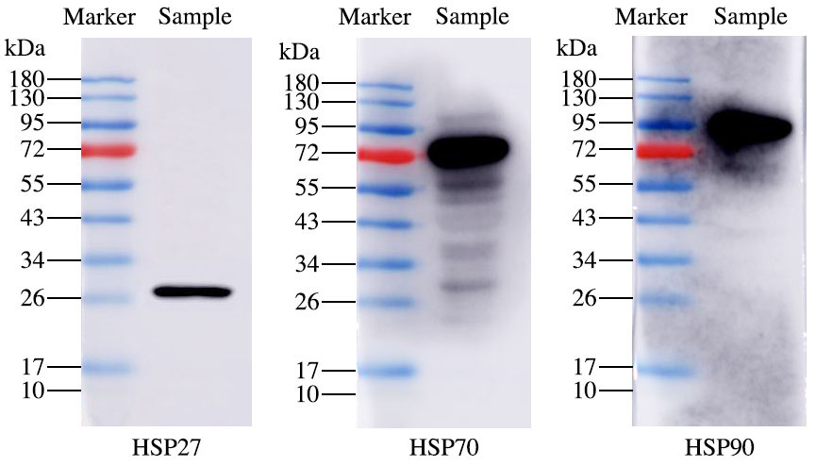
After ensuring the specificity of the anti-HSP27, anti-HSP70 and anti-HSP90, we performed following experiments in article with cropped gels. All original images were showed as follows:
- Rumen
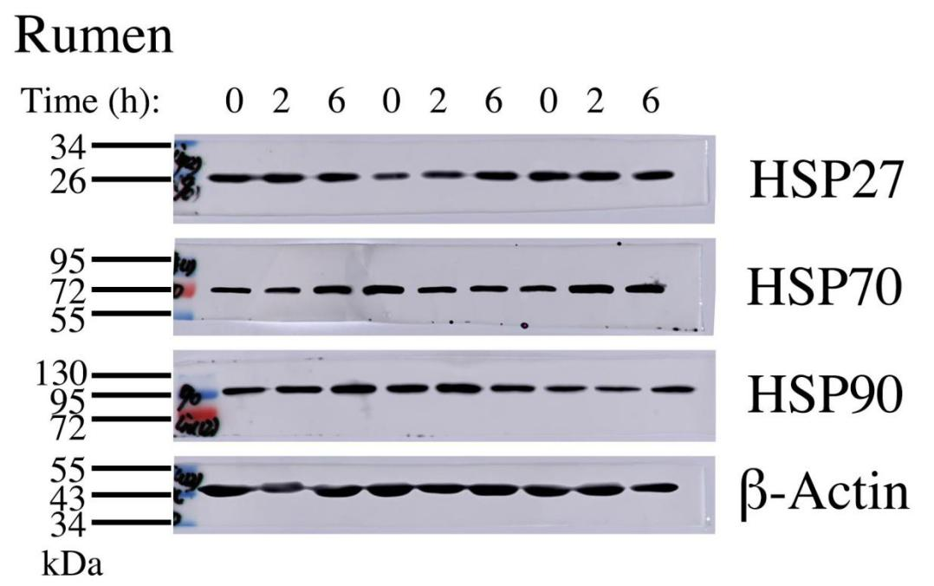
“Time” represents the time of transport. This figure was showed the result of nine goats from three groups. This interpretation is also applied to the following figures.

- Reticulum
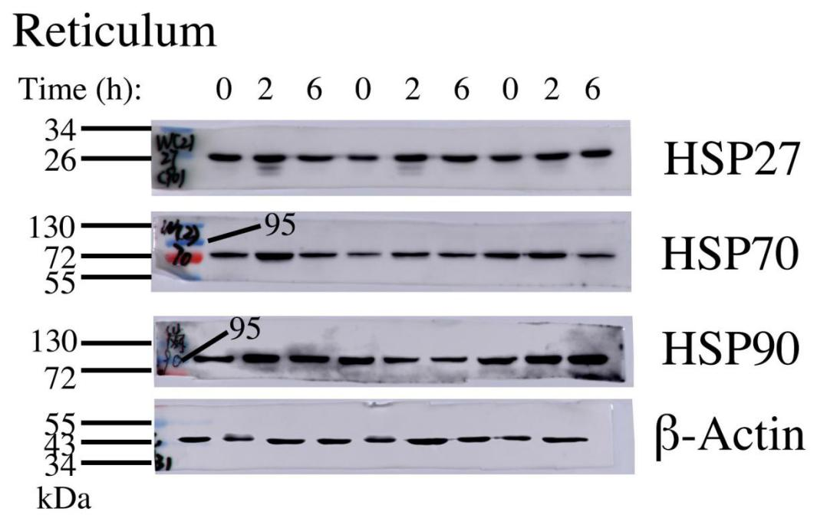

- Omasum
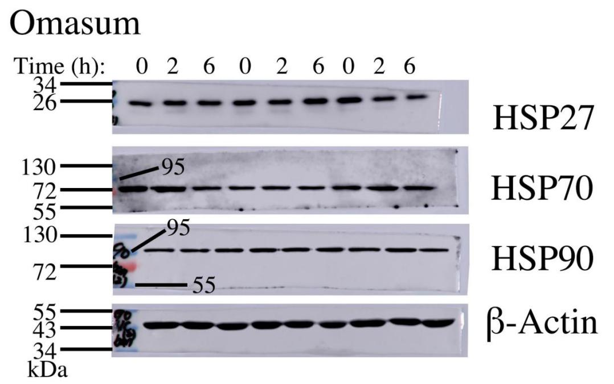

- Abomasum
