Supporting Material S1. Salicinoid identification: Exact masses of 55 salicinoid compounds (Table S1), References (List S1), UV spectra of nine new salicinoids found in the P. tremula foliage (Fig. S1a) and high-resolution MS/MS (Fig. S1b)

Table S1a. Monoisotopic ion exact masses of 55 known (numbers in brackets refer to List S1) and theoretical (*) salicinoids searched for in P. tremula UHPLC-TOF/MS chromatograms in this study. Compounds in bold were found in P. tremula (Information from this study and references [2,8] in List S1, see below).

Compound
Molecular
Monoisotopic exact mass
Reference
 | formula | [M] | [M-H]- [M+FA-H]-
Salicin | C13H18O7 | 286.1052 | 285.0980 | 331.1034 | 1, 2
2'-Acetylsalicin | C15H20O8 | 328.1158 | 327.1085 | 373.1140 | 1, 2
Fragilin | C15H20O8 | 328.1158 | 327.1085 | 373.1140 | 1
Diacetylsalicin | C17H22O9 | 370.1264 | 369.1191 | 415.1246 | *
Tremuloidin | C20H22O8 | 390.1315 | 389.1242 | 435.1297 | 1, 2
Chaenomeloidin | C20H22O8 | 390.1315 | 389.1242 | 435.1297 | 1
Populin | C20H22O8 | 390.1315 | 389.1242 | 435.1297 | 1
Deltoidin | C20H22O9 | 406.1264 | 405.1191 | 451.1246 | 1
Nigracin | C20H22O9 | 406.1264 | 405.1191 | 451.1246 | 1
Salicyloylsalicin | C20H22O9 | 406.1264 | 405.1191 | 451.1246 | 1
Salireposide | C20H22O9 | 406.1264 | 405.1191 | 451.1246 | 1
Trichocarpin | C20H22O9 | 406.1264 | 405.1191 | 451.1246 | 3
Cinnamoylsalicin | C22H24O8 | 416.1471 | 415.1398 | 461.1453 | *
Salicortin | C20H24O10 | 424.1369 | 423.1297 | 469.1351 | 1, 2
Populoside B | C22H24O9 | 432.1420 | 431.1347 | 477.1402 | 1
Trichocarposide | C22H24O9 | 432.1420 | 431.1347 | 477.1402 | 1
Grandidentanin | C21H28O9 | 432.1420 | 431.1347 | 477.1402 | 4
Grandidentoside | C21H28O10 | 440.1683 | 439.1610 | 485.1665 | 5
Populoside | C22H24O10 | 448.1369 | 447.1297 | 493.1351 | 1
Populoside A | C22H24O10 | 448.1369 | 447.1297 | 493.1351 | 1
Acetylsalicyloylsalicin | C22H24O10 | 448.1369 | 447.1296 | 493.1351 | *
Diglucoside salicin | C19H28O12 | 448.1581 | 447.1508 | 493.1563 | 6
Acetylcinnamoylsalicin | C24H26O9 | 458.1577 | 457.1504 | 503.1559 | *
Populoside C | C23H26O10 | 462.1526 | 461.1453 | 507.1508 | 1

2'-Acetylsalicortin | C22H26O11 | 466.1475 | 465.1402 | 511.1457 | 1
Diacetylsalicyloylsalicin | C24H26O11 | 490.1475 | 489.1402 | 535.1457 | *
6'-Benzoyltremuloidin | C27H26O9 | 494.1577 | 493.1504 | 539.1559 | *
Diacetylsalicortin | C24H28O12 | 508.1581 | 507.1508 | 553.1563 | 7
Salicyloyltremuloidin | C27H26O10 | 510.1526 | 509.1453 | 555.1508 | 1
6’-Benzoylcinnamoylsalicin | C29H28O9 | 520.1733 | 519.1660 | 565.1715 | *
6'-Cinnamoyltremuloidin | C29H28O9 | 520.1733 | 519.1660 | 565.1715 | *
Tremulacin | C27H28O11 | 528.1632 | 527.1559 | 573.1614 | 1, 2
HCH-tremuloidin | C27H28O11 | 528.1632 | 527.1559 | 573.1614 | *
Cinnamoylsalicyloylsalicin | C29H28O10 | 536.1683 | 535.1610 | 581.1665 | *
2-Hydroxybenzoylsalicortin | C27H28O12 | 544.1581 | 543.1508 | 589.1563 | *
HCH-deltoidin | C27H28O12 | 544.1581 | 543.1508 | 589.1563 | *
HCH-Salicyloylsalicin | C27H28O12 | 544.1581 | 543.1508 | 589.1563 | *
HCH-nigracin (2’-Bz) | C27H28O12 | 544.1581 | 543.1508 | 589.1563 | *
HCH-nigracin (6’-Bz) | C27H28O12 | 544.1581 | 543.1508 | 589.1563 | *
Dicinnamoylsalicin | C31H30O9 | 546.1890 | 545.1817 | 591.1872 | *
Acetylsalicyloyltremuloidin | C29H28O11 | 552.1632 | 551.1559 | 597.1614 | *
2’-(Z)-Cinnamoylsalicortin | C29H30O11 | 554.1788 | 553.1715 | 599.1770 | 8
2’-(E)-Cinnamoylsalicortin | C29H30O11 | 554.1788 | 553.1715 | 599.1770 | 1, 2
HCH-salicortin | C27H30O13 | 562.1686 | 561.1614 | 607.1668 | 1
6'-Acetyltremulacin | C29H30O12 | 570.1737 | 569.1664 | 615.1719 | 2
HCH-acetylsalicyloylsalicin | C29H30O13 | 586.1686 | 585.1613 | 631.1668 | *
Acetylcinnamoylsalicortin | C31H32O12 | 596.1894 | 595.1821 | 641.1876 | *
Lasiandrin | C29H32O14 | 604.1792 | 603.1719 | 649.1774 | 1
6'-Benzoyltremulacin | C34H32O12 | 632.1894 | 631.1821 | 677.1876 | *
HCH-Salicyloyltremuloidin | C34H32O13 | 648.1843 | 647.1770 | 693.1825 | *
6'-Cinnamoyltremulacin | C36H34O12 | 658.2050 | 657.1977 | 703.2032 | *
HCH-tremulacin | C34H34O14 | 666.1949 | 665.1876 | 711.1931 | 9
Dicinnamoylsalicyloylsalicin | C38H34O11 | 666.2101 | 665.2028 | 711.2083 | *
Dicinnamoylsalicortin | C38H36O12 | 684.2207 | 683.2134 | 729.2189 | *
HCH-cinnamoylsalicortin | C36H36O14 | 692.2105 | 691.2032 | 737.2087 | *

Reference List S1.

1. Boeckler GA, Gershenzon J, Unsicker SB. 2011. Phenolic glycosides of the Salicaceae and their role as anti-herbivore defenses. Phytochemistry 72(13): 1497-1509.
2. Abreu IN, Ahnlund M, Moritz T, Albrectsen BR. 2011. UHPLC-ESI/TOFMS

determination of salicylate-like phenolic glycosides in Populus tremula leaves. Journal of

Chemical Ecology 37(8): 857-870.

4. Si CL, Xu J, Kim JK, Bae YS, Liu PT, Liu Z. 2011. Antioxidant properties and structural analysis of phenolic glucosides from bark of Populus ussuriensis Kom. Wood Science and Technology 45(1): 5-13.
5. Erickson RL, Pearl IA, Darling SF. 1970. Populoside and grandidentoside from bark of

Populus grandidentata. Phytochemistry 9(4): 857-863.

6. Ruuhola TM, Sipura M, Nousiainen O, Tahvanainen J. 2001. Systemic induction of salicylates in Salix myrsinifolia (Salisb.). Annals of Botany 88(3): 483-497.
7. Ruuhola T, Julkunen-Tiitto R. 2003. Trade-off between synthesis of salicylates and growth of micropropagated Salix pentandra. Journal of Chemical Ecology 29(7): 1565-1588
8. Keefover-Ring K, Carlsson M, Albrectsen BR. 2014. 2’-(Z)-Cinnamoylsalicortin: A novel salicinoid isolated from Populus tremula. Phytochemistry Letters 7: 212-216.
9. Paunonen R, Julkunen-Tiitto R, Tegelberg R, Rousi M, Heiska S. 2009. Salicylate and biomass yield, and leaf phenolics of dark-leaved willow (Salix myrsinifolia Salisb.) clones under different cultivation methods after the second cultivation cycle. Industrial Crops and Products 29(2-3): 261-268.

Fig. S1a. UV spectra (210-400 nm) of the new salicinoids found in the foliage of Populus tremula. See Materials and Methods for instrument conditions. Numbers on spectra indicate λmax

HCH-salicortin
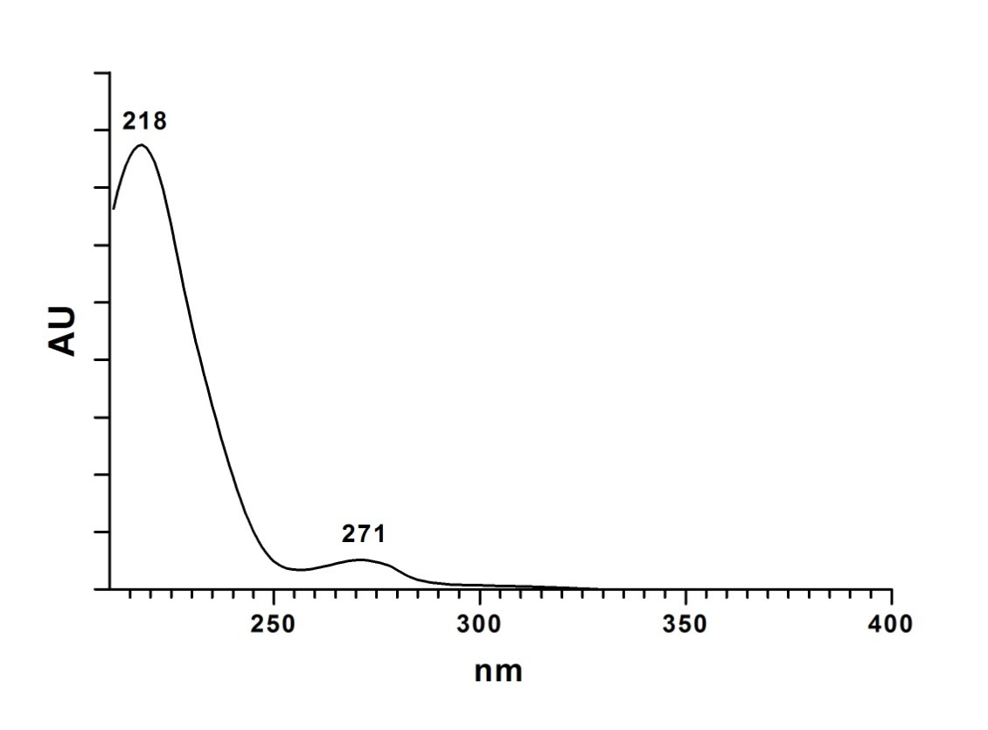

HCH-tremulacin
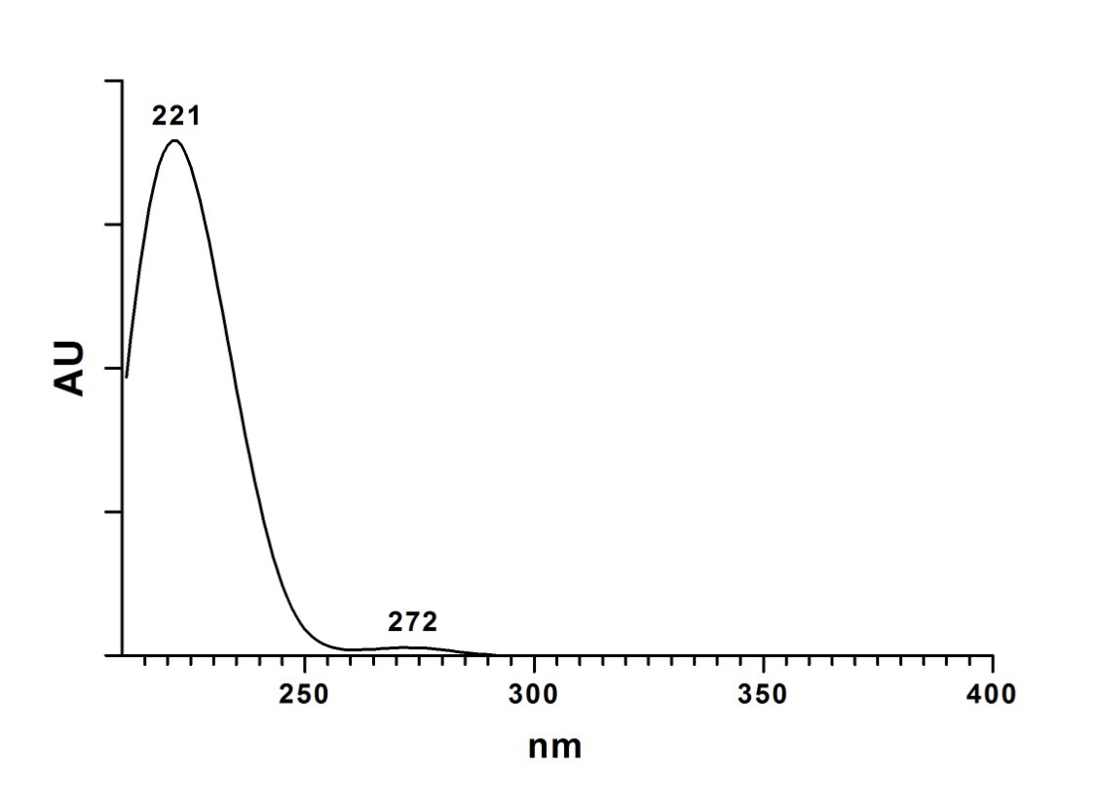

Cinnamoylsalicin isomers 1 (top) and 2 (bottom)
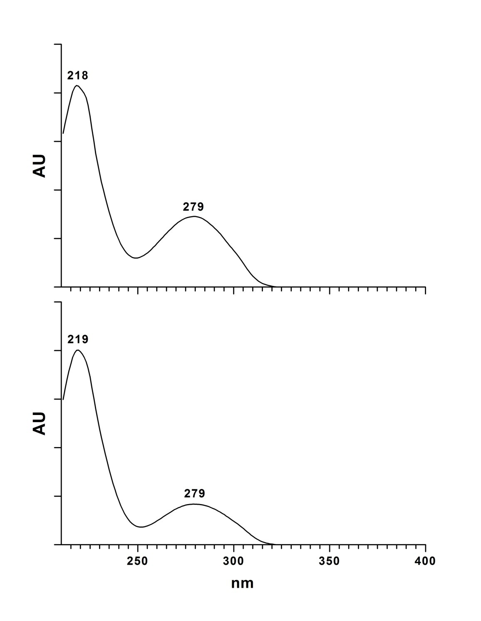

Acetylcinnamoylsalicortin isomers 1 (top) and 2 (bottom)
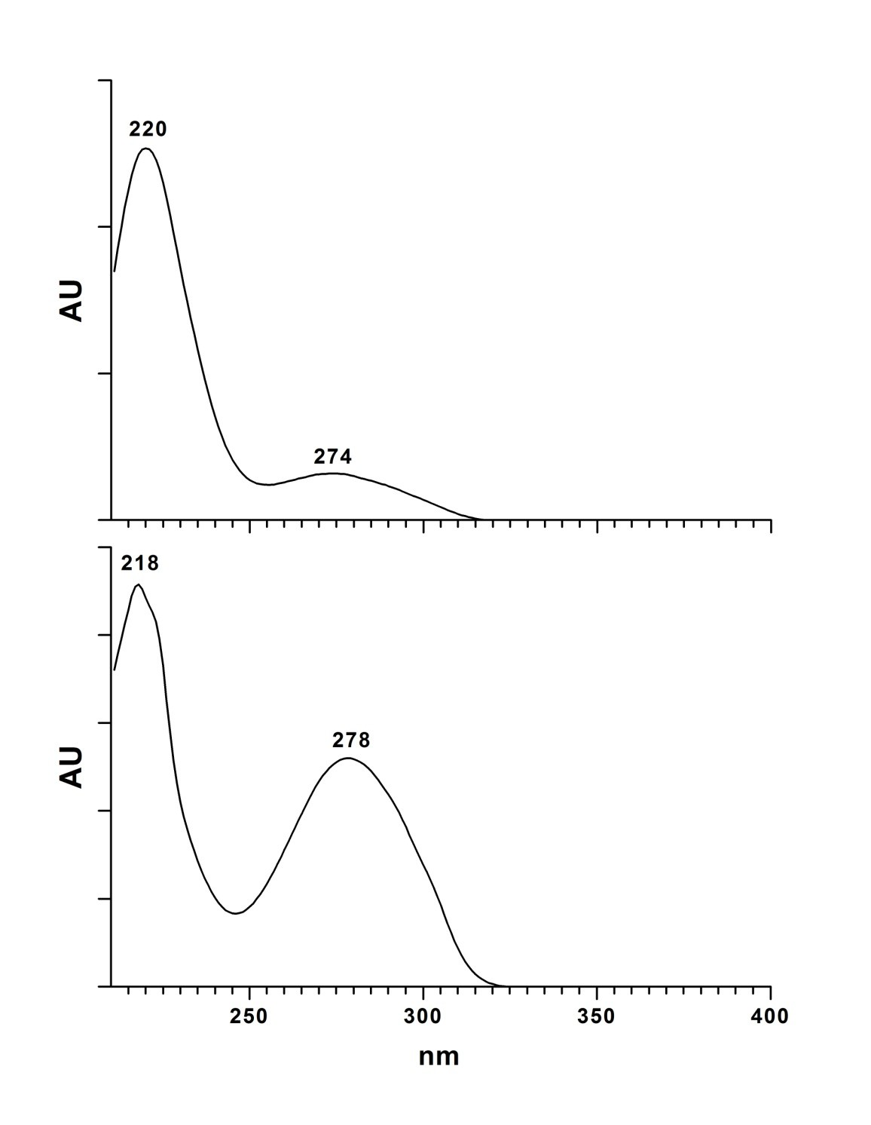

HCH-cinnamoylsalicortin isomers 1 (top) and 2 (bottom)
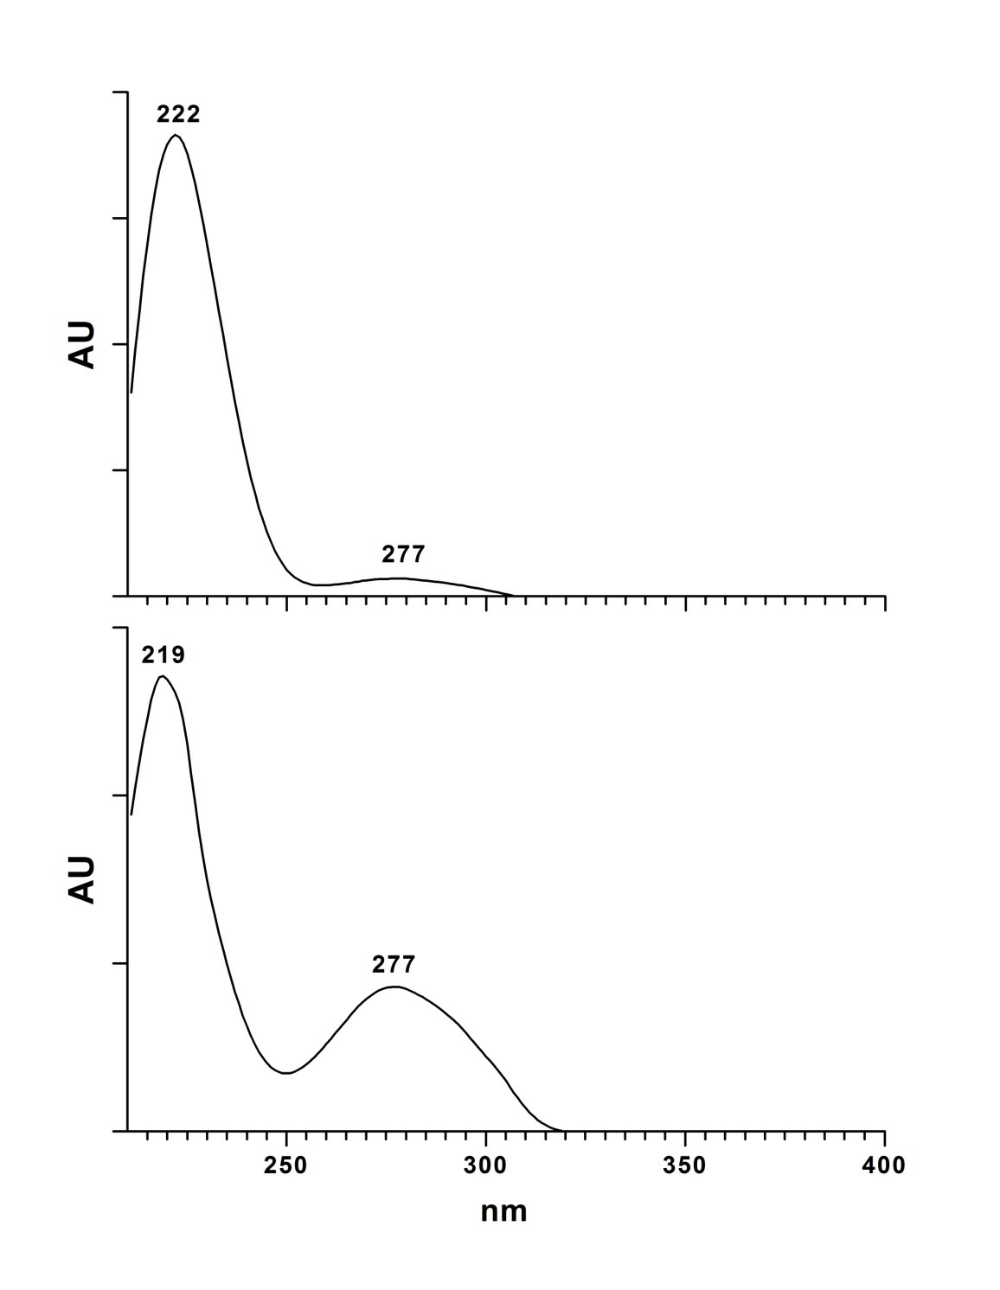

Lasiandrin (HCH-2’-acetylsalicortin)
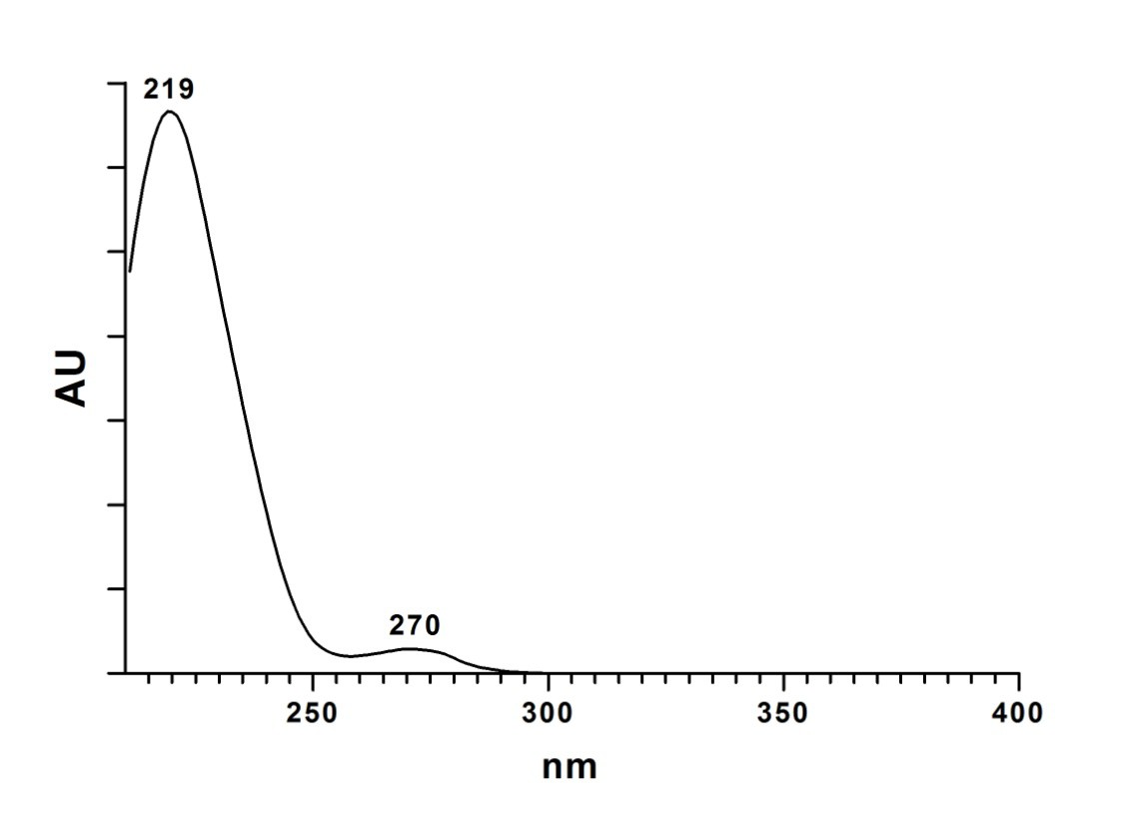

Fig. S1b High-resolution MS/MS spectra of the new salicinoids found in the foliage of Populus tremula. See Methods and Materials for instrument conditions. Arrows on structures show the most abundant fragments. See Table 1 for a list of fragments and their relative intensities

HCH-salicortin - Used [M-H]- m/z 561.161 for fragmentation
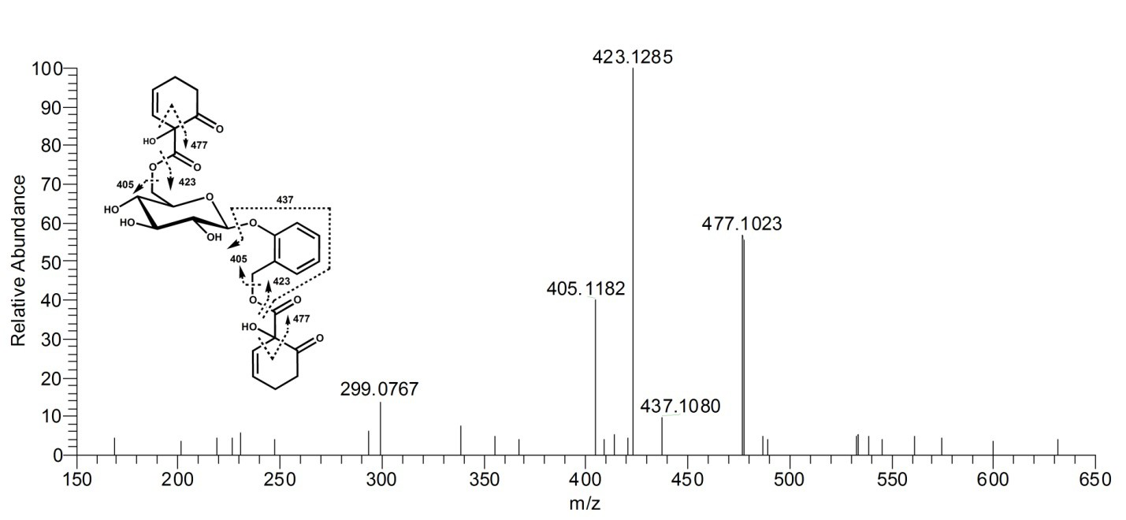

HCH-tremulacin - Used [M-H]- m/z 665.186 for fragmentation
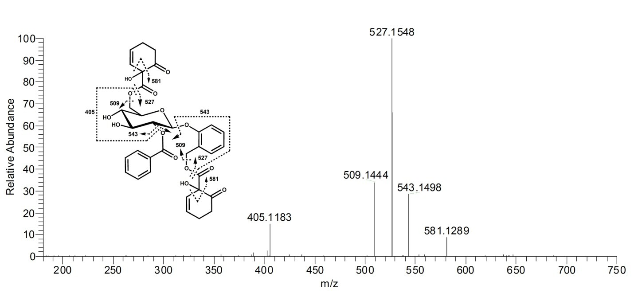

Cinnamoylsalicin Isomer 2 (the putative 2’-(E)-cinnamoylsalicin isomer shown). Used [M- H+FA]- m/z 461.145 for fragmentation
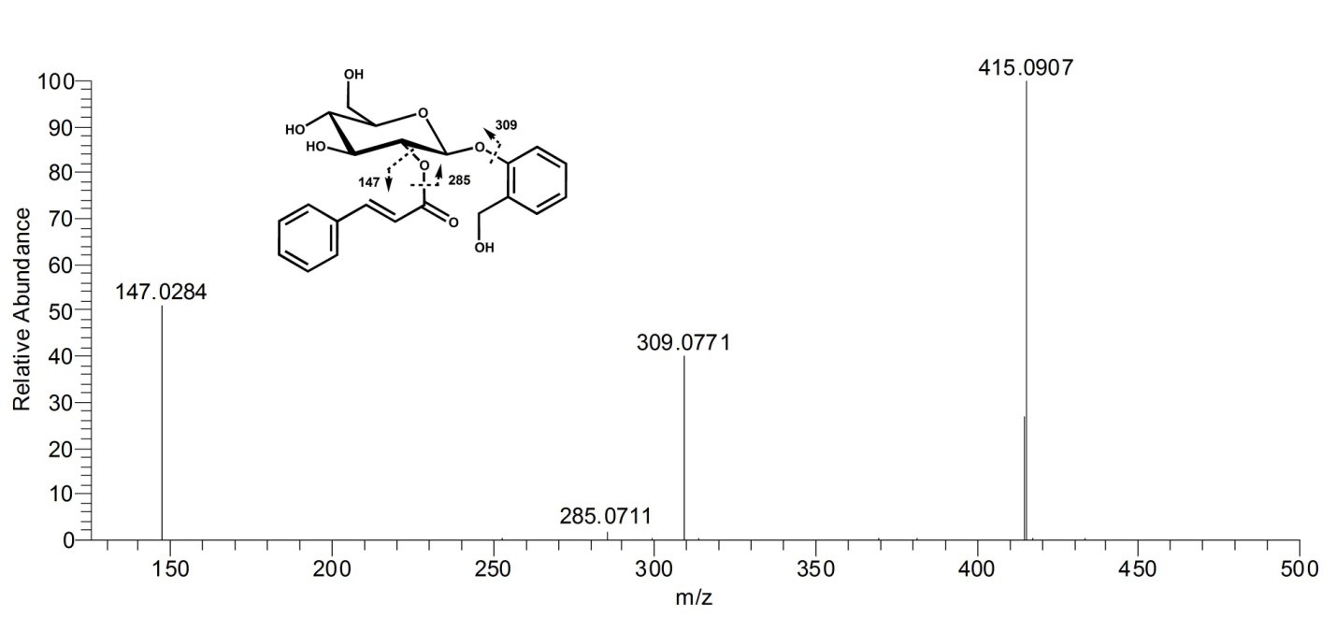

Acetylcinnamoylsalicortin Isomer 2 (the putative 6’-acetyl-2’-(E)-cinnamoylsalicortin isomer shown) - Used [M-H]- m/z 595.179 for fragmentation
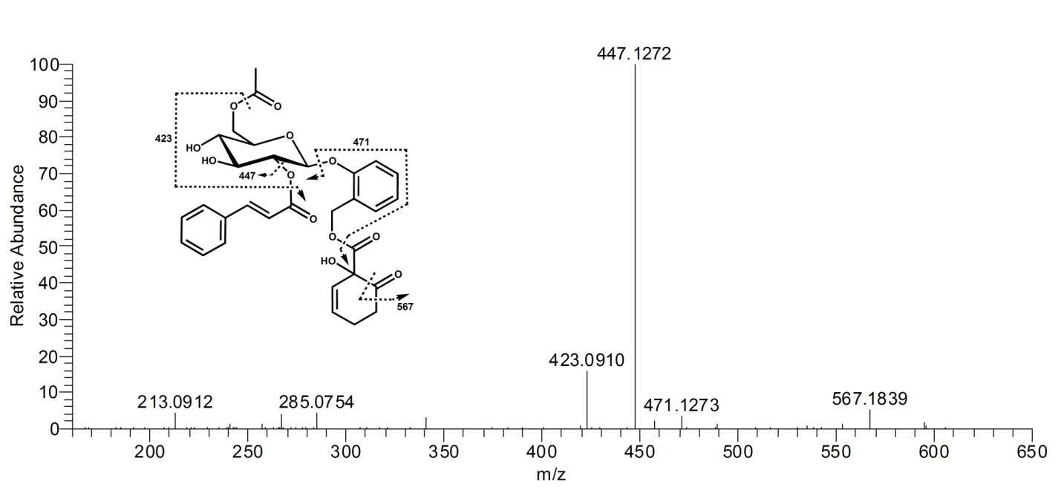

HCH-cinnamoylsalicortin Isomer 2 (the putative 6’-HCH-2’-(E)-cinnamoylsalicortin isomer shown) - Used [M-H]- m/z 691.202 for fragmentation
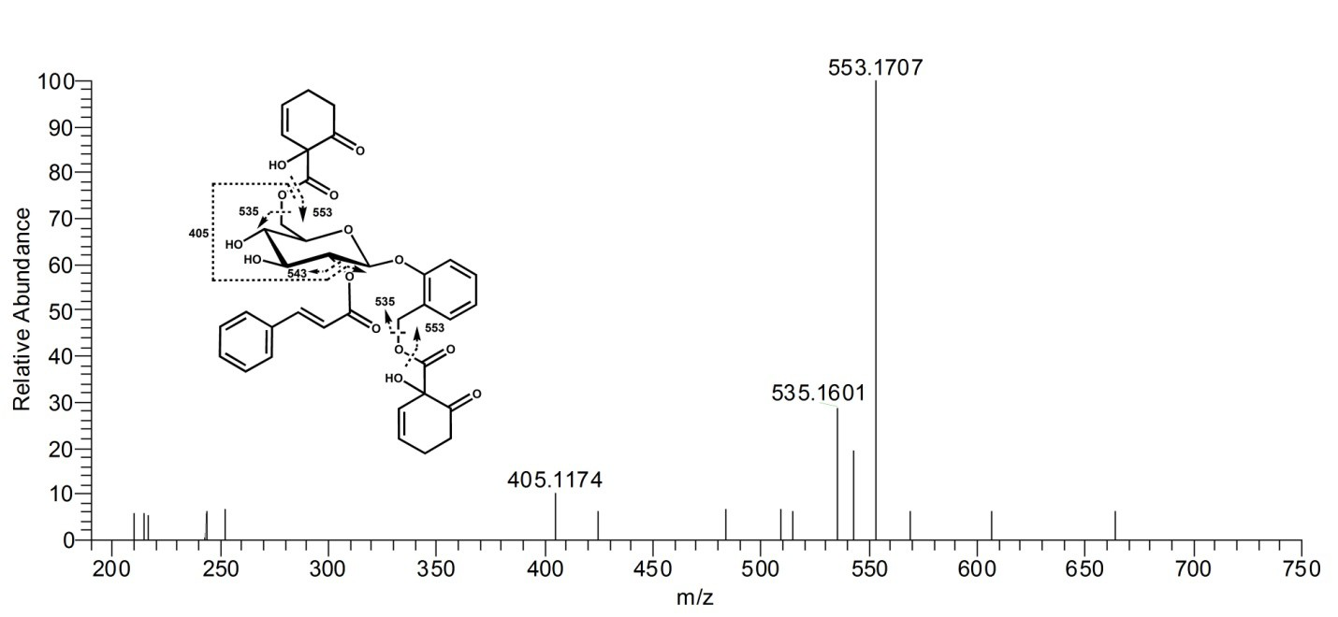

Lasiandrin (HCH-2’-acetylsalicortin) - Used [M-H]- m/z 603.172 for fragmentation

