Isoform selective HDAC1/6/8 inhibitors with an imidazo-ketopiperazine cap containing stereochemical diversity

Bertrand Lecointre, Remy Narozny, Maria Teresa Borrello, Johanna Senger, Alokta Chakrabarti, Manfred Jung, Martin Marek, Christophe Romier, Jelena Melesina, Wolfgang Sippl, Laurent Bischoff, A. Ganesan

Supporting Information

Synthetic procedures and compound characterisation 2-12
Biological assays 13
Molecular docking 14-15

Synthetic procedures and compound characterisation - general methods
Reactions were performed without exclusion of air or moisture unless otherwise stated. All commercially available reagents and anhydrous solvents were used without purification. ¹H and ¹³C NMR analysis were performed in CDCl₃, D₂O, CD₃OD or DMSO-d6 using 400 MHz Brüker Utrashield plus or Brüker AVANCE-300 (300 MHz) and recorded with chemical shifts values (ẟ) in parts per million (ppm) relative to tetramethylsilane (TMS) as internal standard. The chemical shifts for both ¹H and ¹³C spectra were recorded in ppm and coupling constants were recorded in Hz. Multiplicities in the NMR spectra are described as: s = singlet, d = doublet, t = triplet, q = quartet, m = multiplet, dd = double doublet and td = triplet of doublet. IR spectra were recorded on a PERKIN ELMER IRTF Spectrum 100 spectrometer. Absorption bands are given in cm⁻¹. Mass spectra (IC) were recorded with a Water ZQ 2000 and with a Waters LCP 1er XR spectrometer. Mass spectra (ESI) were recorded using a Shimadzu LCMS 2010EV operated under electrospray ionisation in positive (ESI+) mode using Milli-Q water and HPLC grade acetonitrile (0.01% TFA). Melting points were recorded using open capillary tubes on a Stuart Digital Melting Point Model SMP10. Infrared spectra were recorded as neat samples using a Perkin-Elmer Spectrum BX FT-IR. Analytical thin layer chromatography (TLC) was performed on silica gel 60 F254 aluminum sheets (Merck) and visualized by exposure to ultraviolet light and/or exposure to iodine, ninhydrin or ceric ammonium sulfate. Flash chromatography was performed using Combi Flash Rf 150, Telos silica flash column and silica gel 60 (230-400 mesh ASTM) (Merck). Reverse phase flash chromatography was performed using Teledyne Isco C18 RediSepRf Gold column with Milli-Q water and HPLC grade acetonitrile (0.05% TFA).
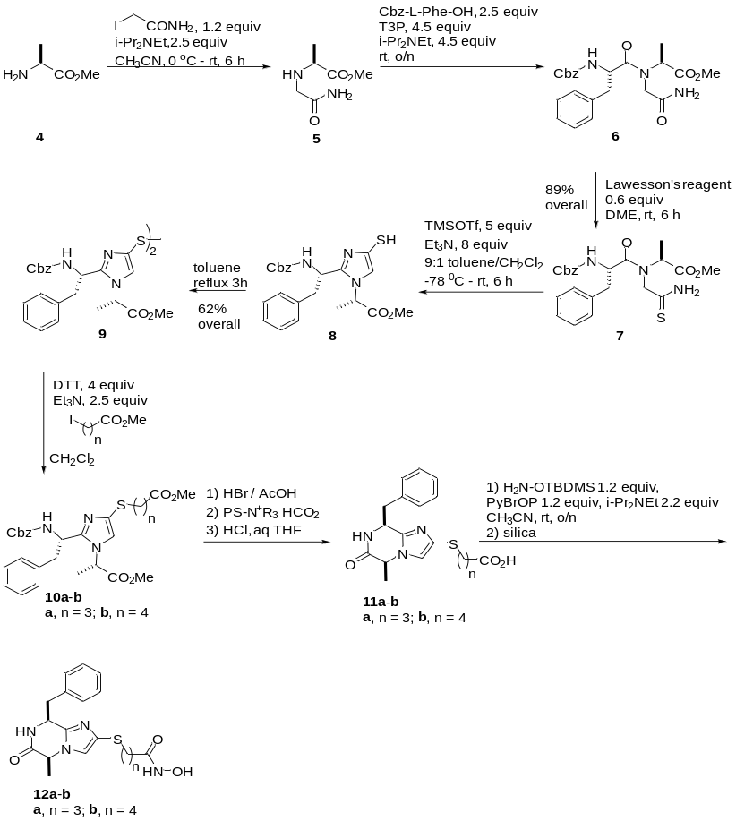

Scheme 1 Route to hydroxamic acids 12a-b.

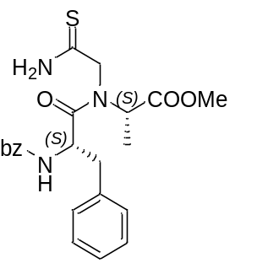
Methyl N-(2-amino-2-thioxoethyl)-N-(((benzyloxy)carbonyl)-L-phenylalanyl)-L-alaninate 7
To Ala-OMe.HCl (10.00 g, 71.64 mmol, 1 eq) in dry MeCN (143 mL) under argon atmosphere and at 0°C was added iodoacetamide (15.9 g, 85.97 mmol, 1.2 eq) and dry DIPEA (31.3 mL, 179.11mmol, 2.5 eq). The reaction was warmed up to room temperature and stirred 6h. The reaction was cooled to 0°C then Z-Phe-OH (53.61 g, 179.11 mmol, 2.5 eq) and dry DIPEA (56.3 mL, 322.40 mmol, 4.5 eq) were added. T3P (50% in EtOAC, 193 mL, 322.40 mmol, 4.5 eq) was then added dropwise. The reaction was stirred at 0°C for 30 min, warmed up to room temperature and stirred for 16h. The reaction was then diluted with water (140 mL) and extracted with EtOAc (2 x 200 mL). Combined organic layers were washed with saturated solution of NaHCO₃ (150 mL), then brine (150 mL). Organic layer was then dried over MgSO₄, filtered and evaporated under reduce pressure to afford a sticky oil. This crude compound was then dissolved in a mixture of dry DME (110 mL) under argon atmosphere. At 0°C was added Lawesson's reagent (17.40 g, 43.00 mmol, 0.6 eq) in one portion. The reaction was warmed up to room temperature and stirred for 6h. The reaction mixture was then diluted with EtOAC (200 mL) and washed with saturated solution of NaHCO₃ (150 mL). The aqueous layer was back-extracted with EtOAc (3 x 150 mL). Combined organic layer was washed with brine (200 mL), dried over MgSO₄, filtered and evaporated. The residue was then purified by flash chromatography (gradient Hexane/EtOAc) to afford the desired compound (29.3 g, 89% yield). ¹H NMR (400 MHz, CDCl₃) δ 9.24 (s, 1H), 7.27 – 7.21 (m, J = 10.1, 6.3 Hz, 8H), 7.15 – 7.10 (m, J = 6.3 Hz, 2H), 5.43 (s, 1H), 5.07 – 4.89 (m, 3H), 4.48 (q, J = 7.4 Hz, 1H), 4.12 – 4.02 (m, 2H), 3.65 (s, J = 17.1 Hz, 3H), 2.99 – 2.82 (m, 2H), 1.32 (d, J = 7.1 Hz, 3H). ¹³C NMR (101 MHz, CDCl₃) δ 201.74, 172.70, 172.47, 156.10, 135.93, 135.06, 129.52, 129.35, 128.94, 128.57, 128.27, 128.01, 127.63, 67.22, 56.84, 56.56, 52.80, 52.75, 38.61, 13.86. IR (cm⁻¹): 3306, 2989, 2902, 1716, 1661, 1526, 1496, 1454, 1255, 1226, 1066, 1049, 749, 700. MS(CI+): Calc for [C₂₃H₂₇N₃O₅S-H⁺] 458,8. Found 458,17. mp: 67-69 °C

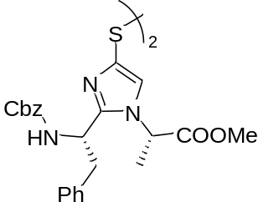
Dimethyl 2,2'-(disulfanediylbis(2-((S)-1-(((benzyloxy)carbonyl)amino)-2-phenylethyl)-1H-imidazole-4,1-diyl))(2S,2'S)-dipropionate 9
To 7 (6.0 g, 13,11 mmol, 1 eq) in dry Toluene (30 mL) and dry DCM (3 mL) under argon and at -78°C were added dry DIPEA (18.3 mL, 104.91 mmol, 8 eq) and TMSOTf (11,9 mL, 104.91 mmol, 5 eq) dropwise. The mixture was then allowed to warm up to room temperature and stirred 16h. MeOH (30 mL) was then added and the reaction was stirred 20 min at room temperature. Volatiles were evaporated under reduce pressure and the residue heated at reflux in toluene for 3h. After completion, toluene was evaporated under reduce pressure. The residue was dissolved in EtOAc and a white precipitate appeared. After filtration, the filtrate was purified by flash chromatography (gradient Hexane/EtOAc) leading to the desired compound as yellow solid (3.57 g, 62%). ¹H NMR (400 MHz, CDCl₃) δ 7.28 – 7.20 (m, 10H), 7.15 – 7.08 (m, 6H), 6.97 (t, J = 7.3 Hz, 5H), 5.84 (dd, J = 25.4, 8.7 Hz, 2H), 4.99 (qd, J = 12.4, 6.4 Hz, 4H), 4.92 – 4.85 (m, J = 9.0, 5.9 Hz, 2H), 4.38 (dq, J = 14.2, 7.1 Hz, 2H), 3.50 (d, J = 18.7 Hz, 6H), 3.29 – 3.12 (m, 4H), 1.05 (d, J = 7.2 Hz, 6H). ¹³C NMR (101 MHz, CDCl₃) δ 170.37, 155.68, 148.60, 136.83, 136.35, 133.70, 129.50, 128.59, 128.49, 128.05, 127.91, 127.86, 126.85, 123.00, 120.84, 66.80, 53.10, 52.89, 52.72, 48.97, 42.21, 17.57, 17.31. IR (cm⁻¹): 3325, 2989, 2901, 1746, 1709, 1528, 1497, 1454, 1255, 1232, 1077, 1050, 750, 701. MS(CI+): Calc for [C₄₆H₄₈N₆O₈S₂-H⁺] 877,31. Found 877,30. mp: 71-75 °C
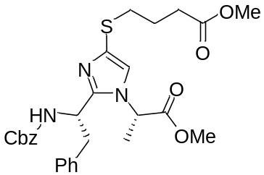
Methyl 4-(2-((S)-1-(benzyloxycarbonylamino)-2-phenylethyl)-1-((S)-1-methoxy-1-oxopropan-2-yl)-1H-imidazol-4-ylthio)butanoate 10a
To a solution of intermediate 9 (500 mg, 0.57 mmol, 1 eq) in dry DCM (4.2 mL) cooled at room temperature was added DTT (356 mg, 2.31 mmol, 4 eq). The mixture was stirred overnight at room temperature. Then Et₃N (200 μL, 1.43 mmol, 2.5 eq) and methyl 4-iodobutanoate (317 mg, 1.37 mmol, 2.4 eq) was added and the reaction was stirred at room temperature for 3,5h. Afterwards 5mL of a saturated solution of Na₂CO₃ was added, stirring was continued for 15min, and then the aqueous layer was extracted with EtOAC (3 x 20 mL). The combined organic layers were dried on MgSO₄ and concentrated. The crude was purified by flash chromatography (gradient Hexane/EtOAC) to lead to the desired product (552 mg, quantitative). ¹H NMR (CDCl₃, 300MHz): 1.1 (d, 3H, J=7.2Hz), 1.90 (q^{t}, 2H, J=7.2Hz), 2.47, (t, 2H, J=7.2Hz), 2.72-2.89 (m, 2H), 3.17 (dd, 1H, J= 8.1; 12.6Hz), 3.30 (dd, 1H, J= 5.4; 12.6Hz), 3.60 (s, 3H), 3.65 (s, 3H), 4.58 (q, 1H, J=7.5Hz), 4.93-5.08 (m, 1H), 5.07(d, 2H,J= 3.6Hz), 5.89 (d, 1H, J=8.4Hz), 6.87 (s, 1H), 6.99-7.02 (m,2H), 7.18-7.20 (m, 3H),7.31-7.33(m, 5H). ¹³C NMR (CDCl₃, 75MHz): 17.6, 24.8, 28.8, 33.7, 34.7, 42.5, 51.8, 53.0, 53.1, 66.9, 73.3, 120.1, 127.0, 128.1, 128.2, 128.6, 128.7, 129.5, 131.8, 136.4, 136.9, 148.3, 155.7, 170.3, 173.8. IR (cm⁻¹): 3307, 2984, 2110, 1732, 1713, 1646, 1528, 1496, 1454, 1229, 1135, 1046, 980, 749, 700. MS(CI+): Calc for [C₂₈H₃₃N₃O₆S -H⁺] 540,21. Found 540,22.

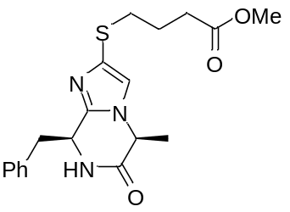
Methyl 4-((5S,8S)-8-benzyl-5-methyl-6-oxo-5,6,7,8-tetrahydroimidazo[1,2-a]pyrazin-2-ylthio) butanoate
To a solution of 10a (512 mg, 0.95 mmol, 1 eq) in dry DCM (7 mL), anisole (0.7 mL) was added. The mixture was cooled at 0°C and a solution of HBr in acetic acid (33%) (2.8 mL, 14.25 mmol, 15 eq) was added dropwise. The reaction was allowed to warm at room temperature and stirred for 2,5h. Then the volatiles were removed under reduce pressure. The residual oil was dissolved in the minimum amount of dichloromethane and Et₂O was added. The residual solid was centrifuged and washed 3 times with Et₂O to give a solid. The intermediate (421 mg) was dissolved in the minimum amount of water and Amberlyt resin (loaded HCO₃⁻) was added (excess). The reaction was stirred at room temperature for 15 minutes. The resin was removed by filtration and washed with methanol. The water was co-evaporated with methanol to afford the desired compound (267 mg, 75%).¹H NMR (CDCl₃, 300MHz): 0.97 (d, 3H, J=7.2Hz), 1.95 (q^{t}, 2H, J=7.2Hz), 2.48, (t, 2H, J=7.5Hz), 2.89 (t, 2H, J= 7.2Hz), 3.27 (d, 2H, J= 4.5Hz), 3.66 (s, 3H), 4.44 (q, 1H, J=7.2Hz), 5.04-5.06 (m, 1H), 6.81 (s, 1H), 6.96-6.99 (m,2H), 7.14 (s, 1H), 7.20-7.21 (m, 3H). ¹³C NMR (CDCl₃, 75MHz): 20.0; 24.8; 32.7; 34.6, 43.1, 51.8, 52.4; 52.7; 52.9, 53.3; 118.2, 127.5, 128.8, 128.9, 129.9, 130.3, 134.4, 135.1, 141.2, 168.3, 173.7. IR (cm⁻¹): 3251, 2989, 2111, 17.69, 1664, 1495, 1454, 1437, 1416, 1362, 1213, 1176, 1137, 1066, 927, 745, 702, 610. MS(CI+): Calc for [C₁₉H₂₃N₃O₃S -H+] 373,15. Found 373,15.

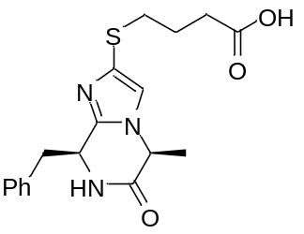
4-((5S,8S)-8-Benzyl-5-methyl-6-oxo-5,6,7,8-tetrahydroimidazo[1,2-a]pyrazin-2-ylthio)butanoic acid 11a
To a solution of methyl butanoate intermediate (250 mg, 0.67 mmol, 1 eq) in THF (2 mL) was added HCl (6M, 2 mL) and the mixture was warmed at 40°C for 7h. THF was evaporated and water was co-evaporated with acetonitrile to afford the desired product. (239 mg, quantitative).¹H NMR (D₂O, 300MHz): 0.64 (d, 3H, J=7.2Hz), 1.74-1.90 (m, 2H), 2.51, (t, 2H, J=7.5Hz), 2.83-2.97 (m, 2H), 3.28 (d, 2H, J= 3.9Hz), 4.90 (q, 1H, J= 7.2Hz), 5.46-4.49 (m, 1H), 6.87-6.90 (m,2H), 7.124-7.27 (m, 3H),7.52 (s, 1H). ¹³C NMR (D₂O, 75MHz): 17.8, 23.9, 31.8, 34.5, 41.0, 50.3, 53.7, 123.4, 126.3, 128.2, 129.1, 129.9, 133.0, 140.7, 168.2, 177.9. IR (cm⁻¹): 3381, 2989, 2907, 2121, 1728, 1677, 1454, 1440, 1349, 1222, 1066, 704, 607, 431, 418, 408, 403. MS(CI+): Calc for [C₁₈H₂₁N₃O₃S -H⁺] 358,13. Found 358,12.
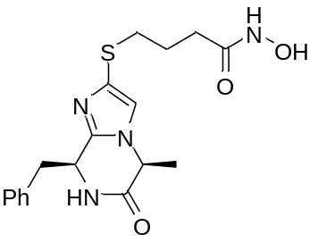
4-((5S,8S)-8-Benzyl-5-methyl-6-oxo-5,6,7,8-tetrahydroimidazo[1,2-a]pyrazin-2-ylthio)-N-hydroxybutanamide 12a
To a solution of carboxylic acid 11a (230 mg, 0.64 mmol, 1 eq) and PyBrOP (358 mg, 0.77 mmol, 1.2eq) in acetonitrile (2.6 mL), DIPEA (250 μL, 1.41 mmol, 2.2eq) and NH₂OTBMDS (113 mg, 0.77 mmol, 1.2eq) were added. The mixture was stirred at room temperature 16h. At the end of the reaction silica was added to cleave the TBDMS moiety. The volatiles were removed under vaccuo, the crude was diluted in EtOAc (15 mL) and washed with water (2 x 10 mL) to afford the desired compound (121 mg, 51%). ¹H NMR (DMSO, 300MHz): 0.50 (d, 3H, J=7.2Hz), 1.77 (q^{t}, 2H, J=7.2Hz), 2.08 (t, 2H, J=7.2Hz), 2.69-2.83 (m, 2H), 3.00 (dd, 1H, J= 4.2; 12.9Hz), 3.17 (dd, 1H, J= 3.3; 12.9Hz), 4.38 (q, 1H, J= 6.9Hz), 4.96 (brs, 1H), 6.75-6.78 (m, 2H), 7.07 (s,1H), 7.13-7.15 (m, 3H),8.56 (d, 1H, J= 2.4Hz), 8.71 (d, 1H, J= 1.8Hz), 10.41 (d, 1H, J= 1.2Hz). ¹³C NMR (MeOD, 75MHz): 19.9, 26.5, 32.3, 35.6, 43.0, 53.2, 54.2, 121.6, 128.3, 129.4, 131.6, 134.4, 136.3, 142.7, 169.9, 172.2. IR (cm⁻¹): 3203, 2929, 1668, 1453, 1356, 1298, 1231, 1071, 1001, 755, 742, 703, 663. MS(CI+): Calc for [C₁₈H₂₂N₄O₃S -H⁺] 374,14. Found 374,13.

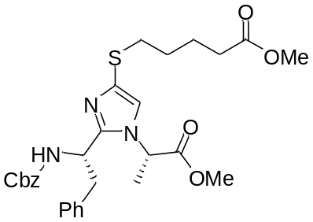
Methyl 5-(2-((S)-1-(benzyloxycarbonylamino)-2-phenylethyl)-1-((S)-1-methoxy-1-oxopropan-2-yl)-1H-imidazol-4-ylthio)pentanoate 10b
To a solution of intermediate 9 (500 mg, 0.57 mmol, 1 eq) in dry DCM (4.2 mL) cooled at room temperature was added DTT (356 mg, 2.31 mmol, 4 eq). The mixture was stirred overnight at room temperature. Then Et₃N (200 μL, 1.43 mmol, 2.5 eq) and methyl 5-iodopentanoate (335 mg, 1.37 mmol, 2.4 eq) was added and the reaction was stirred at room temperature for 3,5h. Afterwards 5mL of a saturated solution of Na₂CO₃ was added, stirring was continued for 15min, and then the aqueous layer was extracted with EtOAC (3 x 20 mL). The combined organic layers were dried on MgSO₄ and concentrated. The crude was purified by flash chromatography (gradient Hexane/EtOAC) to lead to the desired product (525 mg, 85%). ¹H NMR (CDCl₃, 300MHz): 1.10 (d, 3H, J=7.5Hz), 1.58-1.77 (m, 4H), 2.31, (t, 2H, J=7.5Hz), 2.74-2.84 (m, 2H), 3.18 (dd, 1H, J= 9.9; 12.6Hz), 3.30 (dd, 1H, J= 5.4; 12.6Hz), 3.59 (s, 3H), 3.64 (s, 3H), 4.39 (q, 1H, J=7.5Hz), 4.89-5.03 (m, 1H), 5.07(d, 2H,J= 3.6Hz), 5.89 (d, 1H, J=8.7Hz), 6.87 (s, 1H), 6.99-7.02 (m,2H), 7.17-7.20 (m, 3H), 7.25-7.33(m, 5H). ¹³C NMR (CDCl₃, 75MHz): 17.6, 23.9, 28.8, 29.0, 33.7, 35.1, 42.5, 51.7, 53.0, 53.1, 66.9, 73.3, 120., 127.0, 128., 128.2, 128.5, 128.6, 128.7, 129.5, 132.1, 136.4, 136.9, 148.2, 155.7, 170.3, 174.0. IR (cm⁻¹): 3327, 2951, 1737, 1714, 1523, 1496, 1454, 1436, 1234, 1216, 1074, 1044, 976, 749, 739, 701. MS(CI+): Calc for [C₂₉H₃₅N₃O₆S -H⁺] 553,22. Found 553,23.

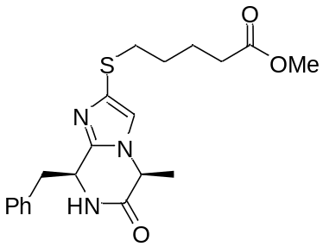
Methyl 5-((5S,8S)-8-benzyl-5-methyl-6-oxo-5,6,7,8-tetrahydroimidazo[1,2-a]pyrazin-2-ylthio)pentanoate
To a solution of 10a (502 mg, 0.91 mmol, 1 eq) in dry DCM (6.5 mL), anisole (0.65 mL) was added. The mixture was cooled at 0°C and a solution of HBr in acetic acid (33%) (2.5 mL, 13.65 mmol, 15 eq) was added dropwise. The reaction was allowed to warm at room temperature and stirred for 2,5h. Then the volatiles were removed under reduce pressure. The residual oil was dissolved in the minimum amount of dichloromethane and Et₂O was added. The residual solid was centrifuged and washed 3 times with Et₂O to give a solid. The intermediate (308 mg) was dissolved in the minimum amount of water and Amberlyt resin (loaded HCO₃⁻) was added (excess). The reaction was stirred at room temperature for 15 minutes. The resin was removed by filtration and washed with methanol. The water was co-evaporated with methanol to afford the desired compound (267 mg, 76%). ¹H NMR (CDCl₃, 300MHz): 0.97 (d, 3H, J=7.2Hz), 1.63-1.79 (m, 4H), 2.34, (t, 2H, J=7.5Hz), 2.86 (t, 2H, J= 6.9Hz), 3.26 (d, 2H, J= 4.8Hz), 3.65 (s, 3H), 4.44 (q, 1H, J=6.9Hz), 5.03-5.06 (m, 1H), 6.80 (s, 1H), 6.96-6.99 (m,2H), 7.20-7.23 (m, 3H), 7.36 (s, 1H). ¹³C NMR (CDCl₃, 75MHz): 20.0, 23.9, 29.1, 33.7, 35.0, 43.1, 51.7, 52.7, 53.3, 119.0, 127.5, 128.7, 128.9, 129.9, 130.2, 134.7, 135.0, 141.1, 168.3, 173.9. IR (cm⁻¹): 3222, 2947, 1733, 1675, 1454, 1438, 1356, 1296, 1230, 1175, 1206, 1090, 782, 756, 745, 703. MS(CI+): Calc for [C₂₀H₂₅N₃O₃S -H+] 387,16. Found 387,17.

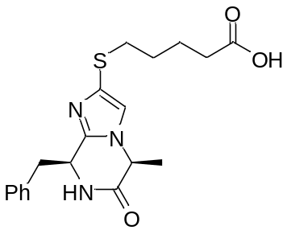
Methyl 5-((5S,8S)-8-benzyl-5-methyl-6-oxo-5,6,7,8-tetrahydroimidazo[1,2-a]pyrazin-2-ylthio)pentanoate 11b
To a solution of methyl pentanoate (133 mg, 0.34 mmol, 1 eq) in THF (2 mL) was added HCl (6M, 2 mL) and the mixture was warmed at 40°C for 7h. THF was evaporated and water was co-evaporated with acetonitrile to afford the desired product. (128 mg, quantitative). ¹H NMR (D₂O, 300MHz): 0.71 (d, 3H, J=7.2Hz), 1.55-1.80 (m, 4H), 2.43, (t, 2H, J=7.2Hz), 2.91-2.97 (m, 2H), 3.34 (d, 2H, J= 3.9Hz), 4.75 (q, 1H, J= 7.2Hz), 5.22-5.54 (m, 1H), 6.92-6.95 (m,2H), 7.31-7.33 (m, 3H), 7.52 (s, 1H). ¹³C NMR (D₂O, 75MHz): 17.9, 22.6, 27.8, 33.1, 34.9, 41.0, 50.4, 52.1, 53.9, 123.1, 127.3, 128.2, 129.1, 129.9, 133.1, 140.7, 168.3, 178.4. IR (cm⁻¹): 2948, 1729, 1683, 1603, 1455, 1438, 1347, 1219, 1206, 1066, 757, 742, 706. MS(CI+): Calc for [C₁₉H₂₃N₃O₃S -H⁺] 373,15 Found 373,14.
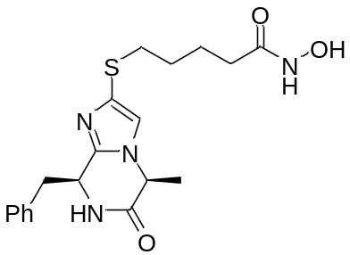
5-((5S,8S)-8-Benzyl-5-methyl-6-oxo-5,6,7,8-tetrahydroimidazo[1,2-a]pyrazin-2-ylthio)-N-hydroxypentanamide 12b
To a solution of carboxylic acid 11b (130 mg, 0.35 mmol, 1 eq) and PyBrOP (192 mg, 0.42 mmol, 1.2eq) in acetonitrile (1.5 mL), DIPEA (130 μL, 0.77 mmol, 2.2eq) and NH₂OTBMDS (60 mg, 0.42 mmol, 1.2eq) were added. The mixture was stirred at room temperature 16h. At the end of the reaction silica was added to cleave the TBDMS moiety. The volatiles were removed under vaccuo, the crude was diluted in EtOAc (15 mL) and washed with water (2 x 10 mL) to afford the desired compound (121 mg, 89%). ¹H NMR (DMSO+TFA, 300MHz): 0.52 (d, 3H, J=7.2Hz), 1.53-1.59 (m, 4H), 1.96 (t, 2H, J=7.2Hz), 2.49-2.82 (m, 2H), 2.97-3.05 (m, 2H), 4.36 (q, 1H, J= 6.9Hz), 4.98 (brs, 1H), 6.76-6.79 (m, 2H), 7.08 (s,1H), 7.14-7.16 (m, 4H), 8.57 (s, 1H), 10.36 (s, 1H). ¹³C NMR (MeOD, 75MHz): 19.9, 27.2, 30.1, 33.2, 34.9, 35.9, 42.9, 47.3, 53.1, 54.3, 54.8, 121.9, 128.4, 129.5, 131.2, 131.6, 134.2, 135.9, 136.2, 142.7, 169.7, 172.6. IR (cm⁻¹): 3201, 2933, 2113, 1995, 1668, 1454, 1356, 1300, 1234, 1207, 1138, 1091, 1022, 847, 787, 756, 740, 703. MS(CI+): Calcd for [C₁₉H₂₄N₄O₃S -H⁺] 388,16. Found 388,15.

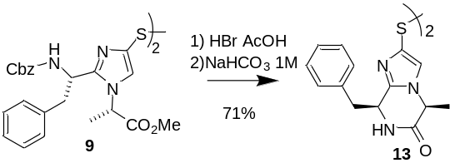
Scheme 2. Synthesis of the disulfide 13.
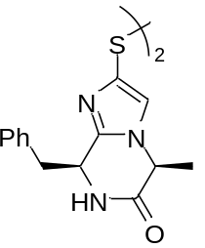
(5S,5'S,8S,8'S)-2,2'-Disulfanediylbis(8-benzyl-5-methyl-7,8-dihydroimidazo[1,2-a]pyrazin-6(5H)-one) 13
To 7 (2.0 g, 2.28 mmol, 1 eq) in dry DCM (20 mL) at 0°C and under argon was added anisole (3.72 mL, 34.21 mmol, 15 eq) and HBr (33% in AcOH, 12.39 mL, 68.41 mmol, 30 eq). The reaction was then stirred at room temperature for 2h. Volatiles were removed by evaporation under reduced pressure and the residue was dissolved in a minimum of DCM and Et₂O was added, leading to the formation of a precipitate recovered by filtration. The solid was then dissolved in water (5 mL) and NaHCO₃ (2M) was added until pH = 8. The reaction was stirred at room temperature 1h. DCM (5 mL) was added and the reaction mixture was stirred vigorously for 16h. The layers were separated and the aqueous layer was extracted with DCM (5 mL). Combined organic layer was washed with brine, filtered and evaporated to afford the desired compound as yellow solid (886 mg, 71%). mp: 126-129 °C. ¹H NMR (400 MHz, CDCl₃) δ 7.16 – 7.09 (m, 6H), 6.96 (s, 2H), 6.87 (d, J = 6.5 Hz, 4H), 4.97 (s, 2H), 4.39 (q, J = 7.0 Hz, 2H), 3.22 (ddd, J = 17.3, 13.7, 4.5 Hz, 4H), 0.85 (d, J = 7.1 Hz, 6H). ¹³C NMR (101 MHz, CDCl₃) δ 167.94, 142.25, 136.45, 135.26, 130.34, 128.50, 127.15, 121.57, 77.41, 77.09, 76.77, 53.36, 52.17, 43.03, 19.99. IR (cm⁻¹) 3060, 2930, 1670, 1452, 1356, 1298, 743, 700, 655, 607. MS(ESI+): Calc for [C₂₈H₂₈N₆O₂S₂ -H⁺] 545,18. Found 545,20.
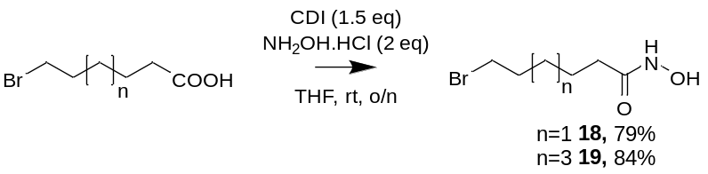
Scheme 3. Synthesis of ω-halo esters 18 and 19.

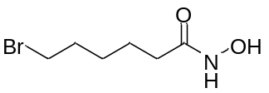
6-Bromo-N-hydroxyhexanamide 18
To 6-bromohexanoic acid (3.0 g, 15.38 mmol, 1 eq) in dry THF (25 mL) under nitrogen atmosphere was added CDI (3.74 g, 23.07 mmol, 1.5 eq) and the reaction was stirred at room temperature 1h. Hydroxylamine hydrochlorine (2.14 g, 30.76 mmol, 2 eq) was added and the reaction was stirred at room temperature 16h. The reaction was stopped by addition of KHSO4 5% (30 mL) and the THF was evaporated. The aqueous solution was extracted with EtOAc (3 x20 mL) and the combined organic layer was washed with brine, dried over MgSO4, filtered and evaporated. The crude was purified by flash chromatography (gradient DCM/MeOH) to afford the desired compound as an orange solid (2.56 g, 79%). mp: 60-64 °C. ¹H NMR (400 MHz, CDCl₃) δ 3.34 (t, J = 6.7 Hz, 2H), 2.11 (t, J = 7.2 Hz, 2H), 1.87 – 1.74 (m, 2H), 1.65 – 1.53 (m, 2H), 1.47 – 1.34 (m, 2H). ¹³C NMR (101 MHz, CDCl₃) δ 171.53, 33.54, 32.72, 32.28, 27.57, 24.48. IR(cm⁻¹) 3205, 3048, 2921, 2863, 1622, 1545, 1462, 1061, 644. MS(ESI+): Calc for [C₆H₁₂BrNO₂ -H⁺] 210,01. Found 209,92.

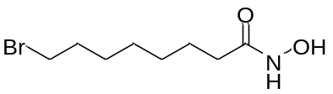
8-Bromo-N-hydroxyoctanamide 19
To 8-bromooctannoic acid (3.0 g, 13.45 mmol, 1 eq) in dry THF (22 mL) under nitrogen atmosphere was added CDI (3.27 g, 20.17 mmol, 1.5 eq) and the reaction was stirred at room temperature 1h. Hydroxylamine hydrochlorine (1.87 g, 26.89 mmol, 2 eq) was added and the reaction was stirred at room temperature 16h. The reaction was stopped by addition of KHSO4 5% (30 mL) and the THF was evaporated. The aqueous solution was extracted with EtOAc (3 x20 mL) and the combined organic layer was washed with brine, dried over MgSO4, filtered and evaporated. The crude was purified by flash chromatography (gradient DCM/MeOH) to afford the desired compound as an orange solid (2.70 g, 84%). mp: 58-60 °C. ¹H NMR (400 MHz, CDCl₃) δ 3.33 (t, J = 6.8 Hz, 2H), 2.08 (t, J = 7.5 Hz, 2H), 1.84 – 1.73 (m, 2H), 1.61 – 1.53 (m, 2H), 1.35 (dd, J = 14.2, 7.0 Hz, 2H), 1.26 (dd, J = 7.0, 3.5 Hz, 4H). ¹³C NMR (101 MHz, CDCl₃) δ 171.68, 33.92, 32.92, 32.64, 28.86, 28.36, 27.92, 25.21. IR (cm-1) 3270, 2929, 2911, 2844, 1661, 1620, 1560, 1424, 1068, 724, 642. MS(ESI+): Calc for [C₈H₁₆BrNO₂ -H⁺] 238,05. Found 237,99.

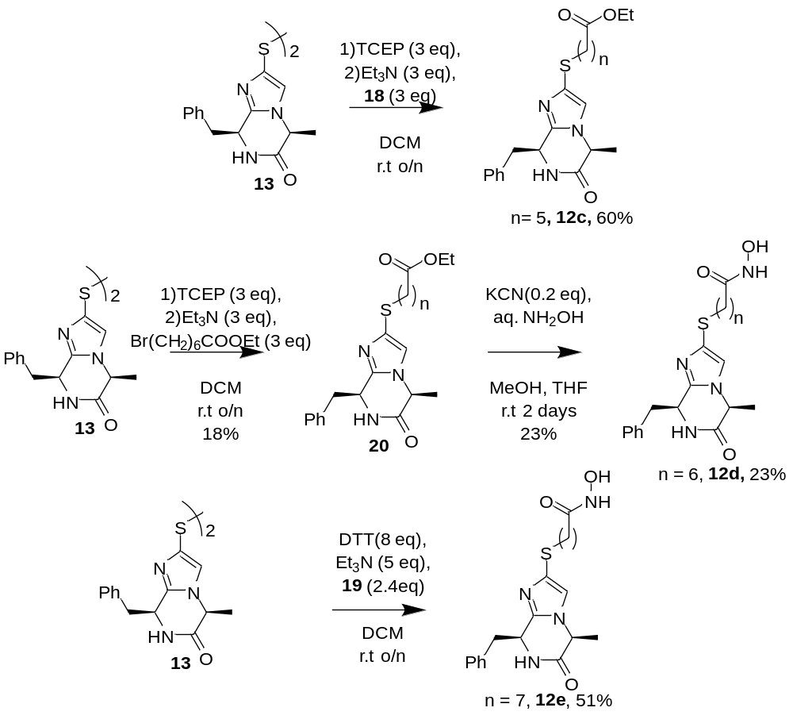
Scheme 4. Synthesis of hydroxamic acids 12c-12e.

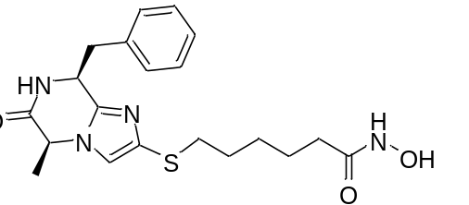
6-(((5S,8S)-8-Benzyl-5-methyl-6-oxo-5,6,7,8-tetrahydroimidazo[1,2-a]pyrazin-2-yl)thio)-N-hydroxyhexanamide 12c
TCEP.HCl (157.9 mg, 0.551 mmol, 3 eq) was added in Milli-Q water (10 mL). Then aqueous NaOH (1M) was added until pH=5. The solution was then added to intermediate 13 (100.0 mg, 0.18 mmol, 1 eq) in MeOH (6 mL) and the reaction was stirred at room temperature for 16h. Volatiles were evaporated and the aqueous was extracted with CHCl₃ (2 x 10 mL). Combined organic layer was dried over MgSO₄, filtered and evaporated. The crude was dissolved in CHCl₃ (5 mL) under nitrogen atmosphere. Compound 18 (115.8 mg, 0.551 mmol, 3 eq) and DIPEA (96.2 μL, 0.551mmol, 3 eq) were added. The reaction mixture was stirred at room temperature for 16h. The solvent was evaporated and the residue purified by reverse phase flash chromatography (gradient water/MeCN-0.05% TFA) to afford the desired compound as an oil (44 mg, 60%). ¹H NMR (400 MHz, MeOD) δ 7.35 (s, J = 3.8 Hz, 1H), 7.17 – 7.13 (m, 3H), 6.82 – 6.77 (m, 2H), 5.21 (td, J = 3.8, 1.7 Hz, 1H), 4.51 (qd, J = 7.2, 1.7 Hz, 1H), 3.25 – 3.22 (m, 1H, overlapping with MeOD peak), 3.13 (dd, J = 14.0, 4.1 Hz, 1H), 2.86 – 2.79 (m, 2H), 2.01 (t, J = 7.1 Hz, 2H), 1.55 (dt, J = 14.5, 7.1 Hz, 4H), 1.40 (dd, J = 14.9, 7.4 Hz, 2H), 0.61 (d, J = 7.2 Hz, 3H). ¹³C NMR (101 MHz, MeOD) δ 171.36, 166.53, 141.48, 133.81, 129.94, 128.56, 127.63, 122.36, 53.76, 50.72, 41.06, 35.22, 32.07, 28.67, 27.16, 24.69, 17.90. MS(ESI+): Calc for [C₂₀H₂₆N₄O₃S-H⁺] 403,18. Found 403,11.

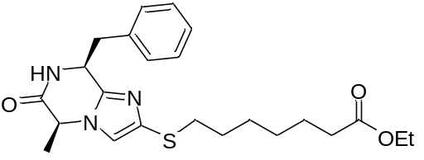
Ethyl 7-(((5S,8S)-8-Benzyl-5-methyl-6-oxo-5,6,7,8-tetrahydroimidazo[1,2-a]pyrazin-2-yl)thio)heptanoate 20
TCEP.HCl (355.0 mg, 1.24 mmol, 3 eq) was added in Milli-Q water (10 mL). Then aqueous NaOH (1M) was added until pH=5. The solution was then added to intermediate 13 (225.0 mg, 0.41 mmol, 1 eq) in a mixture of THF (5 mL) and MeOH (3 mL) and the reaction was stirred at room temperature for 16h. Volatiles were evaporated and the aqueous was extracted with CHCl₃ (2 x 10 mL). Combined organic layer was dried over MgSO₄, filtered and evaporated. The crude was dissolved in dry DCM (5 mL) under nitrogen atmosphere. Ethyl 7-bromoheptanoate (241 μL, 1.23 mmol, 3 eq) and Et₃N (172 μL, 1.23 mmol, 3 eq) were added. The reaction mixture was stirred at room temperature for 6h. The solvent was evaporated and the residue purified by flash chromatography (gradient DCM/MeOH) to afford the desired product as an oil (63 mg, 18%). ¹H NMR (400 MHz, CDCl₃) δ 7.18 – 7.15 (m, 3H), 6.96 – 6.91 (m, 2H), 6.72 (s, 1H), 5.01 – 4.95 (m, 1H), 4.40 (qd, J = 7.1, 1.4 Hz, 1H), 4.10 – 4.01 (m, 2H), 3.24 – 3.18 (m, 2H), 2.83 – 2.75 (m, 2H), 2.22 (t, J = 7.5 Hz, 2H), 1.62 – 1.51 (m, 4H), 1.42 – 1.33 (m, 2H), 1.28 (ddd, J = 13.0, 5.4, 3.2 Hz, 2H), 1.18 (t, J = 7.1 Hz, 4H), 0.95 (d, J = 7.1 Hz, 3H). ¹³C NMR (101 MHz, CDCl₃) δ 173.77, 168.52, 140.97, 135.07, 134.90, 130.31, 130.26, 128.95, 128.50, 128.46, 128.30, 127.25, 118.71, 60.21, 53.09, 52.49, 42.78, 35.34, 34.23, 29.40, 28.69, 28.24, 24.81, 19.80, 14.24.

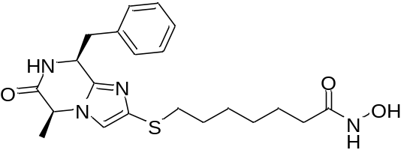
7-(((5S,8S)-8-Benzyl-5-methyl-6-oxo-5,6,7,8-tetrahydroimidazo[1,2-a]pyrazin-2-yl)thio)-N-hydroxyheptanamide 12d
To the ethyl ester intermediate 20 (63 mg, 0.15 mmol, 1 eq) in a mixture of MeOH/THF (2.4 mL, 1:1) was added KCN (1.9 mg, 0.03 mmol, 0.2 eq) followed by an aqueous solution of NH₂OH (50%, 0.6 mL). The reaction was stirred at room temperature for 2 days. Solvent evaporated and the residue purified by reverse phase flash chromatography (gradient water/MeCN-0.05% TFA) to afford the desired compound as an oil (18 mg, 29%). ¹H NMR (400 MHz, D₂O) δ 7.36 (d, J = 7.6 Hz, 1H), 7.22 – 7.14 (m, 3H), 6.77 (ddd, J = 14.9, 6.8, 1.6 Hz, 2H), 5.37 (dtd, J = 5.5, 3.9, 1.6 Hz, 1H), 4.60 – 4.54 (m, 1H), 3.23 – 3.13 (m, 2H), 2.86 – 2.69 (m, 2H), 2.06 – 1.95 (m, 2H), 1.49 – 1.38 (m, 4H), 1.31 (tdd, J = 13.1, 8.1, 5.5 Hz, 2H), 1.16 (dt, J = 7.4, 5.0 Hz, 2H), 0.54 (d, J = 7.2 Hz, 3H). ¹³C NMR (101 MHz, D₂O) δ 173.31, 168.22, 163.09, 162.74, 140.55, 133.07, 129.93, 129.67, 129.13, 129.05, 128.27, 128.18, 127.43, 123.09, 122.76, 117.73, 53.73, 50.37, 40.96, 35.31, 32.16, 28.30, 27.52, 26.74, 24.71, 17.94. IR (cm⁻¹) 3151, 2927, 2851, 1668, 1455, 1200, 1133, 701. MS(ESI+): Calc for [C₂₁H₂₈N₄O₃S-H⁺] 417,20. Found 417,3.

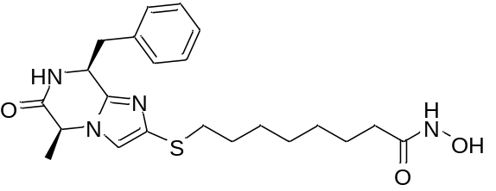
8-(((5S,8S)-8-Benzyl-5-methyl-6-oxo-5,6,7,8-tetrahydroimidazo[1,2-a]pyrazin-2-yl)thio)-N-hydroxyoctanamide 12e
To intermediate 13 (100 mg, 0.18 mmol, 1 eq) in DCM (2 mL) and toluene (0.25 mL) was added DTT (227 mg, 1.47 mmol, 8 eq). The mixture was stirred 16h at room temperature. Compound 19 (105 mg, 0.44 mmol, 2.4 eq) and Et₃N (124 μL, 0.92 mmol, 5 eq) were added and the reaction was stirred 4h at room temperature. The reaction was diluted with EtOAc (20 mL) and washed with saturated solution NaHCO₃ (2 x 10 mL), brine (10 mL). Organic layer was then dried over MgSO₄, filtered and evaporated. Residue was purified by flash chromatography (gradient DCM/MeOH) to afford the desired compound as an oil (40 mg, 51%). ¹H NMR (400 MHz, MeOD) δ 7.33 (s, 1H), 7.27 – 7.21 (m, 3H), 6.94 – 6.88 (m, 2H), 5.24 (td, J = 3.8, 1.7 Hz, 1H), 4.58 (qd, J = 7.1, 1.6 Hz, 1H), 3.37 – 3.34 (m, 1H, overlapping with MeOD signal), 3.21 (dd, J = 13.9, 4.0 Hz, 1H), 2.97 – 2.85 (m, 2H), 2.10 (t, J = 7.4 Hz, 2H), 1.69 – 1.61 (m, 4H), 1.50 (dd, J = 14.1, 7.0 Hz, 2H), 1.42 – 1.32 (m, 4H), 0.69 (d, J = 7.2 Hz, 3H). ¹³C NMR (101 MHz, MeOD) δ 171.60, 167.20, 141.36, 134.20, 130.44, 130.05, 128.37, 127.40, 121.43, 53.45, 51.07, 41.26, 35.27, 32.30, 29.01, 28.53, 28.42, 27.77, 25.20, 18.15. IR (cm⁻¹) 3179, 2927, 2859, 1662, 1456, 1199, 698. MS(ESI+): Calc for [C₂₂H₃₀N₄O₃S-H⁺] 431,21. Found 431,02

Biological assays
1) HDAC1, HDAC6 and HDAC8 enzyme inhibition assays
HDAC1 and HDAC6 inhibition was tested in vitro using biochemical assays as previously described. Reference:
Synthesis and Biological Investigation of Oxazole Hydroxamates as Highly Selective Histone Deacetylase 6 (HDAC6) Inhibitors.
J. Senger, J. Melesina, M. Marek, C. Romier, I. Oehme, O. Witt, W. Sippl, M. Jung; J. Med. Chem. 59 (2016) 1545-1555.

2) HDAC isoform panel assays
The assay of 12d against all eleven human recombinant HDAC isoforms was performed by Eurofins Cerep SA (Celle L’Evescault, France) with trichostatin A as positive control for HDAC1-10 and scriptaid as positive control for HDAC11. The assay procedure involves a similar fluorimetric method to that described above.

3) Cell growth inhibition assays
AML cell lines THP-1, MV4-11 and U937 were obtained from the DMSZ (German Collection of Microorganisms and Cell Cultures) and European Collection of Cell Cultures. They were authenticated by DNA-fingerprinting. The cell lines were used at low passage number for a maximum of 6 months post-resuscitation and tested regularly for mycoplasma infection.
Cells lines were cultured in RPMI 1640 medium (GIBCO) supplemented with 10% Foetal Calf Serum (FCS, GIBCO) and 5% of 2 mM L-glutamine. Cells were grown at 37 ˚C with 5% CO2 and cell density was maintained at 25×104 cells/mL. For the assay, cells were plated in a 96-well clear bottomed microtitre plate at a density of 2.5×104 cells/well for U937 and 5×104 cells/well for THP-1 and MV4-11. Inhibitor stock solutions (20 mM in DMSO) were dissolved in cell media at the appropriate concentration and 10 µL of each concentration incubated with the cells for 72 h or 96 h. Cell viability was then measured using CellTiter-Blue® (Promega, Southampton, UK) and normalised to the vehicle control (DMSO) and a dose-response curve determined with GraphPad 6 using a non-linear regression model.
4) H3K9Ac and AcTubulin Western Blotting
Antibodies for immunoblotting were purchased from Cell Signalling (anti-Acetylated-- (Lys40) tubulin #9725) or Abcam (anti-H3 #ab100938, Goat anti-Rabbit IgG (HRP) #ab97080, and ERK2 #ab32081). The antibodies from Cell Signalling were diluted to 1:1000 in 3% bovine serum albumin (BSA) dissolved in TBS-T (w/v); the antibodies from Abcam were diluted 1:5000 (primary) or 1:10000 (secondary) in 3% BSA dissolved in TBS-T solution.
Blotting procedures were performed as previously described. Reference:
Fluorinated tranylcypromine analogues as inhibitors of lysine-specific demethylase 1 (LSD1, KDM1A).
Borrello MT, Schinor B, Bartels K, Benelkebir H, Pereira S, Al-Jamal WT, Douglas L, Duriez PJ, Packham G, Haufe G, Ganesan A. Bioorg Med Chem Lett. 2017, 27, 2099-2101.

Molecular docking
MOE (version 2012.10, Chemical Computing Group, Montreal, Canada)¹ was used to generate the molecular structures of all inhibitors under study. The inhibitor structures were subsequently prepared for docking using the LigPrep tool² as implemented in Schrödinger’s software, where all possible tautomeric forms were generated and energy minimized using the OPLS force field. Conformers of the prepared ligands were calculated with ConfGen using the default settings.
The crystal structure of human HDAC1 (PDB ID 5ICN), HDAC6 (Catalytic Domain CD2, PDB ID 5EDU), HDAC8 (PDB ID 2V5X) in complex with hydroxamic acid-based inhibitors were retrieved from the Protein Data Bank (PDB; www.rcsb.org).³ All water molecules were deleted except the two water molecules occupying the catalytic pocket, which were kept in the docking step. The protein structure was subsequently prepared with Schrödinger’s Protein Preparation Wizard⁴: Hydrogen atoms were added and the H-bond network was subsequently optimized. The protonation states at pH 7.0 were predicted using the PROPKA tool in Schrödinger. The structures were finally subjected to a restrained energy minimization step using the OPLS2005 force field (RMSD of the atom displacement for terminating the minimization was 0.3 Å).
The receptor grid preparation for the docking procedure was carried out by assigning the co-crystallized ligand as the centroid of the grid box. The generated 3D conformers were docked into the receptor model using Glide⁵ (Schrödinger Inc., New York, USA) in the Standard Precision mode. A total of 20 poses per ligand conformer were included in the post-docking minimization step and a maximum of two docking poses were output for each ligand conformer.
In our previous study we found that rescoring the docking poses by using a MM-GB/SA protocol resulted in a significant correlation between calculated interaction energies and in vitro inhibition data.^{6,7} Therefore, the same protocol was applied to the compounds under study. To calculate the binding free energy, we used the AMBER12EHT force field implemented in the MOE2012.10 program together with the continuum solvation model GB/SA. The experimentally observed geometries of the zinc-hydroxamic acid complexes were best reproduced using this setup. Partial charges were fixed using the MOE Protonate3D tool according to the used force-field followed by a short minimization. To estimate the binding free energy a minimizing of the protein-ligand complexes derived from the docking was carried out. During complex minimization the heavy atoms of the protein were tethered with a deviation of 0.5 Å (force constant (3/2) kT / (0.5)²). The complex showing the lowest binding free energy was chosen for each inhibitor and HDAC isoform. Using this docking and rescoring protocol the experimentally derived structures of the cocrystallized inhibitors of HDAC6 (PDB ID 5EDU), and HDAC8 (PDB 2V5X) could be reproduced with an RMSD value below 1.00 Å.
References
1. Molecular Operating Environment (MOE), 2014.09; Chemical Computing Group Inc., 1010 Sherbooke St. West, Suite #910, Montreal, QC, Canada, H3A 2R7, 2014.
2. Schrödinger Release 2014-2: LigPrep, Schrödinger, LLC, New York, NY, 2014.
3. Berman, H. M.; Westbrook, J.; Feng, Z.; Gilliland, G.; Bhat, T. N.; Weissig, H.; Shindyalov, I. N.; Bourne, P. E. The Protein Data Bank. Nucleic Acids Res. 2000, 28, 235-242.
4. Schrödinger Release 2014-2: Schrödinger Suite 2014-2 Protein Preparation Wizard; Epik version 2.8, Schrödinger, LLC, New York, NY, 2014; Impact version 6.3, Schrödinger, LLC, New York, NY, 2014; Prime version 3.6, Schrödinger, LLC, New York, NY, 2014.
5. Small-Molecule Drug Discovery Suite 2014-2: Glide, version 9.8, Schrödinger, LLC, New York, NY, 2014.
6. Wutz D, Gluhacevic D, Chakrabarti A, Schmidtkunz K, Robaa D, Erdmann F, Romier C, Sippl W, Jung M, König B.Photochromic histone deacetylase inhibitors based on dithienylethenes and fulgimides. Org Biomol Chem. 2017 Jun 7;15(22):4882-4896.
7. Stenzel K, Chakrabarti A, Melesina J, Hansen FK, Lancelot J, Herkenhöhner S, Lungerich B, Marek M, Romier C, Pierce RJ, Sippl W, Jung M, Kurz T. Isophthalic Acid-Based HDAC Inhibitors as Potent Inhibitors of HDAC8 from Schistosoma mansoni. Arch Pharm (Weinheim). 2017 Aug;350(8).

