Bird and bat species’ global vulnerability to collision mortality at wind farms revealed through a trait-based assessment Appendix 6. doi.org/10.1098/rspb.2017.0829
Summary of model predictions of collisions per turbine per year for families of birds and bats.
Proceedings of the Royal Society B
Author List:
*Chris B. Thaxter^{1,2}, Graeme M. Buchanan³, Jamie Carr⁴, Stuart H. M. Butchart^{5,7}, Tim Newbold⁶,
Rhys E. Green^{7,8}, Joseph A. Tobias⁹, Wendy B. Foden¹⁰, Sue O’Brien¹¹, James W. Pearce-Higgins^{1,2,7}
¹British Trust for Ornithology, The Nunnery, Thetford, Norfolk IP24 2PU, UK
²British Trust for Ornithology, David Attenborough Building, Pembroke Street, Cambridge, CB2 3QZ, UK.
³RSPB Centre for Conservation Science, Royal Society for the Protection of Birds, 2 Lochside View, Edinburgh Park, Edinburgh, EH12 9DH, UK.
⁴International Union for Conservation of Nature, David Attenborough Building, Pembroke Street, Cambridge, CB2 3QZ, UK.
⁵BirdLife International, David Attenborough Building, Pembroke Street, Cambridge, CB2 3QZ, UK.
⁶Centre for Biodiversity and Environment Research, Department of Genetics, Evolution and Environment, University College London, Gower Street, London, WC1E 6BT, UK.
⁷Conservation Science Group, Department of Zoology, University of Cambridge, Downing Street, Cambridge CB2 3EJ, UK.
⁸RSPB Centre for Conservation Science, David Attenborough Building, Pembroke Street, Cambridge CB2 3QZ, UK.
⁹Department of Life Sciences, Imperial College London, Silwood Park, Buckhurst Rd, Ascot SL5 7PY, UK
¹⁰Department of Botany and Zoology, University of Stellenbosch, P/Bag X1, Matieland, 7602 Stellenbosch, South Africa.
¹¹Joint Nature Conservation Committee, Inverdee House, Baxter Street, Aberdeen, AB11 9QA, UK.
*Corresponding author: telephone: +44(0)1842 750050; fax: +44(0)1842 750030
*Corresponding Author: Chris B. Thaxter. Email: chris.thaxter@bto.org

Summary of predictions for birds: notable species and families
Summary predictions of collision per turbine per year are provided for the Order level to show proportionally greater impacted groups of species. Data are separated for passerines (Fig. S8) and non-passerines, respectively (Fig. S9). This appendix provides further level of detail by summarising data at the family level. The finest level of detail for individual species are provided as supplementary datasets S3 and S4, from which percentiles of the data were assigned.
For birds, predictions across all species were on average 0.026±[SD]0.021 collisions per turbine per year (mean LCI <0.001, mean UCI, 0.115), and for bats 0.723±0.374 (mean LCI 0.005, mean UCI, 2.065), ranging up to 0.544 (95% Credible Intervals, CIs, <0.001, 1.436) for birds and 8.656 (CIs, 0.021-31.206) for bats. For birds, the Falconidae, Cathartidae and Accipitidae (Accipitrifomes) had the highest predictions. The 90% quartile of ordered mean predictions included Red Kite (99% percentile), Griffon Vulture Gyps fulvus (99%), Burrowing Owl Athene cunicularia (99%) and Red-tailed Hawk Buteo jamaicensis (99% percentile), frequently recorded within the dataset. Some families, particularly Apodiformes (swifts) and motacillidae (e.g. wagtails) scored more highly. Further passerine species commonly impacted were also highly predicted, including: European Starling Sturnus vulgaris (99%), Northern House-martin Delichon urbicum (95%), Red-eyed Vireo Vireo olivaceus (95% percentile), Brewer’s Blackbird Euphagus cyanocephalus (95%) Western Meadowlark Sturnella neglecta (95%), and Northern Flicker Colaptes auratus (95%). Least impacted Families included Coraciiformes such as Alcedinidae (e.g. kingfishers), Gruiformes such as Rallidae (moorhens, rails) and Anseriformes such as Anatidae (ducks, geese and swans), although the latter did include some species that were predicted as being more highly impacted such as Barnacle Goose Branta leucopsis (98% percentile) and Mute Swan (98% percentile).
For bats, the range of predicted mean collisions/turbine/year was relatively small between least and greatest impacted (see Fig. S5); the family with the highest mean predictions were the Craseonycterida, however only one species represented this group. Of particular note was the family of Vespertilionidae, which contained the largest proportion of species, over 250 species, being among the mid-range of family predictions but with largest standard errors (see Fig 3 in the main paper). This family contained the top five species most frequently observed in collision with wind turbines within the main dataset, including Hoary Bat (Lasiurus cinereus, 99% percentile), Eastern Red Bat (Lasiurus borealis, 99% percentile) Silver-haired Bat (Lasionycteris noctivagans, 98% percentile) and Common pipistrelle (Pipistrellus pipistrellus, 90% percentile).

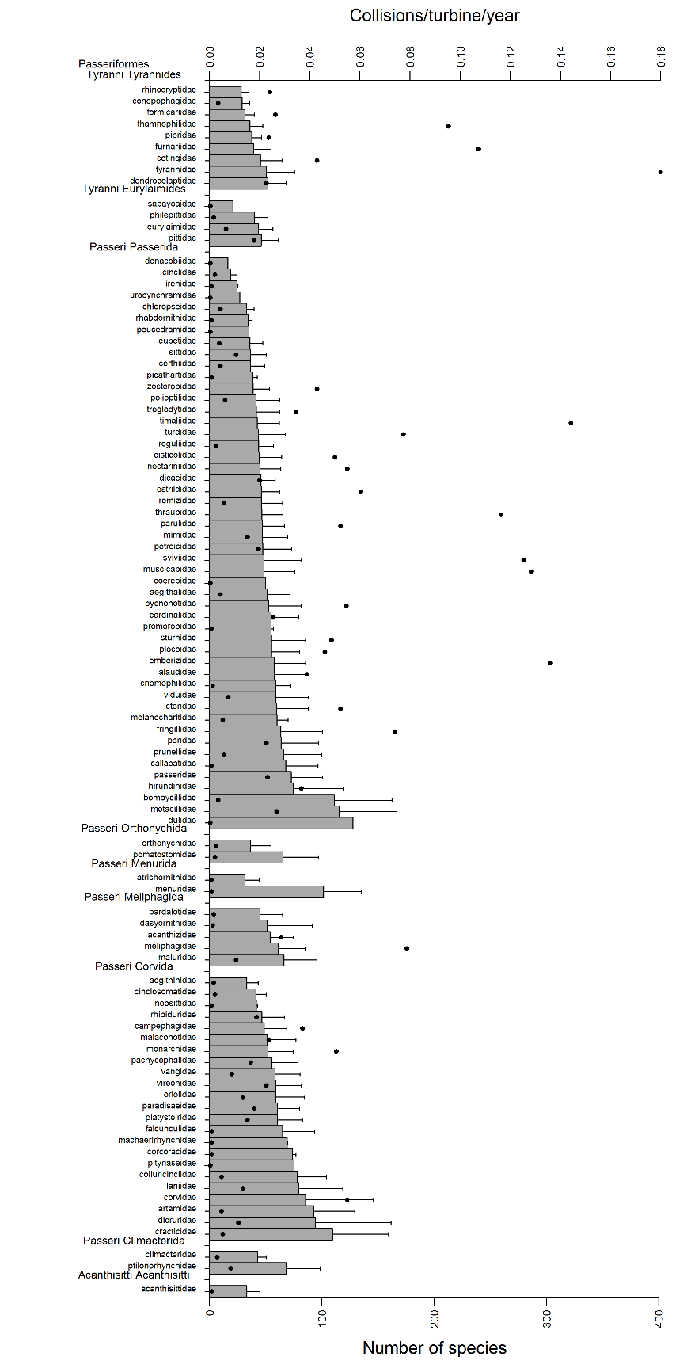
Figure S8. Predictions of mean collisions per turbine (per year) (±SD) for passerine birds (5,795 species) from posterior distributions from MCMCglmm models, ordered by mean predicted number of collisions within classification Order; numbers of species per family category are shown by black dots.

Figure S9. Predictions of mean collisions per turbine (per year) (±SD) for non-passerine birds (3,773 species) from posterior distributions from MCMCglmm models, ordered by mean predicted number of collisions within classification Order; numbers of species per family category are shown by black dots.

