Bird and bat species’ global vulnerability to collision mortality at wind farms revealed through a trait-based assessment Appendix 4. doi.org/10.1098/rspb.2017.0829
Additional information on data manipulation and statistical analyses.
Proceedings of the Royal Society B
Author List:
*Chris B. Thaxter^{1,2}, Graeme M. Buchanan³, Jamie Carr⁴, Stuart H. M. Butchart^{5,7}, Tim Newbold⁶,
Rhys E. Green^{7,8}, Joseph A. Tobias⁹, Wendy B. Foden¹⁰, Sue O’Brien¹¹, James W. Pearce-Higgins^{1,2,7}
¹British Trust for Ornithology, The Nunnery, Thetford, Norfolk IP24 2PU, UK
²British Trust for Ornithology, David Attenborough Building, Pembroke Street, Cambridge, CB2 3QZ, UK.
³RSPB Centre for Conservation Science, Royal Society for the Protection of Birds, 2 Lochside View, Edinburgh Park, Edinburgh, EH12 9DH, UK.
⁴International Union for Conservation of Nature, David Attenborough Building, Pembroke Street, Cambridge, CB2 3QZ, UK.
⁵BirdLife International, David Attenborough Building, Pembroke Street, Cambridge, CB2 3QZ, UK.
⁶Centre for Biodiversity and Environment Research, Department of Genetics, Evolution and Environment, University College London, Gower Street, London, WC1E 6BT, UK.
⁷Conservation Science Group, Department of Zoology, University of Cambridge, Downing Street, Cambridge CB2 3EJ, UK.
⁸RSPB Centre for Conservation Science, David Attenborough Building, Pembroke Street, Cambridge CB2 3QZ, UK.
⁹Department of Life Sciences, Imperial College London, Silwood Park, Buckhurst Rd, Ascot SL5 7PY, UK
¹⁰Department of Botany and Zoology, University of Stellenbosch, P/Bag X1, Matieland, 7602 Stellenbosch, South Africa.
¹¹Joint Nature Conservation Committee, Inverdee House, Baxter Street, Aberdeen, AB11 9QA, UK.
*Corresponding author: telephone: +44(0)1842 750050; fax: +44(0)1842 750030
*Corresponding Author: Chris B. Thaxter. Email: chris.thaxter@bto.org

Additional information on the literature review
Potential biases may arise through exclusion of non-English searches [1], therefore we repeated searches for key European countries using translated keywords as presented in the main paper. Where repeat information was presented in different studies (such as multiple years of monitoring reports), the data were extracted once for the given site.

Species classification
In this study, we follow the classification system of IUCN and BirdLife International [2] for species common and latin names of birds and bats, prioritising the first common name if multiple synonyms for a species were available. Data extracted during the literature was therefore matched to this classification system, adjusting the species classification to match that above if the taaxonomy in the paper had changed since it was published. Similar complication arose with use of phylogenetic trees in statistical analyses. Since the phylogentic trees were published, classifications have since been revised in some cases. Tree tip labels (scientific names) were required in the analysis. Consequently, each species entry in the collisons dataset was assigned the corresponding phylogentic tree tip label to allow models to interpret species to the correct node on the tree. For predictions, however, some species were either not present in the original tree and so could not be included, or had been subsequently split into sub-species. Final predictions were made for the tree tip labels and translated back to the current taxonomy of IUCN and BirdLife International. A total of 9,993 bird species and 916 bat species were specified in phylogenetic trees, and a total of 10,425 bird and 1,143 bat species were listed in original species trait databases. We produce predictions for a total of 9,568 bird and 888 bat species that had trait data and phylogeny presence in the analysis, excluding those flightless and extinct bird species, marine bird species that were not adequately covered in this study, and species with paucity of data.

Land cover types of wind farms
We scrutinsed whether the land cover types of wind farms reviewed in this study were characteristic of the land cover types available globally. The proportion of forest, agricultural, shrub and grassland land cover types within a 5 km buffer of the centre point of wind farms were quantified, alongside the dominant habitat habitat as scored at the centroid of the wind farm. Land cover types < 1% were excluded from this comparison. In total, 36% studies were in forests and 29% were in agricultural areas (e.g. artificial landscapes) with fewer in shrub (9%) and grassland (14%) landscapes. The proportion of wind farms where each land cover type was dominant was similar to the above land cover proportions (forest, 37%; agricultural, 30%; shrub, 7%; grassland, 16%), indicating no overall bias in our definition of land cover within 5 km of the wind farm centroid; although we note that there were cases (9% studies) where the dominant land cover type was actually ‘sea’ i.e. for coastal developments. Agricultural land cover (including those without wind farms), however, was over-represented in the review in comparison to percentage of total global land cover (17%), whereas shrub (21%) and grassland (26%) were under-represented and forests percentages were sampled approximately in proportion to their global area (37%).

Prior specification in analyses
Within R package ‘MCMCglmm’, for the residual model structure (R) we used the prior: R=list(V=diag(c(1,1)),nu=0.002, fix = 2) and for random effects of tip.label and study ID we included the prior: G=list(G1 = list(V=diag(c(1,1e-6)),nu=0.002), G2 = list(V=diag(c(1,1e-6)),nu=0.002, fix = T))). In both cases we fixed the R-structure of the binary part of the data to 1 (because it is not identifiable) and likewise we constrained the random effects G-structure in the same way [3]. For fixed effects we defined a prior with zero mean and high variance (1e4); however to include an offset in the model for log(number of turbines) to model collisions per turbine (per period), we included a strong prior with a mean of 1.0 and very small variance (1e-6) (see Bolker et al. 2012 for more details). Thus, the default prior: B=list(mu=c(0,1)[N.terms],V=diag(c(1e4,1e-6)[N.terms])), for the number of fixed effect terms (n.var) included in the model (N.terms = rep(1,nvar)), was altered at the position where the offset variable was defined, e.g. N.terms[3] = 2. Phylogeny was incorporated directly for each phylogenetic reconstruction method used. This was done by including a random effect for phylogeny and specifying a ‘ginverse’ structure to the model, a list of inverse matrices proportional to the covariance straucture of that random effect; tree tip labels were used to associate the matrices with the random term [4].

Correlation of fixed effects feeding into the model
We tested for nonlinear correlations between the traits fittted for both birds and bats (Figs. S2 and S3). For bats, there was no Pearson’s R correlation above 0.7 found for variables included in the final model. For birds one pair of variables, gestation length and Kipp’s distance, were correlated at the threshold of R = 0.7.

Figure S2. Correlation matrix of fixed effects fed into the bird model; shown are a levels of the effects for variables feeding into the final model of 769 species – see Figure 1 in the main paper for effect levels.

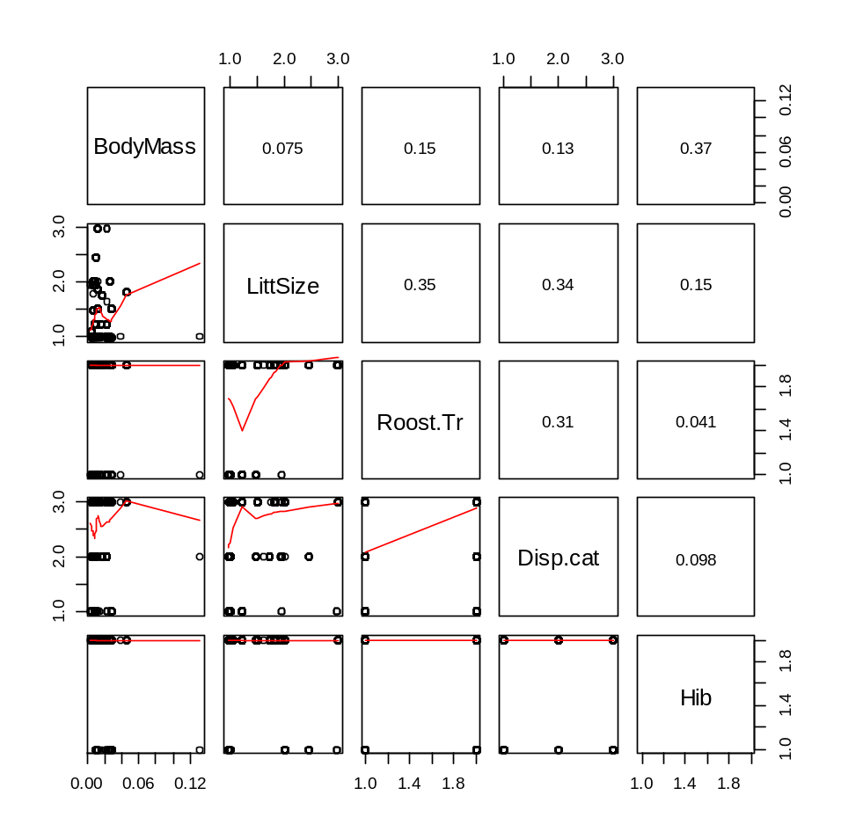
Figure S3. Correlation matrix of fixed effects fed into the bat model; shown are a levels of the effects for variables feeding into the final model of 67 species for the trait-based model (out of 72 species with collision data and pseudo-absences), in order from top to bottom along the diaganol: Body mass, litter size, use of tree roosting sites, dispersal distance (sedentary, <10 km; regional, 10-100 km, long-distannce > 100 km), and hibernating behaviour.

Model selection
A model selection and simplification process was considered for this study, based on stepwise model selection to avoid reliance on potentially spurious DIC values from models with non-normal errors [4]. However, a single full model with 105,000 chains took up to 10 days to run and given the large number of traits to individually assess, it was not possible to carry out such a model simplification process. Inclusion of all traits in final predictions may increase variance on final estimates, however a subset of potentially likely traits of migration status, dispersal, artificial habitat, grassland, turbine size and peer review produced similar final outputs. Moreover, sole reliance on P-values overlooked some variables that were very close to not overlapping zero (such as scavenging diets for birds), and inclusion of predictions from the full global, although potentially unorthodox, therefore reflected both model runtime constraints whilst maximising variation across all traits.

Model fitting
Given the high number of zeros in the database, we tested zero-inflated models as a primary error structure to examine if zero presence was best modelled through a separate process for excess zeros or whether fixed effects could account for such variation alone. The number of zeros predicted was more than under a standard Poisson distribution, and models subsequently were better fitted with zero-inflated response. Zero-inflated models (zero-inflated, zero-added and hurdle Poisson structures) were much better fitting than a standard Poisson (dDIC < -2.0 in all cases), with the zero-added model the best fitting, hence selected for generating predictions. It was not possible to fully account for spatial autocorrelation in this analysis, however, it is expected that the inclusion of the random effect of study ID was highly site specific and thus likely controlled for much variation.

Quality of model fit
For MCMCglmm models for birds, effective sample sizes of count model structure coefficients (ID and tip label terms as random effects, and the “units” term for residual variance) were greater than the 20% threshold deemed an approximate minimum requirement of the total number of posterior samples (200 from the 1000 sample size total, after thinning and burn in removal of samples, Table S2) in all but one case; this was the “Mayr Par Sho Ericson” phylogeny reconstruction method for study ID; however the sample size was still suitably high and diagnostic plots were still deemed suitable. Similarly, for the bat models, effective sample sizes slipped slightly below the threshold for the tip label term (Table S2); however overall the graphical model diagnostic checks were still deemed highly suitable.

Table S2. (a) Mean posterior coefficients from MCMCglmm models for the random effects of ID and tip label of phylogenetic tree (G-structure) and the residual model structure “units” (R-structure), and (b) Summary of the fit of individual MCMCglmm models to the underlying data, assessed using pseudo-R² values; for bats an additional ‘no traits’ model is presented, from which eventual predictions are made.
(a)
Taxa (model type) | Phylogeny reconstruction method | ID |  | Tip label |  | Units
Taxa (model type) | Phylogeny reconstruction method | Mean (95% LCI,UCI) | Sample size | Mean (95% LCI,UCI) | Sample size | Mean (95% LCI,UCI) | Sample size
Birds (traits) | Ericson | 1.49 (0.90,2.07) | 410.3 | 1.77 (1.12,2.40) | 264.6 | 1.05 (0.95,1.14) | 568.3
 | Hackett | 1.49 (0.94,2.09) | 503.9 | 1.80 (1.23,2.48) | 361.1 | 1.05 (0.97,1.16) | 485.2
 | Parrot | 1.47 (1.00,2.12) | 296.3 | 1.81 (1.25,2.43) | 260.6 | 1.05 (0.95,1.14) | 648.0
 | Mayr Ericson | 1.47 (0.88,2.02) | 441.1 | 1.84 (1.21,2.51) | 301.5 | 1.05 (0.96,1.17) | 509.1
 | Mayr Hackett | 1.46 (0.88,2.04) | 473.8 | 1.79 (1.13,2.41) | 269.8 | 1.05 (0.95,1.14) | 614.9
 | Mayr Par Sho Ericson | 1.51 (0.98,2.10) | 142.5 | 1.81 (1.22,2.46) | 271.9 | 1.05 (0.97,1.16) | 601.2
 | Mayr Par Sho Hackett | 1.44 (0.92,2.02) | 338.4 | 1.79 (1.17,2.47) | 243.8 | 1.05 (0.95,1.15) | 502.5
Bats (traits) | R package: ape | 1.62 (0.94,2.44) | 809.5 | 3.84 (0.11,11.31) | 160.6 | 1.55 (1.30,1.80) | 831.0
Bats (no traits) | R package: ape | 1.47 (0.87,2.13) | 888.3 | 11.71 (1.60,26.68) | 185.2 | 1.58 (1.36,1.85) | 861.2

Table S2 cont.
(b)
Taxa (model type) | Phylogeny reconstruction method | Marginal R² |  | Conditional R²
Taxa (model type) | Phylogeny reconstruction method |  |  | Random ID + Phylo |  | Random ID
Taxa (model type) | Phylogeny reconstruction method | Mean | Posterior mode (95% HPD CI) | Mean | Posterior mode (95% HPD CI) | Mean | Posterior mode (95% HPD CI)
Birds (traits) | Erickson | 0.46 | 0.45 (0.36-0.56) | 0.85 | 0.85 (0.82-0.88) | 0.64 | 0.65 (0.56-0.71)
 | Hackett | 0.46 | 0.45 (0.36-0.56) | 0.85 | 0.85 (0.82-0.88) | 0.64 | 0.66 (0.57-0.72)
 | Parrot | 0.46 | 0.45 (0.35-0.56) | 0.85 | 0.85 (0.82-0.88) | 0.64 | 0.64 (0.56-0.72)
 | Mayr-Erickson | 0.46 | 0.48 (0.36-0.56) | 0.85 | 0.86 (0.82-0.87) | 0.65 | 0.66 (0.58-0.72)
 | Mayr-Hackett | 0.46 | 0.48 (0.36-0.57) | 0.85 | 0.86 (0.82-0.88) | 0.65 | 0.66 (0.58-0.73)
 | Mayr-Par-Sho-Erickson | 0.46 | 0.46 (0.36-0.56) | 0.85 | 0.85 (0.82-0.88) | 0.64 | 0.66 (0.57-0.71)
 | Mayr-Par-Sho-Hackett | 0.46 | 0.47 (0.34-0.55) | 0.85 | 0.85 (0.81-0.87) | 0.64 | 0.66 (0.56-0.71)
Bats (traits) | R package: ape | 0.30 | 0.30 (0.11-0.50) | 0.84 | 0.83 (0.77-0.92) | 0.58 | 0.64 (0.37-0.75)
Bats (no traits) | R package: ape | 0.19 | 0.08 (0.04-0.42) | 0.88 | 0.87 (0.81-0.95) | 0.39 | 0.39 (0.16-0.62)

For birds, the models performed reasonably well in predicting observed data (Fig. S4). Mean predicted collision rates for highest impacted species followed the pattern of predicted rates of collision when ordered from highest to lowest impacted (Fig. S4). However, the variation in the predictions was still large, ranging from just over zero for all species, up to 1.436 (mean across all phylogenetic trees) for Ayres's Hawk-eagle Hieraaetus ayresii. For the model predicted well those species impacted most and least (Fig. S4), but predictions for species with no data made up the majority, but not exclusively, values in between these ranges.

Figure S4. Plot of species predictions for birds from MCMCglmm models plotted from the mean posterior distribution with lower and upper credible intervals; species are ranked by the posterior mean prediction and plotted in descending order from the highest to the lowest prediction across species phylogenetic tip labels (9,568 species). Also shown is the species mean collision rate value (red dots) for species feeding into the modelling (769 species).

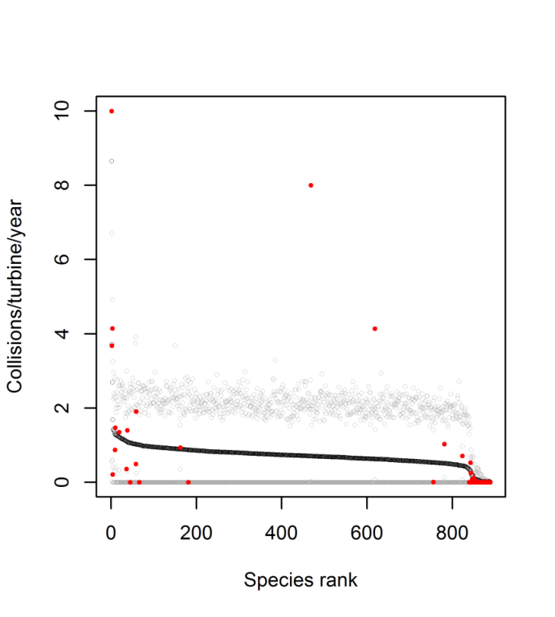
Figure S5. Plot of species predictions for bats from the MCMCglmm model contining no species traits, plotted from the mean posterior distribution with lower and upper credible intervals; species are ranked by the posterior mean prediction and plotted in descending order from the highest to the lowest prediction across species (888 species). Also shown is the species mean collision rate value (red dots) for species feeding into the ‘no-trait’ model (72 species).

Bird predictions
Full model predictions are provided as supplementary online files S3 and S4, alongside species IUCN Red List Status and population trend from the Red List Database. Predictons were made from global models marginal to the random effect of study ID. For birds, global population size was estimated for only 3,467 species. The variable of population size, however, was not significant, and was therefore contrained to a mean value within the prediction matrix to allow prediction for the full suite of species. To account for variation in survey duration, initial models considered the interaction between terms of study duration (years) and number of days moitoring per year; however, this interaction was not significant and excluded from further models. Therefore, studies that covered part of the year, typically March to October, were thus assumed to equate to annual rates of mortality.
For birds the seven different phylogentic models were averaged, and for both birds and bats, species were ranked according to mean predictions. Given the uncertainty surrounding marine species in this study (see main paper), we separated out “marine” species from “terrestrial” species in these datasets, using the Birdlife habitat categories used in the analysis for species’ habitat association. Species just associated with “marine” and “marine and coastal” were separated firstly into the marine category; however many seabird species were also flagged as having association with breeding habitats particularly grassland and forest; for example Atlantic puffin Fratercula arctica is a coastal-marine species that breeds on grassland clifftops slighty further from the immediate coastal habitat. Hence, the species list was further filtered to account for these species, that were also treated as “marine”. Those species that used marine habitats but also used inland habitats extensively such as inland wetlands and artificial habitats (such as some species of gulls, terns, cormorants and ducks), were treated as “terrestrial”. Some marine species were infrequently recorded as collisions within the main dataset with coastal turbines, hence being included in the study, however no offshore studies were included in the analysis (due to lack of data). Given the uncertainty in extrapolating from our model, based only on terrestrial wind farms, we subsequently removed marine species from final predictions. Predictions are also mapped globally (Fig. 5) using the MCMC posterior distributions for birds (seven models, 7000 samples) and for bats (one model, 1000 samples).

Bat predictions
We present a final model for bats based on traits, including body size, number of litters per year, dispersal distance, hibernation tendency and whether species used trees for roosting. Information on dispersal was not defined sufficiently for five species, thus reducing this model to 67 species. The final trait-based model contained a significant effect for dispersal distance, which was not available for all species globally. We therefore predicted from a model only containing phylogenetic signal (for 72 species) to produce the final model predictions for bats.
For bats, we also provide predictions for the trait-based model based on those species with data available for modelling. This exercise served to highlight quality of model fit and to compare how predictions from the ‘traits model’ compared to the ‘no-traits’ model (see Fig. S5); predictions from the latter are presented in supplementary online file S4, and Fig. S6 presents this comparison graphically. The trait-based predictions were notably influenced by the inclusion of the dispersal variable, but tallied with observed values of collisions/turbine/year, as species with highest mortality rates were charcaterised at the higher end of Fig. S6. Although overall confidence in the predictions was low (given the large credible intervals), the mean predicted fit line corresponded well to the magnitude of the observed data. The no-traits model predictions tallied well with the trait-based model predictions (Pearsons R = 0.8, Fig S6), however, the no-traits model was a significantly poorer fitting model compared to the trait-based model (dDIC = -9.50). Further, the predictions from the no-traits model, had a relatively shallow slope of collision rate change across ranked species in Fig S5 above, and so a high degree of caution is necessary in interpretion. Although predictions for bats were based on a model excluding species traits, the similarly high proportion of variance explained by phylogeny for models with and without traits (Table 1 in the main paper) could suggest traits are phylogenetically conserved, but this would need further verification.

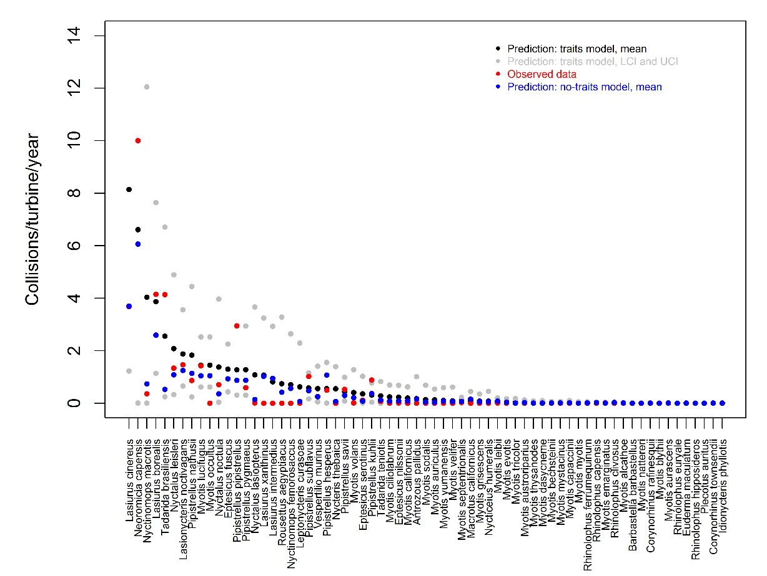
Figure S6. Plot of species predictions for bats from MCMCglmm models of the ‘no-traits’ model (used for extrapolating predictions to species globally – see Figure S5) and the trait model, for which predictions could be made for those species modelled. Predictions in both cases are plotted from the mean (black dots) posterior distribution with lower and upper credible intervals (grey dots, UCI, LCI) from the trait model; comparable predictions from the no-traits model (presented also in Figure S3) are presented (blue dots). Species are ranked by the posterior mean prediction of the trait-based model, and plotted in descending order from the highest to the lowest prediction. Also shown is the species mean collision rate value (red dots) for species feeding into the modelling.

Supplementary references
- Amano T, González-Varo JP, Sutherland WJ. 2016 Languages Are Still a Major Barrier to Global Science. PLoS Biol. 14: e2000933. (dx.doi:10.1371/journal.pbio.2000933)
- Birdlife International. 2016 Birdlife datazone. http://www.birdlife.org/datazone. (accessed 17/03/2017)
- Bolker B, Brooks M, Gardner B, Lennert C, Minami M. 2012 Owls example: a zero-inflated, generalized linear mixed model for count data. https://groups.nceas.ucsb.edu/non-linear-modeling/projects/owls/WRITEUP/owls.pdf. (last accessed 20/10/2016)
- Hadfield J. 2016 Package ‘MCMCglmm’, Version 2.22.1. https://cran.r-project.org/web/packages/MCMCglmm/MCMCglmm.pdf. (last accessed 12/12/2016)

