Bird and bat species’ global vulnerability to collision mortality at wind farms revealed through a trait-based assessment Appendix 1. doi.org/10.1098/rspb.2017.0829
Supplementary figure for the location of onshore wind farms included in this study.
Proceedings of the Royal Society B
Author List:
*Chris B. Thaxter^{1,2}, Graeme M. Buchanan³, Jamie Carr⁴, Stuart H. M. Butchart^{5,7}, Tim Newbold⁶,
Rhys E. Green^{7,8}, Joseph A. Tobias⁹, Wendy B. Foden¹⁰, Sue O’Brien¹¹, James W. Pearce-Higgins^{1,2,7}
¹British Trust for Ornithology, The Nunnery, Thetford, Norfolk IP24 2PU, UK
²British Trust for Ornithology, David Attenborough Building, Pembroke Street, Cambridge, CB2 3QZ, UK.
³RSPB Centre for Conservation Science, Royal Society for the Protection of Birds, 2 Lochside View, Edinburgh Park, Edinburgh, EH12 9DH, UK.
⁴International Union for Conservation of Nature, David Attenborough Building, Pembroke Street, Cambridge, CB2 3QZ, UK.
⁵BirdLife International, David Attenborough Building, Pembroke Street, Cambridge, CB2 3QZ, UK.
⁶Centre for Biodiversity and Environment Research, Department of Genetics, Evolution and Environment, University College London, Gower Street, London, WC1E 6BT, UK.
⁷Conservation Science Group, Department of Zoology, University of Cambridge, Downing Street, Cambridge CB2 3EJ, UK.
⁸RSPB Centre for Conservation Science, David Attenborough Building, Pembroke Street, Cambridge CB2 3QZ, UK.
⁹Department of Life Sciences, Imperial College London, Silwood Park, Buckhurst Rd, Ascot SL5 7PY, UK
¹⁰Department of Botany and Zoology, University of Stellenbosch, P/Bag X1, Matieland, 7602 Stellenbosch, South Africa.
¹¹Joint Nature Conservation Committee, Inverdee House, Baxter Street, Aberdeen, AB11 9QA, UK.
*Corresponding author: telephone: +44(0)1842 750050; fax: +44(0)1842 750030
*Corresponding Author: Chris B. Thaxter. Email: chris.thaxter@bto.org
(a) birds
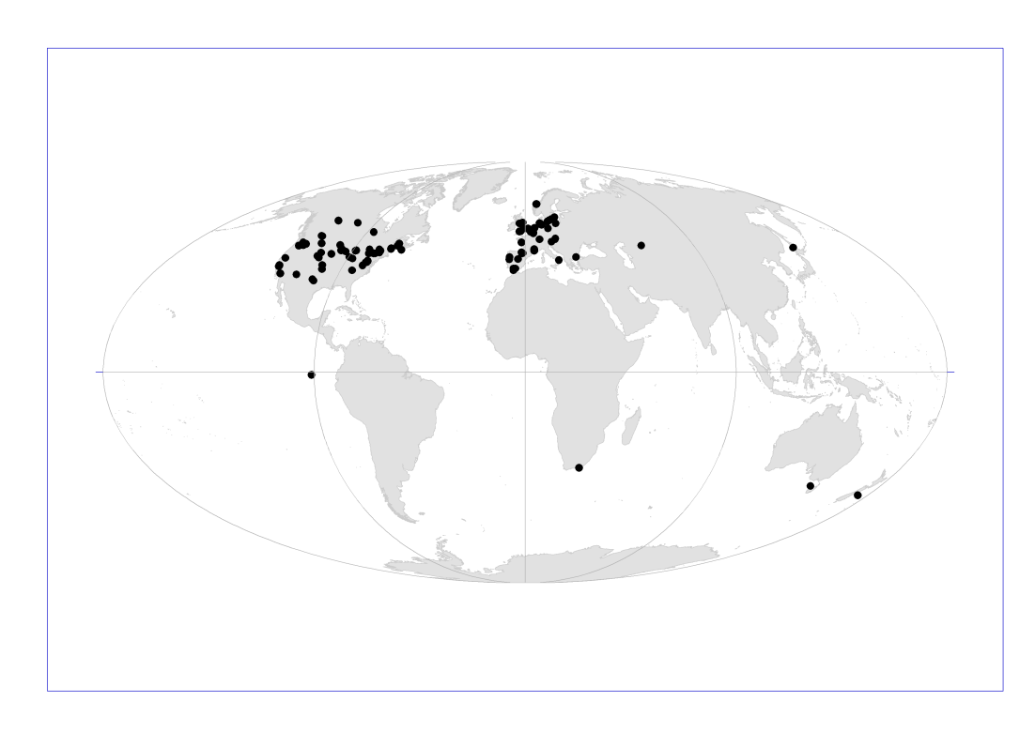
(b) bats
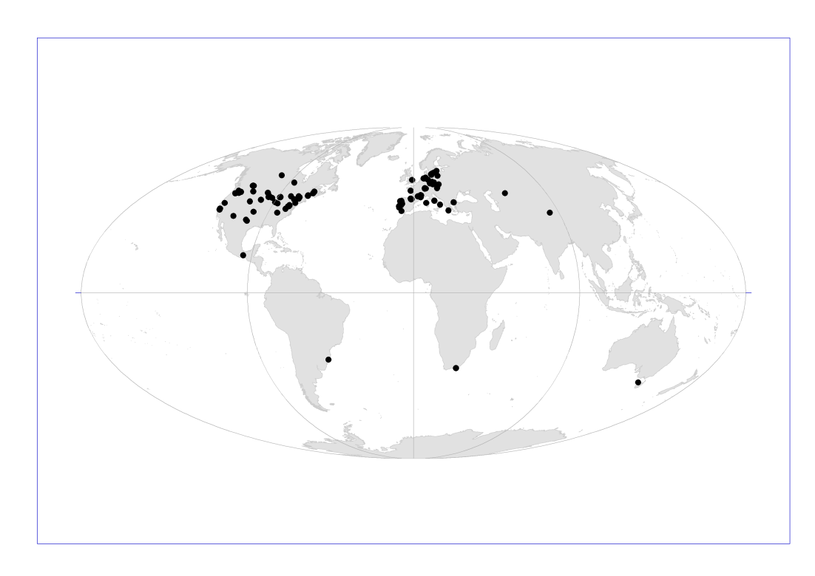
Figure S1. Location of wind farms included in the meta-analysis for this study for (a) birds and (b) bats.

