Supplementary File 2
LC-MS/MS analysis of protein samples

1D protein separation
Electrophoretic separation (SDS-PAGE-based method) of samples was carried out using the Hoefer miniVE system (gel size 80 × 90 × 1 mm). Proteins were separated under reducing conditions in 20% polyacrylamide gels with Tris-glycine buffer. Each of 11 proteins (~2 µg in buffer contained 2% LDS, 0.065M Tris, pH 6.8, 1% DTT, 10% glycerin, 0.01% bromphenol blue) and Precision Plus Protein Standards (BioRad) was introduced into 5 mm well. Electrophoresis was performed in the following conditions: 180 V, 100 mA, 7W (3.5W per gel) for 2.5 h. Gels were visualized with Coomassie R-350.
After protein separation, all bands were detected and quantified by ImageMaster 2D Platinum 7 v.7.02 software. The relative protein abundance (%Vol) of each band was calculated according to the normalized staining intensity of the band. The each band was cut into a slice of about 1.5 mm thickness.

LC-MS/MS analysis
To the subsequent mass-spectrometric analysis proteins in each gel slice were destained and digested with a trypsin (Sequencing Grade Modified, Promega, Madison, WI, USA) using the protocol described previously [1]. In addition, in-solution protein digestion was performed for EsZNF1 protein with a trypsin (Sequencing Grade Modified, Promega, Madison, WI, USA as described in [2].
The peptides were separated with high-performance liquid chromatography (HPLC, Ultimate 3000 Nano LC System, Thermo Scientific, Rockwell, IL, USA) in a 15-cm long C18 column with an inner diameter of 75 μm (Acclaim® PepMap™ RSLC, Thermo Fisher Scientific, Rockwell, IL, USA). The peptides were eluted with a gradient from 5–35% buffer B (80% acetonitrile, 0.1% formic acid) over 45 min at a flow rate of 0.3 μL/min. Total run time including 5 min to reach 99% buffer B, flushing 5 min with 99% buffer B and 5 min re-equilibration to buffer A (0.1% formic acid) amounted 60 min. MS analysis was performed at least in triplicate with a Q Exactive HF mass spectrometer (Q ExactiveTM HF Hybrid Quadrupole-OrbitrapTM Mass spectrometer, Thermo Fisher Scientific, Rockwell, IL, USA). Mass spectra were acquired at a resolution of 120,000 (MS) and 15,000 (MS/MS) in a m/z range of 300−1500 (MS) and 100–2000 (MS/MS). An isolation threshold of 100,000 counts was determined for precursor’s selection and up to top 10 precursors were chosen for fragmentation with high-energy collisional dissociation (HCD) at 30 NCE and 100 ms accumulation time. Precursors with a charged state of +1 were rejected and all measured precursors were excluded from measurement for 20 s.
For the analysis of the mass spectrometry data, a database was built using the E.coli (k12) proteome database and 11 desired sequences each individually appended to it. Database search was performed using X!Tandem search engine using SearchGUI v.3.3.2 (2). Parameters were set as follows: tryptic specificity allowing two missed cleavage, MS tolerance of 5 ppm and 0.01 Da tolerance for MS/MS ions. Carbamidomethylation of C was used as fixed modification and oxidation of M as variable modification. PeptideShaker v.1.16.23 was used to import the results for peptide and protein identifications. Peptide-Spectrum Matches (PSMs), peptides and proteins were validated at a 1.0% False Discovery Rate estimated using the decoy hit distribution. Only proteins having at least two unique peptides were considered as positively identified.
1. Filatov, A. V., Krotov, G. I., Zgoda, V. G., Volkov, Y., Fluorescent immunoprecipitation analysis of cell surface proteins: a methodology compatible with mass-spectrometry. J. Immunol. Methods 2007, 319, 21–33 PMID: 17098248 DOI: 10.1016/j.jim.2006.09.014
2. . Anselm V, Novikova S, Zgoda V. Re-adaption on Earth after Spaceflights Affects the Mouse Liver Proteome. Int J Mol Sci. 2017 Aug 12;18(8). pii: E1763. doi: 10.3390/ijms18081763. PubMed PMID: 28805685; PubMed Central PMCID: PMC5578152.
3. Vaudel M, Barsnes H, Berven FS, Sickmann A, Martens L. SearchGUI: an open-source graphical user interface for simultaneous OMSSA and X!Tandem searches. Proteomics (2011) 11(5):996–9.10.1002/pmic.201000595

Result
Purity of expressed plant proteins was estimated with SDS-PAGE followed by LC-MS/MS analysis.
Figure 1 shows a one-dimensional (1D) electrophoresis gel images with detected protein bands. Each band was quantified with %Vol value that represents the relative protein abundance. Only one band was visualized for EsZnF1, Es1F(4Z), and Es1F(2Z) proteins. Several protein bands were present for other expressed plant proteins with the most abundant band for target mass.
Protein identification results are listed in the table 1. The proteins detected by at least two peptides were taken into account. Purity of expressed plant proteins from single band (Es1F(4Z), Es1F(2Z)) and from the most abundant bands was confirmed by LC-MS/MS of in-gel digested protein. E.coli contaminant proteins (thioredoxin 1, citrate synthase, 50S ribosomal protein) were identified only in minor protein bands.
Since no significant identification was obtained for EsZnF1 this protein sample was additionally subjected by in-solution protein digestion followed by mass-spectrometry analysis. Only EsZnF1 plant protein was significant identified in this case.

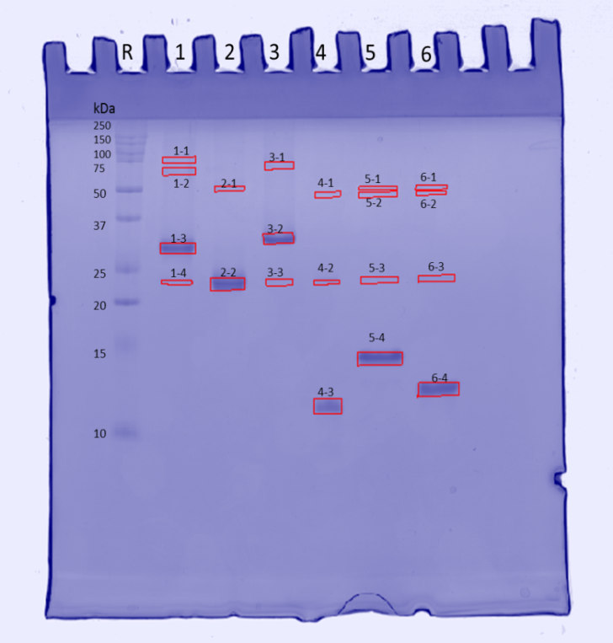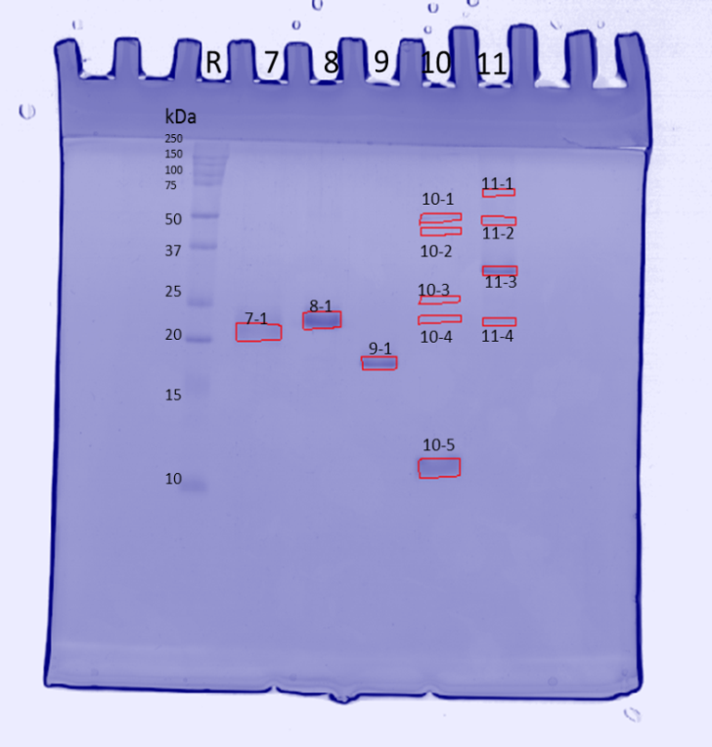
Figure 1. 1D electrophoresis gel images of 11 plant protein samples. R - Precision Plus Protein Standards, 1- ECSDP1, 2- ECSDP2, 3 - EsCSDP3, 4 - EsCSD1, 5 – EsCSD2, 6 – EsCSD3, 7 - EsZnF1, 8 - Es1F(4Z), 9 - Es1F(2Z), 10 - CspA, 11 - EsCSDP3mut.

Table 1. Protein identification by LC-MS/MS of in-gel digested proteins
Sample protien | Band number | Band Mw (kDa) | Quantity (%Vol) | Protein name  (Swiss-Prot AC and ID) | MW calculated (kDa) | Sequence coverage (%)
EsCSDP1 | 1_1 | 81 | 0.73 | EsCSDP1 | 27.91 | 31.14
EsCSDP1 | 1_2 | 65 | 1.12 | EsCSDP1 | 27.91 | 31.14
EsCSDP1 | 1_3 | 30 | 13.02 | EsCSDP1 | 27.91 | 31.87
EsCSDP1 | 1_4 | 23 | 0.74 | EsCSDP1 | 27.91 | 20.15
EsCSDP2 | 2_1 | 51 | 0.53 | EsCSDP2 | 20.49 | 21.33
EsCSDP2 | 2_2 | 23 | 17.88 | EsCSDP2 | 20.49 | 40.76
EsCSDP3 | 3_1 | 71 | 0.59 | EsCSDP3 | 30.38 | 19.34
 |  |  |  | Thioredoxin 1 (P0AA25, THIO_ECOLI) | 11.8 | 33.94
EsCSDP3 | 3_2 | 32 | 13.11 | EsCSDP3 | 30.38 | 19.34
EsCSDP3 | 3_3 | 23 | 0.53 | EsCSDP3 | 30.38 | 15.08
ESCSD1 | 4_1 | 48 | 0.26 | ESCSD1 | 9.48 | 52.87
 |  |  |  | Citrate synthase (P0ABH7, CISY_ECOLI) | 47.98 | 5.85
ESCSD1 | 4_2 | 23 | 0.78 | ESCSD1 | 9.48 | 52.87
ESCSD1 | 4_3 | 11 | 8.38 | ESCSD1 | 9.48 | 94.25
ESCSD2 | 5_1 | 52 | 0.41 | ESCSD2 | 9.7 | 48.86
ESCSD2 | 5_2 | 48 | 0.58 | ESCSD2 | 9.7 | 48.86
 |  |  |  | Citrate synthase (P0ABH7, CISY_ECOLI) | 47.98 | 19.91
 |  |  |  | Thioredoxin 1 (P0AA25, THIO_ECOLI) | 11.8 | 19.27
ESCSD2 | 5_3 | 23 | 0.44 | ND
ESCSD2 | 5_4 | 14 | 21.38 | ESCSD2 | 9.7 | 68.18
ESCSD3 | 6_1 | 53 | 0.38 | ESCSD3 | 9.3 | 55.17
ESCSD3 | 6_2 | 49 | 0.26 | ESCSD3 | 9.3 | 52.87
 |  |  |  | Citrate synthase (P0ABH7, CISY_ECOLI) | 47.98 | 15.46
ESCSD3 | 6_3 | 24 | 0.93 | ESCSD3 | 9.3 | 52.87
ESCSD3 | 6_4 | 12 | 17.95 | ESCSD3 | 9.3 | 81.61
EsZnF1 | 7_1 | 21 | 8.67 | ND (in-gel protein digestion) | - | -
EsZnF1 | - | - | - | EsZnF1 (in-solution protein digestion) | 19.63 | 30.61
Es1F(4Z) | 8_1 | 23 | 32.63 | Es1F(4Z) | 23.01 | 41.26
Es1F(2Z) | 9_1 | 17 | 16.75 | Es1F(2Z) | 15.85 | 45.64
CspA | 10_1 | 49 | 3.25 | ND
CspA | 10_2 | 43 | 0.73 | ND
CspA | 10_3 | 26 | 0.60 | 50S ribosomal protein L1 (P0A7L0, RL1_ECOLI) | 24.71 | 54.27
CspA | 10_4 | 23 | 1.23 | ND
CspA | 10_5 | 11 | 16.26 | CspA | 8.58 | 98.75
EsCSDP-3mut | 11_1 | 67 | 1.12 | EsCSDP-3mut | 29.88 | 30.82
 |  |  |  | Thioredoxin 1 (P0AA25, THIO_ECOLI) | 11.8 | 47.71
EsCSDP-3mut | 11_2 | 48 | 2.40 | EsCSDP-3mut | 29.88 | 18.36
 |  |  |  | Thioredoxin 1 (P0AA25, THIO_ECOLI) | 11.8 | 33.03
EsCSDP-3mut | 11_3 | 31 | 13.7046 | EsCSDP-3mut | 29.88 | 49.18
EsCSDP-3mut | 11_4 | 22 | 2.64 | EsCSDP-3mut | 29.88 | 15.74

