SUPPLEMENTARY MATERIAL
Production of bioactive tryptamine derivatives by co-culture of marine Streptomyces with Bacillus mycoides
Liyan Yu, Zhifei Hu, Zhongjun Ma*
Institute of Marine Biology & Natural Products, Ocean College, Zhejiang University, Hangzhou 310058, People’s Republic of China
∗ Corresponding author. E-mail: mazj@zju.edu.cn; Tel. (+86) 571 88206621; Fax: (+86) 571 88208891.

Abstract
Tryptamine derivatives such as tryptamine and bacillamides were strong algicidal compounds promising in controlling harmful algae blooms (HABs), but their bioactivity and application researches were hindered by extremely low natural production rates. This study found an induced production of these compounds by co-culture of marine Streptomyces with Bacillus mycoides, and optimized the culture method through changing important factors such as medium nutrition content, culture mode and pH value. The final established co-culture method used only 5 g yeast extracts and 5 g glycerol in 1 liter 75% sea water, but get a yields of 14.9 mg/L N-acetyltryptamine, 2.8 mg/L N-propanoyltryptamine, 3.0 mg/L bacillamide A, 13.7 mg/L bacillamide B and 9.6 mg/L bacillamide C, which were all undetectable under normal culture conditions.
Keywords: co-culture; tryptamine; bacillamide; Streptomyces; Bacillus mycoides

1. Experimental

1.1. Strains and culture conditions
Bacillus mycoides CGMCC1.197 was bought from China General Microbiological Culture Collection Center, Streptomyces sp. CGMCC4.7185 (deposited in China General Microbiological Culture Collection Center and publically available) was isolated from marine sediments of Nanji Islands (China, 27º42′N，121º08′E) and identified through morphology characters and 16S rDNA sequencing (GenBank accession number KJ729120). Culture mediums used were ISP2, MM and PY (dissolved in 75% sea water). The ISP2 medium contained 4 g/L yeast extract, 10 g/L malt extract, 4 g/L glucose; the MM medium contained 5 g/L yeast extract, 5g/L glycerol; the PY medium contained 5 g/L peptide, 3 g/L yeast extract, 10 g/L glucose. All microorganisms were cultivated in 500-mL Erlenmeyer flasks containing 200 mL culture medium under 28 ºC.

1.2. Analysis methods.
Microorganism growth was evaluated by OD₅₉₀ on Shimadzu UV 2550, for Streptomyces sp. CGMCC4.7185, the clumps of cells were scattered using homogenizer before testing. Secondary metabolites analysis: 100 mL culture medium was extracted with equal volume of ethyl acetate, the resulting ethyl acetate part was dried under vacuum and re-dissolved in 1 mL MeOH. The MeOH solution was either subject to TLC analysis, HPLC analysis or UPLC-MS analysis. TLC analysis was carried out using CH₂Cl₂-MeOH (15:1) and visualized using iodine. HPLC analysis (20 μL testing sample) was performed on Shimadzu High Performance Liquid Chromatography equipped with a diode array detector and Inerstil ODS-SP (5 μm, 4.6 × 250 mm) column, with gradient elution (0-70 min, 30-100% methanol) under 0.8 mL/min at 35 ºC; UPLC-MS analyses were performed by Acquity UPLC system (Waters, Milford, MS, USA) and a BEH C18 column (2.1 mm × 100 mm, 1.7 μm), with gradient elution (0-7 min, 30-100% methanol) under 0.3 ml/min at 35 ºC.
1.3 Compounds isolation and structure determination.
68 liters of co-culture fermentation medium (340 flasks, 200 mL each) was extracted with equal volume of ethyl acetate three times and then fractioned by silica gel chromatography using CH₂Cl₂-MeOH (100:1, 75:1, 50:1). Fractions containing induced peaks (analyzed by HPLC) were further purified by preparative HPLC (Beijing Chuangxintongheng LC3000 Semi-preparation Gradient HPLC System equipped with Sepax Amethyst C-18 (5 μm, 21.2 × 250 mm) column). Structure determination was carried out using MS and NMR analysis on Bruker MicrOTOF mass spectrometer and Bruker Avance III plus 400.

2. Chemical structures and MP, UV, MS, NMR data of tryptamine derivatives

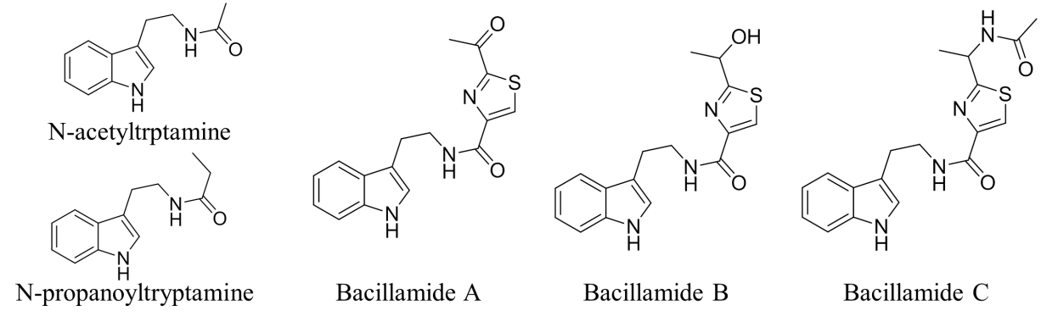
N-acetyltryptamine: white solid. LC-ESI-MS, 203.28 [M+H]⁺ (cal. 203.12). ¹H NMR (CD₃OD, 400 MHz) : 7.05 (1H, s), 7.55 (1H, d, J=7.9 Hz), 6.70 (1H, dt, J=7.5 Hz, 1.0 Hz), 7.08 (1H, dt, J=7.4 Hz, 0.9 Hz), 7.32 (1H, d, J=7.9 Hz), 2.93 (2H, t, J=7.3 Hz), 3.46 (2H, t, J=7.3 Hz), 1.90 (3H, s). ¹³C NMR (CD₃OD, 100 MHz): 122.3, 113.3, 119.3, 119.6, 123.4, 112.2, 138.2, 128.8, 26.2, 41.6, 173.3, 2.6. UV_{max}: 222 nm, 281 nm.
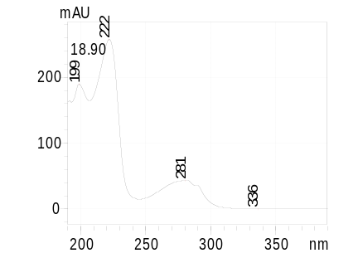
N-propanoyltryptamine: white solid. LC-ESI-MS, 217.29 [M+H]⁺ (cal. 217.13). ¹H NMR (CDCl₃, 600 MHz): 5.52 (1H, br.s), 7.03 (1H, d, J=2.0 Hz), 7.61 (1H, d, J=7.9 Hz), 7.13 (1H, t, J=7.2 Hz), 7.21 (1H, t, J=7.2 Hz), 7.38 (1H, d, J=8.1 Hz), 2.98 (2H, t, J=6.7 Hz), 3.60 (2H, dd, J=12.8 Hz, 6.6 Hz), 2.14 (2H, q, J=7.6 Hz), 1.11 (3H, t, J=7.6 Hz). UV_{max}: 222 nm, 281 nm.
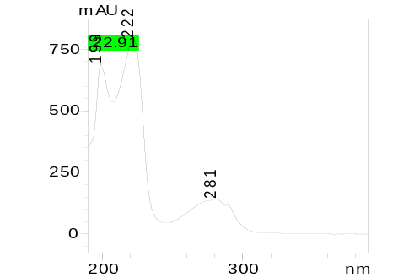
Bacillamide A: yellow solid. LC-ESI-MS, 316.30 [M+H]⁺ (cal. 316.11). ¹H NMR (CDCl₃, 400 MHz): 8.21 (1H, br.s), 7.10 (1H, s), 7.64 (1H, d, J=8.0 Hz), 7.12 (1H, t, J=7.1 Hz), 7.20 (1H, t, J=7.1 Hz), 7.37(1H, d, J=8.0 Hz), 3.12 (2H, t, J=6.8 Hz), 3.82 (2H, dd, J=13.1 Hz, 6.7 Hz), 7.43 (1H, br.s), 8.39 (1H, s), 2.60 (3H, s). ¹³C NMR (CDCl_{3,} 100 MHz): 122.1, 113.0, 118.7, 119.6, 122.2, 111.3, 136.4, 127.4, 25.4, 40.0, 160.4, 151.2, 129.5, 166.4, 191.1, 25.9. UV_{max}: 221 nm, 282 nm.
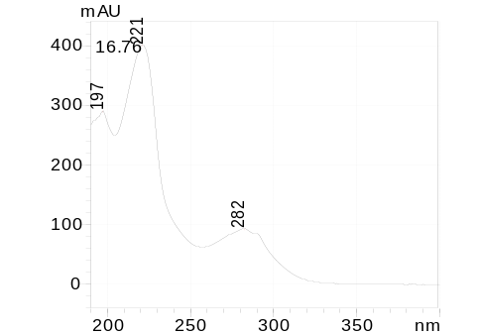
Bacillamide B: yellow solid. LC-ESI-MS, 314.34 [M+H]⁺ (cal. 314.10). ¹H NMR (CDCl₃, 400 MHz): 8.17 (1H, br.s), 7.11 (1H, s), 7.64 (1H, d, J=7.9 Hz), 7.11 (1H, t, J=7.3 Hz), 7.20 (1H, t, J=7.3 Hz), 7.37 (1H, d, J=7.9 Hz), 3.07 (2H, t, J=6.8 Hz), 3.75 (2H, dd, J=13.0 Hz, 6.4 Hz), 7.44 (1H, br.s), 8.17 (1H, s), 3.17 (1H, br.s), 5.04 (1H, q, J=6.4 Hz), 1.59 (3H, d, J=6.4 Hz). ¹³C NMR (CDCl₃, 100 MHz): 122.0, 113.0, 118.8, 119.4, 122.2, 111.2, 136.4, 127.4, 25.4, 39.8, 161.2, 149.7, 123.0, 175.9, 68.0, 23.4. UV_{max}: 221 nm, 282 nm.
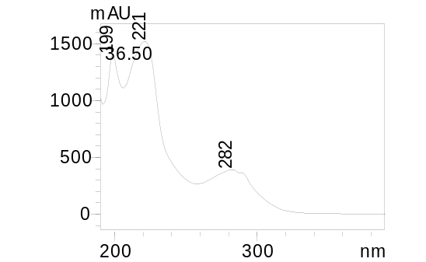
Bacillamide C: yellow solid. LC-ESI-MS, 357.28 [M+H]⁺ (cal. 357.14). ¹H NMR (CDCl₃, 400 MHz): 8.28 (1H, br.s), 7.07 (1H, s), 7.65 (1H, d, J=8.0 Hz), 7.12 (1H, t, J=7.0 Hz), 7.21 (1H, t, J=7.2 Hz), 7.37 (1H, d, J=8.0 Hz), 3.08 (2H, t, J=7.2 Hz), 3.77 (2H, m), 7.41 (1H, br.s), 7.98 (1H, s), 5.04 (1H, m), 1.54 (3H, d, J=7.2 Hz), 6.15 (1H, d, J=8.0 Hz), 2.01 (3H, s). ¹³C NMR (CDCl₃, 100 MHz): 122.1, 113.0, 118.8, 119.4, 122.2, 111.3, 136.4, 127.4, 25.4, 39.8, 160.9, 149.9, 123.0, 172.4, 47.0, 21.4, 169.5, 23.2. UV_{max}: 222 nm, 282 nm.
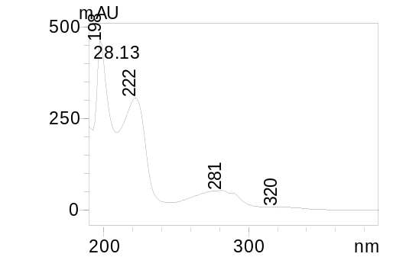

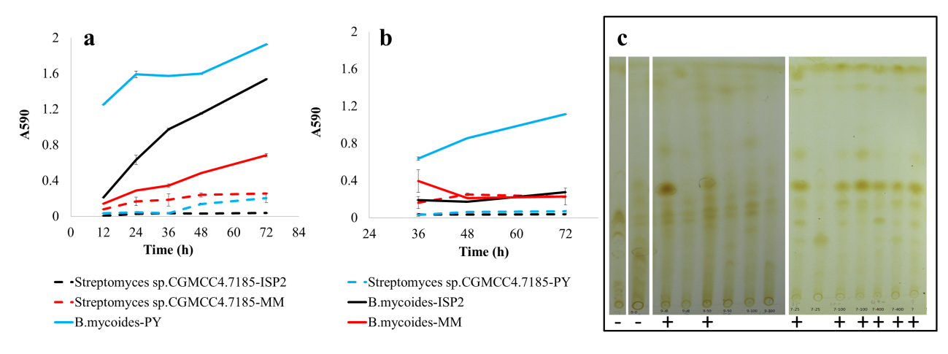
Figure S1. Growth curves of Streptomyces sp. CGMCC4.7185 and B. mycoides in different culture medium under 150 rpm (a) and static (b). TLC analysis results of B. mycoides single culture (first plate), Streptomyces sp. CGMCC4.7185 single culture (second plate), shaken co-culture in ISP2 medium (third plate) and static co-culture in MM medium (last plate), successfully induced samples were marked by cross and treat as a positive control (c).

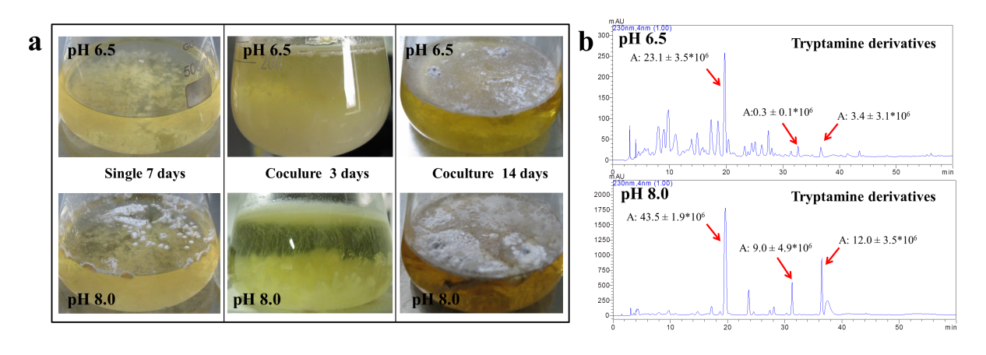
Figure S2. Morphological changes (a) and metabolites HPLC analysis (b) of Streptomyces sp. CGMCC4.7185 and B. mycoides co-culture under initial medium pH value of 6.5 and 8.0.

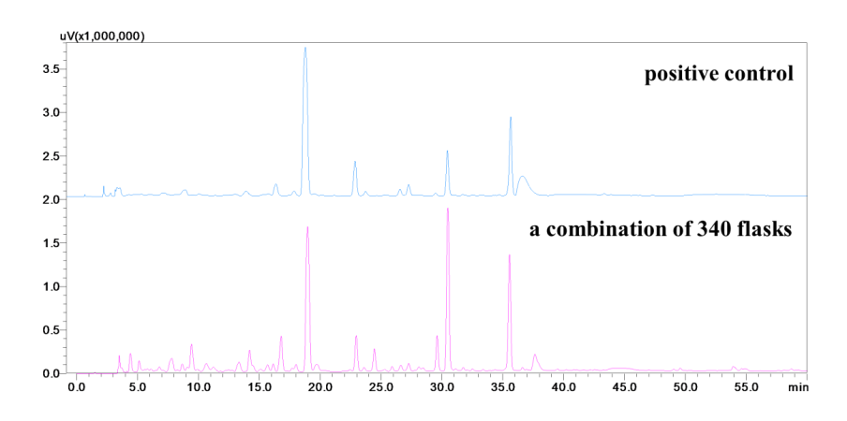
Figure S3. Metabolites comparison of large scale fermentation and the positive control.

