Electronic Supplementary Information

One-Pot, Expeditious Synthesis of 2-Amino-4,6-(disubstituted) nicotinonitriles using Solid Heterogeneous Activated Fuller’s Earth Catalyst
Deelip S. Rekungeª, Anil S. Mali^{b}, and Ganesh U. Chaturbhujª∗

ªDepartment of Pharmaceutical Sciences and Technology, Institute of Chemical Technology, Mumbai, India-400019.
^{b}DKSS’s Institute of Pharmaceutical Science and Research, Swami Chincholi, Pune, India-413130
*Corresponding author. E-mail: gu.chaturbhuj@gmail.com
Table of Contents
Page
- Experimental
  - Materials and methods S2
  - Preparation of Activated Fuller’s earth catalyst S2
  - General procedure for the 2-Amino-4,6-(disubstituted)nicotinonitriles S2
- Spectral data of synthesized compounds S3-S5
- Copies of ¹HNMR spectra of synthesized compounds S6-S13
- Copies of HRMS spectra of 5k, 5q, 5r, 5v, 5w and 5x S14-S16

- Experimental:

1.1. Materials and methods:
All the chemicals and solvents used were of LR grade and purchased from SD fine, Avra Synthesis, and Spectrochem and used as received. The purity determination of the starting materials and the reaction monitoring was accomplished by thin-layer chromatography (TLC) on Merck silica gel G F₂₅₄ plates. Melting points of all the compounds were recorded by the Analab ThermoCal melting point apparatus in the open capillary tube and are uncorrected. ¹H NMR spectra were recorded on an MR400 Agilent Technology. NMR spectrometer using tetramethylsilane as an internal standard and DMSO-d6 or CDCl₃ as a solvent. HRMS was recorded on a Shimadzu LCMS-QTOF-9030 instrument by the direct infusion method. The synthesized compounds were characterized by melting points, compared with the literature values, ¹H NMR and HRMS spectroscopy.

1.2. Preparation of Activated Fuller’s earth catalyst:
Fuller’s earth (commercial) 10 g was stirred with 100 ml of distilled water to separate water-soluble material if any. The suspended solid was filtered, washed with distilled water, and dried in an oven at 100 °C for 1h. In a 250 ml round bottom flask containing 50 ml of 5% HCl solution, added 5 g of solid obtained from the above treatment. The mixture was heated at 100 °C for 4h, cool to room temperature, and filtered; the residue was washed with distilled water till neutrality. The resultant activated fuller's earth was dried at 100 °C till constant weight.

1.3. General procedure for the synthesis of 2-Amino-4,6-(disubstituted)nicotinonitriles:
A mixture of substituted aldehyde (2 mmol), substituted acetophenone (2 mmol), malononitrile (2 mmol), ammonium acetate (2.4 mmol), and Activated Fuller's earth (20 wt %) was heated at 90 °C in an oil bath. The reaction was monitored by thin-layer chromatography. After completion of the reaction, the insoluble product was dissolved in hot ethanol to separate activated Fuller’s earth by filtration and the filtrate was evaporated to get the product. The product was technically pure subject to purification by recrystallization for spectral analysis.

2. Spectral data of ¹H NMR and HRMS spectroscopy of representative compounds:
- ¹H NMR spectra of 2-amino-4,6-diphenylnicotinonitrile (5a):
¹H NMR (400 MHz, DMSO-d₆) δ 8.10 (m, 2H), 7.64 (m, 2H), 7.51-7.45 (m, 6H), 7.24 (s, 1H), 6.98 (s, 2H).

- ¹H NMR spectra of 2-amino-4-(4-methoxyphenyl)-6-phenylnicotinonitrile (5b):
¹H NMR (400 MHz, CDCl₃) δ 7.98-7.96 (m, 2H), 7.59 (d, J = 8.8 Hz, 2H), 7.46-7.44 (m, 3H), 7.17 (s, 1H), 7.02 (d, J = 8.8 Hz, 2H), 5.32 (s, 2H), 3.86 (s, 3H).

- ¹H NMR spectra of 2-amino-4-(4-hydroxyphenyl)-6-phenylnicotinonitrile (5c):
¹H NMR (400 MHz, DMSO-d₆) δ 9.90 (s, 1H), 8.08-8.07 (m, 2H), 7.52 (d, J = 8.4 Hz, 2H), 7.44 (m, 3H), 7.18 (s, 1H), 6.89-6.87 (m, 4H).

- ¹H NMR spectra of 2-amino-4-(4-bromophenyl)-6-phenylnicotinonitrile (5d):
¹H NMR (400 MHz, DMSO-d₆) δ 8.10-8.08 (m, 2H), 7.73 (d, J = 8.4 Hz, 2H), 7.61 (d, J = 8.8 Hz, 2H), 7.46-7.45 (m, 3H), 7.29 (s, 1H), 7.03 (s, 2H).

- ¹H NMR spectra of 2-amino-6-phenyl-4-(p-tolyl)nicotinonitrile (5f):
¹H NMR (400 MHz, CDCl₃) δ 7.97-7.96 (m, 2H), 7.53-7.51 (m, 2H), 7.45 (m, 3H), 7.32-7.30 (m, 2H), 7.17 (s, 1H), 5.40 (s, 2H), 2.42 (s, 3H).

- ¹H NMR spectra of 2-amino-4-(3-nitrophenyl)-6-phenylnicotinonitrile (5i):
¹H NMR (400 MHz, DMSO-d₆) δ 8.47 (s, 1H), 8.36-8.34 (m, 1H), 8.13 (m, 3H), 7.85-7.81 (m, 1H), 7.46 (m, 3H), 7.38 (s, 1H), 7.11 (s, 2H).

- ¹H NMR spectra of 2-amino-4-(2-chlorophenyl)-6-phenylnicotinonitrile (5j):
¹H NMR (400 MHz, CDCl₃) δ 7.98-7.97 (m, 2H), 7.54-7.52 (m, 2H), 7.44-7.37 (m, 6H), 7.14 (s, 1H), 5.33 (s, 2H).

- ¹H NMR spectra of 2-amino-4-(2-nitrophenyl)-6-phenylnicotinonitrile (5k):
¹H NMR (400 MHz, DMSO-d6) δ 8.23 (d, J = 8.2 Hz, 1H), 8.12 – 8.02 (m, 2H), 7.94 – 7.85 (m, 1H), 7.79 (dd, J = 17.7, 9.6 Hz, 1H), 7.64 (d, J = 7.6 Hz, 1H), 7.45 (d, J = 3.1 Hz, 3H), 7.24 (s, 1H), 7.10 (s, 2H). HRMS calculated for C₁₈H₁₂N₄O₂: 316.096026; found: (MH⁺) 317.10234 m/z.

- ¹H NMR spectra of 2-amino-6-(4-methoxyphenyl)-4-phenylnicotinonitrile (5m):
¹H NMR (400 MHz, CDCl₃) δ 8.00-7.44 (m, 2H), 7.61-7.50 (m, 5H), 7.14 (s, 1H), 6.98 (m, 2H), 5.29 (s, 2H), 3.85 (s, 3H).

- ¹H NMR spectra of 2-amino-6-(4-chlorophenyl)-4-phenylnicotinonitrile (5p):
¹H NMR (400 MHz, DMSO-d₆) δ 8.13 (d, J = 8.4 Hz, 2H), 7.65-7.63 (m, 2H), 7.53-7.51 (m, 5H), 7.27 (s, 1H), 7.01 (s, 2H).

- ¹H NMR spectra of 2-amino-6-(3-bromophenyl)-4-phenylnicotinonitrile (5q):
¹H NMR (400 MHz, DMSO-d₆) δ 8.33 (s, 1H), 8.11 (d, J = 8.0 Hz, 1H), 7.65 (m, 3H), 7.52 (d, J = 6.8 Hz, 3H), 7.41 (t, J = 7.6 Hz, 1H), 7.32 (s, 1H), 7.04 (s, 2H). HRMS calculated for C₁₈H₁₂BrN₃: 349.021458; found: (MH⁺) 350.02764 m/z.

- ¹H NMR spectra of 2-amino-4-(3-nitrophenyl)-6-phenylnicotinonitrile (5r)
¹H NMR (400 MHz, DMSO-d₆) δ 8.96 (s, 1H), 8.60 (d, J = 7.8 Hz, 1H), 8.32 (d, J = 8.0 Hz, 1H), 7.78 (t, J = 8.1 Hz, 1H), 7.75 – 7.66 (m, 2H), 7.57 (d, J = 5.1 Hz, 3H), 7.47 (s, 1H), 7.19 (s, 2H). HRMS calculated for C₁₈H₁₂BrN₃: 316.096026; found: (MH⁺) 317.1020 m/z.

- ¹H NMR spectra of 2-amino-6-(4-bromophenyl)-4-(p-tolyl)nicotinonitrile (5u):
¹H NMR (400 MHz, DMSO-d₆) δ 8.04 (m, 2H), 7.66-7.54 (m, 4H), 7.32-7.25 (m, 3H), 6.97 (s, 2H), 2.37 (s, 3H).

- ¹H NMR spectra of 2-amino-6-(3-bromophenyl)-4-(4-methoxyphenyl)nicotinonitrile (5v):
¹H NMR (400 MHz, DMSO-d₆) δ 8.32 (m, 1H), 8.10 (s, 1H), 7.65-7.63 (m, 2H), 7.43-7.41 (m, 1H), 7.08-6.98 (m, 4H), 3.81 (s, 3H). HRMS calculated for C₁₉H₁₄BrN₃O: 379.032023; found: (MH⁺) 382.03616 m/z.

- ¹H NMR spectra of 2-amino-6-(3-bromophenyl)-4-(p-tolyl)nicotinonitrile (5w):
¹H NMR (400 MHz, DMSO-d₆) δ 8.35 (s, 1H), 8.13 (d, J = 7.8 Hz, 1H), 7.67 (d, J = 7.9 Hz, 1H), 7.59 (d, J = 7.9 Hz, 2H), 7.45 (t, J = 7.9 Hz, 1H), 7.36 (d, J = 7.9 Hz, 2H), 7.32 (s, 1H), 7.06 (s, 2H), 2.40 (s, 3H). HRMS calculated for C₁₉H₁₄BrN₃: 363.037108; found: (MH⁺) 364.04324 m/z.

- ¹H NMR spectra of 2-amino-4,6-bis(3-bromophenyl)nicotinonitrile (5x):
¹H NMR (400 MHz, DMSO-d₆) δ 8.34 (s, 1H), 8.13 (d, J = 8.8 Hz, 1H), 7.86 (s, 1H), 7.71 (d, J = 8.0 Hz, 1H), 7.65 (t, J = 7.2 Hz, 2H), 7.50-7.42 (m, 2H), 7.35 (s, 1H), 7.09 (s, 2H). HRMS calculated for C₁₈H₁₁Br₂N₃: 426.931969; found: (MH⁺) 429.3570 m/z.

3. Copies of ¹H spectra of synthesized compounds:
- 2-amino-4,6-diphenylnicotinonitrile (5a):
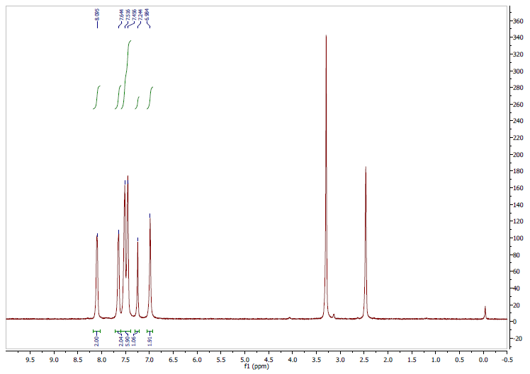
- 2-amino-4-(4-methoxyphenyl)-6-phenylnicotinonitrile (5b):
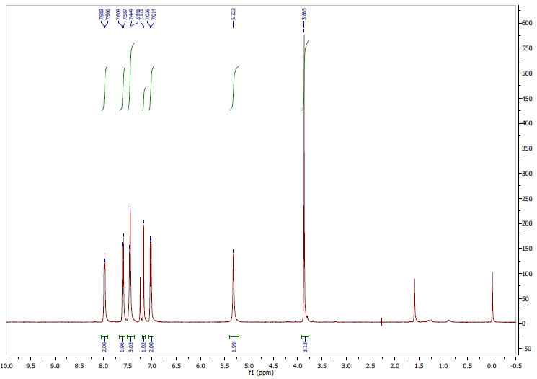
- 2-amino-4-(4-hydroxyphenyl)-6-phenylnicotinonitrile (5c) :
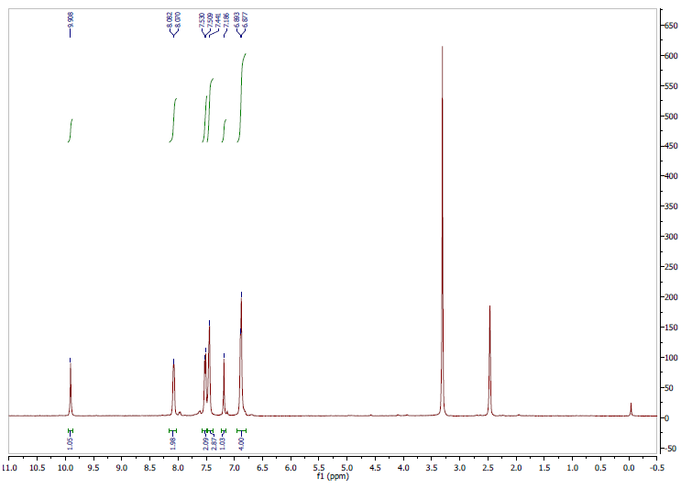
- 2-amino-4-(4-bromophenyl)-6-phenylnicotinonitrile (5d):
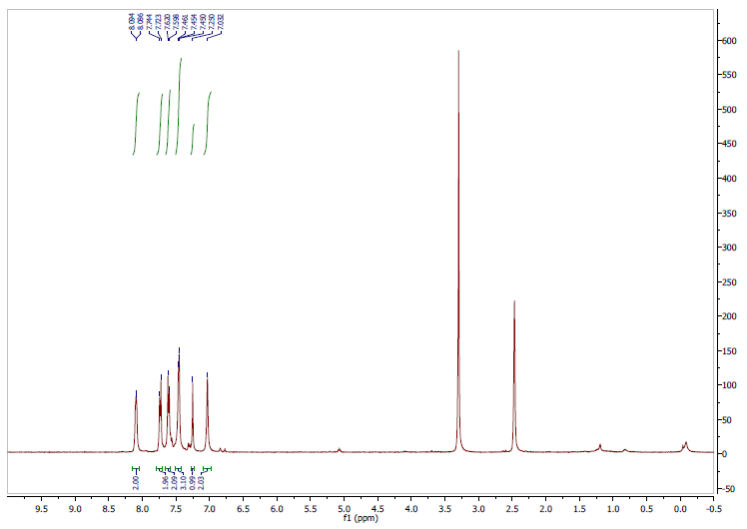

- 2-amino-6-phenyl-4-(p-tolyl)nicotinonitrile (5f):
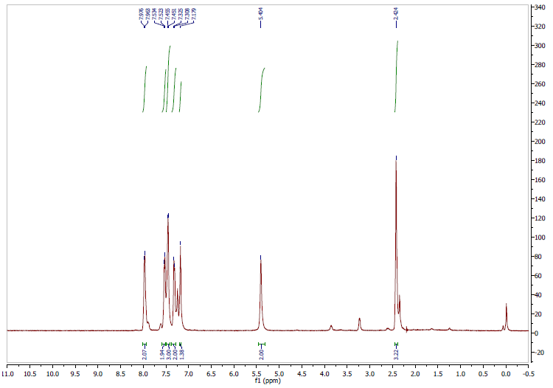

- 2-amino-4-(3-nitrophenyl)-6-phenylnicotinonitrile (5i):
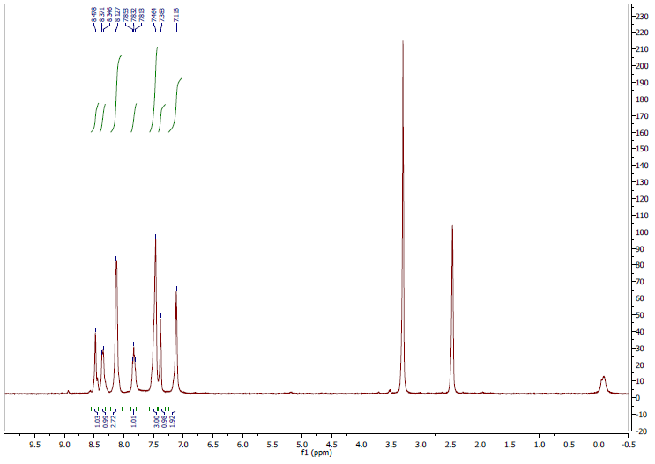

- 2-amino-4-(2-chlorophenyl)-6-phenylnicotinonitrile (5j):
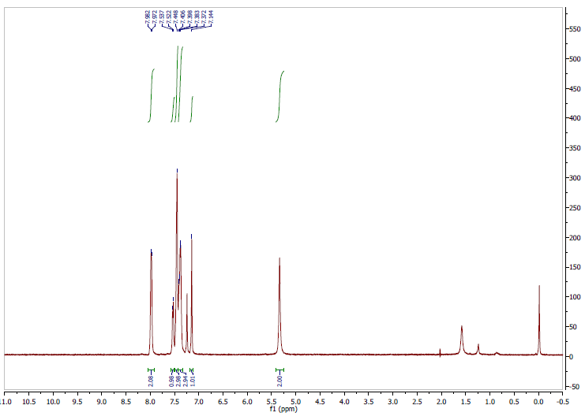
- 2-amino-4-(2-nitrophenyl)-6-phenylnicotinonitrile (5k):

- 2-amino-6-(4-methoxyphenyl)-4-phenylnicotinonitrile (5m):
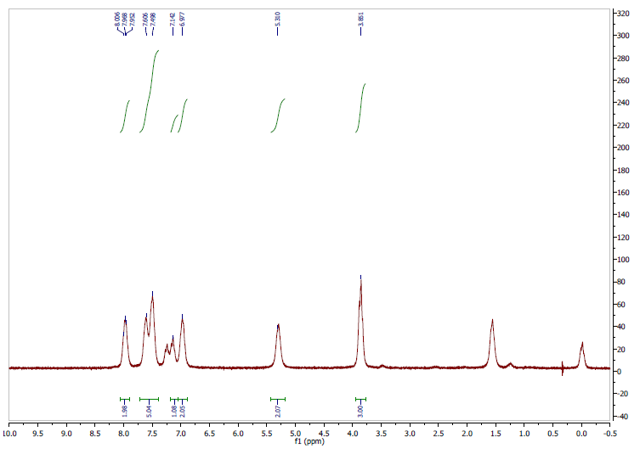
- 2-amino-6-(4-chlorophenyl)-4-phenylnicotinonitrile (5p):
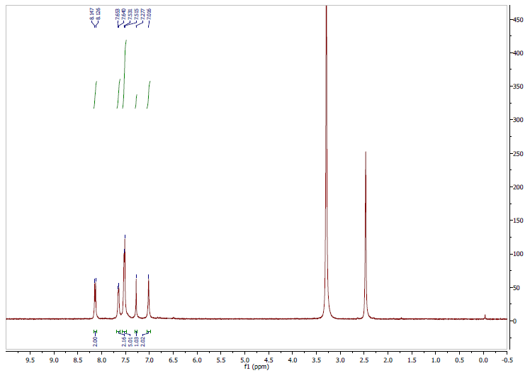
- 2-amino-6-(3-bromophenyl)-4-phenylnicotinonitrile (5q):
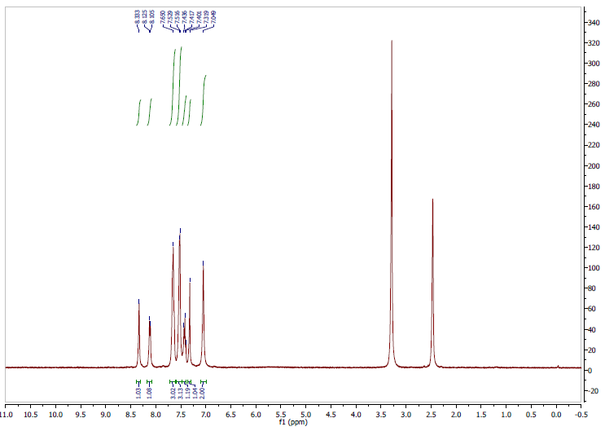

- 2-amino-4-(3-nitrophenyl)-6-phenylnicotinonitrile (5r):

- 2-amino-6-(4-bromophenyl)-4-(p-tolyl)nicotinonitrile (5u):
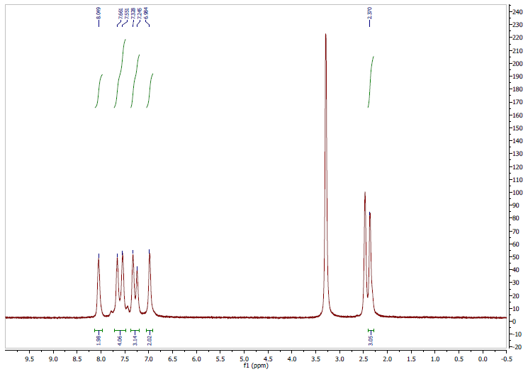
- 2-amino-6-(3-bromophenyl)-4-(4-methoxyphenyl)nicotinonitrile(5v): 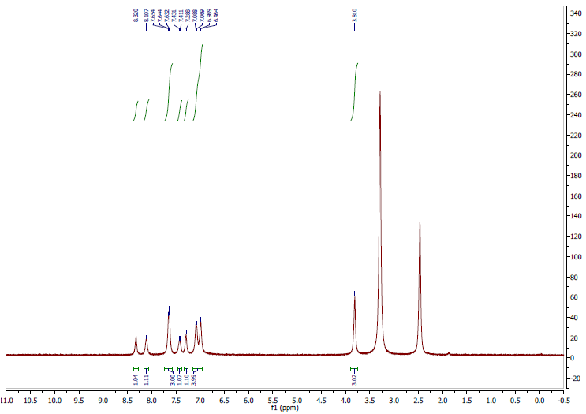

- 2-amino-6-(3-bromophenyl)-4-(p-tolyl)nicotinonitrile (5w):
- 2-amino-4,6-bis(3-bromophenyl)nicotinonitrile (5x):
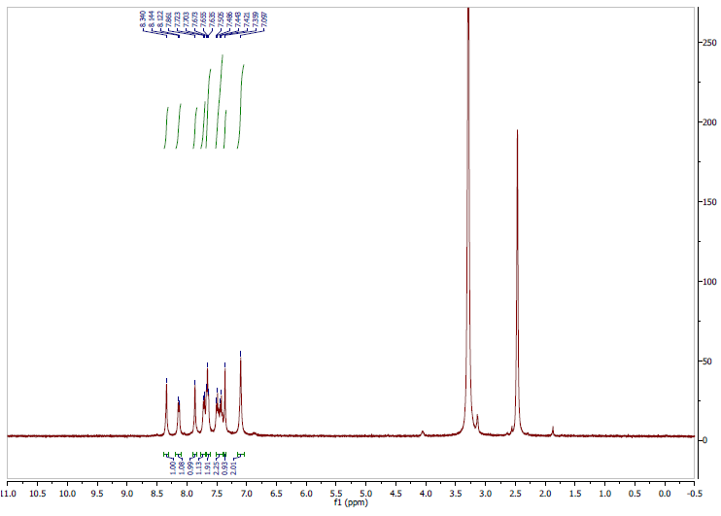
- Copies of HRMS of the synthesized compounds
- HRMS spectra of 2-amino-4-(2-nitrophenyl)-6-phenylnicotinonitrile (5k)
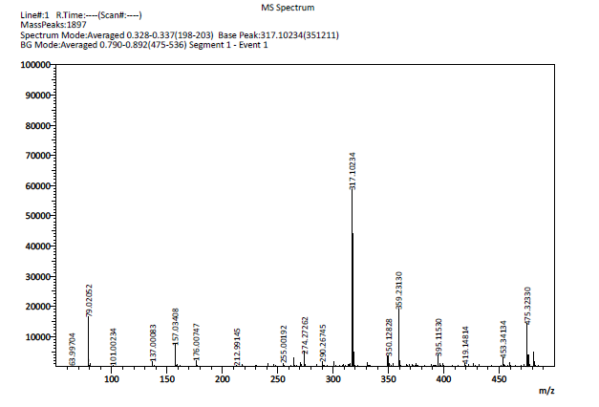
- HRMS spectra of 2-amino-6-(3-bromophenyl)-4-phenylnicotinonitrile (5q):
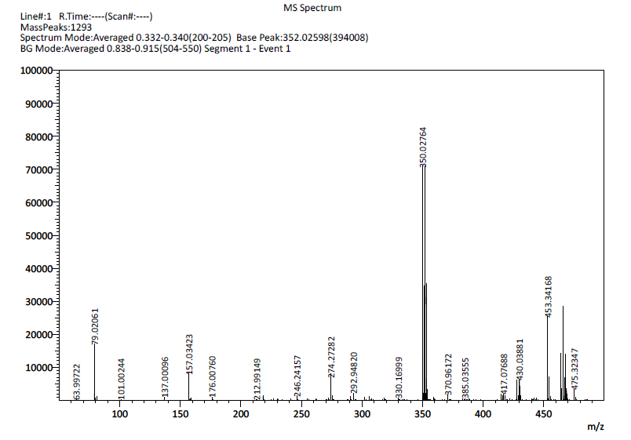
- HRMS spectra of 2-amino-4-(3-nitrophenyl)-6-phenylnicotinonitrile (5r):
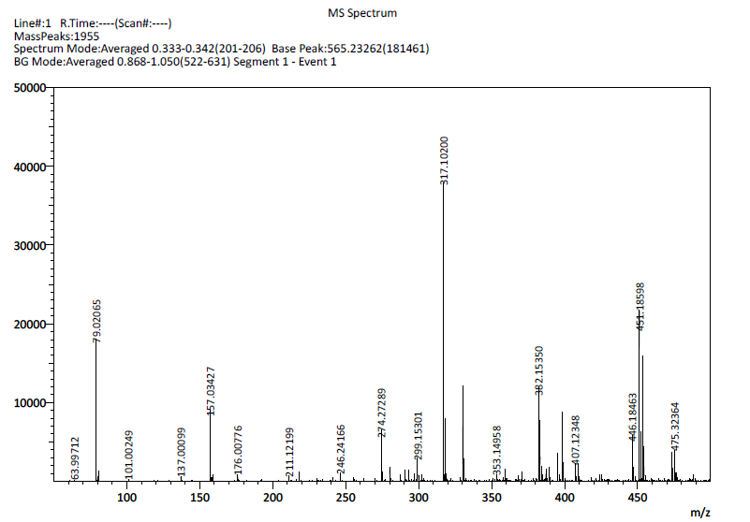
- HRMS spectra of 2-amino-6-(3-bromophenyl)-4-(4-methoxyphenyl)nicotine nitrile (5v):
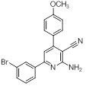
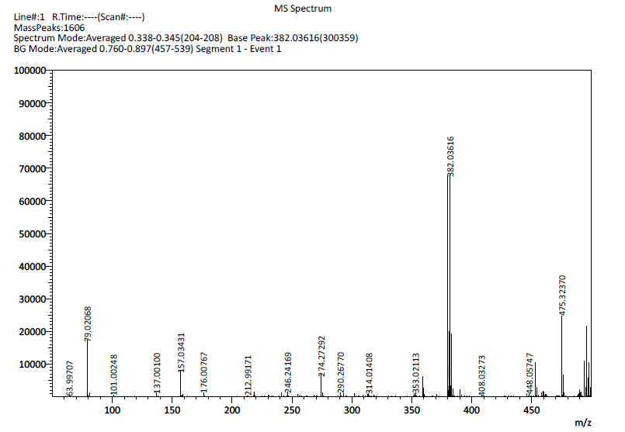
- HRMS spectra of 2-amino-6-(3-bromophenyl)-4-(p-tolyl)nicotinonitrile (5w):
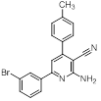
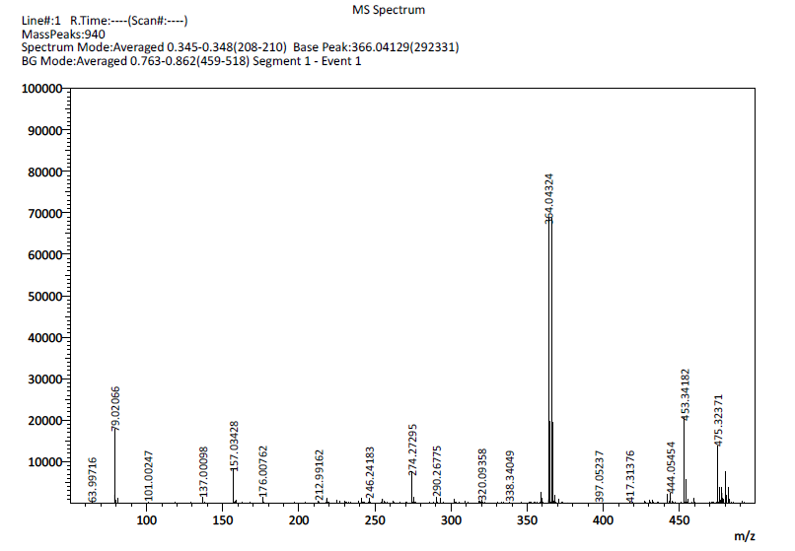
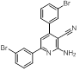
6. HRMS spectra of 2-amino-4,6-bis(3-bromophenyl)nicotinonitrile (5x): 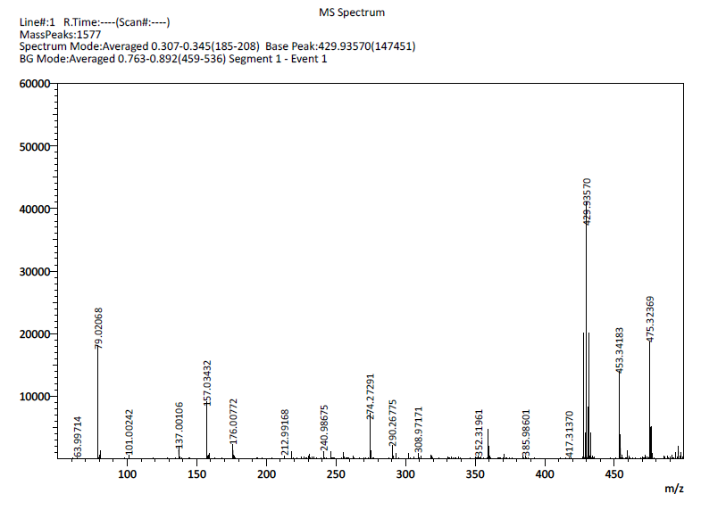

References:
- A. M. Abdollahi, V. N. Sadeghi, A. Moaddeli, A. A. Rezaeipoor, Res. Chem. Intermed. 42, 2867 (2016).
- D. Khalili, Tetrahedron Lett. 57, 1721 (2016).
- M. Mantri, O. de Graaf, van J. Veldhoven, A. Göblyös, J. K. von Frijtag Drabbe Künzel, T. K. Mulder, R. Link, H. de Vries, M. W. Beukers, J. Brussee, A. P. I. Jzerman, J. Med. Chem., 51, 4449 (2008).
- M. Zadpour, F. K. Behbahani, Monatsh. Chem., 146, 1865 (2015).
- G V. R. Ghorbani, S. Z. Toghraei, N. R. Karimi, C. R. Chim., 16, 1111 (2013).

∗ Corresponding author. Tel.: +91-223-361-2212; fax: +91-222-414-5614; e-mail: gu.chaturbhuj@gmail.com

