Supporting Information
Nervione, a new benzofuran derivative from Nervilia concolor
Cong-Luan Tranª, Mai Dinh Tri^{b,c}, Nguyen Tien Trung^{d}, Nhat-Minh Phan^{b,c}, Cam-Tu D. Phan^{d}, Thanh-Nha Tran^{e}, Thanh-Hung Do^{f}, Nguyen-Minh-An Tran^{g}, Thi-Ngoc-Mai Tran^{h}*, Thuc-Huy Duong^{e}*
ªFaculty of Pharmacy and Nursery, Tay Do University, Can Tho, Vietnam
^{b}Graduate University of Science and Technology, Vietnam Academy of Science and Technology, 18 Hoang Quoc Viet, Cau Giay, Ha noi, Vietnam
^{c}Institute of Chemical Technology, Vietnam Academy of Science and Technology, 1A TL29 Street, Thanh Loc ward, District 12, Ho Chi Minh City, Vietnam
^{d}Laboratory of Computational Chemistry and Modelling (LCCM), Quy Nhon University, 55100, Vietnam
^{e}Department of Chemistry, Ho Chi Minh City University of Education, 280 An Duong Vuong Street, District 5, Ho Chi Minh City 748342, Vietnam
^{f}NTT Hi-Tech Institute, Nguyen Tat Thanh University, Ho Chi Minh City 700000, Vietnam
^{g}Faculty of Chemical Engineering, Industrial University of Ho Chi Minh City, Ho Chi Minh City, Vietnam
^{h}Institute of Applied Sciences, Ho Chi Minh City University of Technology (HUTECH), Ho Chi Minh City, Viet Nam
huydt@hcmue.edu.vn
ttn.mai79@hutech.edu.vn
Abstract
A new benzofuran derivative, nervione (1), was isolated from Nervilia concolor (Blume) Schltr. (Orchidaceae). Eight previously-reported compounds were also isolated: 5,7-dimethoxyflavone (2), 3,5,7-trimethoxyflavone (3), 7-methoxyflavone (4), 3,7-dimethoxy-5-hydroxyflavone (5), tetramethylscutellarein (4',5,6,7-tetramethoxyflavone) (6), 5,7-dimethoxy-4'-hydroxyflavone (7), rhamnetin (8), 5,7-dihydroxy-3’,4’-dimethoxyflavone (9). The structures were elucidated by 1D, 2D NMR, and HRESIMS spectroscopy in addition to the literature. The relative configuration of 1 was defined using DP4+ probability while its absolute configuration was defined by comparison of the ECD spectrum of 1 with those of previously reported compounds. All isolated compounds were evaluated for alpha-glucosidase inhibition, revealing weak or no activity.
Keywords. Orchidaceae, Nervilia concolor, benzofuran, flavone, alpha-glucosidase

Table S1. NMR data of Compound 1
 | Compound 1 (CD₃OD) |  | Compound 1 (DMSO-d₆)
No | δ_{H}  ppm, J (Hz) | δ_{C}  ppm | δ_{H}  ppm, J (Hz) | δ_{C}  ppm
1 | - | 170.9 | - | 167.4
3 | 5.39 d (5.0) | 84.7 | 5.33 dd (1.0, 4.5) | 82.4
3a | - | 147.6 | - | 145.7
4 | 7.42 s | 101.1 | 7.45 t (0.5) | 99.8
5 | - | 162.6 | - | 160.0
6 | - | 119.0 | - | 117.6
7 | - | 155.6 | - | 152.6
7a | - | 110.1 | - | 108.9
8 | 4.07 m | 70.3 | 3.96 m | 67.9
9 | 1.23 d (6.5) | 17.8 | 1.06 d (6.5) | 17.9
10 | 7.30 d (2.5) | 106.9 | 7.37 dd (1.0, 2.5) | 105.9
11 | 7.86 d (2.5) | 147.2 | 8.07 d (2.5) | 145.9
12 | 4.35 s | 60.8 | 4.25 s | 60.2
8-OH |  |  | 5.24 d (5.5)

Table S2. Alpha-glucosidase inhibitory activity of 1-9
Compound | IC₅₀ (μg/mL)
1 | >300
2 | >300
3 | >300
4 | >300
6 | >300
7 | 155
8 | 210
9 | >300
Acarbose  (positive control) | 214

Table S3. ¹ H NMR data of Compound 2-9
No | 2 (DMSO-d₆)  δ_{H}  ppm, J (Hz) | 3 (DMSO-d₆)  δ_{H}  ppm, J (Hz) | 4 (CDCl₃)  δ_{H}  ppm, J (Hz) | 5 (Acetone-d₆)  δ_{H}  ppm, J (Hz) | 6 (DMSO-d₆)  δ_{H}  ppm, J (Hz) | 7 (CDCl₃)  δ_{H}  ppm, J (Hz) | 8 (DMSO-d₆)  δ_{H}  ppm, J (Hz) | 9 (DMSO-d₆)  δ_{H}  ppm, J (Hz)
2 | - | - | - | - | - | - | - | -
3 | 6.69 s | - | 6.67 s | - | 6.71 s | 6.58 s | - | 6.95 s
4 | - | - | - | - | - | - | - | -
4a | - | - | - | - | - | - | - | -
5 | - | - | - | - | - | - | - | -
6 | 6.41 d (2.5) | 6.49 d (2.0) | 6.38 d (2.5) | 6.35 d (2.5) | - | 6.40 d (2.0) | 6.34 s | 6.02 d (1.5)
7 | - | - | - | - | - | - | - | -
8 | 6.73 d (2.5) | 6.74 d (2.0) | 6.51 d (2.5) | 6.68 d (2.0) | 7.21 s | 6.60 d (2.0) | 6.69 s | 6.52 d (1.5)
8a | - | - | - | - | - | - | - | -
1’ | - | - | - | - | - | - | - | -
2’ | 7.96 dd (1.5, 7.5) | 8.01 d (7.0) | 7.89 dd (1.5, 8.0) | 8.11 dd (1.5, 7.5) | 8.02 d (9.0) | 7.78 d (9.0) | 7.72 s | 7.56 s
3’ | 7.50 m | 7.55 m | 7.54 m | 7.59 m | 7.11 d (9.0) | 6.94 d (9.0) | - | -
4’ | 7.50 m | 7.55 m | 7.54 m | 7.59 m | - | - | - | -
5’ | 7.50 m | 7.55 m | 7.54 m | 7.59 m | 7.11 d (9.0) | 6.94 d (9.0) | 6.89 d (8.5) | 7.12 d (8.5)
6’ | 7.96 dd (1.5, 7.5) | 8.01 d (7.0) | 7.89 dd (1.5, 8.0) | 8.11 dd (1.5, 7.5) | 8.02 d (9.0) | 7.78 d (9.0) | 7.57 d (8.0) | 7.67 dd (1.0, 8.0)
5-OMe | - | 3.87 s | - | - | 3.80 s | 3.92 s |  | -
6-OMe |  |  | - | - | 3.77 s | - |  | -
7-OMe | - | 3.89 s | 3.87 s | 3.92 s | 3.95 s | 3.95 s | 3.86 s | -
3-OMe | - | 3.78 s | - | 3.90 s | - | - |  | -
3’-OMe |  |  |  |  |  |  |  | 3.88 s
4’-OMe |  |  |  |  | 3.86 s |  |  | 3.85 s
5-OH |  |  | 12.72 s | 12.64 s |  |  | 12.47 s | 12.92 s

Table S4. ¹³ C NMR data of Compound 2-9
NO | 2 (DMSO-d₆)  δ_{C}  ppm | 3 (DMSO-d₆)  δ_{C}  ppm | 4 (CDCl₃)  δ_{C}  ppm | 5 (Acetone-d₆)  δ_{C}  ppm | 6 (DMSO-d₆)  δ_{C}  ppm | 7 (CDCl₃&CD₃OD)  δ_{C}  ppm | 8 (DMSO-d₆)  δ_{C}  ppm | 9 (DMSO-d₆)  δ_{C}  ppm
2 | 159.4 | 151.3 | 162.3 | 156.6 | 160.3 | 162.1 | 147.3 | 163.3
3 | 108.1 | 140.8 | 131.4 | 140.4 | 106.1 | 106.3 | 136.0 | 103.8
4 | 175.5 | 171.8 | 182.5 | 179.8 | 175.6 | - | 175.9 | 181.8
4a | 108.3 | 108.6 | 105.9 | 106.8 | 106.1 | 106.3 | 104.0 | 103.7
5 | 160.2 | 160.3 | 164.0 | 162.9 | 151.5 | 160.7 | 160.4 | 161.4
6 | 96.1 | 95.8 | 98.2 | 98.6 | 139.7 | 96.1 | 97.4 | 98.8
7 | 163.6 | 163.5 | 165.7 | 166.8 | 157.4 | 164.3 | 164.9 | 164.2
8 | 93.2 | 92.9 | 92.7 | 92.9 | 97.3 | 92.9 | 91.9 | 94.1
8a | 159.1 | 158.0 | 157.8 | 157.9 | 153.9 | 160.4 | 156.1 | 157.3
1’ | 131.2 | 130.2 | 131.8 | 131.5 | 123.0 | 122.2 | 121.9 | 122.9
2’ | 125.7 | 128.2 | 126.3 | 129.2 | 127.8 | 127.9 | 115.2 | 109.4
3’ | 128.8 | 128.6 | 129.1 | 129.5 | 123.0 | 115.9 | 145.1 | 149.0
4’ | 130.8 | 130.0 | 131.8 | 131.8 | 161.8 | 159.9 | 147.8 | 152.1
5’ | 128.8 | 128.6 | 129.1 | 129.5 | 123.0 | 115.9 | 115.6 | 111.7
6’ | 125.7 | 128.2 | 126.3 | 129.2 | 127.8 | 127.9 | 120.0 | 120.0
5-OMe |  | 55.9 |  |  | 61.8 | 55.7
6-OMe |  |  |  |  | 60.9
7-OMe |  | 55.6 | 55.8 | 56.5 | 56.4 | 56.0 | 56.0
3-OMe |  | 59.1 |  | 60.5
3’-OMe |  |  |  |  | 55.5 |  |  | 55.7
4’-OMe |  |  |  |  |  |  |  | 55.8

Figure S1. Key HMBC correlations of 1
Figure S2. Two possible isomers of 1

Figure S3. The biosynthetic formation of nervione from coriandrone E

Figure S4. Two possible diasteroisomers of 1

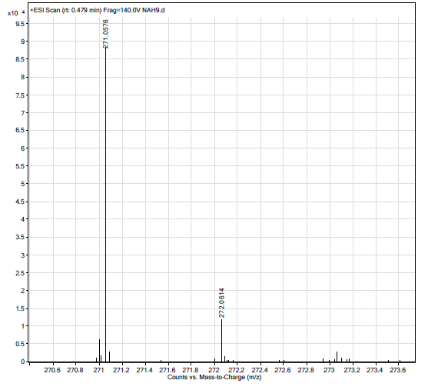
Figure S5. HRESIMS spectrum of compound 1.

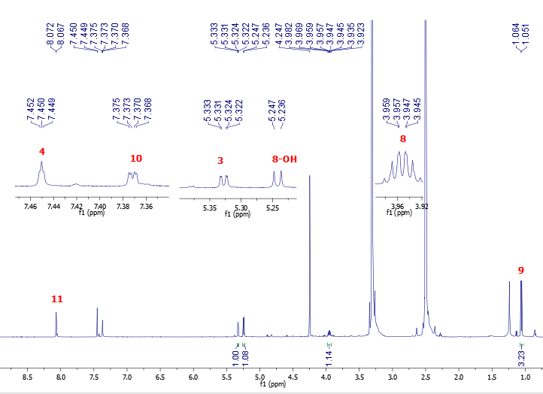
Figure S6: The ¹H NMR spectrum of 1 in DMSO-d₆
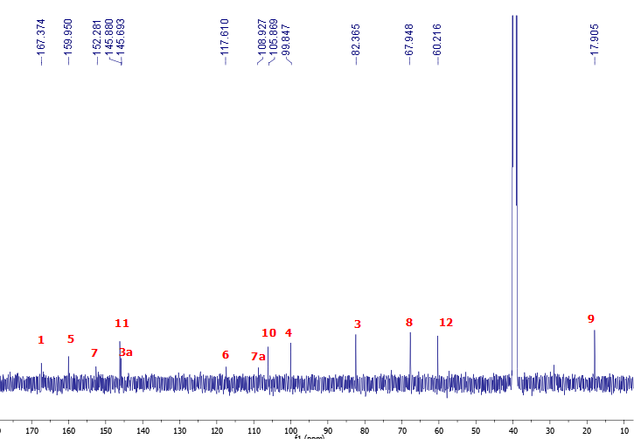
Figure S7: The ¹³C NMR spectrum of 1 in DMSO-d₆
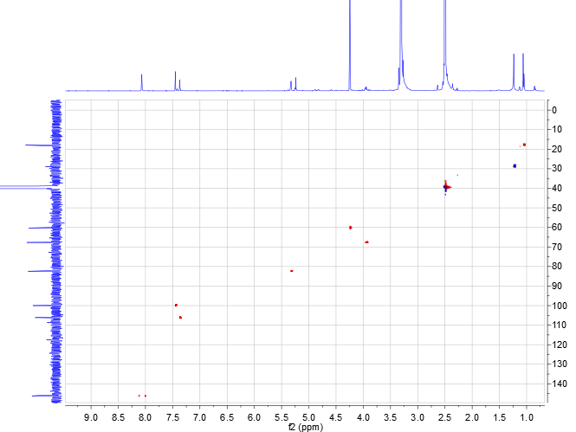
Figure S8: The HSQC spectrum of 1 in DMSO-d₆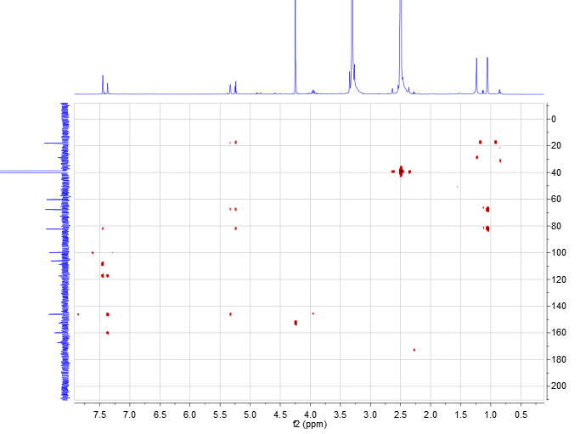
Figure S9: The HMBC spectrum of 1 in DMSO-d₆
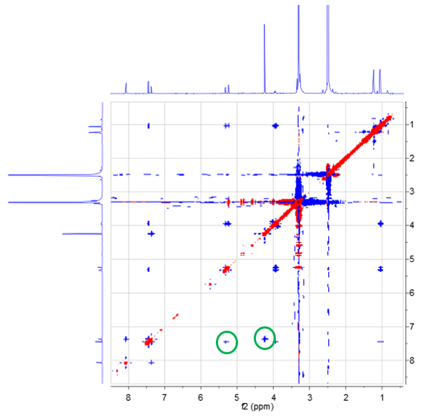 Figure S10: The NOESY spectrum of 1 in DMSO-d₆

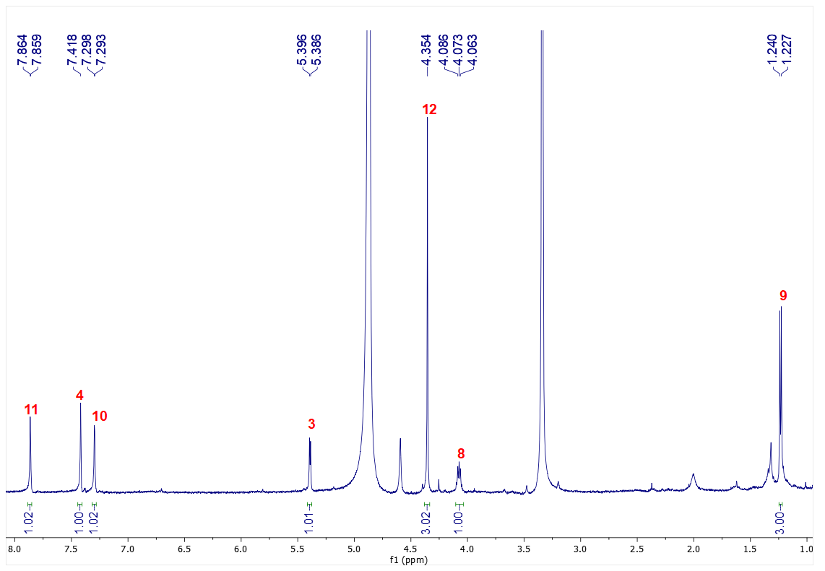Figure S11: The ¹H NMR spectrum of 1 in CD₃OD
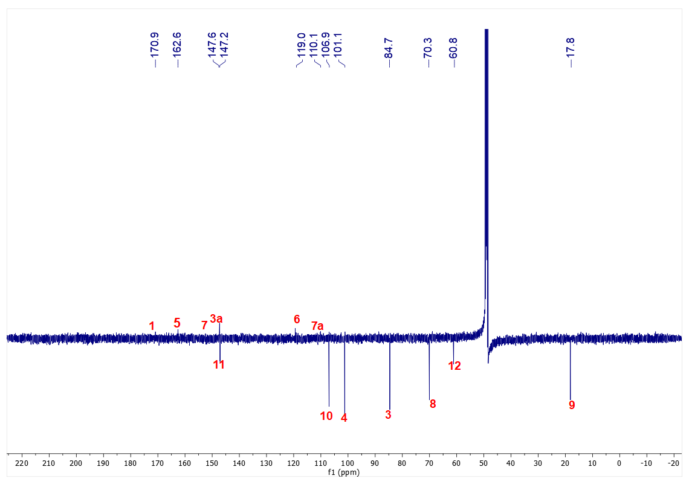 Figure S12: The ¹³C NMR spectrum of 1 in CD₃OD
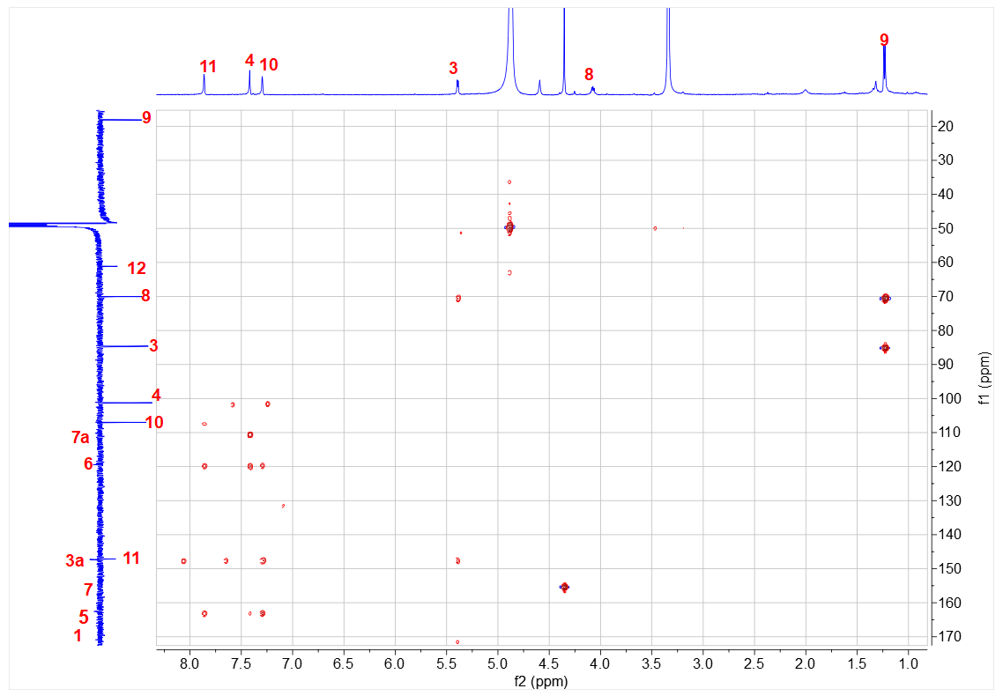
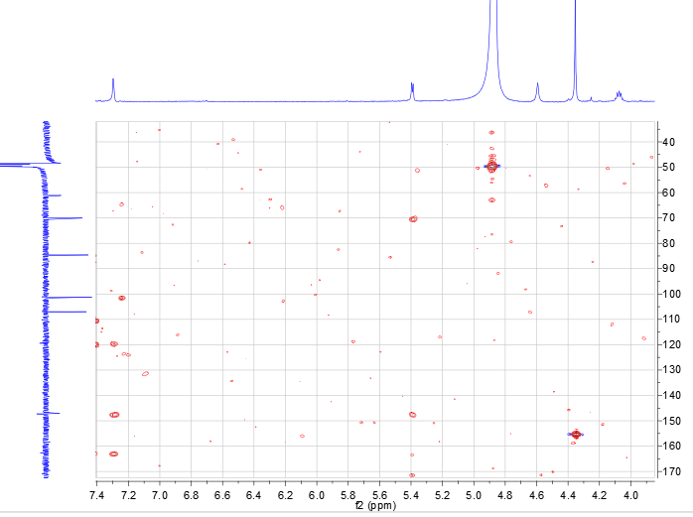 Figure S13: The HMBC spectrum of 1 in CD₃OD

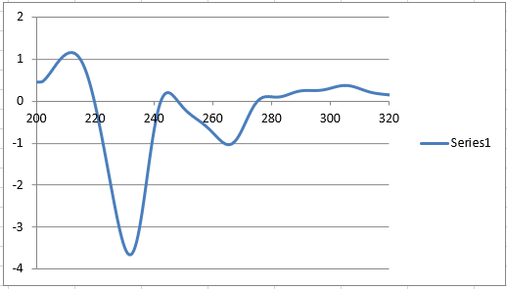
Figure S14: The electronic circular dichroism (ECD) spectroscopy of 1

DP4+ results
For isomers (S-R and S-S)
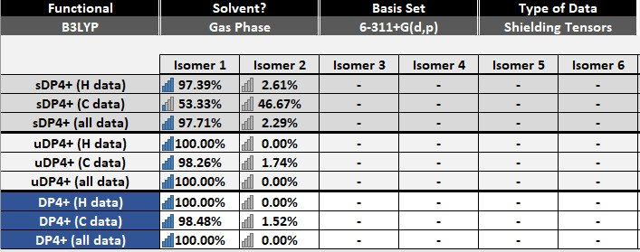

Gaussian Coordinates
Isomer 1 (anti)
1a (14.3%)
O -2.71123300 -2.23561700 -0.18137300
C -2.14644200 -0.07077500 0.15952700
C -1.67770900 -1.35097400 -0.17608200
C -1.26256900 1.02401400 0.20751300
C -0.35195800 -1.64940300 -0.47970100
C 0.09030300 0.73753100 -0.05665400
C 0.50494700 -0.56831300 -0.39994300
H -0.03452800 -2.64827900 -0.74855100
O -1.81875100 2.20865400 0.52983100
C -1.37909900 3.42995000 -0.09907200
H -0.45054200 3.78461300 0.34046500
H -1.24502600 3.26912000 -1.17236100
H -2.18826400 4.13948900 0.06681500
C 1.99394000 -0.55182300 -0.61420100
H 2.25765700 -0.74648400 -1.65837500
C 1.30539400 1.57791500 0.04464200
O 1.45876200 2.71527600 0.40437500
O 2.38167000 0.80931100 -0.32799300
C 2.82816900 -1.50338000 0.26496600
H 2.53141900 -2.52301600 0.00005700
O 4.19841800 -1.41258100 -0.11476100
H 4.49426400 -0.50962800 0.05438500
C 2.64078900 -1.28856600 1.76517500
H 2.93979500 -0.27805400 2.05603400
H 1.60002400 -1.43796000 2.06319000
H 3.26287300 -2.00030300 2.31055100
C -3.56617200 -0.21412000 0.36566900
H -4.26676800 0.55671300 0.64033500
C -3.84094300 -1.52000500 0.15378400
H -4.75015800 -2.09573400 0.19636000
1b (15.1%)
O 2.62732300 2.30354200 -0.06753400
C 2.11558500 0.11354900 0.18526800
C 1.61849300 1.39200300 -0.11464100
C 1.26142600 -1.00538200 0.17573700
C 0.29135700 1.66552600 -0.43512100
C -0.09317300 -0.74582000 -0.10599700
C -0.53711100 0.55970900 -0.41135500
H -0.04759800 2.66459500 -0.67545700
O 1.84231000 -2.18648800 0.46673800
C 1.45673800 -3.39071700 -0.22739000
H 2.27646200 -4.08756300 -0.05970800
H 0.52166700 -3.78516400 0.16174700
H 1.35932200 -3.18808900 -1.29761000
C -2.02051800 0.50999000 -0.65781300
H -2.26784500 0.73318400 -1.70030500
C -1.28569000 -1.62239600 -0.06029000
O -1.41342700 -2.77634900 0.25391000
O -2.37573200 -0.87034400 -0.42633900
C -2.89895500 1.40756400 0.23479400
H -2.62641200 2.44346700 0.01014700
O -4.25819800 1.29121600 -0.17604100
H -4.53181000 0.37555300 -0.04129500
C -2.73498300 1.14740600 1.73061400
H -1.70565200 1.31870600 2.05528600
H -3.39000600 1.82052100 2.28635500
H -3.00762700 0.11867400 1.98066900
C 3.52651100 0.28727200 0.42541600
H 4.24239400 -0.47398200 0.68707400
C 3.76945600 1.60677200 0.26536800
H 4.66153300 2.20467500 0.34695400
1c (13.5%)
O 2.70944500 2.29971400 0.05775300
C 2.15010800 0.10784500 -0.01146800
C 1.67711100 1.42716500 -0.09530400
C 1.26261200 -0.97916300 -0.12605700
C 0.34219300 1.77368000 -0.28624400
C -0.08712700 -0.65234400 -0.35879000
C -0.51021800 0.69397700 -0.41479200
H 0.01727500 2.80426100 -0.34458600
O 1.82419800 -2.20103700 -0.03307200
C 1.14588700 -3.27986100 0.64192900
H 1.92253500 -4.01393800 0.85064000
H 0.71815200 -2.92011600 1.58202200
H 0.36386800 -3.70334200 0.01733300
C -1.99050900 0.71628900 -0.67764900
H -2.22855700 1.21276500 -1.62312200
C -1.25893400 -1.49947800 -0.68007800
O -1.36399100 -2.68728500 -0.83617800
O -2.34686500 -0.67405300 -0.83548300
C -2.87497800 1.34490800 0.41643300
H -2.59878100 2.40206000 0.47939100
O -4.23133800 1.34720800 -0.01967700
H -4.50262100 0.43113600 -0.15645100
C -2.72271800 0.69527500 1.78998700
H -1.69682100 0.77692100 2.15784100
H -3.38577000 1.19444000 2.49859200
H -2.99360800 -0.36330600 1.75429100
C 3.57098400 0.21369300 0.20884300
H 4.27581000 -0.59333200 0.32019300
C 3.84381300 1.53676300 0.23661800
H 4.75461300 2.09655600 0.36704600
1d (4.3%)
O -2.54121500 -2.39302800 -0.07135600
C -2.15626200 -0.16245200 -0.05235300
C -1.57445500 -1.43730500 -0.15144700
C -1.35283900 0.99147600 -0.08671000
C -0.21001900 -1.67457100 -0.28704800
C 0.02682400 0.77762400 -0.26178100
C 0.55997400 -0.52836500 -0.34410700
H 0.21033500 -2.66853500 -0.33402000
O -2.00750700 2.16838000 0.01391500
C -1.46831900 3.24084600 0.81217800
H -1.10808700 2.84926100 1.76793000
H -0.66141200 3.75050600 0.29151200
H -2.30697000 3.91339800 0.98629800
C 2.05046100 -0.41703200 -0.53992400
H 2.35815500 -0.84091500 -1.50391600
C 1.13792000 1.72812900 -0.47985300
O 1.15493100 2.92651500 -0.58158600
O 2.29911300 1.00034300 -0.59988700
C 2.91229800 -1.04913000 0.57342400
H 2.53340300 -0.69793100 1.53734600
O 2.69648700 -2.46371000 0.57180700
H 3.32053000 -2.86880000 -0.04046300
C 4.38797300 -0.69812500 0.43699500
H 4.53496600 0.38213300 0.46854200
H 4.95600600 -1.15690200 1.24945500
H 4.78785000 -1.06230200 -0.51703500
C -3.57238400 -0.38675600 0.09804200
H -4.34413300 0.35798300 0.19950500
C -3.73863300 -1.72765800 0.07552900
1e (9.9%)
O -2.38919700 -2.49245900 -0.14862500
C -2.11889900 -0.26331500 0.13831600
C -1.47521500 -1.48258100 -0.13093000
C -1.38264600 0.93395100 0.19009500
C -0.11059700 -1.62163400 -0.36504300
C 0.00510500 0.81370900 -0.00827200
C 0.59871800 -0.43770600 -0.28862200
H 0.35846100 -2.57293700 -0.56901400
O -2.09224500 2.05152300 0.45882500
C -1.81441600 3.27942500 -0.24362500
H -0.91884500 3.75897500 0.14365300
H -1.69952200 3.07841700 -1.31277600
H -2.69228100 3.90320900 -0.08176600
C 2.08273700 -0.22657800 -0.45483400
H 2.39931700 -0.41099400 -1.48763300
C 1.09373600 1.80658400 0.11245100
O 1.08348600 2.96787700 0.42668000
O 2.27866500 1.17205800 -0.17648300
C 2.98560800 -1.04844600 0.47849300
H 2.61627400 -0.92349700 1.50548300
O 2.80548800 -2.40564100 0.05694800
H 3.37425100 -2.97215600 0.58742700
C 4.44676800 -0.62188600 0.39719300
H 4.56232600 0.42066900 0.69743500
H 5.05718200 -1.23853600 1.06472300
H 4.82446900 -0.74040200 -0.62202300
C -3.51719700 -0.58085200 0.28782700
H -4.32193800 0.10187600 0.50421000
C -3.61381900 -1.91711700 0.11054800
H -4.44478800 -2.60204500 0.13313000
1f (6.1%)
O -2.57400900 -2.36637900 -0.16835300
C -2.14837700 -0.14865800 -0.03254900
C -1.59270700 -1.42494100 -0.20840300
C -1.32633100 0.99519300 -0.03454300
C -0.23270200 -1.67613200 -0.37933200
C 0.04673600 0.76910000 -0.24444300
C 0.55818900 -0.54100400 -0.38341100
H 0.15529400 -2.67307000 -0.53906100
O -1.96563300 2.16898900 0.13159100
C -1.36098800 3.24827100 0.87250900
H -0.87842700 2.85835200 1.77293200
H -0.63322700 3.78048400 0.26583300
H -2.18971900 3.89695600 1.15210300
C 2.04925800 -0.44719800 -0.57269100
H 2.37370800 -0.92281400 -1.50337500
C 1.16346700 1.70799500 -0.50179200
O 1.18678100 2.90663900 -0.59799200
O 2.30390300 0.96698600 -0.68813600
C 2.89647300 -1.00182000 0.59839400
H 2.63145200 -0.42681700 1.49581700
O 2.61539000 -2.38679100 0.79929800
H 1.75833500 -2.47134800 1.23006200
C 4.38562200 -0.87186200 0.32511800
H 4.66382600 -1.48195300 -0.53877700
H 4.64935500 0.16736700 0.12338700
H 4.95314600 -1.22324100 1.18877000
C -3.56624800 -0.35509500 0.12491300
H -4.32246200 0.39696800 0.27664800
C -3.75818800 -1.68947800 0.03157000
H -4.63661600 -2.31068800 0.08061400
1g (4.2%)
O -2.80655900 -2.03961700 -0.10398400
C -2.08167300 0.10246400 -0.01528800
C -1.70933300 -1.23912600 -0.19259300
C -1.11182800 1.12070100 -0.05901200
C -0.40442500 -1.67448600 -0.40522900
C 0.20840200 0.70561500 -0.31382700
C 0.53552500 -0.66186700 -0.44972500
H -0.16778400 -2.72066500 -0.53911000
O -1.57135400 2.37746400 0.11059700
C -0.81897600 3.33704000 0.88065100
H 0.00735000 3.74125200 0.30160100
H -1.53467700 4.11633800 1.13804700
H -0.44224100 2.86775300 1.79384000
C 2.01389200 -0.77187200 -0.72325600
H 2.20498400 -1.25931800 -1.68541100
C 1.42602500 1.48655200 -0.61503300
O 1.61251000 2.67127300 -0.70924200
O 2.45267000 0.59898100 -0.84330400
C 2.90831600 -1.43809400 0.34755100
H 3.93334400 -1.35454900 -0.03898600
O 2.81296600 -0.75989800 1.59344700
H 3.15971600 0.13203800 1.47787400
C 2.58506200 -2.90294700 0.59382600
H 1.61117000 -3.00681500 1.07539000
H 2.58627700 -3.47102000 -0.34060200
H 3.33660900 -3.33351600 1.25750600
C -3.50770400 0.09005500 0.19606500
H -4.14965600 0.93839500 0.36542400
C -3.88029700 -1.20706000 0.12902800
H -4.83176200 -1.70350000 0.21974300
1h (4.1%)
O -2.88183300 -1.93390500 -0.07705000
C -2.07656000 0.17968700 -0.00034100
C -1.75482700 -1.17613600 -0.16794900
C -1.06886300 1.16023600 -0.04831100
C -0.46671900 -1.66188100 -0.37416900
C 0.23531100 0.69390400 -0.29685200
C 0.51094000 -0.68580800 -0.42273100
H -0.26927600 -2.71704100 -0.50082500
O -1.48093800 2.43454800 0.11176400
C -0.69432200 3.37029400 0.87685700
H -1.38105400 4.17682800 1.12925700
H -0.33547300 2.89278300 1.79296400
H 0.14656000 3.74062600 0.29608400
C 1.98489200 -0.85301700 -0.69157900
H 2.15992100 -1.35496900 -1.64930900
C 1.48196500 1.42652200 -0.60082700
O 1.71296500 2.60274400 -0.70269800
O 2.47482700 0.49945400 -0.82127700
C 2.85120400 -1.54342900 0.38708700
H 3.87945800 -1.50216000 0.00235700
O 2.77893200 -0.85120600 1.62683400
H 3.16194600 0.02491500 1.50500400
C 2.47226600 -2.99277600 0.64524200
H 1.49424900 -3.05548700 1.12552900
H 2.45365800 -3.56869400 -0.28419200
H 3.20569400 -3.44572800 1.31427200
C -3.50245300 0.22275200 0.20744600
H -4.11210900 1.09594000 0.36968100
C -3.92379600 -1.05972500 0.14780100
H -4.89361500 -1.51914900 0.23918100
1i (3.9%)
O 2.43828500 2.43859700 -0.26139400
C 2.11512100 0.23524100 0.13982500
C 1.50374900 1.45127600 -0.20197500
C 1.35535300 -0.94715900 0.22185500
C 0.14502600 1.60350000 -0.46741100
C -0.02723700 -0.81031500 -0.00381100
C -0.59419300 0.44002200 -0.33849900
H -0.27926200 2.54880400 -0.77663700
O 2.04638400 -2.06180700 0.53557600
C 1.75293500 -3.32164200 -0.10339300
H 0.85881700 -3.77539300 0.31571600
H 1.62617100 -3.17217200 -1.17930800
H 2.63011800 -3.94037700 0.07915800
C -2.08205400 0.25925700 -0.49273900
H -2.41905300 0.49806500 -1.50651300
C -1.13431500 -1.79007200 0.08695000
O -1.14763400 -2.94562100 0.42108100
O -2.29336800 -1.15021000 -0.27371100
C -2.95773400 1.03182300 0.52490200
H -2.67982000 0.68176500 1.52753400
O -2.72898300 2.43677600 0.41221600
H -1.90952500 2.65597700 0.86708600
C -4.43894200 0.78831800 0.28696500
H -5.02572800 1.29998500 1.05199700
H -4.73205200 1.18305000 -0.68993600
H -4.66322200 -0.27877900 0.31939300
C 3.51809000 0.52967500 0.29217800
H 4.30419100 -0.15849000 0.55471700
C 3.64740300 1.85209300 0.04626100
H 4.49228700 2.52003400 0.04494900
1j (2.3%)
O 2.57005600 2.24814100 -0.19587800
C 2.04905800 0.07615800 0.16769500
C 1.55493200 1.34139000 -0.18487400
C 1.18765700 -1.03498300 0.21286000
C 0.22622200 1.61042700 -0.49958500
C -0.16768700 -0.77742000 -0.06394600
C -0.61623000 0.51814200 -0.40776300
H -0.10000100 2.59941500 -0.78726800
O 1.76371600 -2.20926000 0.54465900
C 1.38821400 -3.43162900 -0.12131000
H 0.45335100 -3.82186300 0.27272800
H 1.29532000 -3.25717200 -1.19702100
H 2.21041700 -4.12032400 0.06752500
C -2.10469100 0.45734700 -0.64775100
H -2.34757800 0.67787000 -1.69330200
C -1.35131900 -1.65913600 -0.00534600
O -1.47889500 -2.80423700 0.34104300
O -2.44342100 -0.92678400 -0.40832000
C -3.03631800 1.29538200 0.25805200
H -4.05446600 1.02392800 -0.05328900
O -2.85407500 0.96821600 1.62878400
H -3.11130900 0.04805000 1.75761500
C -2.85898800 2.79898800 0.11598500
H -2.90948700 3.10776600 -0.93185100
H -3.65358800 3.30957800 0.66251900
H -1.90504900 3.11705400 0.53940600
C 3.46409800 0.25165800 0.38031100
H 4.17899600 -0.50074600 0.66885700
C 3.71222000 1.56061100 0.15451800
H 4.60877400 2.15594100 0.19659600
1k (3.9%)
O 2.42532700 2.45405700 -0.26909800
C 2.11708800 0.24760300 0.12684200
C 1.49691600 1.46107700 -0.20813600
C 1.36466200 -0.93948600 0.20888800
C 0.13605200 1.60613700 -0.46649900
C -0.01982000 -0.81004800 -0.00953700
C -0.59571600 0.43795900 -0.33759300
H -0.29522100 2.54988300 -0.77078100
O 2.06376600 -2.05104500 0.51562700
C 1.77431600 -3.31061900 -0.12566000
H 1.64075300 -3.15858400 -1.20038800
H 2.65615000 -3.92467100 0.05016800
H 0.88522500 -3.77099400 0.29689200
C -2.08321700 0.24898600 -0.48517900
H -2.42649000 0.48869700 -1.49663700
C -1.12073500 -1.79649500 0.08376200
O -1.12571200 -2.95309000 0.41447700
O -2.28527200 -1.16230400 -0.26915300
C -2.95849900 1.01361500 0.53876400
H -2.67332500 0.66296800 1.53915200
O -2.73902500 2.42023800 0.42825700
H -1.91885800 2.64350800 0.87984700
C -4.43933800 0.76136900 0.30773300
H -5.02546700 1.26779100 1.07674600
H -4.73983300 1.15619300 -0.66688900
H -4.65672300 -0.30718100 0.33906700
C 3.51906200 0.54982100 0.27313900
H 4.31049500 -0.13450700 0.52963000
C 3.63938100 1.87373200 0.03071400
H 4.48030900 2.54663900 0.02731400
1l (9.7%)
O -2.42130800 -2.45807800 -0.13663100
C -2.12791400 -0.24145900 0.21678700
C -1.49849300 -1.45675600 -0.09993200
C -1.38077300 0.94747600 0.29611500
C -0.13841400 -1.59947900 -0.35707100
C 0.00308300 0.82219200 0.07511400
C 0.58216700 -0.42448800 -0.25272600
H 0.31940800 -2.54774800 -0.59733200
O -2.07687100 2.06179200 0.60993600
C -1.79906600 3.30849300 -0.05871500
H -1.70489100 3.14002800 -1.13551700
H -2.66773800 3.93510700 0.13801900
H -0.89218000 3.76724100 0.32749300
C 2.06578800 -0.22043700 -0.43114800
H 2.36813300 -0.37521400 -1.47303000
C 1.10160000 1.80189100 0.21247200
O 1.10528000 2.95279500 0.56300700
O 2.27720100 1.16713200 -0.11187700
C 2.97265400 -1.07851200 0.46504300
H 2.61578800 -0.98356100 1.49963300
O 2.77695700 -2.42013400 0.00262400
H 3.34668400 -3.00770700 0.50860500
C 4.43617200 -0.66076900 0.38079600
H 4.56332800 0.37083200 0.71253700
H 5.04887200 -1.30298700 1.02158600
H 4.80175600 -0.74978200 -0.64582100
C -3.52665100 -0.55215100 0.37603600
H -4.32232600 0.12996300 0.62537100
C -3.63722200 -1.88127800 0.15804300
H -4.47363400 -2.55980300 0.17087200
1m (2.3%)
O -2.20936500 -2.55447000 -0.42498600
C -1.99701700 -0.35297800 0.05401400
C -1.32807500 -1.52027000 -0.34480300
C -1.29712800 0.86140300 0.17301000
C 0.03046300 -1.59025000 -0.63832000
C 0.08576600 0.80483200 -0.08227100
C 0.71329500 -0.39926300 -0.47531400
H 0.49402300 -2.51045700 -0.96348200
O -2.03578600 1.92748700 0.54585700
C -1.81946600 3.22256900 -0.04965900
H -1.70092200 3.12005800 -1.13213000
H -2.72494200 3.78746700 0.16683100
H -0.94485800 3.70871200 0.37467300
C 2.18312000 -0.12549800 -0.67698100
H 2.47256400 -0.26094200 -1.72512500
C 1.13675200 1.83532100 0.04401700
O 1.10110600 2.96887200 0.44594400
O 2.32506700 1.27906500 -0.36774700
C 3.20417600 -0.87033300 0.21346200
H 4.18055700 -0.44574000 -0.05767000
O 2.94975100 -0.63882800 1.59225100
H 3.07769100 0.29989900 1.77071500
C 3.24182600 -2.37516900 -0.00250500
H 2.33448700 -2.84388700 0.38134500
H 3.35423800 -2.62175300 -1.06198700
H 4.09003700 -2.79676200 0.53931100
C -3.37877200 -0.72900000 0.22092700
H -4.19515300 -0.09564200 0.52566900
C -3.44145600 -2.04641000 -0.07285800
H -4.24896300 -2.75902300 -0.08263900
1n (4.3%)
O -2.75638800 -2.08272800 -0.23653100
C -2.05054100 0.05921000 -0.04698800
C -1.66292000 -1.27263000 -0.26160800
C -1.08727000 1.08427200 -0.02351600
C -0.34890000 -1.69172900 -0.44930900
C 0.24299300 0.68714300 -0.25301400
C 0.58446300 -0.67218800 -0.42835900
H -0.10086800 -2.73088000 -0.61396800
O -1.55996200 2.33145100 0.17823500
C -0.84000300 3.26266300 1.01156300
H -1.56855400 4.02787700 1.27512100
H -0.49222100 2.75862900 1.91770400
H 0.00326200 3.69376400 0.47798600
C 2.07120400 -0.76241400 -0.65974400
H 2.29586900 -1.21608200 -1.63108500
C 1.46264300 1.48669800 -0.48975200
O 1.64229300 2.67534200 -0.53501000
O 2.50224700 0.61493200 -0.72059600
C 2.93742600 -1.45734100 0.41617700
H 3.97332400 -1.35311600 0.06534200
O 2.79705400 -0.82189900 1.68022800
H 3.14296500 0.07477200 1.60648600
C 2.61905900 -2.93192400 0.60329500
H 1.63085300 -3.05903400 1.04876100
H 2.65575400 -3.46855200 -0.34883100
H 3.35222700 -3.37857700 1.27682600
C -3.48229700 0.02996100 0.11946200
H -4.13550900 0.86738800 0.29974000
C -3.84294200 -1.26611000 -0.00676400
H -4.79304000 -1.77152800 0.03604800
Isomer 2 (syn)
2a (11.4%)
O -2.77424000 -2.26437400 0.02422000
C -2.17805900 -0.08150600 0.08351800
C -1.72518600 -1.40860300 0.16088500
C -1.27030800 0.98911200 0.18067900
C -0.39372500 -1.77683300 0.33024500
C 0.07651400 0.63877800 0.39236200
C 0.47867800 -0.71234000 0.44305500
H -0.08559200 -2.81321200 0.37632300
O -1.80732400 2.22381700 0.09441800
C -1.13110700 3.26899400 -0.63373200
H -1.89375400 4.02426300 -0.81727500
H -0.30672700 3.67889300 -0.05580800
H -0.76289100 2.87948700 -1.58705400
C 1.26610400 1.46638900 0.68451600
O 1.39955000 2.65325800 0.82559600
C -3.60357900 -0.16443300 -0.11588100
H -4.29646900 0.65398800 -0.21873300
C -3.89829100 -1.48278800 -0.13892000
H -4.81987300 -2.02751000 -0.25682900
C 1.96284400 -0.76045700 0.68709700
H 2.19119200 -1.26009100 1.63495000
O 2.34588100 0.62251700 0.82841200
C 2.80628700 -1.40040300 -0.43496200
H 2.40301000 -2.40248700 -0.61054500
O 2.62316300 -0.70754700 -1.66242700
H 3.01038800 0.17119600 -1.56875800
C 4.28191800 -1.50280900 -0.05245600
H 4.41471500 -2.11518300 0.84416700
H 4.84316800 -1.95986700 -0.86954300
H 4.69992300 -0.51265800 0.14910000
2b (1.4%)
O 2.59108800 2.30750200 0.19028600
C 2.09137600 0.10261500 0.09907800
C 1.58105500 1.39899400 0.26723600
C 1.23348000 -1.01369100 0.13675200
C 0.23470200 1.69639300 0.46608100
C -0.12697200 -0.73981400 0.37206700
C -0.59156900 0.58803200 0.50478100
H -0.11699100 2.70754700 0.61943700
O 1.83171700 -2.21041700 -0.02331700
C 1.18147100 -3.27777000 -0.74212000
H 1.98314500 -3.96151100 -1.01711200
H 0.43898500 -3.77272200 -0.12190300
H 0.70718500 -2.88447200 -1.64556400
C -1.27097900 -1.63785800 0.65581200
O -1.33428500 -2.83469800 0.75888700
C 3.51142200 0.26082600 -0.09292200
H 4.23960700 -0.51751000 -0.24920300
C 3.74808100 1.58949300 -0.02514500
H 4.64471900 2.18096900 -0.10350500
C -2.07755200 0.54618800 0.74119000
H -2.34420500 1.02040500 1.68977400
O -2.38272500 -0.85724500 0.85316300
C -2.97132800 1.16963500 -0.36017100
H -4.00409100 1.00407300 -0.04293400
O -2.79805200 2.58719500 -0.35310600
H -2.04574200 2.80665100 -0.91350500
C -2.76916000 0.57185300 -1.74658800
H -2.95290700 -0.50436200 -1.73790000
H -3.46832000 1.03199900 -2.44806100
H -1.75043400 0.74338300 -2.10954700
2c (12.3%)
O 2.71265200 2.29619300 0.07901400
C 2.14275200 0.12382600 -0.20126100
C 1.67914700 1.41173800 0.11157800
C 1.25719100 -0.96968600 -0.21207200
C 0.35893700 1.71800400 0.42884200
C -0.09042600 -0.67540700 0.06844100
C -0.49909900 0.63715100 0.38835900
H 0.04547100 2.72524300 0.66937200
O 1.80478500 -2.16318400 -0.51968400
C 1.37434000 -3.36659400 0.14689600
H 0.43490000 -3.72786000 -0.26362500
H 2.17625200 -4.08430600 -0.01964700
H 1.26478100 -3.18028000 1.21904200
C -1.30663600 -1.51224100 -0.00430100
O -1.47248900 -2.65381900 -0.34463900
C 3.55887500 0.26219700 -0.43436200
H 4.25491300 -0.51464900 -0.70365200
C 3.83664700 1.57269700 -0.25824900
H 4.74470800 2.14725200 -0.33072000
C -1.98430000 0.62694700 0.63607700
H -2.21030000 0.83385300 1.68833800
O -2.38044100 -0.73352600 0.36778800
C -2.82066500 1.56831500 -0.25360600
H -2.41280000 2.57635200 -0.12982100
O -2.63560500 1.26155900 -1.62837800
H -3.00631700 0.38584400 -1.79263400
C -4.29717000 1.56492800 0.13970000
H -4.72124900 0.56132500 0.04820900
H -4.43015700 1.89614400 1.17385600
H -4.85280000 2.24013400 -0.51361200
2d (1.3%)
O 2.72641900 2.09066500 0.10226900
C 2.06090400 -0.06999100 0.01028400
C 1.65267300 1.25999500 0.19420800
C 1.12232100 -1.11904600 0.05929800
C 0.33654500 1.65671200 0.41994200
C -0.20914600 -0.74498000 0.32213900
C -0.56986400 0.61337100 0.46939300
H 0.06523300 2.69060500 0.58460200
O 1.62631500 -2.35609600 -0.11811100
C 0.88296600 -3.36897700 -0.82537100
H 1.62342000 -4.11567500 -1.10798700
H 0.11069100 -3.80060000 -0.19443000
H 0.43121100 -2.94033000 -1.72435400
C -1.41229300 -1.55546900 0.62524800
O -1.56428200 -2.74460700 0.72523900
C 3.48498700 -0.01738900 -0.20816100
H 4.14957600 -0.84714800 -0.38220200
C 3.82196600 1.28937400 -0.13874000
H 4.75886200 1.81244100 -0.23129600
C -2.05033900 0.68248900 0.73261300
H -2.26418000 1.17314400 1.68615100
O -2.45751800 -0.69428900 0.84844700
C -2.91302200 1.37381400 -0.35332400
H -3.94922700 1.29439700 -0.01479400
O -2.62474000 2.77228500 -0.35695700
H -1.86286700 2.92592800 -0.92634300
C -2.78865100 0.75638700 -1.74037400
H -3.06320600 -0.30019600 -1.72280300
H -3.45916300 1.27227800 -2.43092300
H -1.76604200 0.83902100 -2.12296400
2e (25.7%)
O -2.64169300 -2.34798200 0.12187500
C -2.18255000 -0.13408400 0.03679300
C -1.64553200 -1.42290900 0.17808100
C -1.34106400 0.99393500 0.05761300
C -0.28967300 -1.70015900 0.33160700
C 0.02901800 0.73923800 0.25503900
C 0.52243300 -0.58182800 0.35861300
H 0.07784900 -2.71088000 0.44207900
O -1.95693000 2.18488000 -0.07715500
C -1.34816700 3.25320000 -0.83089900
H -2.16882700 3.92190900 -1.08614300
H -0.59322200 3.76699200 -0.24163100
H -0.89934300 2.85585800 -1.74544300
C 1.15412000 1.65935300 0.52841000
O 1.19613600 2.85551800 0.64306100
C -3.60451700 -0.31488900 -0.11571000
H -4.35003400 0.45207800 -0.24396700
C -3.81633800 -1.64800100 -0.05304700
H -4.70474600 -2.25409100 -0.11089600
C 2.01418600 -0.51561000 0.55878800
H 2.33325100 -0.99951600 1.48720800
O 2.28572000 0.89876300 0.70555900
C 2.89807100 -1.02440400 -0.59839000
H 2.55973000 -0.52185000 -1.51637900
O 4.25393400 -0.68351500 -0.33164200
H 4.29133500 0.26136000 -0.13838800
C 2.84777400 -2.53202300 -0.78805700
H 1.86171600 -2.86199600 -1.11871000
H 3.57625900 -2.81672400 -1.54921800
H 3.11052100 -3.04849100 0.13932800
2f (4.2%)
O -2.43557000 -2.45241400 0.20123300
C -2.08300600 -0.21742600 0.12896900
C -1.48404200 -1.48052100 0.26919400
C -1.29905900 0.95074300 0.14841400
C -0.11811000 -1.69236600 0.43082300
C 0.08171900 0.76353700 0.34603500
C 0.63145300 -0.53199800 0.46556100
H 0.31983300 -2.67609300 0.52252300
O -1.97397000 2.11215800 0.01245600
C -1.43347900 3.18866600 -0.77895900
H -2.28144200 3.83907000 -0.98861400
H -0.65623600 3.72232000 -0.23780100
H -1.03164700 2.79605800 -1.71755900
C 1.17819000 1.73334900 0.56445800
O 1.17634300 2.93399300 0.64012100
C -3.49358500 -0.46686500 -0.03384500
H -4.27471000 0.26346500 -0.16420700
C -3.64065800 -1.80906300 0.02141700
H -4.49876700 -2.45663700 -0.04496000
C 2.11444900 -0.39485200 0.68990700
H 2.40228400 -0.80047600 1.66461000
O 2.34545500 1.02466000 0.72254000
C 3.04194600 -1.02651100 -0.36316200
H 4.05885800 -0.70229400 -0.10644600
O 2.91636800 -2.43772400 -0.15215000
H 3.46492200 -2.89817600 -0.79462500
C 2.73289000 -0.62496900 -1.80003000
H 2.80716500 0.45859500 -1.91937000
H 3.45756700 -1.08008900 -2.48239900
H 1.73185000 -0.94914200 -2.09249300
2g (1.1%)
O 2.55180400 2.16552900 0.07072900
C 1.99150500 -0.00467100 -0.24194500
C 1.52729300 1.27077200 0.11598100
C 1.11958100 -1.10986700 -0.23125100
C 0.21646700 1.55695800 0.48903400
C -0.22027100 -0.83642100 0.10184100
C -0.63598000 0.46785400 0.45162100
H -0.09128200 2.54477900 0.80282300
O 1.67297500 -2.29220300 -0.56932900
C 1.30401700 -3.50656600 0.11619200
H 2.11215300 -4.20546800 -0.09417300
H 1.24681700 -3.32392900 1.19284000
H 0.35233200 -3.88717600 -0.24528500
C -1.42133300 -1.70309700 0.11157200
O -1.57328400 -2.85387800 -0.20480500
C 3.39802600 0.15194600 -0.51744900
H 4.09177100 -0.61261600 -0.82509900
C 3.67035500 1.46057000 -0.31949000
H 4.57099700 2.04473900 -0.40646800
C -2.11431500 0.43109200 0.73701400
H -2.32736300 0.69398100 1.77716500
O -2.48241600 -0.94839300 0.54472000
C -3.02164100 1.30749600 -0.16353400
H -4.04731600 1.10480000 0.15566500
O -2.79324800 2.68423000 0.14162400
H -2.10261500 3.01662700 -0.44142100
C -2.89304100 1.01749500 -1.65318400
H -3.60274800 1.63441200 -2.20872700
H -1.88357700 1.23672800 -2.01623600
H -3.11219000 -0.03037400 -1.86684500
2h (3.6%)
O 2.67400100 2.13286800 0.05075600
C 2.06613000 -0.04785300 0.03136700
C 1.61911400 1.27821800 0.15789500
C 1.15405400 -1.11731900 0.09202200
C 0.29088300 1.64902800 0.34396900
C -0.19118700 -0.76846800 0.31490000
C -0.58606700 0.58358700 0.41889800
H -0.02781300 2.67845800 0.42551800
O 1.68712000 -2.35194000 -0.03158600
C 1.01295100 -3.36776600 -0.80056500
H 1.76855900 -4.12947900 -0.98697100
H 0.16976100 -3.78044500 -0.25232600
H 0.67228700 -2.94915400 -1.75222100
C -1.38510300 -1.60166700 0.58083700
O -1.51877800 -2.79302700 0.68160100
C 3.49212000 0.03498300 -0.16480200
H 4.18131300 -0.78256400 -0.29575400
C 3.79308000 1.35212800 -0.14013200
H 4.71804600 1.89542200 -0.23694300
C -2.06871000 0.62191900 0.68014100
H -2.28437100 1.07962800 1.65036800
O -2.45874500 -0.76083300 0.75379700
C -2.94457900 1.33096000 -0.36801600
H -3.98503700 1.13423000 -0.07840500
O -2.65034700 2.72247500 -0.19958900
H -3.15847000 3.22777800 -0.84160900
C -2.72245900 0.86061100 -1.80011700
H -2.92347500 -0.20977400 -1.88798800
H -3.40834100 1.37933700 -2.47717500
H -1.69925600 1.06027000 -2.12537000
2i (1.9%)
O -2.53274400 -2.31680800 0.13138900
C -2.08020700 -0.09933400 0.08511700
C -1.53984000 -1.38927700 0.21819500
C -1.24433900 1.03167800 0.12163200
C -0.18641600 -1.66363800 0.39079300
C 0.12444600 0.78064300 0.33122600
C 0.61493900 -0.53895900 0.44555300
H 0.20249000 -2.66901600 0.46869600
O -1.86316500 2.22432100 -0.00990700
C -1.27478000 3.27277600 -0.80564300
H -0.90951400 2.86187600 -1.75133900
H -2.08829800 3.96990200 -1.00078700
H -0.46200500 3.76077600 -0.27355900
C 1.26035100 1.70024400 0.56261600
O 1.31073900 2.89924000 0.64458500
C -3.49884400 -0.28376400 -0.09360100
H -4.24517800 0.48200800 -0.22435300
C -3.70616400 -1.61846600 -0.05354200
H -4.59143300 -2.22646800 -0.13546400
C 2.10057100 -0.46897700 0.68237300
H 2.35576800 -0.87797200 1.66730500
O 2.39445400 0.93954100 0.72479800
C 3.01056600 -1.15040300 -0.36513800
H 4.03716500 -0.84388100 -0.13026100
O 2.88052200 -2.57200300 -0.23851600
H 3.38652000 -2.86907600 0.52463700
C 2.69378100 -0.77996100 -1.80346500
H 1.69800000 -1.13018100 -2.08291600
H 2.74158200 0.30261200 -1.93929500
H 3.42211600 -1.24510100 -2.47011100
2j (14.9%)
O -2.45848600 -2.47333300 0.22579500
C -2.12714700 -0.26344800 -0.13040000
C -1.52125200 -1.48732900 0.19229100
C -1.36135800 0.91543400 -0.18957100
C -0.16539000 -1.64951300 0.46193400
C 0.01903200 0.76804100 0.04288100
C 0.58167400 -0.49000800 0.36037900
H 0.24923700 -2.60994600 0.73300800
O -2.04221500 2.03993900 -0.49128500
C -1.75474000 3.28308100 0.18188000
H -2.63015400 3.90673700 0.00768300
H -1.63711200 3.10663700 1.25476700
H -0.85761800 3.74752000 -0.21882000
C 1.12393000 1.74755400 -0.03450300
O 1.14341600 2.90456900 -0.36184600
C -3.52950500 -0.55119300 -0.29917700
H -4.31187700 0.14364300 -0.55516700
C -3.66367700 -1.87776300 -0.07954000
H -4.51018100 -2.54341000 -0.09777900
C 2.06809100 -0.31326700 0.54346800
H 2.39200700 -0.53673900 1.56520300
O 2.28120300 1.10297000 0.33042400
C 2.99694900 -1.04854700 -0.44601500
H 2.64927300 -0.81210600 -1.46211000
O 4.32743400 -0.57537000 -0.26701200
H 4.31072100 0.38793600 -0.32523500
C 3.03640400 -2.55615100 -0.25237000
H 3.29128400 -2.80981400 0.78034000
H 2.08559100 -3.02114700 -0.51554800
H 3.80915700 -2.97220800 -0.90114100
2k (3.1%)
O 2.81843500 2.18730100 0.10226000
C 2.15362100 0.02527800 0.03349300
C 1.74451600 1.35733200 0.19759100
C 1.21342800 -1.02403900 0.07604200
C 0.42519600 1.75513300 0.40331700
C -0.11954300 -0.64829500 0.32703000
C -0.47755100 0.70996000 0.46664100
H 0.14951300 2.79467800 0.52509500
O 1.71852200 -2.25853500 -0.10574300
C 0.96503300 -3.28359800 -0.78565900
H 1.70864700 -4.00971500 -1.11056200
H 0.23501000 -3.73758900 -0.12130800
H 0.45702000 -2.85978900 -1.65579600
C -1.33615800 -1.45269300 0.60315300
O -1.49125600 -2.64020500 0.70939000
C 3.57887200 0.07559700 -0.17692200
H 4.24423100 -0.75628800 -0.33732200
C 3.91562600 1.38313500 -0.12116700
H 4.85314000 1.90505200 -0.21380100
C -1.96426400 0.78570600 0.70122700
H -2.19714500 1.26550300 1.65837400
O -2.37881500 -0.58685700 0.80164600
C -2.74743300 1.51610700 -0.41053800
H -2.44271200 2.57249800 -0.35071400
O -2.44947600 0.99781300 -1.70197100
H -1.51145900 1.12417100 -1.88375400
C -4.25287100 1.41397800 -0.21860000
H -4.76185400 1.97604900 -1.00342200
H -4.56826800 0.37114000 -0.27130000
H -4.54866400 1.82169400 0.75157000
2l (14.8%)
O -2.38022400 -2.50538600 0.34263700
C -2.07535700 -0.30934100 -0.10983700
C -1.45628900 -1.50872400 0.27401300
C -1.32522000 0.87646400 -0.21463000
C -0.10127900 -1.63948900 0.56412500
C 0.05461900 0.75921800 0.03801500
C 0.63088300 -0.47531900 0.41762700
H 0.32367000 -2.58099600 0.88170500
O -2.01861900 1.97609500 -0.57380800
C -1.75308700 3.25393900 0.04084800
H -0.85940700 3.71114000 -0.37553100
H -2.63568700 3.85614200 -0.16896200
H -1.64086200 3.13095500 1.12173100
C 1.14714800 1.74951400 -0.07252800
O 1.15491800 2.89067300 -0.45183300
C -3.47178600 -0.62431000 -0.27956000
H -4.26083900 0.04706900 -0.57467500
C -3.59009900 -1.94136800 -0.00148000
H -4.42714100 -2.61910700 0.00179000
C 2.11283700 -0.27015700 0.60616900
H 2.43008400 -0.44402400 1.63954500
O 2.30903400 1.13809900 0.33273700
C 3.06054700 -1.03513100 -0.34204800
H 2.71850300 -0.84842900 -1.37034200
O 4.38273200 -0.53576800 -0.17317200
H 4.35310800 0.42372900 -0.27370900
C 3.11911700 -2.53208500 -0.08187000
H 3.36826800 -2.73645100 0.96310400
H 2.17727800 -3.02177500 -0.33224300
H 3.90340000 -2.96507500 -0.70521800

