A Facile Synthesis of Novel 3-Substituted Pyrido[1,2-a]pyrimidinium Salts Using Vinamidinium Salts

Enayatollah Bahman Jahromi¹ , Abdolmohammad Mehranpour¹ and Najmeh Nowrouzi¹

¹Department of Chemistry, Faculty of Sciences, Persian Gulf University, Bushehr, 75169, Iran

e-mail: ammehranpour@hotmail.com

Supporting Information

Table of Contents

Generalmethods…..................................................................................................................... 2

General Procedure For The Synthesis Of Pyrido[1,2-a]pyrimidinium Salts (2a-f).......................2

Characterization data for new compounds………..………………………………………….…4-6

Copies of NMR ........................................................................................................................... 7
General methods

All reactants and chemicals were purchased from Merk and Fluka chemical companies or prepared according to literature procedures.Solvents were of analytical grade. ¹H NMR and ¹³C NMR spectra were measured on a BrukerAvance DRX-400. Dimethyl sulfoxide (DMSO) was used as solvent. Chemical shifts are reported in δ (ppm).Mass spectral data were obtained on a Finnigan–Matt 8430(70–ev) spectrometer.UV absorption spectra were recorded at room temperature in DMSO using a Perkin-Elmer 781 spectrophotometer and the FT-IR spectra were recorded using a Jasco Fourier transform infrared instrument with KBr pellet. Elemental analyses were made with a CHN Analyzer [Flash, 1112 series (EA), Thermo Finnigan company], and the melting points were determined on the Electrothermal 9200 apparatus.

General Procedure For The Synthesis Of Pyrido[1,2-a]pyrimidinium Salts (2a-f)
The 2-substituted vinamidinium salts 1a-f were prepared according to procedures described by means of Vilsmeier-Arnold formylation.The 2-substituted vinamidinium salt (1.0 mmol) was dissolved in CH₃CN (6.0 mL). The resulting solution was heated to 80 °C and gradually added to a solution of 2-aminopyridine (1.0 mmol) in CH₃CN (4.0 mL). The mixture was refluxed at 80 °C. The progress of the reaction was monitored by TLC. After the appropriate reaction time (2 h), the mixture was cooled to room temperature and, distilled H₂O (20 mL) was added to the mixture. The resulting precipitate was collected by filtration, washed with Et₂O (2×10 mL), and dried under vacuum at 80 °C.

Figure 1.Synthesis of pyrido[1,2-a]pyrimidinium salt derivatives 2a-f.

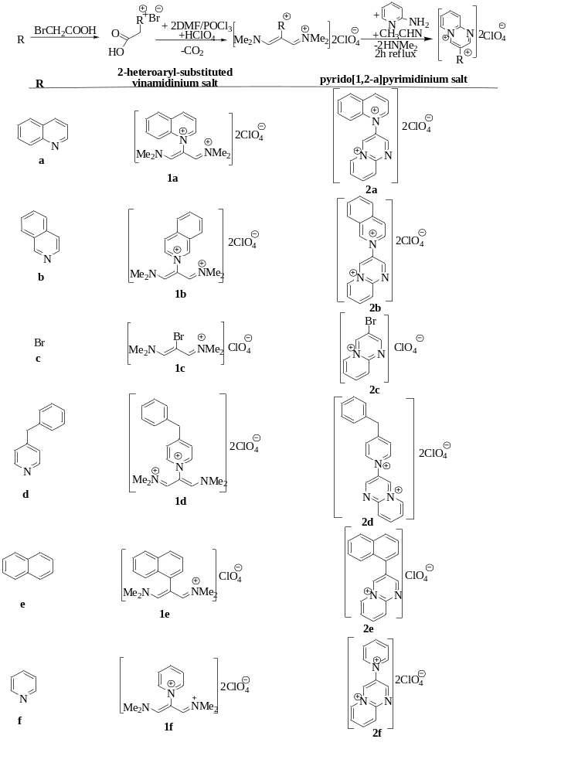

Characterization data for new compounds

3-(Quinolinium-1-yl)pyrido[1,2-a]pyridin-5-ium bis(perchlorate) (2a)

Black powder; yield 71%; mp> 400 °C; IR (KBr), ῡ (cmˉ¹): 1621, 1111; ¹H-NMR (400MHz, d₆-DMSO) δ ppm: 6.97 (d, 1H, J = 8.4 Hz), 7.23 (t, 1H, J = 6.8 Hz), 7.86 (t, 1H, J = 7.6 Hz), 8.13 (t, 1H, J = 8.0 Hz), 8.27-8.32 (m, 1H), 8.39-8.45 (m, 2H), 9.15 (s, 1H), 9.30 (t, 1H, J = 7.2 Hz), 9.45 (t, 1H, J = 5.2 Hz), 9.56 (d, 1H, J = 8.4 Hz), 9.67 (s, 1H); ¹³C-NMR: (100MHz, d₆-DMSO) δ ppm: 112.5, 118.6, 119.4, 120.8, 123.6, 130.6, 130.8, 131.1, 131.2, 137.2, 139.5, 139.9, 148.8, 149.8, 150.9, 152.9, 184.1; UV: λ_{max} (DMSO)/nm = 470; EI-MS (70ev); m/z = 259 [M⁺]; Anal. Calcd for (C₁₇H₁₃N₃)(ClO₄)₂: C, 44.55; H, 2.83; N, 9.16. Found: C, 44.98; H, 2.23; N, 8.70.

3-Isoquinolinium-2-ylpyrido[1,2-a]pyridine-5-ium bis(perchlorate) (2b)

Black powder; yield 66%; mp> 400 °C; IR (KBr), ῡ (cmˉ¹): 3061, 1617, 1089; ¹H-NMR (400MHz, d₆-DMSO) δ ppm: 6.98 (d, 1H, J = 9.6 Hz), 7.06-7.38 (m, 2H), 7.74-8.03 (m, 4H), 8.12-8.48 (m, 2H), 8.57 (d, 1H, J = 8.0 Hz), 8.66 (s, 1H), 9.08 (S, 1H), 9.95 (s, 1H); ¹³C-NMR (100MHz, d₆-DMSO) δ ppm: 106.0, 119.1, 121.1, 126.2, 127.8, 127.9, 130.3, 131.5, 132.0, 132.9, 135.4, 135.8, 137.4, 138.0, 138.4, 145.7, 150.5; UV: λ_{max} (DMSO)/nm = 453; EI-MS (70ev): m/z = 259 [M⁺]; Anal. Calcd for (C₁₇H₁₃N₃)(ClO₄)₂: C, 44.55; H, 2.83; N, 9.16. Found: C, 44.83; H, 2.25; N, 9.60.

3-Bromopyrido[1,2-a]pyrimidin-5-ium perchlorate (2c)

Dark black powder; yield 73%; mp> 400 °C; IR (KBr), ῡ (cm⁻¹): 3062, 1617, 1112; ¹H-NMR (400MHz, d₆-DMSO) δ ppm: 7.70 (t, 1H, J = 7.1 Hz), 8.00 (m, 1H), 8.22 (d, 1H, J = 7.5 Hz), 8.40 (d, 1H, J = 7.1 Hz), 8.76 (s, 1H), 9.31 (s, 1H); ¹³C-NMR: (100MHz, d₆-DMSO) δ ppm: 110.2, 111.5, 112.3, 117.3, 120.1, 139.5, 148.3, 188.6; UV: λ_{max} (DMSO)/nm = 408; EI-MS (70ev): m/z = 210 [M⁺]; Anal. Calcd for (C₈H₆BrN₂)(ClO₄): C, 31.04; H, 1.93; N, 9.04. Found: C, 30.85; H, 1.38; N, 9.48.

3-(4-Benzylpyridinium-1-yl) pyrido[1,2-a]pyrimidin-5-ium bis(perchlorate) (2d)

Dark red powder; yield 68%; mp> 400 °C; IR (KBr), ῡ (cmˉ¹): 3055, 2926, 1616, 1091; ¹H-NMR (400MHz, d₆-DMSO) δ ppm: 4.67 (s, 2H, CH₂), 7.13-7.26 (m, 5H), 7.45 (t, 1H, J = 7.1 Hz), 7.51 (t, 1H, J = 7.5 Hz), 7.66 (s, 1H), 7.83 (d, 2H, J = 6.8 Hz), 8.10 (d, 1H, J = 7.5 Hz), 8.25 (s, 1H), 8.40 (d, 1H, J = 7.1 Hz), 8.89 (d, 2H, J = 6.8 Hz); ¹³C-NMR: (100MHz, d₆-DMSO) δ ppm: 50.0, 126.2, 127.81, 127.84, 131.5, 132.0, 132.9, 133.4, 135.5, 137.5, 138.1, 138.5, 147.5, 150.7, 157.7, 162.6; UV: λ_{max}(DMSO)/nm = 428; EI-MS (70ev): m/z = 299 [M⁺]; Anal. Calcd for (C₂₀H₁₇N₃)(ClO₄)₂: C, 48.21; H, 3.41; N, 8.43. Found: C, 48.69; H, 3.11; N, 8.84.

3-Naphthalen-1-ylprido[1,2-a]pyrimidin-5-ium perchlorate (2e)

Brown powder; yield 79%; mp> 400 °C; IR (KBr), ῡ (cm⁻¹): 3049, 1587, 1096; ¹H-NMR (400MHz, d₆-DMSO) δ ppm: 7.46-7.70 (m, 9H), 7.80 (d, 1H, J = 7.5 Hz), 7.85 (s, 1H), 7.96 (s, 1H), 8.05 (t, 1H, J = 7.1 Hz); ¹³C-NMR: (100MHz, d₆-DMSO) δ ppm: 102.3, 125.7, 126.1, 127.2, 127.4, 128.1, 128.2, 128.4, 129.1, 129.9, 130.3, 130.9, 131.4, 133.2, 133.7, 134.1, 163.5, 164.3; UV: λ_{max}(DMSO)/nm = 311; EI-MS (70ev): m/z = 257 [M⁺]; Anal. Calcd for (C₁₈H₁₃N₂)(ClO₄): C, 60.60; H, 3.64; N, 7.84. Found: C, 61.04; H, 3.88; N, 7.39.

3-Pyridinium-1-ylpyrido[1,2-a]pyrimidin-5-ium bis(perchlorate) (2f)

Black powder; yield 80%; mp> 400 °C; IR (KBr), ῡ (cm⁻¹): 3059, 1633, 1088; ¹H-NMR (400MHz, d₆-DMSO) δ ppm: 7.09 (d, 1H, J = 8.4 Hz), 7.24 (t, 1H, J = 6.8 Hz), 7.89 (t, 1H, J = 7.2 Hz), 8.37 (t, 2H, J = 6.8 Hz), 8.44 (d, 1H, J = 3.6 Hz), 8.82 (t, 1H, J = 7.6 Hz), 9.00 (d, 2H, J = 5.2 Hz), 9.08 (s, 1H), 9.53 (s, 1H); ¹³C-NMR: (100MHz,d₆-DMSO) δ ppm: 112.7, 120.8, 122.5, 129.4, 139.9, 144.0, 147.6, 148.1, 148.7, 150.9, 183.6; UV: λ_{max} (DMSO)/nm = 367; EI-MS (70ev): m/z = 209 [M⁺]; Anal. Calcd for (C₁₃H₁₁N₃)(ClO₄)₂: C, 38.23; H, 2.69; N, 10.28. Found: C, 37.91; H, 2.40; N, 9.81.

Copies of NMR

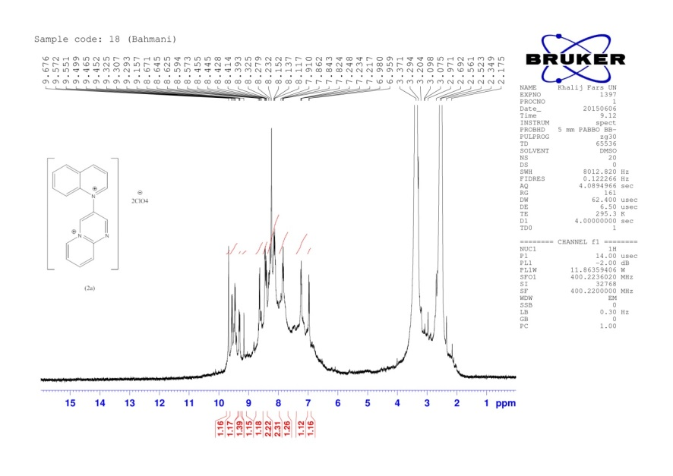
¹H-NMR of 3-(Quinolinium-1-yl)pyrido[1,2-a]pyridin-5-ium bis(perchlorate) (2a)
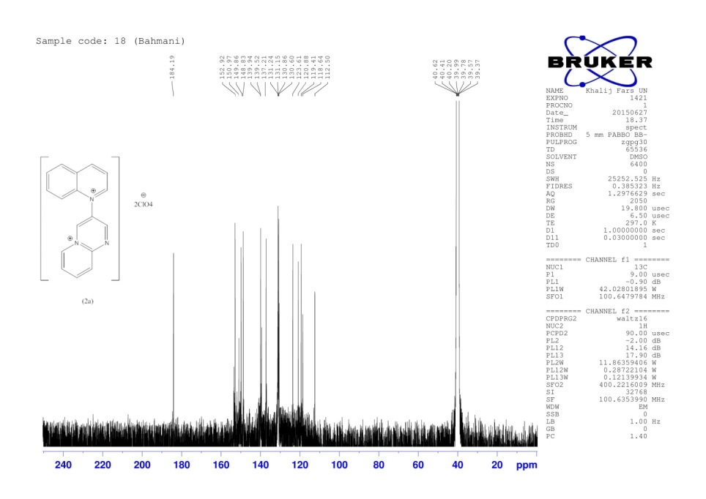
¹³C-NMR of 3-(Quinolinium-1-yl)pyrido[1,2-a]pyridin-5-ium bis(perchlorate) (2a)

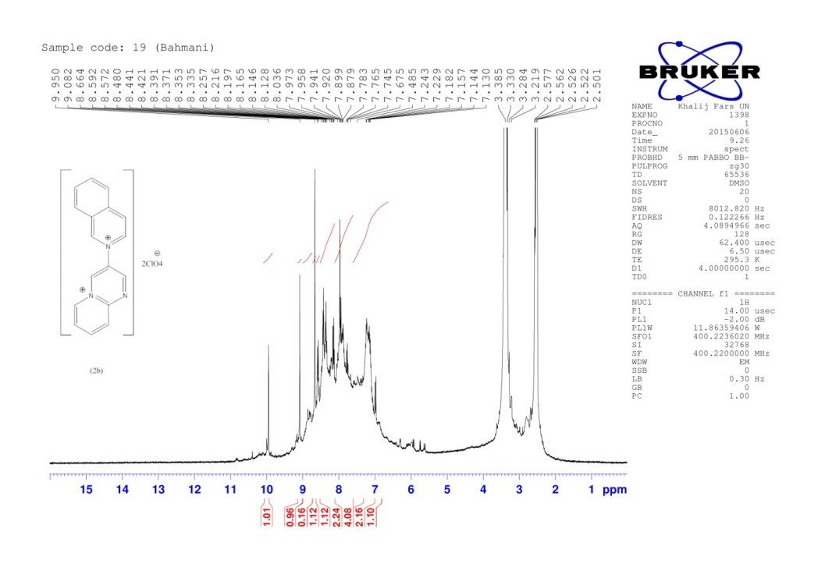
¹H-NMR of 3-Isoquinolinium-2-ylpyrido[1,2-a]pyridine-5-ium bis(perchlorate) (2b)

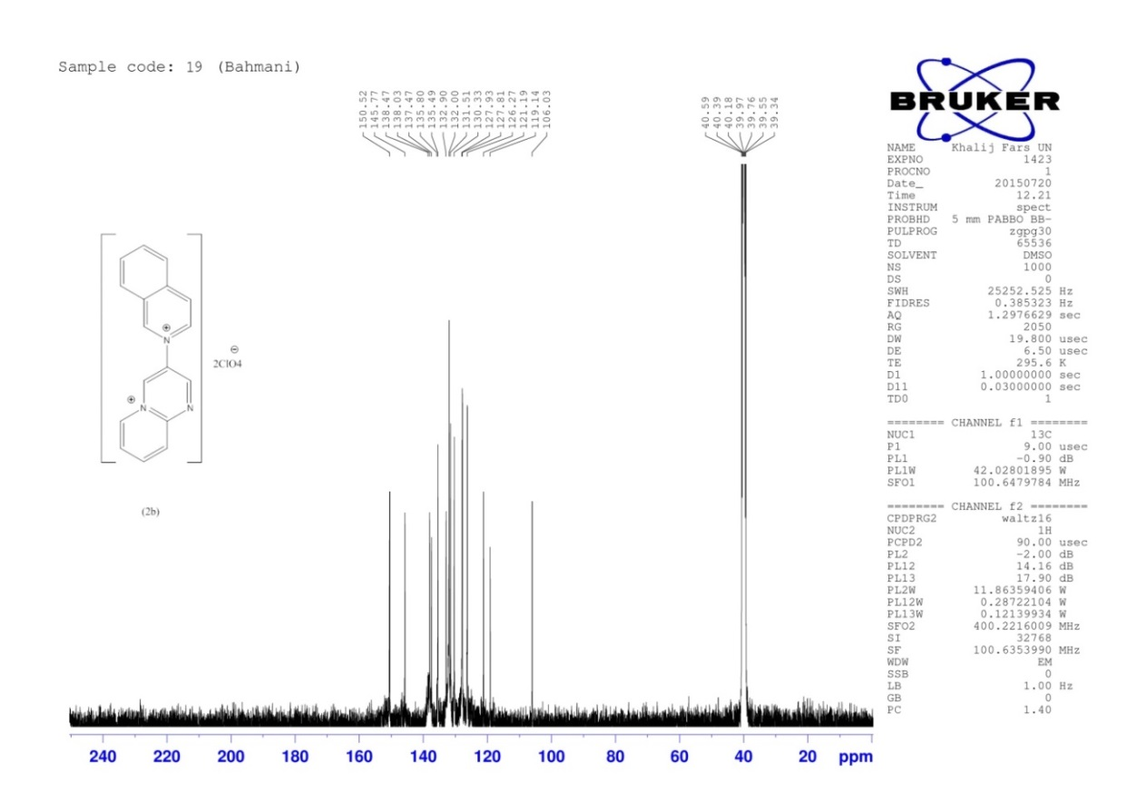
¹³C-NMR of 3-Isoquinolinium-2-ylpyrido[1,2-a]pyridine-5-ium bis(perchlorate) (2b)

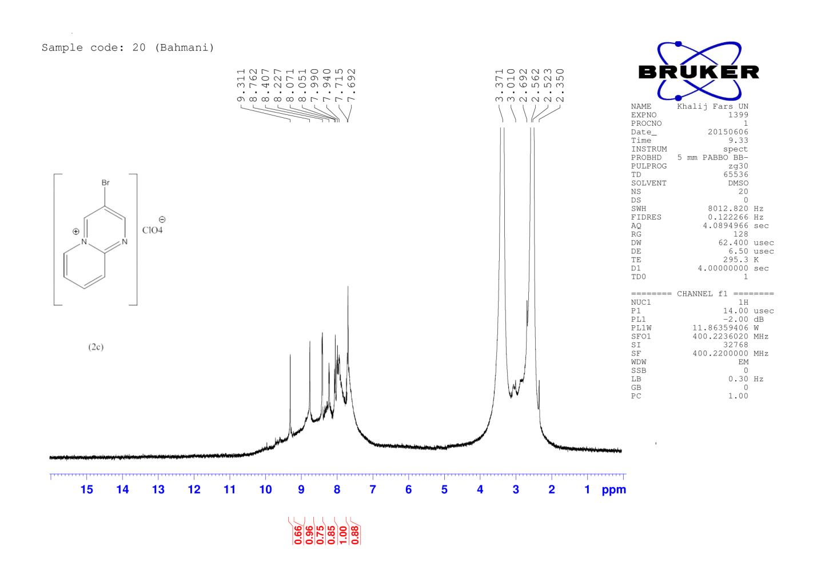
¹H-NMR of 3-Bromopyrido[1,2-a]pyrimidin-5-ium perchlorate (2c)

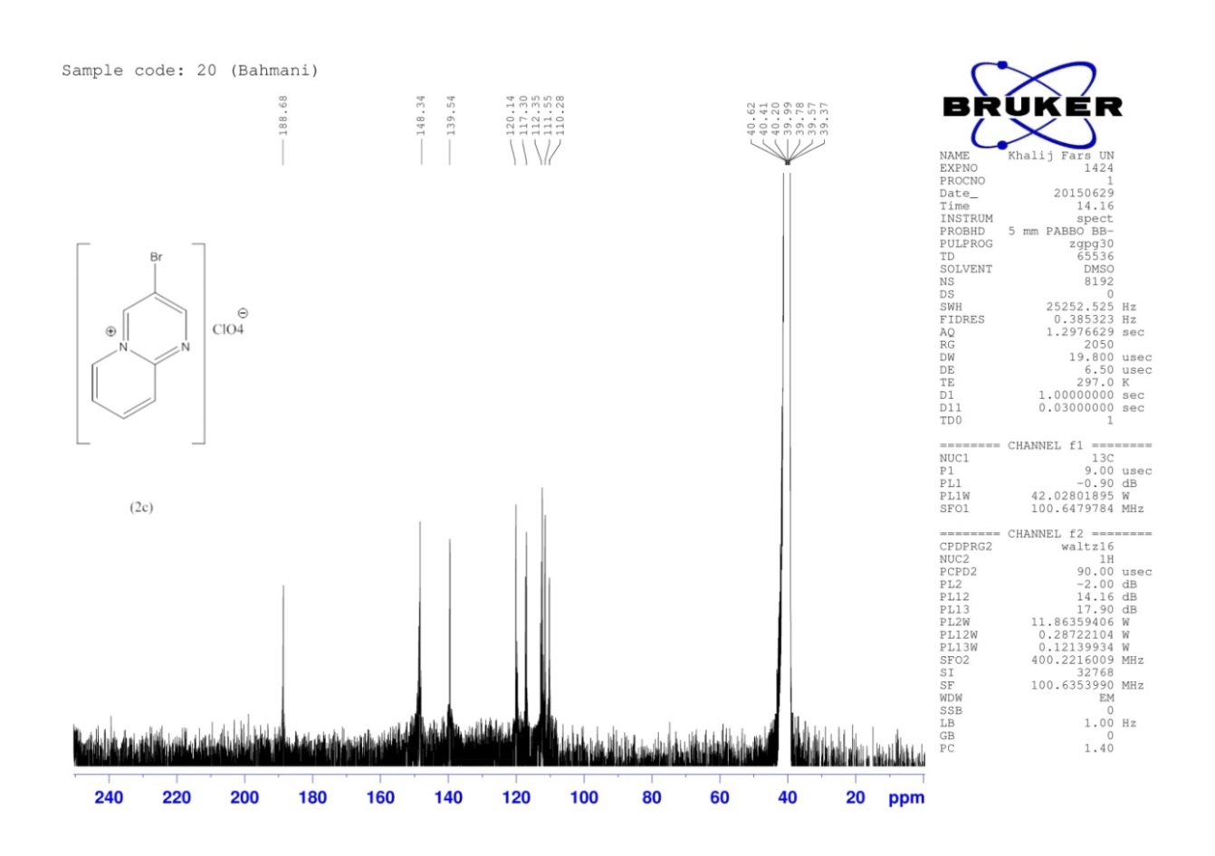
¹³C-NMR of 3-Bromopyrido[1,2-a]pyrimidin-5-ium perchlorate (2c)

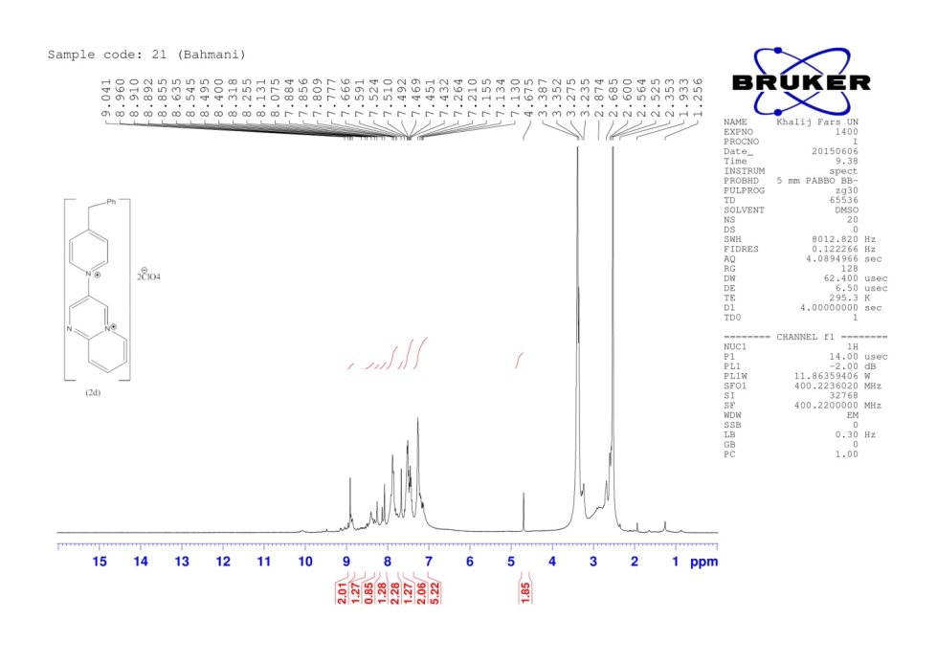
¹H-NMR of 3-(4-Benzylpyridinium-1-yl) pyrido[1,2-a]pyrimidin-5-ium bis(perchlorate) (2d)

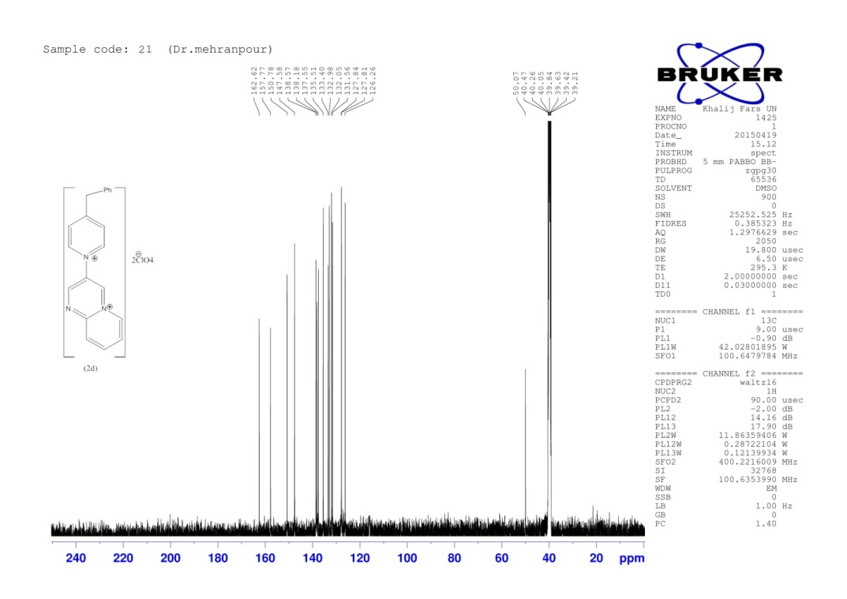
¹³C-NMR of 3-(4-Benzylpyridinium-1-yl) pyrido[1,2-a]pyrimidin-5-ium bis(perchlorate) (2d)

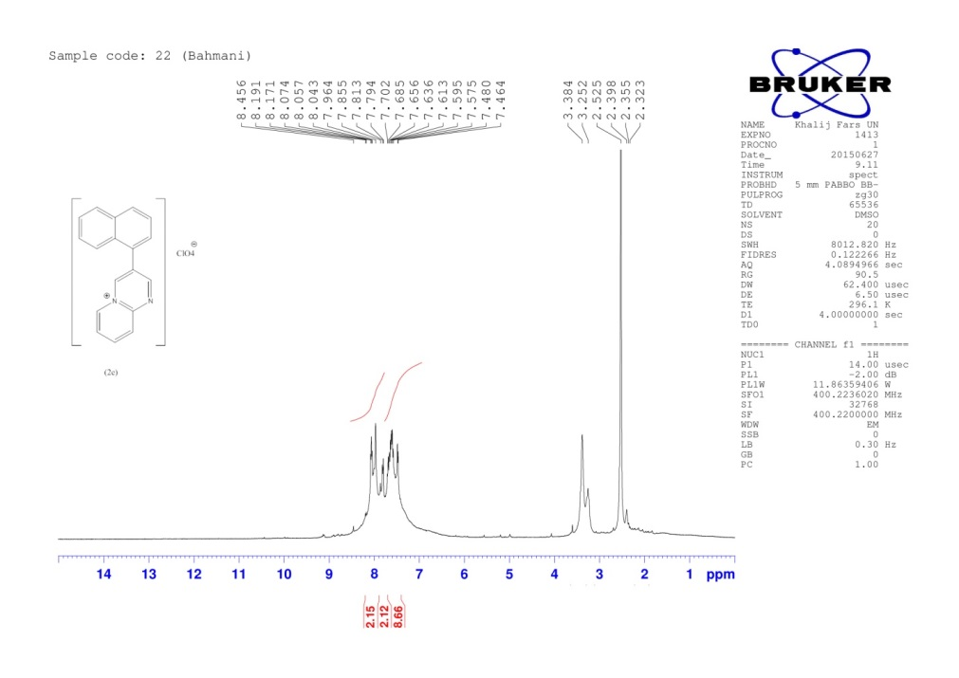
¹H-NMR of 3-Naphthalen-1-ylprido[1,2-a]pyrimidin-5-ium perchlorate (2e)

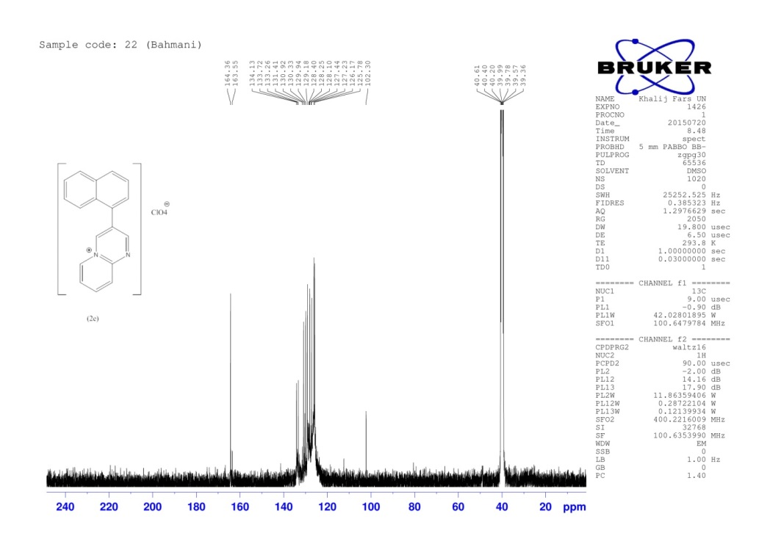
¹³C-NMR of 3-Naphthalen-1-ylprido[1,2-a]pyrimidin-5-ium perchlorate (2e)

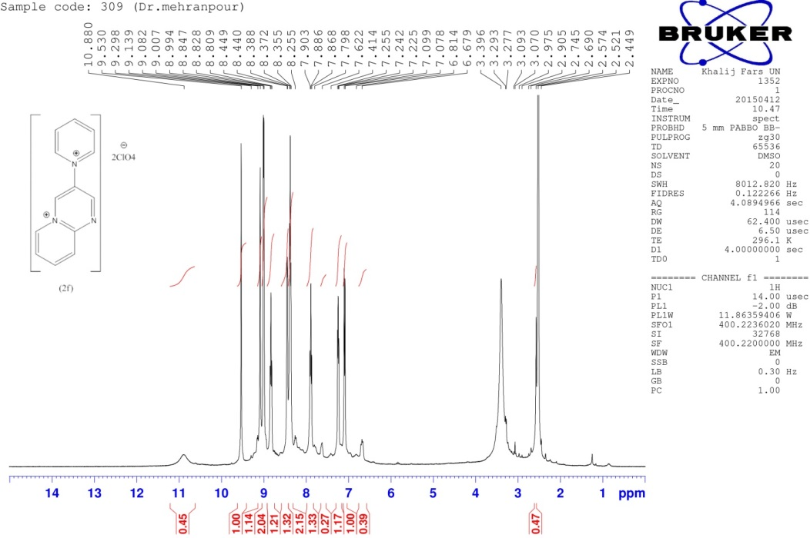
¹H-NMR of 3-Pyridinium-1-ylpyrido[1,2-a]pyrimidin-5-ium bis(perchlorate) (2f)

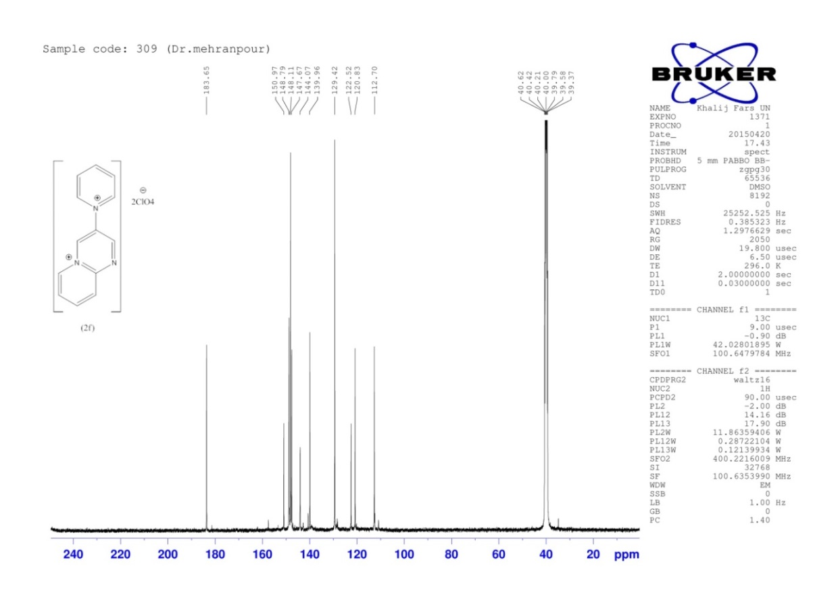
¹³C-NMR of 3-Pyridinium-1-ylpyrido[1,2-a]pyrimidin-5-ium bis(perchlorate) (2f)

