Supporting Information

Solvent and substituent effects on the conversion of 4-methoxypyridines to N-methyl-4-pyridones
Xiao Yi, Jing Chen, Xiuling Xu and Yongmin Ma *
College of Pharmaceutical Science, Zhejiang Chinese Medical University, Hangzhou, P R China; E-mail: yongmin.ma@zcmu.edu.cn

Experimental
General Procedure for methylation of compounds in solvent-free system
To a round bottle flask containing 1 (2 mmol) was added methyl iodide (10 mmol; 5 equiv.) and the mixture was stirred at room temperature or reflux overnight. The reaction was detected by TLC. After completion, the precipitate was filtrated and purified by recrystallization to afford products.

General Procedure for methylation of compounds in the presence of acetone
A solution of 1 (2 mmol) in acetone (15 ml) was added methyl iodide (4 mmol; 2 equiv.) and the mixture was refluxed overnight. The reaction was detected by TLC. After completion, the solvent was removed under reduced pressure and the residue was purified by column chromatography (EtOAc: MeOH=20:1→5:1) to obtain target compounds.

Characterization data for selected compounds
1-methylpyridinium iodide (2a): white solid, m.p. 138 ºC-139 ºC (acetonitrile, lit.¹ 137.5 ºC-138.9 ºC). ¹H NMR (600 MHz, DMSO-d₆) δ 8.78 (d, J = 7.5 Hz, 2H), 7.62 (d, J = 7.5 Hz, 2H), 4.17 (s, 3H), 4.08 (s, 3H). ¹³C NMR (151 MHz, DMSO-d₆) δ 170.62, 147.31, 113.49, 58.45, 46.51. HRMS (ESI): m/z calcd for (C₇H₁₀NO)⁺: 124.0757; found: 124.0763.
1-methyl-4-pyridone (3a): pale yellow needles, m.p. 91 ºC-92 ºC (lit.² 92 ºC-93 ºC).
¹H NMR (600 MHz, CDCl₃) δ 8.46 (d, J = 6.2 Hz, 2H), 6.84 (d, J = 6.2 Hz, 2H), 3.87 (s, 3H). ¹³C NMR (151 MHz, DMSO-d₆) δ 177.41, 142.44, 117.63, 43.21. HRMS (ESI): m/z calcd for (C₆H₈NO)⁺: 110.0528; found: 110.0531.
4-methoxy-1,3-dimethylpyridinium iodide (2b): white needles, m.p. 132 ºC-134 ºC (lit.³ 133 ºC). ¹H NMR (500 MHz, DMSO-d₆) δ 8.83 (d, J = 6.8 Hz, 1H), 8.75 (s, 1H), 7.66 (d, J = 6.8 Hz, 1H), 4.16 (s, 3H), 4.12 (s, 3H), 2.22 (s, 3H). ¹³C NMR (126 MHz, DMSO-d₆) δ 168.94, 146.27, 145.03, 126.00, 109.53, 58.52, 45.63, 13.25. HRMS (ESI): m/z calcd for (C₈H₁₂NO)⁺: 138.0913; found: 138.0910.
1,3-dimethyl-4-pyridone (3b): white needles, m.p. 110 ºC-112 ºC. ¹H NMR (500 MHz, DMSO-d₆) δ 7.67 (s, 1H), 7.64 (d, J = 7.3 Hz, 1H), 6.13 (d, J = 7.3 Hz, 1H), 3.64 (s, 3H), 1.85 (s, 3H). ¹³C NMR (126 MHz, DMSO-d₆) δ 176.63, 141.51, 139.85, 126.04, 114.98, 43.34, 14.02. HRMS (ESI): m/z calcd for (C₇H₁₀NO)⁺: 124.0684; found: 124.0689.
4-hydroxy-3-methoxy-1,2-dimethylpyridinium iodide (2c): brown solid, m.p. 246 ºC-248 ºC (EtOH). ¹H NMR (600 MHz, DMSO-d₆) δ 8.84 (s, 1H), 8.25 (s, 1H), 4.22 (s, 3H), 3.93 (s, 3H), 2.72 (s, 3H). ¹³C NMR (151 MHz, DMSO-d₆) δ 154.32, 153.45, 145.06, 142.71, 126.43, 62.39, 46.68, 15.11. HRMS (ESI): m/z calcd for (C₈H₁₂NO₂) ⁺: 154.0863; found: 154.0867.
3-methoxy-1,2-dimethyl-4-pyridone (3c): white needles, m.p. 85 ºC-86 ºC (lit.⁴ 85 ºC-86 ºC). ¹H NMR (600 MHz, CDCl₃) δ 7.26 (d, J = 7.5 Hz, 1H), 6.40 (d, J = 7.5 Hz, 1H), 3.86 (s, 3H), 3.63 (s, 3H), 2.36 (s, 3H). HRMS (ESI): m/z calcd for (C₈H₁₂NO₂)⁺: 154.0790; found: 154.0793.
1-methyl-3-nitro-4-pyridone (3d): yellow solid, m.p. 232 ºC-235 ºC (lit.⁵ 235 ºC). ¹H NMR (600 MHz, DMSO-d₆) δ 8.92 (s, 1H), 7.76 (d, J = 7.6 Hz, 1H), 6.50 (d, J = 7.6 Hz, 1H), 3.76 (s, 3H). HRMS (ESI): m/z calcd for (C₆H₇N₂O₃)⁺: 155.0378; found: 155.0384.
5-bromo-3-methoxy-1,2-dimethyl-4-pyridone (3e): white needles, m.p. 172 ºC-173 ºC (lit.⁶ 172 ºC-173 ºC). ¹H NMR (600 MHz, CDCl₃) δ 7.64 (s, 1H), 3.90 (s, 3H), 3.63 (s, 3H), 2.34 (s, 3H). ¹³C NMR (151 MHz, CDCl₃) δ 168.29, 146.52, 140.22, 139.22, 113.11, 59.55, 41.71, 12.71. HRMS (ESI): m/z calcd for (C₈H₁₁⁷⁹BrNO₂)⁺: 231.9895; found: 231.9899.
3,5-dibromo-1-methyl-4-pyridone (3f): white needles, m.p. 193 ºC-195 ºC (lit.² 193 ºC-194 ºC). ¹H NMR (600 MHz, DMSO-d₆) δ 8.34 (s, 2H), 3.70 (s, 3H). ¹³C NMR (151 MHz, DMSO-d₆) δ 166.93, 142.59, 111.85, 43.58. HRMS (ESI): m/z calcd for (C₆H₆⁷⁹Br₂NO)⁺: 265.8738; found: 265.8721.
4-methoxy-1,2-dimethylpyridinium iodide (2g): white needles, m.p. 168 ºC-169 ºC (lit.⁷ 168 ºC). ¹H NMR (600 MHz, DMSO-d₆) δ 8.76 (d, J = 7.2 Hz, 1H), 7.61 (d, J = 3.0 Hz, 1H), 7.48 (dd, J = 7.2, 3.0 Hz, 1H), 4.06 (s, 6H), 2.69 (s, 3H). ¹³C NMR (151 MHz, DMSO-d₆) δ 170.46, 157.31, 147.78, 113.90, 111.82, 58.28, 44.02, 20.36. HRMS (ESI): m/z calcd for (C₈H₁₂NO)⁺: 138.0913; found: 138.0917.
2-chloro-4-methoxy-1-methylpyridinium iodide (2h): pale yellow needles, m.p. 115 ºC-117 ºC. ¹H NMR (600 MHz, DMSO-d₆) δ 8.95 (dd, J = 7.2, 2.9 Hz, 1H), 8.02 (d, J = 2.9 Hz, 1H), 7.65 (dd, J = 7.2, 1H), 4.15 (s, 3H), 4.11 (s, 3H). ¹³C NMR (151 MHz, DMSO-d₆) δ 171.65, 148.92, 148.07, 114.66, 112.95, 59.19, 45.89, 40.42. HRMS (ESI): m/z calcd for (C₇H₉³⁵ClNO)⁺: 158.0367; found: 158.0370.
2-chloro-1-methyl-4-pyridone (3h): pale yellow needles, m.p. 53 ºC-54 ºC (lit.⁸ 52 ºC-54 ºC). ¹H NMR (600 MHz, CDCl₃) δ 7.31 (d, J = 7.6 Hz, 1H), 6.54 (d, J = 2.6 Hz, 1H), 6.34 (dd, J = 7.6, 2.6 Hz, 1H), 3.72 (s, 3H). ¹³C NMR (151 MHz, CDCl₃) δ 178.67, 141.34, 118.99, 118.19, 106.00, 42.17. HRMS (ESI): m/z calcd for (C₆H₇³⁵ClNO)⁺: 144.0138; found: 144.0121.
2-carboxy-4-methoxy-1-methylpyridinium iodide (2i): white solid, m.p. ≥320 ºC. ¹H NMR (600 MHz, DMSO-d₆) δ 8.95 (d, J = 7.3 Hz, 1H), 8.02 (d, J = 2.9 Hz, 1H), 7.65 (dd, J = 7.3 Hz, 2.9 Hz, 1H), 4.15 (s, 3H), 4.11 (s, 3H). HRMS (ESI): m/z calcd for (C₈H₁₀NO₃)⁺: 168.0655; found: 144.0657.
Methyl 1-methyl-4-oxo-1,4-dihydropyridine-2-carboxylate (3i): white solid, m.p. 190 ºC-191 ºC (lit.⁹ 190 ºC-192 ºC). ¹H NMR (600 MHz, CDCl₃) δ 7.30 (d, J = 7.6 Hz, 1H), 6.96 (d, J = 2.6 Hz, 1H), 6.40 (dd, J = 7.5, 2.6 Hz, 1H), 3.87 (s, 3H), 3.78 (s, 3H). ¹³C NMR (151 MHz, CDCl₃) δ 162.65, 144.11, 139.66, 122.46, 119.45, 53.39, 43.36. HRMS (ESI): m/z calcd for (C₈H₁₀NO₃)⁺: 168.0582; found: 168.0591.
3,5-dibromo-1-ethylpyridin-4(1H)-one (4f): white solid. ¹H NMR (600 MHz, CDCl₃) δ 7.75 (s, 2H), 3.91 (q, J = 7.0 Hz, 2H), 1.51 (t, J = 7.0 Hz, 3H). HRMS (ESI): m/z calcd for (C₇H₇⁷⁹Br₂NO)⁺: 279.8894; found: 279.8903.
3,5-dibromo-1-isopropylpyridin-4(1H)-one (5f): white solid. ¹H NMR (600 MHz, CDCl₃) δ 7.82 (s, 1H), 4.19 (septet, J = 6.8 Hz, 1H), 1.52 (d, J = 6.8 Hz, 3H). HRMS (ESI): m/z calcd for (C₈H₉⁷⁹Br₂NO)⁺: 293.9051; found: 293.9043.

References
1 S. S. Hanson, N. A. Richard, C. A. Dyker, Chemistry-a European Journal 2015, 21, 8052-8055 10.1002/chem.201500809.
2 P. Beak, J. Bonham, Journal of the American Chemical Society 1965, 87, 3365-3371.
3 E. Profft, G. Schulz, Archiv der Pharmazie 1961, 294, 292-301.
4 Z. Stiplošek, M. Šindler‐Kulyk, K. Jakopĉić, Z. Meić, D. Vikić‐Topić, Journal of heterocyclic chemistry 1989, 26, 1707-1711.
5 Y. Ahmad, D. Hey, Journal of the Chemical Society (Resumed) 1954, 4516-4523.
6 J. H. Looker, R. J. Prokop, W. E. Serbousek, M. D. Cliffton, The Journal of Organic Chemistry 1979, 44, 3408-3410.
7 E. Profft, Archiv der Pharmazie 1958, 291, 429-436.
8 A. Katritzky, J. Rowe, S. Roy, Journal of the Chemical Society B: Physical Organic 1967, 758-761.
9 L. Deady, Australian journal of chemistry 1985, 38, 637-641.

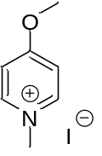 2a
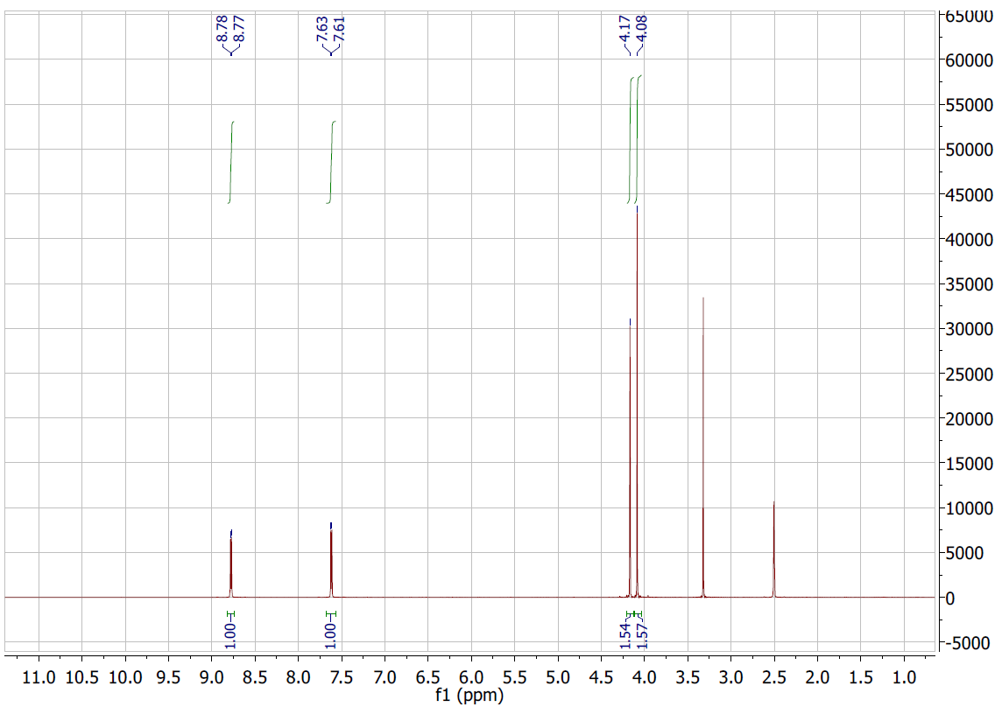

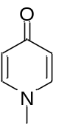 3a
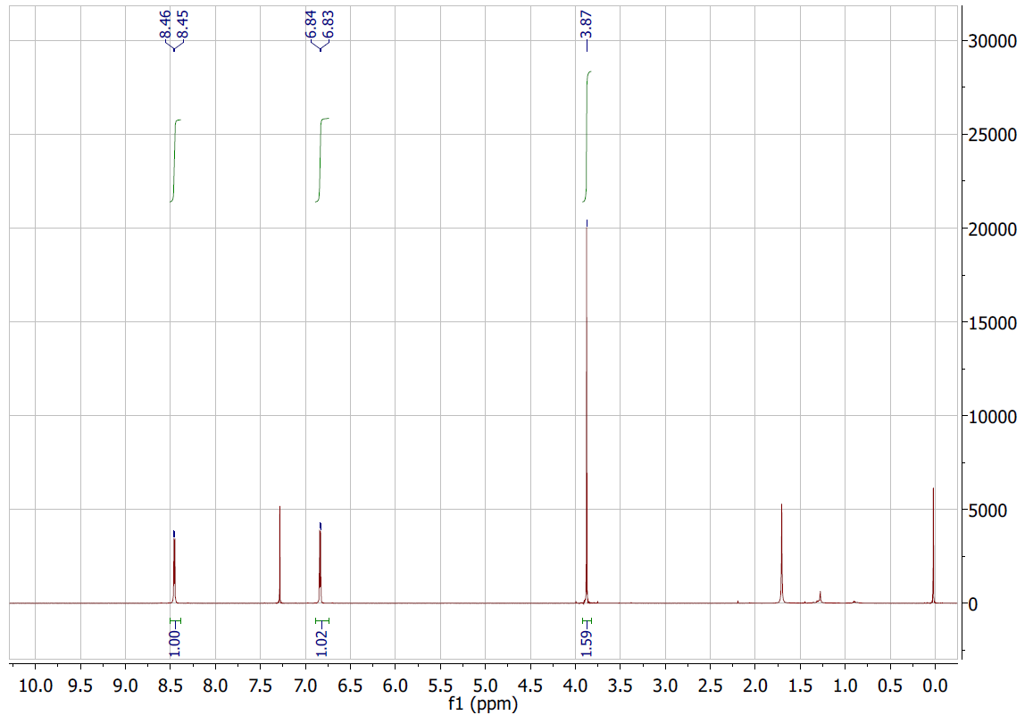

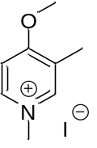2b
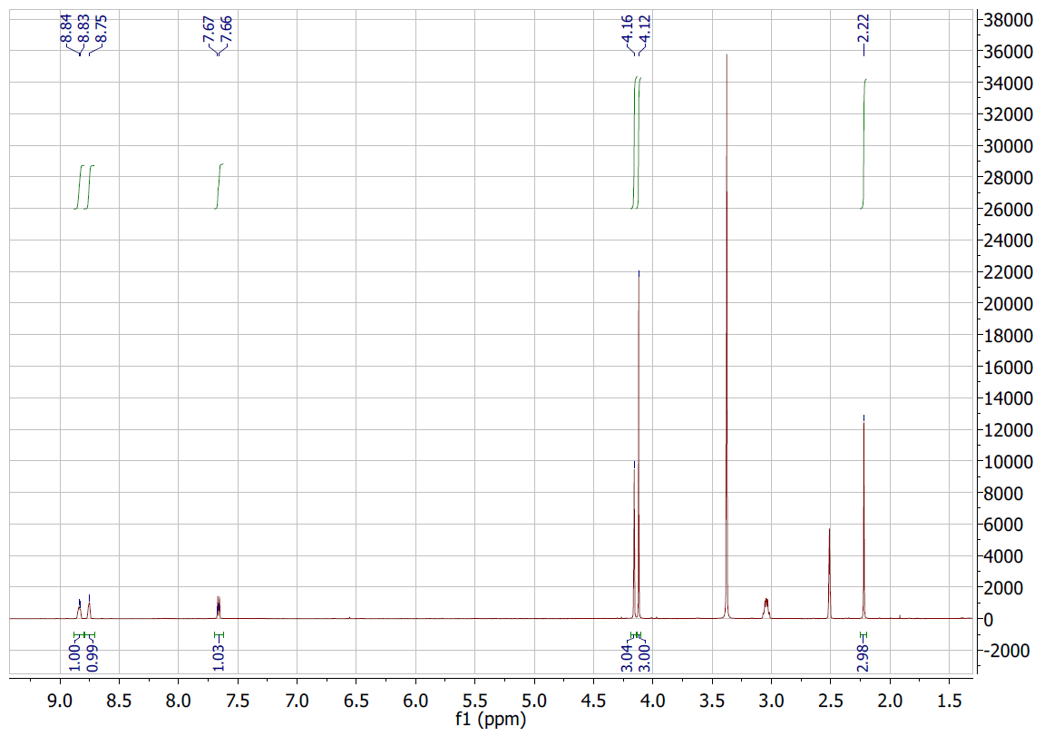

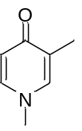3b
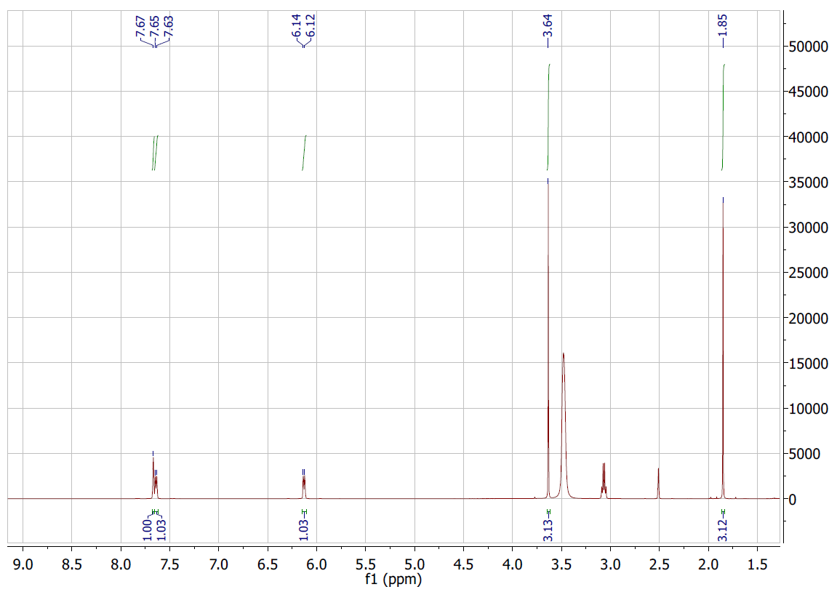

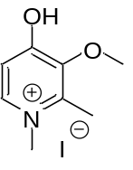2c
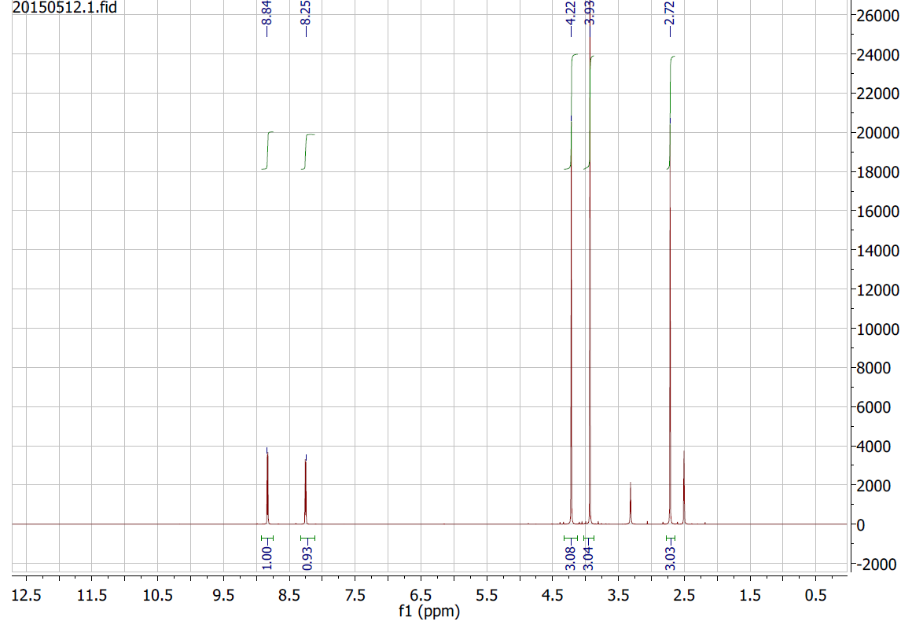

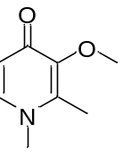3c
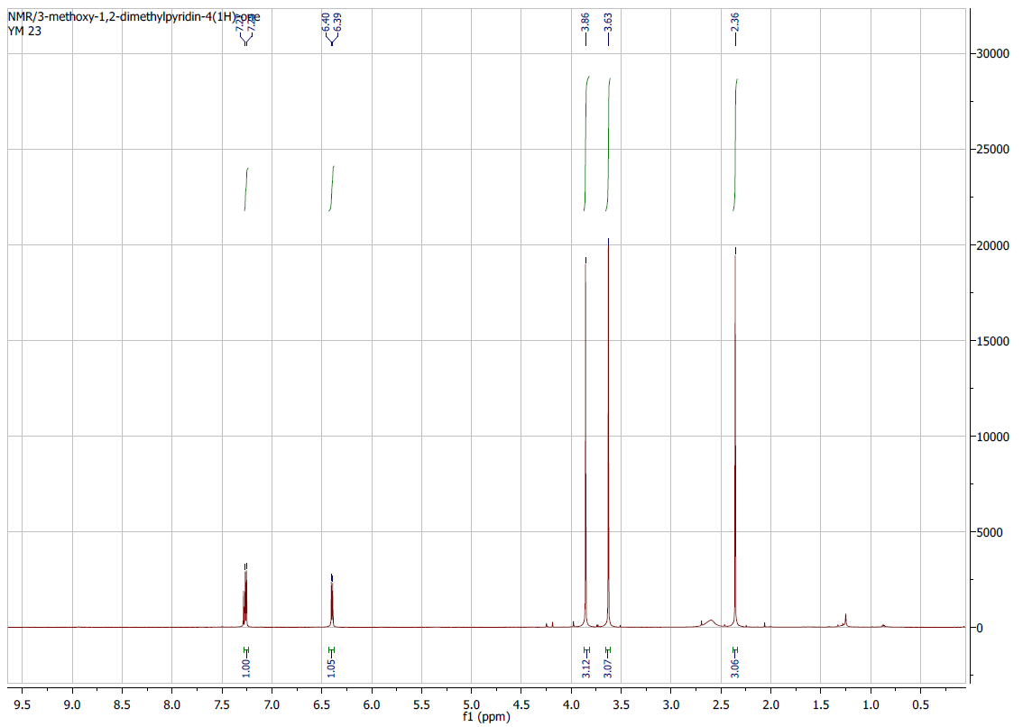

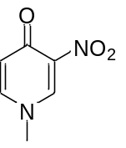3d
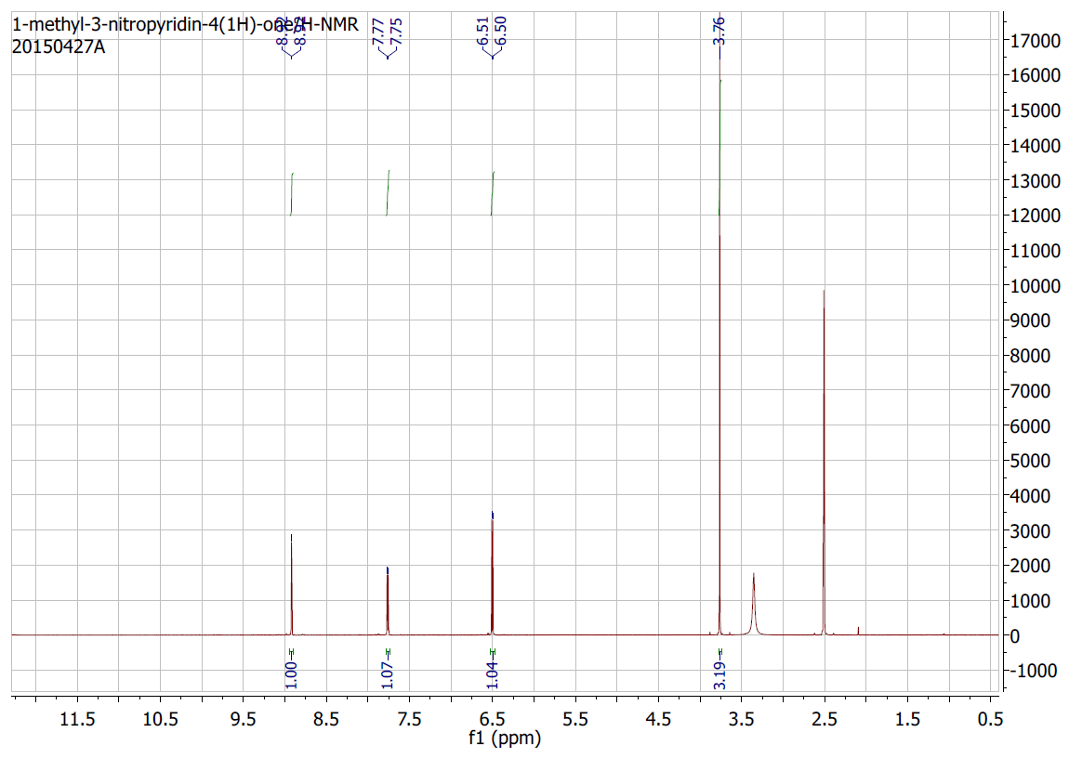

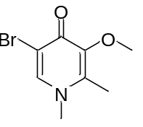3e
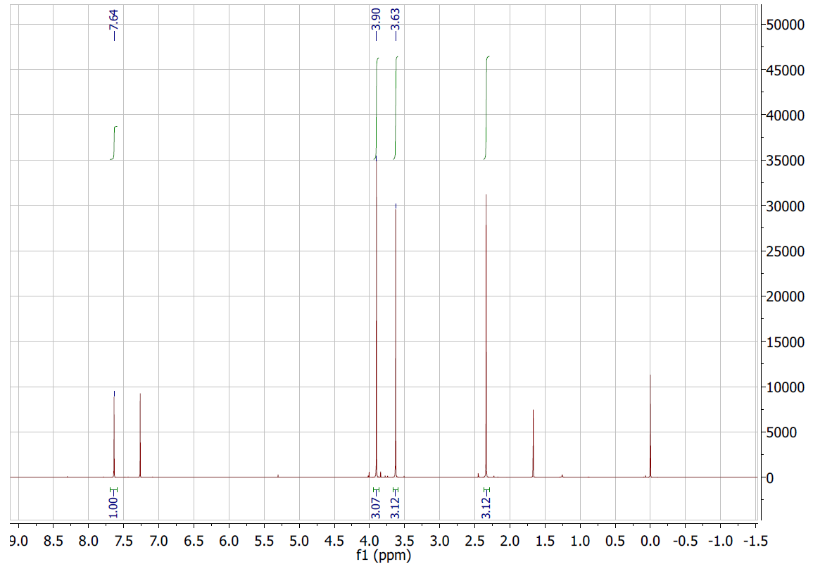

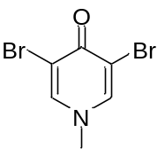3f
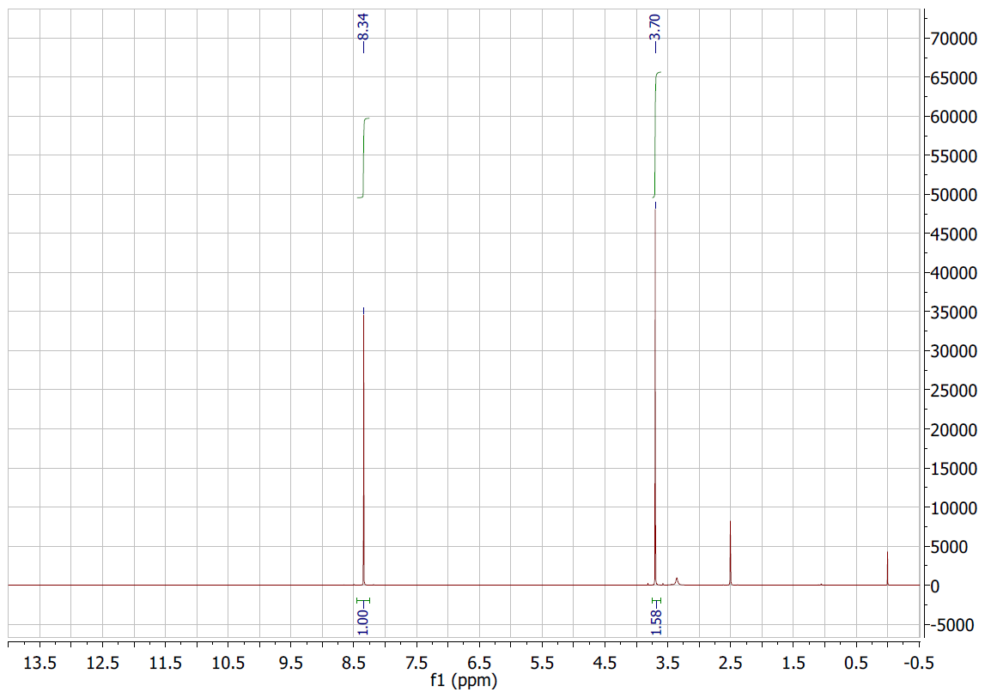

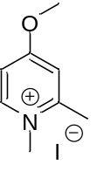2g
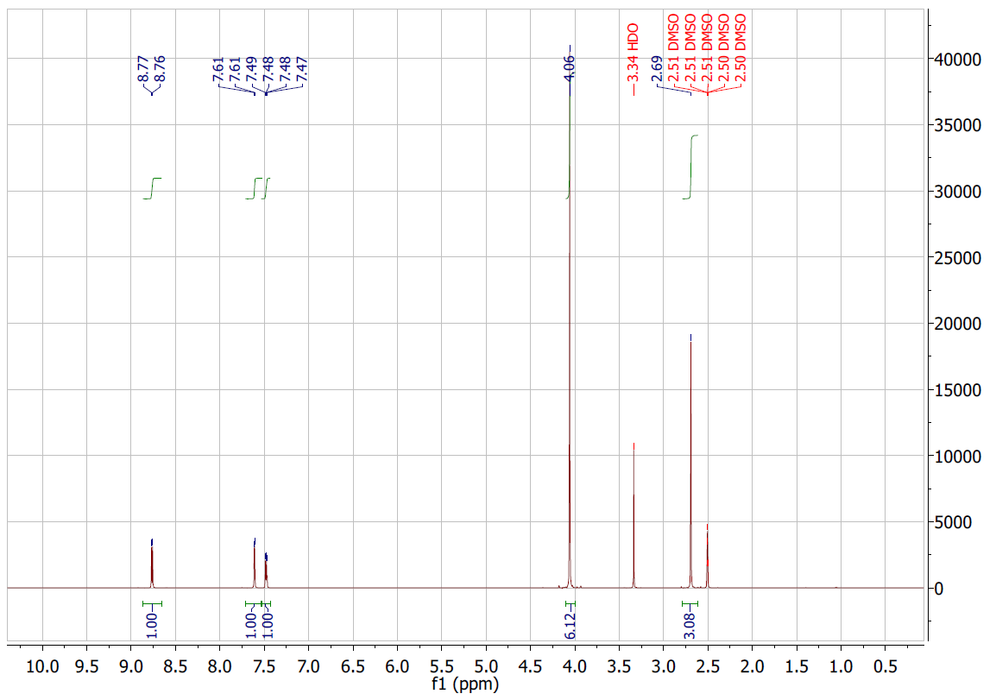

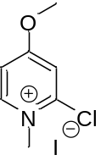2h
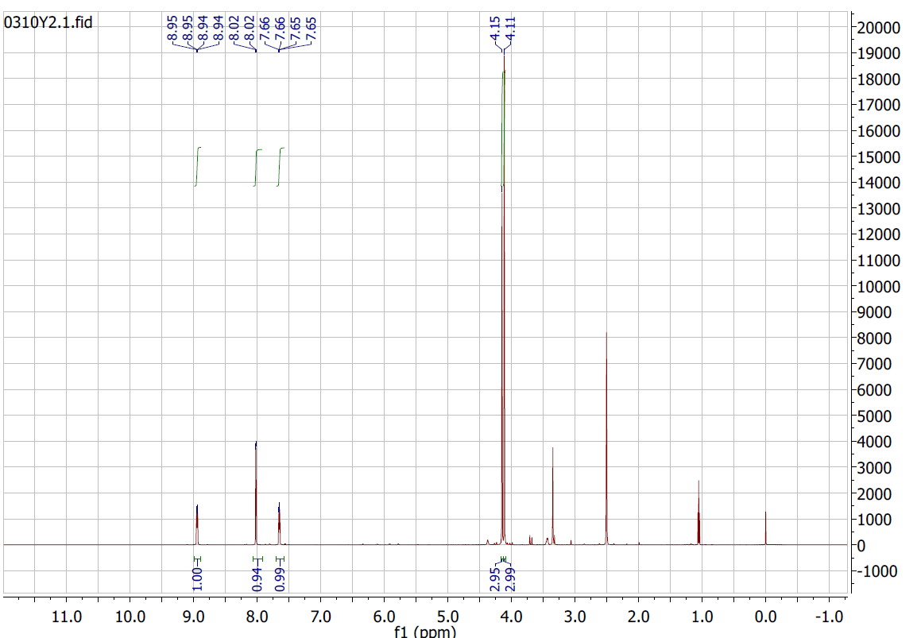

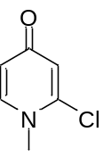3h
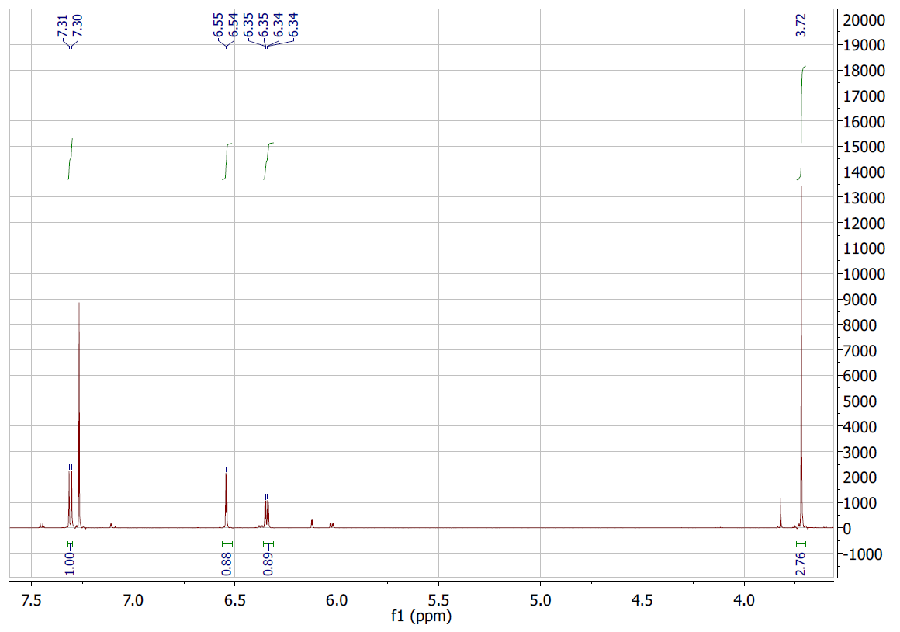

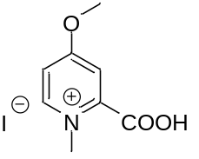2i
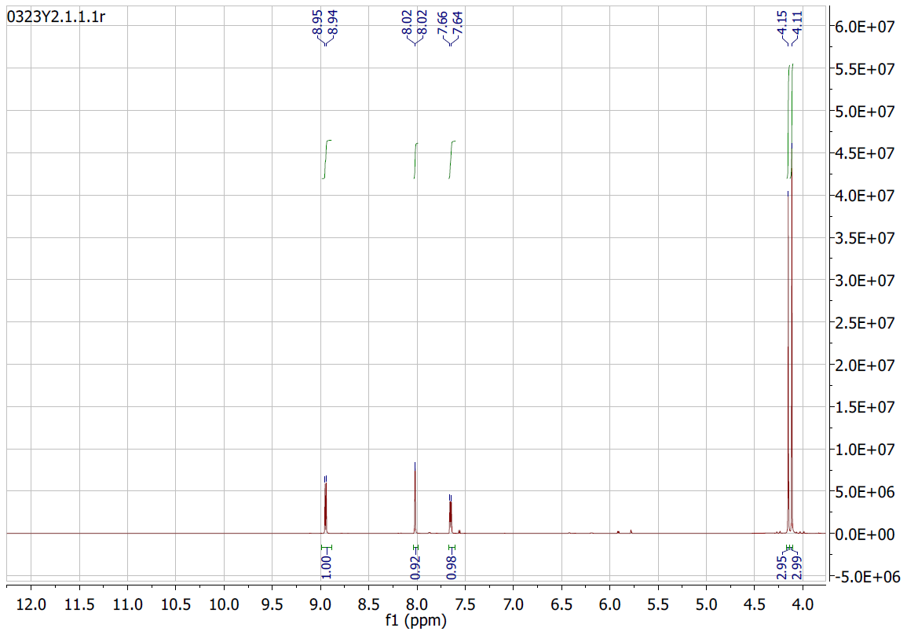

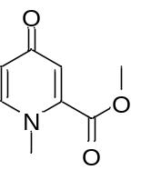3i
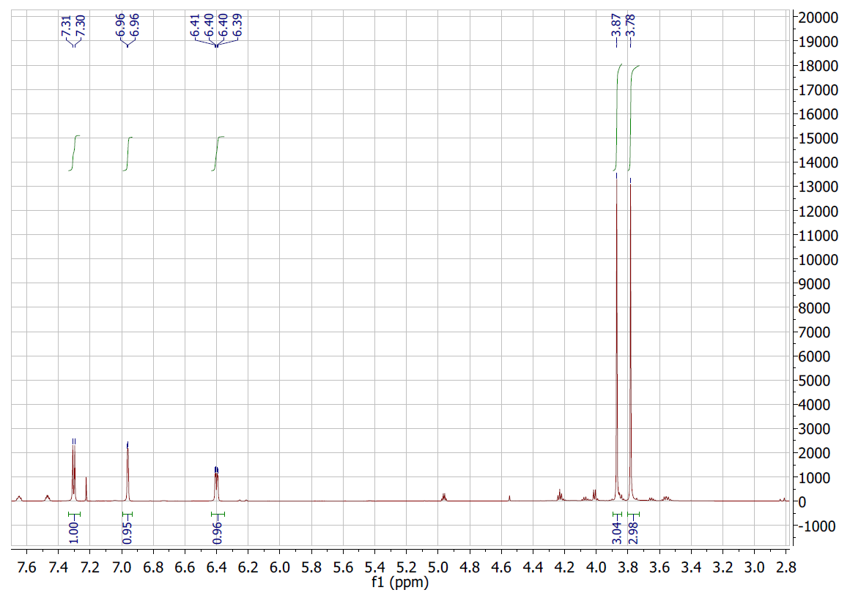

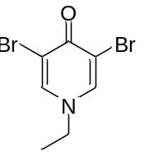4f
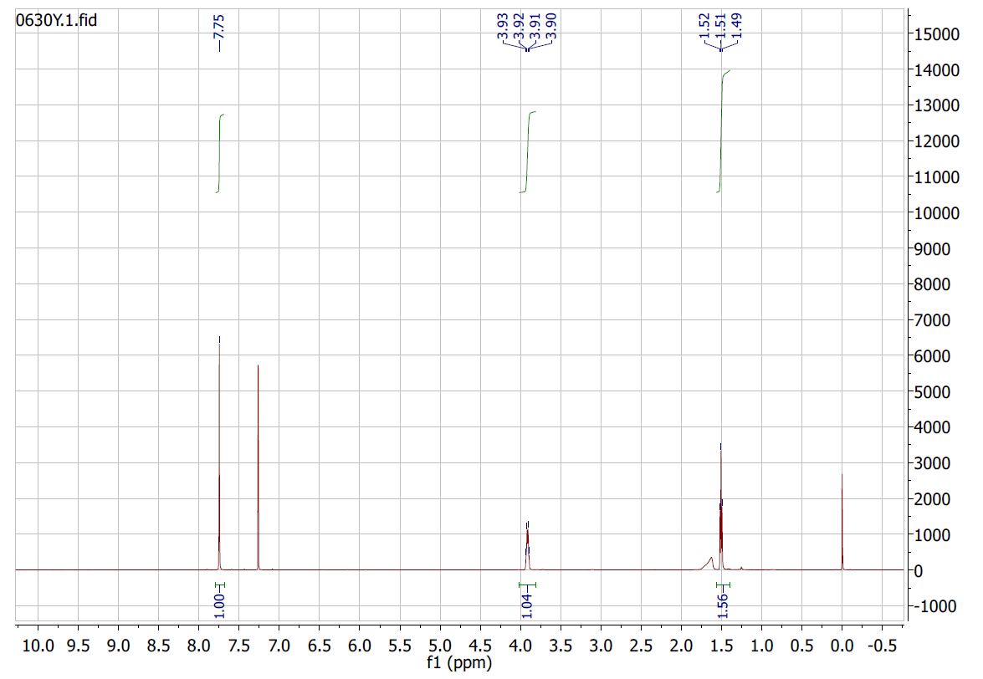

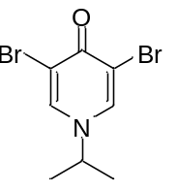5f
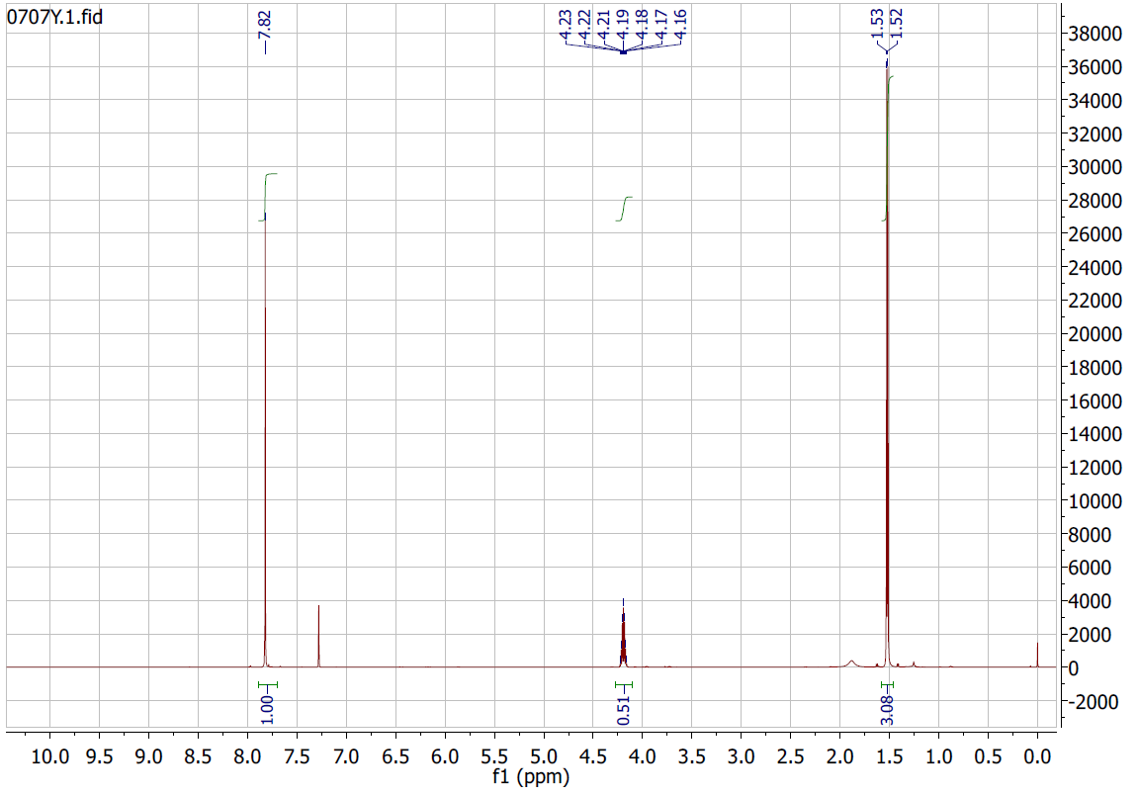

2a
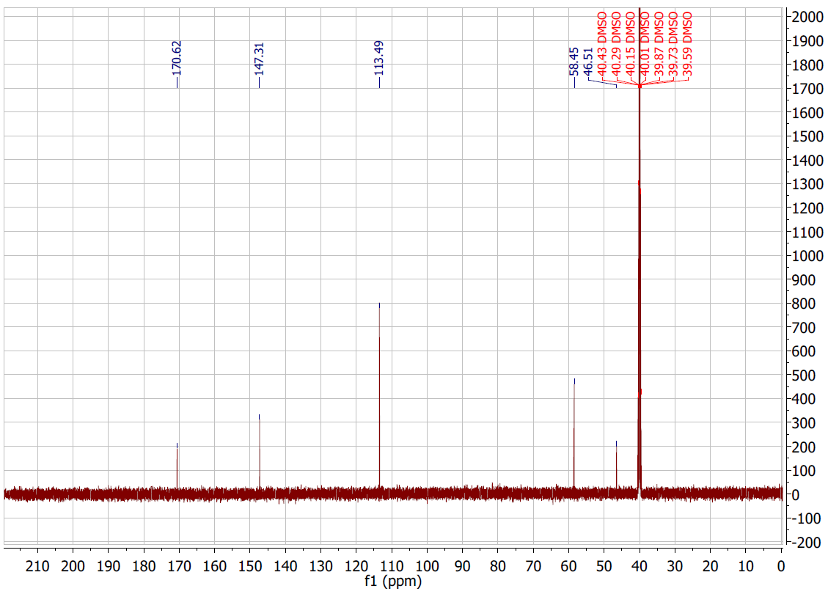

3a
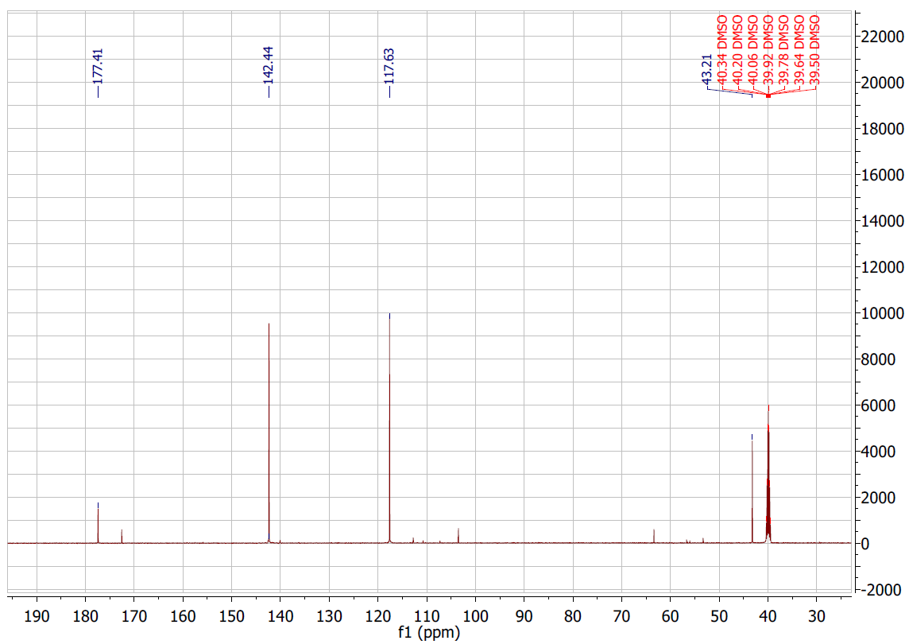

2b
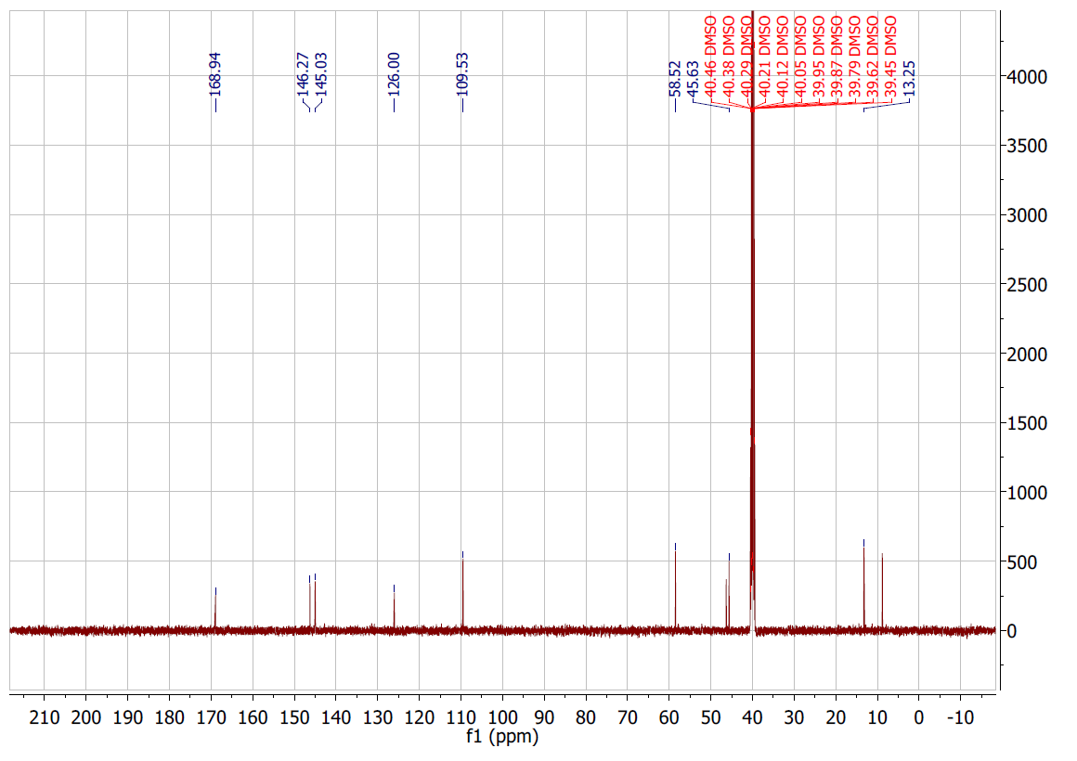

3b
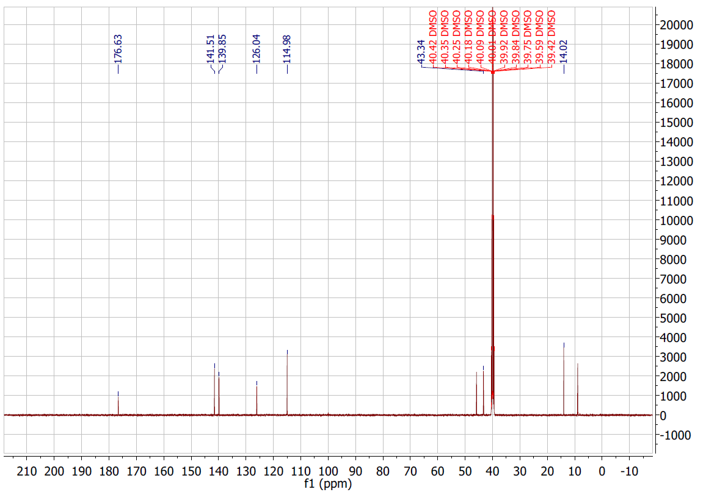

2c
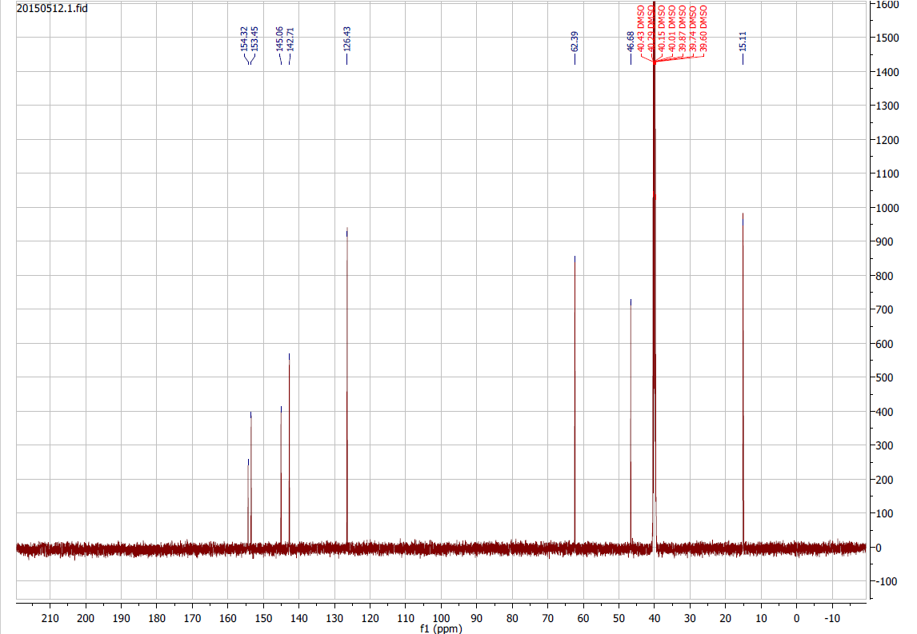

3e
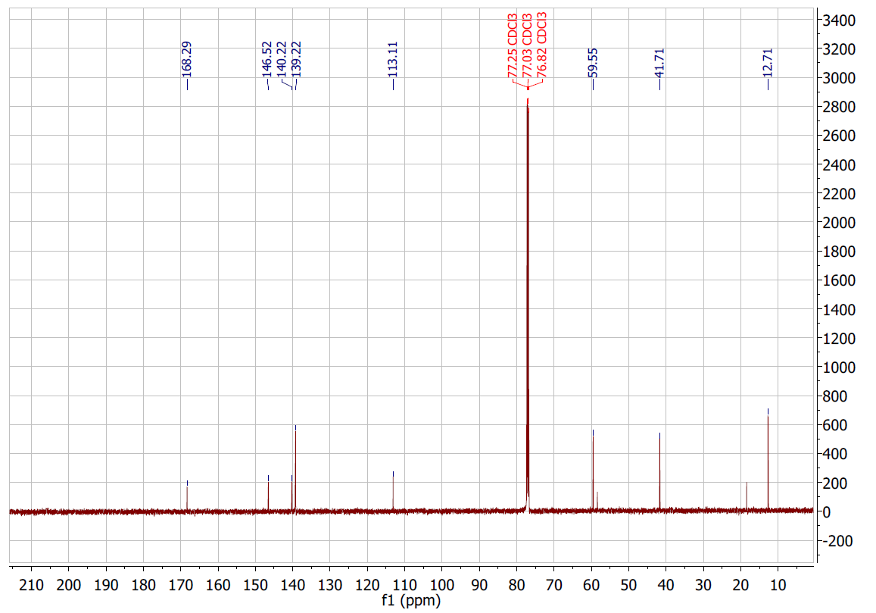

3f
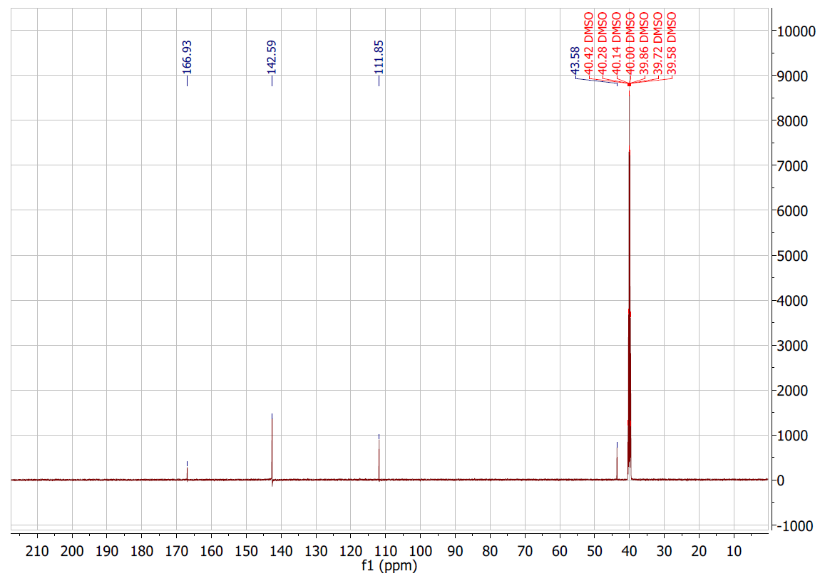

2g
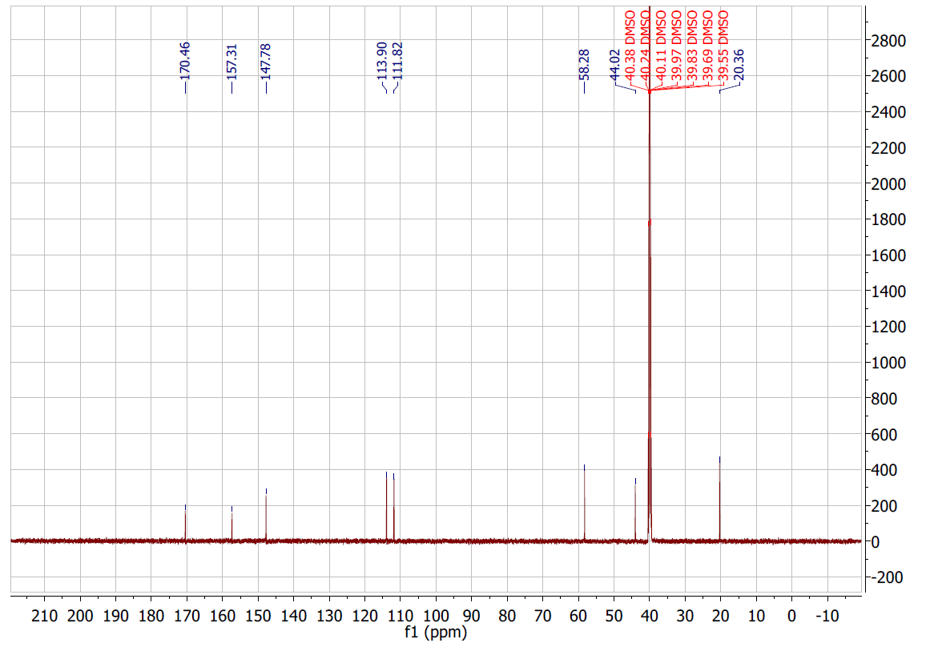

2h
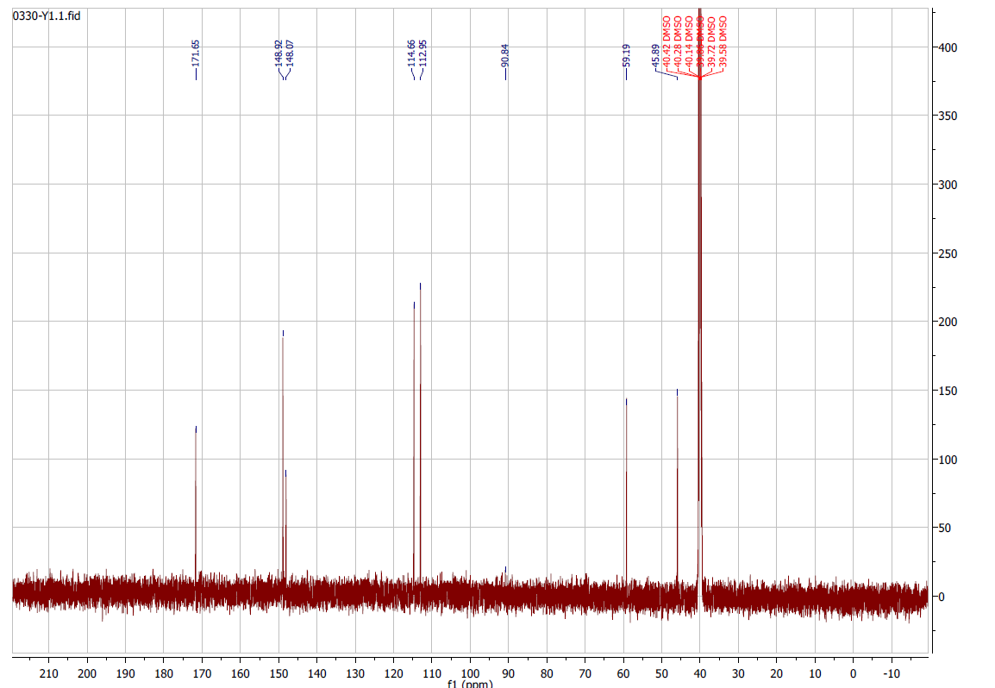

3h
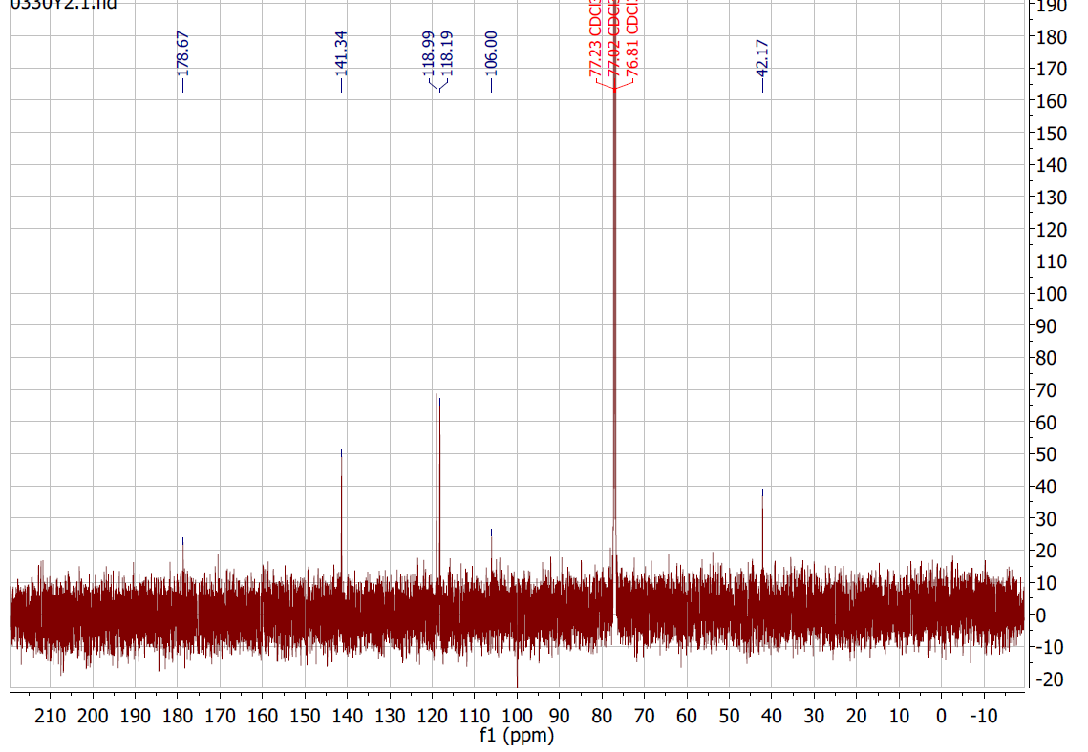

3i
