Supporting Information
Synthesis and anti-microbial evaluation of novel 3-(arylideneamino)-3a,8a-dihydroxy-1,3,3a,8a-tetrahydroindeno[1,2-d]imidazole-2,8-diones and their 2-thioxo analogues
Yeshwinder Saini¹ . Rajni Khajuria¹ . Ramneet Kaur¹ . Sanjana Kaul^{2**} . Tanwi Sharma² . Suruchi Gupta² . Vivek K. Gupta³ . Rajni Kant³ and Kamal K. Kapoor^{1,*}
¹ Department of Chemistry, University of Jammu, Jammu-180 006, India
² School of Biotechnology, University of Jammu, Jammu-180 006, India
³ Department of Physics & Electronics, University of Jammu, Jammu-180 006, India (X-ray crystallography group)
E-mail:* k2kapoor@yahoo.com ** sanrozie@rediffmail.com

EXPERIMENTAL
General
All the experiments were performed in an oven dried glass apparatus. All the commercially available reagents were purchased from Aldrich and were used without further purification. Melting points (°C) were measured in open glass capillaries using Perfit melting point apparatus and are uncorrected. The progress of reaction was monitored by thin layer chromatography (TLC) using silica gel pre-coated aluminum sheets (60 F254, Merck). Visualization of spots was effected by exposure to ultraviolet light (UV) at 365 nm and 254 nm, iodine vapours and 2% 2,4-dinitrophenylhydrazine solution in methanol containing few drops of H₂SO₄ and draggendroff reagent. IR spectra (ν, cm⁻¹) were recorded on Perkin-Elmer FTIR spectrophotometer using KBr discs. ¹H and ¹³C NMR were recorded on Bruker AC-400 spectrometer operating respectively at 400 MHz and 100 MHz with tetramethylsilane (TMS) as an internal standard. The chemical shifts are expressed in δ (ppm) downfield from TMS. J values are given in Hertz (Hz). The abbreviations s, bs, d, t, q and m in ¹H NMR spectra refer to singlet, broad singlet, doublet, triplet, quartet and multiplet respectively. Electron impact mass spectra (EIMS) were recorded on Micro Mass VG-7070 H mass spectrometer at 70eV. Elemental analysis was performed on Leco CHNS 932 analyzer. Solvents were removed using Heidolph rotary evaporator. Column chromatography was performed using a gradient of ethylacetate and petroleum ether.
The synthesized 3-(arylideneamino)-3a,8a-dihydroxy-1,3,3a,8a-tetrahydroindeno[1,2-d]
imidazole-2,8-diones 8(i-xiv) and 3-(arylideneamino)-3a,8a-dihydroxy-2-thioxo-1,3,3a,8a-tetrahydroindeno[1,2-d]imidazol-8(2H)-ones 9(i-xiv) were screened for their in vitro anti-bacterial activity using agar well diffusion method^{[1]}. The test pathogens used in the study included four gram positive bacteria [Bacillus subtilis (MTCC 441), Staphylococcus aureus (MTCC 3160), Klebsiellapneumoniae (MTCC 109), Bacillus cereus (MTCC 430)] and four gram negative bacteria [Escherichia coli (MTCC 40), Enterococcus faecalis (MTCC 439), Pseudomonas aeruginosa (MTCC 1934) and Pseudomonas alcaligenes (MTCC 493)]. For anti-bacterial assay, test pathogens were revived by growing overnight at 37°C and 100 rpm. Test compounds were prepared by dissolving in DMSO at concentrations of 100μg/ml, 250μg/ml, 500μg/ml, 750μg/mland 1000μg/ml whereas the standard drug chloramphenicol was used at a concentration of 100 μg/ml. DMSO was used as negative control. Sterile petri-plates were poured with 35ml of Nutrient agar medium. 100 μl of bacterial suspension was spread on the solidified plates. Wells were bored in the plates with the help of borer of 6 mm diameter. 100 μl of prepared compounds were added to labeled wells. Results were observed as diameter of zone of inhibition after incubating the plates at 37°C overnight.
Anti-fungal activity of these compounds was evaluated against Fusarium oxysporum (MTCC 2485) and Alternaria alternata (MTCC 2724) by poison food technique^{[2]}. 1000 μg of each compound was added in sterile luke warm Potato dextrose agar medium before pouring. Fungal agar plug of five days old test culture was placed at the centre of the medium plate. Plates were incubated at 28ºC for seven days. Percentage inhibition of fungal culture in presence of test compounds was assessed by comparing mycelia growth diameter on poisoned (media + compound) and non-poisoned (media + DMSO) plates and calculated using the formula
% age inhibition= [(R1- R2)/ R1] × 100
R1 means radial growth of test fungi in non-poisoned plate; R2 means radial growth of same in poisoned plate.
General procedure for the synthesis of 8(i-xiv) and 9(i-xiv)
A mixture of aldehyde (5i-5xiv, 1mmol) and semicarbazide hydrochloride 6(i) (0.11g, 1mmol)/thiosemicarbazide 6(ii) (0.09g, 1mmol) in 1,4-dioxane (10 ml) was refluxed for the time mentioned in Scheme 2 to achieve the complete formation of the desired semicarbazones/thiosemicarbazones (TLC). At this stage, ninhydrin (0.21g, 1.2 mmol) was added to the reaction mixture and refluxing was continued till the completion of reaction (time given in Scheme2). The reaction mixture was poured into ice-cold water (50 ml) and kept in refrigerator overnight. The solid separated was filtered, dried and column chromatographed to obtain the pure product [8(i-xiv); 9(i-xiv); 78-93% yield].

Spectral data of the synthesized compounds
3-(Benzylideneamino)-3a,8a-dihydroxy-1,3,3a,8a-tetrahydroindeno[1,2-d]imidazole-2,8-dione (8i); white solid; m.p: 185 °C; ¹H NMR (400 MHz, DMSO-d₆) δ 9.02 (bs, 2H), 7.98 – 7.77 (m, 3H), 7.72 -7.63 (m, 4H), 7.53 – 7.34 (m, 3H), 7.05 (bs, 1H); ¹³C NMR (100 MHz, DMSO-d₆) δ 195.5, 152.6, 151.6, 145.7, 137.7, 135.5, 132.1, 131.1, 130.1, 129.2, 127.1, 125.5, 124.2, 89.8, 84.5; IR (KBr)ν_{max}/cm⁻¹: 3365.78, 1724.36, 1695.48; Anal. calcd. for C₁₇H₁₃N₃O₄ : C, 63.16; H, 4.05; N, 13.00; found C, 63.12; H, 4.07; N, 12.96; ESI-MS m/z : [M+H]⁺ = 324.
3a,8a-Dihydroxy-3-((2-hydroxbenzylidene)amino)-1,3,3a,8a-tetrahydroindeno[1,2-d]imidazole-2,8-dione (8ii); white solid; m.p: 220 °C; ¹H NMR (400 MHz, DMSO-d₆) δ 11.20 (bs, 1H), 9.18 (bs, 2H), 8.05 – 7.73 (m, 4H), 7.70-7.65 (d, J = 4 Hz, 1H), 7.49-7.43 (d, J = 8 Hz, 1H), 7.31-7.25 (d, J = 4 Hz, 1H), 7.15 (bs, 1H), 6.96-6.90 (d, J = 8 Hz, 2H); ¹³C NMR (100 MHz, DMSO-d₆)δ 195.3, 157.7, 152.2, 151.7, 148.2, 137.8, 132.1, 131.4, 131.2, 130.4, 125.5, 124.3, 119.8, 119.2, 117.0, 89.3, 84.7; IR (KBr)ν_{max}/cm⁻¹: 3217.27, 1747.51, 1698.58; Anal. calcd. for C₁₇H₁₃N₃O₅: C, 60.18; H, 3.86; N, 12.38; found C, 60.26; H, 3.89; N, 12.34; ESI-MS m/z: [M+H]⁺ = 340.
3a,8a-Dihydroxy-3-((4-methylbenzylidene)amino)-1,3,3a,8a-tetrahydroindeno[1,2-d]imidazole-2,8-dione (8iii); white solid; m.p: 213 °C;¹H NMR (400 MHz, DMSO-d₆) δ 9.20 (s, 1H), 8.79 (s, 1H), 8.16-8.10 (d, J = 8 Hz, 1H), 7.97-7.89 (m, 1H), 7.88–7.78 (m, 1H), 7.72–7.60 (m, 3H), 7.31-7.23 (m, 3H), 7.03 (s, 1H), 2.35 (s, 3H); ¹³C NMR (100 MHz, DMSO-d₆)δ 197.5, 153.2, 149.8, 149.6, 140.1, 136.9, 132.8, 131.0, 129.9, 129.7, 127.2, 127.1, 124.1, 89.0, 84.0, 21.5; IR (KBr)ν_{max}/cm⁻¹: 3365.78, 1726.29, 1697.36;Anal. calcd. for C₁₈H₁₅N₃O₄ : C, 64.09; H, 4.48; N, 12.46; found C, 64.12; H, 4.50; N, 12.48; ESI-MS m/z: [M+H]⁺ = 338.
3a,8a-Dihydroxy-3-((4-methoxybenzylidene)amino)-1,3,3a,8a-tetrahydroindeno[1,2-d]imidazole-2,8-dione (8iv);white solid; m.p: 215 °C; ¹H NMR (400 MHz, DMSO-d₆) δ 8.95 (s, 1H), 8.90 (s, 1H), 7.95-7.82 (m, 1H), 7.81- 7.74 (m, 2H), 7.71 – 7.54 (m, 4H), 7.06 – 6.92 (m, 3H), 3.81 (s, 3H); ¹³C NMR (100 MHz, DMSO-d₆) δ 195.6, 160.9, 152.7, 151.7, 146.0, 137.6, 132.2, 131.0, 128.6, 128.1, 125.4, 124.2, 114.7, 89.8, 84.5, 55.7; IR (KBr)ν_{max}/cm⁻¹: 3350.35, 1724.36, 1697.21;Anal. calcd. for C₁₈H₁₅N₃O₅ : C, 61.19; H, 4.28; N, 11.89; found C, 61.14; H, 4.27; N, 11.93;ESI-MS m/z: [M+H]⁺ = 354.
3a,8a-Dihydroxy-3-((3-methoxybenzylidene)amino)-1,3,3a,8a-tetrahydroindeno[1,2-d]imidazole-2,8-dione (8v); white solid; m.p: 189 °C; ¹H NMR (400 MHz, DMSO-d₆) δ 9.23 (bs, 1H), 8.99 (bs, 1H), 8.84 (bs, 1H), 8.17 – 7.75 (m, 3H), 7.66 (bs, 1H), 7.50 – 6.90 (m, 5H), 4.0-3.75 (d, J = 12 Hz, 3H); ¹³C NMR (100 MHz, DMSO-d₆) δ 195.5, 152.5, 151.7, 149.0, 145.5, 137.7, 137.0, 132.1, 131.1, 130.3, 125.5, 124.1, 120.0, 116.2, 111.8, 111.2, 89.8, 84.5, 55.6; IR (KBr)ν_{max}/cm⁻¹: 3298.31, 1719.30, 1691.42;Anal. calcd. for C₁₈H₁₅N₃O₅ : C, 61.19; H, 4.28; N, 11.89; found C, 61.17; H, 4.29; N, 11.91; ESI-MS m/z: [M+H]⁺ = 354.
3-((4-Chlorobenzylidene)amino)-3a,8a-dihydroxy-1,3,3a,8a-tetrahydroindeno[1,2-d]imidazole-2,8-dione (8vi);white solid; m.p:200 °C; ¹H NMR (400 MHz, DMSO-d₆) δ 9.05 (s, 1H), 9.00 (s, 1H), 7.96-7.89 (m, 1H), 7.83-7.76 (m, 2H), 7.74 – 7.63 (m, 4H), 7.54-7.48 (d, J = 8 Hz, 2H), 7.05 (bs, 1H); ¹³C NMR (100 MHz, DMSO-d₆) δ 195.5, 152.5, 151.6, 144.2, 137.7, 134.4, 132.1, 131.1, 129.3, 128.7, 125.5, 124.3, 89.7, 84.5; IR (KBr)ν_{max}/cm⁻¹: 3377.30, 1717.23, 1689.95;Anal. calcd. for C₁₇H₁₂ClN₃O₄ : C, 57.07; H, 3.38; N, 11.75;found C, 57.11; H, 3.37; N, 11.76; ESI-MS m/z: [M+H]⁺ = 358, 360.
3-((2-Chlorobenzylidene)amino)-3a,8a-dihydroxy-1,3,3a,8a-tetrahydroindeno[1,2-d]imidazole-2,8-dione (8vii); white solid; m.p: 190 °C; ¹H NMR (400 MHz, DMSO-d₆) δ 9.44 (bs, 1H), 9.11 (bs, 1H), 8.02 – 7.36 (m, 9H), 7.09 (bs, 1H); ¹³C NMR (100 MHz, DMSO-d₆) δ 195.3, 170.8, 152.4, 151.6, 141.6, 137.7, 133.5, 132.9, 132.1, 131.1, 130.3, 127.8, 126.9, 125.5, 124.3, 89.7, 84.5; IR (KBr)ν_{max}/cm⁻¹: 3298.43, 1729.78, 1697.66;Anal. calcd. for C₁₇H₁₂ClN₃O₄ : C, 57.07; H, 3.38; N, 11.75; found C, 57.09; H, 3.40; N, 11.78; ESI-MS m/z: [M+H]⁺ = 358, 360.
3-((4-Bromobenzylidene)amino)-3a,8a-dihydroxy-1,3,3a,8a-tetrahydroindeno[1,2-d]imidazole-2,8-dione 8viii); pale yellow solid; m.p: 165 °C; ¹H NMR (400 MHz, DMSO-d₆) δ 9.02-8.90 (d, J = 8 Hz, 2H), 7.87-7.80 (d, J = 4 Hz, 2H), 7.77-7.71 (d, J = 8 Hz, 1H), 7.65 – 7.50 (m, 6H), 6.90 (s, 1H); ¹³C NMR (100 MHz, DMSO-d₆) δ 195.1, 152.7, 151.4, 144.4, 137.3, 134.7, 132.2, 131.9, 131.5, 130.7, 128.8, 125.3, 124.1, 123.2, 89.7, 84.5; IR (KBr)ν_{max}/cm⁻¹: 3309.32, 1750.91, 1701.88;Anal. calcd. for C₁₇H₁₂BrN₃O₄ : C, 50.77; H, 3.01; N, 10.45; found C, 50.75; H, 3.04; N, 10.46; ESIMS m/z: [M+H]⁺ = 402, 404.
3a,8a-Dihydroxy-3-((4-nitrobenzylidene)amino)-1,3,3a,8a-tetrahydroindeno[1,2-d]imidazole-2,8-dione (8ix); white solid; m.p: 225 °C; ¹H NMR (400 MHz, DMSO-d₆) δ 9.42 (bs, 1H), 9.04 (bs, 1H), 8.33-8.25 (d, J = 4 Hz, 2H), 8.17 – 8.02 (m, 3H), 7.95 – 7.84 (m, 2H), 7.83-7.65 (m, 2H), 7.19 (bs, 1H); ¹³C NMR (100 MHz, DMSO-d₆) δ 197.3, 152.8, 149.4, 148.1, 145.7, 142.0, 137.2, 132.8, 131.3, 128.0, 127.0, 124.5, 124.3, 89.0, 84.0; IR (KBr)ν_{max}/cm⁻¹: 3378.21, 1739.48, 1710.60;Anal. calcd. for C₁₇H₁₂N₄O₆ : C, 55.44; H, 3.28; N, 15.21; found C, 53.45; H, 3.31; N, 15.15; ESIMS m/z : [M+H]⁺ = 369.
3a,8a-Dihydroxy-3-((3-nitrobenzylidene)amino)-1,3,3a,8a-tetrahydroindeno[1,2-d]imidazole-2,8-dione (8x); white solid; m.p: 218 °C; ¹H NMR (400 MHz, DMSO-d₆) δ 9.14 (bs, 2H), 8.50 (s, 1H), 8.27-8.22 (d, J = 4 Hz, 1H), 8.12-8.06 (d, J = 8 Hz, 1H), 7.98-7.91 (t, J = 8 Hz, 1H), 7.88 – 7.72 (m, 4H), 7.70-7.62 (m, 1H), 7.10 (bs, 1H); ¹³C NMR (100 MHz, DMSO-d₆) δ 195.4, 152.3, 151.7, 148.7, 143.0, 137.8, 137.3, 133.7, 132.0, 131.1, 130.9, 125.5, 124.3, 124.3, 120.5, 89.7, 84.5; IR (KBr)ν_{max}/cm⁻¹: 3329.31, 1738.59, 1709.48;Anal. calcd. for C₁₇H₁₂N₄O₆ : C, 55.44; H, 3.28; N, 15.21; found C, 55.41; H, 3.31; N, 15.19; ESI-MS m/z : [M+H]⁺ = 369.
3a,8a-Dihydroxy-3-((3,4,5-trimethoxybenzylidene)amino)-1,3,3a,8a-tetrahydroindeno[1,2-d]imidazole-2,8-dione (8xi);pale yellow solid; m.p: 225 °C;¹H NMR (400 MHz, DMSO-d₆) δ 9.01 (s, 1H), 8.93 (s, 1H), 8.01 – 7.74 (m, 3H), 7.70-7.58 (d, J = 4 Hz, 2H), 7.1-6.91 (m, 3H), 3.84 (s, 6H), 3.71 (s, 3H); ¹³C NMR (100 MHz, DMSO-d₆) δ 195.4, 153.6, 152.7, 151.6, 145.9, 139.3, 137.7, 132.1, 131.1, 125.4, 124.2, 104.3, 89.8, 84.5, 60.6, 56.4; IR (KBr)ν_{max}/cm⁻¹: 3259.98, 1738.09, 1710.65; Anal. calcd. for C₂₀H₁₉N₃O₇ : C, 58.11; H, 4.63; N, 10.16; found C, 58.13; H, 4.67; N, 10.12; ESI-MS m/z : [M+H]⁺ = 414.
3a,8a-Dihydroxy-3-((napthalen-1-ylmethylene)amino)-1,3,3a,8a-tetrahydroindeno[1,2-d]imidazole-2,8-dione (8xii); white solid; m.p: 157 °C; ¹H NMR (400 MHz, DMSO-d₆) δ 9.78 (s, 1H), 9.09 (s, 1H), 8.79-8.72 (d, J = 8 Hz, 1H), 8.07 – 7.82 (m, 6H), 7.79 (s, 1H), 7.73 – 7.56 (m, 4H), 7.09 (s, 1H); ¹³C NMR (100 MHz, DMSO-d₆) δ 195.9, 170.8, 152.6, 151.8, 144.4, 137.8, 133.9, 132.2, 131.1, 130.9, 130.4, 129.2, 127.5, 126.6, 126.0, 125.5, 124.4, 124.1, 90.0, 84.7, 60.2; IR (KBr)ν_{max}/cm⁻¹: 3321.65, 1743.59, 1716.98;Anal. calcd. for C₂₁H₁₅N₃O₄ : C, 67.56; H, 4.05; N, 11.25;found C, 67.54; H, 4.07; N, 11.26; ESI-MS m/z : [M+H]⁺ = 374.
3-((Furan-2-ylmethylene)amino)-3a,8a-dihydroxy-1,3,3a,8a-tetrahydroindeno[1,2-d]imidazole-2,8-dione; (8xiii); pale yellow solid; m.p: 218 °C; ¹H NMR (400 MHz, DMSO-d₆) δ 8.99 (bs, 1H), 8.89 (s, 1H), 8.05 – 7.58 (m, 6H), 6.86 (bs, 1H), 6.85 (d, J = 4 Hz, 1H), 6.62 (s, 1H); ¹³C NMR (100 MHz, DMSO-d₆) δ 195.5, 152.4, 151.7, 150.4, 145.0, 137.7, 135.8, 132.0, 131.1, 125.5, 124.3, 112.9, 112.5, 89.8, 84.5; IR (KBr)ν_{max}/cm⁻¹: 3425.23, 1739.22, 1721.43; Anal. calcd. for C₁₅H₁₁N₃O₅ : C, 57.51; H, 3.54; N, 13.41;found C, 57.49; H, 3.51; N, 13.40; ESI-MS m/z : [M+H]⁺ = 314.
3-(((6-Bromobenzo[d][1,3]dioxol-5-yl)methylene)amino)-3a,8a-dihydroxy-1,3,3a,8a-tetrahydroindeno
[1,2-d]imidazole-2,8-dione (8xiv); pale yellow solid; m.p: 240 °C; ¹H NMR (400 MHz, DMSO-d₆) δ 9.55 (s, 1H), 8.89 (s, 1H), 8.10-8.03 (d, J = 4 Hz, 1H), 7.96-7.89 (t, J = 8 Hz, 1H), 7.86-7.78 (d, J = 8 Hz, 1H), 7.70-7.63 (t, J = 8 Hz, 1H), 7.59 (s, 1H), 7.44 (s, 1H), 7.30 (s, 1H), 7.07 (s, 1H), 6.21 – 6.11 (t, J = 8 Hz, 2H); ¹³C NMR (100 MHz, DMSO-d₆) δ 197.4, 153.0, 150.3, 149.6, 148.3, 147.0, 137.1, 132.7, 131.1, 128.0, 126.8, 124.2, 116.1, 112.9, 105.4, 102.9, 88.8, 84.0; IR (KBr)ν_{max}/cm⁻¹: 3367.45, 1716.09, 1687.54; Anal. calcd. for C₁₈H₁₂BrN₃O₆ : C, 48.45; H, 2.71; N, 9.42; found C, 48.42; H, 2.65: N, 9.45; ESI-MS m/z : [M+H]⁺ = 446, 448.
3-(Benzylideneamino)-3a,8a-dihydroxy-2-thioxo-1,3,3a,8a-tetrahydroindeno[1,2-d]imidazol-8(2H)-one (9i); yellow crystalline solid; m.p: 203 °C; ¹H NMR (400 MHz, DMSO-d₆) δ 10.28 (bs, 1H), 9.58 (s, 1H), 8.14-8.07 (d, J = 8 Hz, 1H), 7.97 – 7.86 (m, 4H), 7.79-7.69 (d, J = 8.0 Hz, 2H), 7.55 (s, 3H), 7.40 (bs, 1H); ¹³C NMR (100 MHz, DMSO-d₆) δ 196.1, 174.9, 156.1, 148.4, 137.3, 134.4, 133.2, 131.5, 131.4, 129.4, 128.1, 127.4, 124.3, 92.7, 86.8; IR (KBr)ν_{max}/cm⁻¹: 3365.32, 1711.14, 1707.34,1285.10; Anal. calcd. for C₁₇H₁₃N₃O₃S : C, 60.17; H, 3.86; N, 12.38; S, 9.45; found C, 60.01; H, 3.69; N, 12.84; S, 9.61; ESI-MS m/z : [M+H]⁺ = 340.
3a,8a-Dihydroxy-3-((2-hydroxybenzylidene)amino)-2-thioxo-1,3,3a,8a-tetrahydroindeno[1,2-d]imidazol-8(2H)-one (9ii); white solid; m.p: 220 °C;¹H NMR (400 MHz, DMSO-d₆) δ 11.49 (s, 1H), 11.01 (bs, 1H), 9.28 (s, 1H), 8.33 (bs, 1H), 8.08-7.99 (d, J = 8 Hz, 1H), 7.97-7.85 (m, 2H), 7.78-7.70 (d, J = 8 Hz, 1H), 7.65 – 7.46 (m, 2H), 7.42-7.33 (d, J = 8 Hz, 1H), 7.06-6.92 (m, 2H); ¹³C NMR (100 MHz, DMSO-d₆) δ 194.3, 176.1, 157.8, 150.5, 149.2, 138.3, 132.2, 132.0, 131.6, 131.4, 125.9, 124.7, 119.9, 118.5, 117.3, 92.1, 88.5; IR (KBr)ν_{max}/cm⁻¹: 3292.21, 1720.17, 1680.46, 1276.44; Anal. calcd. for C₁₇H₁₃N₃O₄S : C, 57.46; H, 3.69; N, 11.82; S, 9.02; found C, 57.69; H, 3.83; N, 11.78; S, 9.26; ESI-MS m/z : [M+H]⁺= 356.
3a,8a-Dihydroxy-3-((4-methylbenzylidene)amino)-2-thioxo-1,3,3a,8a-tetrahydroindeno[1,2-d]imidazol-8(2H)-one (9iii); light brown solid; m.p: 232 °C; ¹H NMR (400 MHz, DMSO-d₆) δ 8.96 (s, 1H), 7.95-7.43 (m, 10H), 7.12 (s, 1H), 2.31(s, 3H); ¹³C NMR (100 MHz, DMSO-d₆) δ 195.4, 177.2, 149.3, 147.6, 144.2, 138.0, 137.5, 134.1, 131.9, 131.2, 129.8, 126.3, 125.8, 125.4, 124.4, 89.7, 84.5, 21.4; IR (KBr)ν_{max}/cm⁻¹: 3358.81, 1710.66, 1683.20, 1281.43; Anal. calcd. for C₁₈H₁₅N₃O₃S : C, 61.18; H, 4.28; N, 11.89; S, 9.07; found C, 60.90; H, 4.46; N, 12.05; S, 9.30; ESI-MS m/z : [M+H]⁺= 354.
3a,8a-Dihydroxy-3-((4-methoxybenzylidene)amino)-2-thioxo-1,3,3a,8a-tetrahydroindeno[1,2-d]imidazol-8(2H)-one (9iv); brown solid; m.p: 241 °C; ¹H NMR (400 MHz, DMSO-d₆) δ 15.06 (bs, 1H), 11.34 (s, 1H), 8.2-8.08 (d, J = 8 Hz, 2H), 8.05 – 7.88 (m, 4H), 7.8-7.67 (d, J = 8 Hz, 2H), 7.03-6.89 (d, J = 8 Hz, 2H), 3.79 (s, 3H); ¹³C NMR (100 MHz, DMSO-d₆) δ 182.7, 178.0, 161.9, 161.1, 142.6, 139.8, 137.8, 137.2, 136.2, 129.3, 127.1, 124.97, 124.8, 114.6, 89.3, 84.3, 55.7; IR (KBr)ν_{max}/cm⁻¹: 3439.41, 1730.48, 1685.34, 1253.09; Anal. calcd. for C₁₈H₁₅N₃O₄S : C, 58.53; H, 4.09; N, 11.38; S, 8.68; found C, 58.86; H, 3.82; N, 11.60; S, 8.85; ESI-MS m/z : [M+H]⁺=370.
3a,8a-dihydroxy-3-((3-methoxybenzylidene)amino)-2-thioxo-1,3,3a,8a-tetrahydroindeno[1,2-d]imidazol-8(2H)-one (9v); white solid; m.p: 234 °C; ¹H NMR (400 MHz, DMSO-d₆) δ 8.98 (s, 1H), 8.87 (s, 1H), 7.92 – 7.86 (d, J = 8 Hz, 1H), 7.85-7.74 (m, 3H), 7.68-7.60 (d, J = 8 Hz, 3H), 7.16 (bs, 1H), 7.02-6.94 (d, J = 8 Hz, 2H), 3.75 (s, 3H); ¹³C NMR (100 MHz, DMSO-d₆) δ 195.6, 178.0, 161.0, 151.1, 146.7, 138.1, 131.8, 131.4, 129.0, 127.6, 125.2, 124.4, 114.7, 89.9, 84.5, 55.6; IR (KBr)ν_{max}/cm⁻¹: 3321.12, 1745.21, 1708.22,1365.60;Anal. calcd. for C₁₈H₁₅N₃O₄S : C, 58.53; H, 4.09; N, 11.38; S, 8.68; found C, 58.47; H, 3.99; N, 11.33; S, 8.61;ESI-MS m/z : [M+H]⁺= 370.
3-((4-Chlorobenzylidene)amino)-3a,8a-dihydroxy-2-thioxo-1,3,3a,8a-tetrahydroindeno[1,2-d]imidazol-8(2H)-one (9vi); white solid; m.p: 250 °C; ¹H NMR (400 MHz, DMSO-d₆) δ 10.36 (s, 1H), 9.64 (s, 1H), 8.13-8.07 (d, J = 8 Hz, 1H), 7.96 – 7.90 (t, J = 4 Hz, 3H), 7.89 – 7.82 (m, 2H), 7.74-7.68 (t, J = 8 Hz, 1H), 7.62-7.57 (d, J = 8 Hz, 2H), 7.43 (s, 1H); ¹³C NMR (100 MHz, DMSO-d₆) δ 196.0, 175.1, 153.7, 148.5, 137.4, 135.8, 133.4, 133.1, 131.6, 129.7, 129.5, 127.43, 124.3, 92.8, 86.8; IR (KBr)ν_{max}/cm⁻¹: 3388.91, 1718.24, 1635.23, 1286.22; Anal. calcd. for C₁₇H₁₂ClN₃O₃S : C, 54.62; H, 3.24; N, 11.24; S, 8.58; found C, 54.34; H, 3.41; N, 11.01; S, 8.77; ESI-MS m/z : [M+H]⁺= 374, 376.

3-((2-Chlorobenzylidene)amino)-3a,8a-dihydroxy-2-thioxo-1,3,3a,8a-tetrahydroindeno[1,2-d]imidazol-8(2H)-one (9vii); white solid; m.p: 242 °C; ¹H NMR (400 MHz, DMSO-d₆) δ 11.61 (s, 1H), 8.45 (s, 1H), 8.26-8.21 (d, J = 8 Hz, 2H), 8.11 – 7.99 (m, 4H), 7.64 (s, 1H), 7.54 – 7.32 (m, 3H); ¹³C NMR (100 MHz, DMSO-d₆) δ 197.5, 178.5, 171.2, 139.0, 138.8, 137.8, 133.6, 131.8, 131.6, 130.2, 127.9, 127.7, 124.4, 87.9, 79.4; IR (KBr)ν_{max}/cm⁻¹: 3381.11, 1716.09, 1644.34, 1280.09; Anal. calcd. for C₁₇H₁₂ClN₃O₃S : C, 54.62; H, 3.24; N, 11.24; S, 8.58; found C, 54.48; H, 3.42; N, 11.07; S, 8.49; ESI-MS m/z : [M+H]⁺=374, 376.
3-((4-Bromobenzylidene)amino)-3a,8a-dihydroxy-2-thioxo-1,3,3a,8a-tetrahydroindeno[1,2-d]imidazol-8(2H)-one (9viii);light brown solid; m.p: 258 °C; ¹H NMR (400 MHz, DMSO-d₆) δ 8.32 (s, 2H), 8.26 (s, 1H), 8.10-7.95 (m, 3H), 7.90-7.57 (m, 6H); ¹³C NMR (100 MHz, DMSO-d₆) δ 197.4, 175.9, 147.1, 143.9, 137.1, 134.1, 131.2, 129.9, 126.9, 126.4, 126.3, 125.9, 125.8, 124.2, 89.6, 84.0 ; IR (KBr)ν_{max}/cm⁻¹: 3320.55, 1710.98, 1635.08, 1289.10; Anal. calcd. for C₁₇H₁₂BrN₃O₃S : C, 48.82; H, 2.89; N, 10.05; S, 7.67; found C, 48.67; H, 3.10; N, 9.85; S, 7.49; ESI-MS m/z : [M+H]⁺= 417, 419.
3a,8a-Dihydroxy-3-((4-nitrobenzylidene)amino)-2-thioxo-1,3,3a,8a-tetrahydroindeno[1,2-d]imidazol-8(2H)-one (9ix); pale yellow solid; m.p: 212 °C; ¹H NMR (400 MHz, DMSO-d₆) δ 9.42 (s, 1H), 9.04 (s, 1H), 8.35-8.25 (d, J = 12 Hz, 2H), 8.16-8.11 (d, J = 8 Hz, 1H), 8.09-8.03 (d, J = 8 Hz, 2H), 7.95-7.88 (t, J = 8 Hz, 1H), 7.86-7.80 (d, J = 8 Hz, 1H), 7.72-7.64 (t, J = 8 Hz, 1H), 7.61-7.50 (bs, 1H), 7.18 (bs, 1H); ¹³C NMR (100 MHz, DMSO-d₆) δ 197.3, 177.8, 149.4, 148.1, 145.7, 142.0, 137.2, 132.7, 131.3, 128.0, 126.9, 124.5, 124.2, 89.0, 84.0; IR (KBr)ν_{max}/cm⁻¹: 3323.05, 1726.29, 1642.85, 1261.45; Anal. calcd. for C₁₇H₁₂N₄O₅S : C, 53.12; H, 3.15; N, 14.58; S, 8.34; found C, 52.98; H, 2.99; N, 14.46; S, 8.39; ESI-MS m/z : [M+H]⁺= 385.
3a,8a-Dihydroxy-3-((3-nitrobenzylidene)amino)-2-thioxo-1,3,3a,8a-tetrahydroindeno[1,2-d]imidazol-8
(2H)-one (9x); pale yellow solid; m.p: 201 °C; ¹H NMR (400 MHz, DMSO-d₆) δ 10.87 (s, 1H), 9.25 (s, 1H), 8.53 (s, 1H), 8.32 – 8.27 (d, 8 Hz, 1H), 8.24 (s, 1H), 8.18-8.12 (d, J = 8 Hz, 1H), 8.03-7.96 (t, J = 8 Hz, 1H), 7.93-7.87 (d, J = 8 Hz, 1H), 7.85 – 7.75 (m, 2H),7.73-7.67 (m, 1H), 7.48 (s, 1H); ¹³C NMR (100 MHz, DMSO-d₆) δ 197.5, 178.6, 148.7, 140.7, 138.8, 137.8, 136.44, 133.9, 132.1, 130.6, 124.5, 124.3, 121.8, 92.3, 87.9; IR (KBr)ν_{max}/cm⁻¹: 3342.64, 1740.22, 1699.26, 1292.21;Anal. calcd. for C₁₇H₁₂N₄O₅S : C, 53.12; H, 3.15; N, 14.58; S, 8.34; found C, 53.19; H, 3.23; N, 14.50; S, 8.29; ESI-MS m/z : [M+H]⁺= 385.
3a,8a-Dihydroxy-2-thioxo-3-((3,4,5-trimethoxybenzylidene)amino)-1,3,3a,8a-tetrahydroindeno[1,2-d]imidazol-8(2H)-one (9xi ); pale yellow solid; m.p: 238 °C; ¹H NMR (400 MHz, DMSO-d₆) δ 9.07 (s, 1H), 8.84 (s, 1H), 8.02-7.97 (d, J = 8 Hz, 1H), 7.94 – 7.75 (m, 4H), 7.66 – 7.61 (m, 1H), 7.06 (s, 2H), 3.78 (s, 6H), 3.66 (s, 3H);¹³C NMR (100 MHz, DMSO-d₆) δ 195.5, 175.8, 150.8, 146.5, 139.0, 138.4, 138.0, 131.7, 131.5, 130.7, 125.1, 124.5, 124.4, 104.6, 89.9, 84.6, 60.8, 56.3;IR (KBr)ν_{max}/cm⁻¹: 3076.23, 1724.43, 1670.90, 1296.29; Anal. calcd. for C₂₀H₁₉N₃O₆S : C, 55.94; H, 4.46; N, 9.78; S, 7.47; found C, 56.19; H, 4.23; N, 9.95; S, 7.29; ESI-MS m/z : [M+H]⁺= 430.
3a,8a-Dihydroxy-3-((napthalen-1-ylmethylene)amino)-2-thioxo-1,3,3a,8a-tetrahydroindeno[1,2-d]imidazol-8(2H)-one (9xii);white solid; m.p: 240 °C;¹H NMR (400 MHz, DMSO-d₆) δ 10.82 (s, 1H), 9.87 (s, 1H), 9.16-9.04 (d, J = 8 Hz, 1H), 8.25 (s, 1H), 8.12 – 7.87 (m, 6H), 7.78-7.62 (m, 4H), 7.48 (s, 1H); ¹³C NMR (100 MHz, DMSO-d₆) δ 194.8, 177.0, 150.7, 147.4, 138.2, 134.0, 132.3, 131.5, 131.1, 130.8, 130.4, 129.2, 127.8, 126.7, 126.0, 125.94, 125.0, 124.6, 92.5, 88.3; IR (KBr)ν_{max}/cm⁻¹: 3433.51, 1727.22, 1687.02, 1288.04; Anal. calcd. for C₂₁H₁₅N₃O₃S : C, 64.77; H, 3.88; N, 10.79; S, 8.23; found C, 64.93; H, 4.03; N, 10.58; S, 8.41; ESI-MS m/z : [M+H]⁺= 390.

3-((Furan-2-yl-methylene)amino)-3a,8a-dihydroxy-2-thioxo-1,3,3a,8a-tetrahydroindeno[1,2-d]imidazol-8(2H)-one (9xiii); brown crystalline solid; m.p: 175 °C; ¹H NMR (400 MHz, DMSO-d₆) δ 10.65 (s, 1H), 9.05 (s, 1H), 8.08 (s, 1H), 8.03-7.95 (m,1H), 7.91-7.86 (d, J = 8 Hz, 2H), 7.84-7.80 (d, J = 8 Hz, 1H), 7.71-7.65 (m, 1H), 7.37 (s, 1H), 6.98-6.93 (d, J = 4 Hz, 1H), 6.67 (s, 1H); ¹³C NMR (100 MHz, DMSO-d₆) δ 194.4, 176.6, 150.6, 149.9, 145.7, 138.4, 138.1, 132.2, 131.4, 125.8, 124.5, 114.4, 112.7, 92.4, 87.8; IR (KBr)ν_{max}/cm⁻¹: 3525.51, 1728.61, 1674.34, 1290.06; Anal. calcd. for C₁₅H₁₁N₃O₄S : C, 54.71; H, 3.37; N, 12.76; S, 9.74; found C, 54.50; H, 3.56; N, 12.59; S, 9.56; ESI-MS m/z : [M+H]⁺=330.
3-(((6-Bromobenzo[d][1,3]dioxol-5-yl)methylene)amino)-3a,8a-dihydroxy-2-thioxo-1,3,3a,8a-tetrahydroindeno[1,2-d]imidazol-8(2H)-one (9xiv); pale yellow solid; m.p: 246 °C; ¹H NMR (400 MHz, DMSO-d₆) δ 10.75 (s, 1H), 9.46 (s, 1H), 8.08 – 7.81 (m, 4H), 7.74-7.63 (m, 1H), 7.46-7.35 (m, 2H), 7.33 (s, 1H), 6.15 (s, 2H); ¹³C NMR (100 MHz, DMSO-d₆) δ 194.2, 176.6, 150.5, 148.1, 146.1, 138.0, 132.3, 131.5, 127.9, 125.8, 124.5, 116.4, 113.0, 105.7, 103.0, 92.2, 87.9; IR (KBr)ν_{max}/cm⁻¹: 3508.61, 1748.96, 1698.29, 1248.16; Anal. calcd. for C₁₈H₁₂BrN₃O₅S : C, 46.77; H, 2.62; N, 9.09; S, 6.94; found C, 46.67; H, 2.56; N, 8.99;S, 6.86; ESI-MS m/z : [M+H]⁺ = 462, 464.
X-ray crystallography
The crystals suitable for diffraction were obtained after recrystallization with ethanol. Three-dimensional X-ray intensity diffraction data for a block-shaped single crystal of compound 9(i) having a well-defined morphology were collected on X’calibur, Computer-Controlled Single Crystal X-ray Diffractometer having CCD Camera.The diffractometer provides reflections of a large number of individual planes and their corresponding intensities were recorded electronically with the help of a CCD camera. The radiation used for data collection is MoKα (λ= 0.71073Å). The cell measurement and refinement was carried out at 293(2) K. The intensities were measured by ω scan mode for θ ranges 3.70 to 29.11º. A total number of 5577 reflections were recorded of which 3143 reflections were found unique with index range: -22 < h < 42, -24 < k < 11, -10 < l < 9. The number of reflections after applying the limiting criterion [I > 2σ (I)] converged to 2459 which were considered as observed. The reflection data were corrected for Lorentz and polarization effects. Compound 9(i) crystallizes in the trigonal crystal system with space group R3c having unit cell parameters: a = 32.229(5), b = 32.229(5), c = 7.8369(12) Å, γ = 120.00 and Z = 18. The crystal structure of the title compound was solved by employing direct methods using SHELXS97 software^{[3]}. Isotropic refinement of the structure by least squares methods using SHELXL97 was followed by anisotropic refinement of all non-hydrogen atoms. The values of R_{int} = 0.0388 and R_{sigma} = 0.0639 shows that the quality of the data is satisfactory. A total of 256 phase sets were refined with the correct phase set having an absolute figure of merit, M(abs) = 1.178 and combined figure of merit CFOM = 0.092.
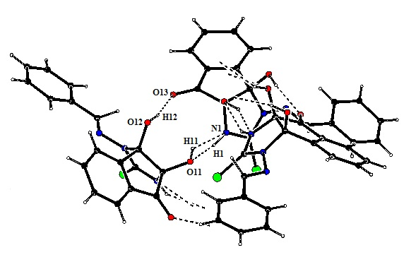
Figure1: Packing diagram in product 9(i) as viewed from axis a.
Table 1: Important cell and refinement parameters in compound 9(i).
Identification code | Compound 9(i) | Crystal size | 0.30 x 0.20 x 0.20 mm3
Empirical formula | C₁₇H₁₃N₃O₃S | Theta range for data collection | 4.07 to 27.58 º
Formula weight | 339.36 | Index ranges | h= -22 to 42,  k= -24 to 41, l= -10 to 9
Temperature | 293(2) K | Reflections collected | 5577
Wavelength | 0.71073 Å | Independent reflections | 3143 [R(int) = 0.0388]
Crystal system | Trigonal | Completeness to theta = 27.64° | 75 %
Space group | R3c | Absorption correction | Semi-empirical from equivalents
Unit cell dimensions | a = 32.229(5) Å,  α = 90° | Max. and min. transmission | 1.0000 and 0.70917
 | b = 32.229(5) Å,  β = 90° | Refinement method | Full-matrix least-squares on F2
 | c = 7.8369(12) Å,  γ = 120° | Data / restraints / parameters | 3143 / 1 / 221
Volume | 7049.4(18) Å3 | Goodness-of-fit on F2 | 1.041
Z | 18 | Final R indices [I>2sigma(I)] | R1 = 0.0607,  wR2 = 0.1499
Density (calculated) | 1.44 g/cm3 | R indices (all data) | R1 = 0.0816, wR2 = 0.1661
Absorption coefficient | 0.228 mm-1 | Largest diff. peak and hole | 0.477 and -0.521 e.Å-3
F(000) | 3168 | CCDC number | 1406164

Table 2:H-bonding interactions in product 9(i)
X-H···Y | X···Y | H···Y | ∠X-H···Y
N1-H1···O11¹ | 2.820(8) | 2.08 | 144
O11-H11···N1² | 2.820(11) | 2.15 | 139
O12-H12···O13² | 2.839(11) | 2.04 | 167
- -y+1/3, x-y-1/3, z-1/3
- -x+y+2/3, -x+1/3, z+1/3

Table 3:Bond lengths (Å) for product 9(i)
S2-C2 | 1.666(5) | O13-C8 | 1.214(6)
O12-C10 | 1.390(6) | O12-H12 | 0.8200
O11-C9 | 1.377(6) | O11-H11 | 0.8200
N3-C2 | 1.352(6) | N3-N14 | 1.394(6)
N3-C10 | 1.458(6) | N1-C2 | 1.342(6)
N1-C9 | 1.434(6) | N1-H1 | 0.8600
C10-C4A | 1.505(7) | C10-C9 | 1.556(7)
C8A-C4A | 1.387(7) | C8A-C7 | 1.396(7)
C8A-C8 | 1.446(7) | N14-C15 | 1.254(7)
C9-C8 | 1.548(7) | C4A-C4 | 1.393(7)
C7-C6 | 1.361(9) | C7-H7 | 0.9300
C4-C5 | 1.369(8) | C4-H4 | 0.9300
C6-C5 | 1.396(10) | C6-H6 | 0.9300
C15-C16 | 1.463(8) | C15-H15 | 1.05(7)
C5-H5 | 0.9300 | C16-C17 | 1.339(11)
C16-C21 | 1.359(9) | C20-C19 | 1.271(15)
C20-C21 | 1.373(10) | C20-H20 | 0.9300
C21-H21 | 0.9300 | C19-C18 | 1.371(16)
C19-H19 | 0.9300 | C17-C18 | 1.381(15)
C17-H17 | 0.9300 | C18-H18 | 0.9300

Table 4: Bond angles (°) for product9(i)
C10-O12-H12 | 109.5 | C9-O11-H11 | 109.5
C2-N3-N14 | 126.5(4) | C2-N3-C10 | 113.4(4)
N14-N3-C10 | 118.7(4) | C2-N1-C9 | 114.2(4)
C2-N1-H1 | 122.9 | C9-N1-H1 | 122.9
O12-C10-N3 | 111.1(4) | O12-C10-C4A | 108.8(4)
N3-C10-C4A | 114.0(4) | O12-C10-C9 | 116.1(4)
N3-C10-C9 | 101.8(4) | C4A-C10-C9 | 104.9(4)
N1-C2-N3 | 107.6(4) | N1-C2-S2 | 124.4(3)
N3-C2-S2 | 127.9(4) | C4A-C8A-C7 | 120.9(5)
C4A-C8A-C8 | 110.9(4) | C7-C8A-C8 | 128.2(5)
C15-N14-N3 | 114.8(5) | O11-C9-N1 | 110.5(4)
O11-C9-C8 | 112.3(4) | N1-C9-C8 | 110.5(4)
O11-C9-C10 | 115.6(4) | N1-C9-C10 | 102.8(4)
C8-C9-C10 | 104.6(4) | C8A-C4A-C4 | 120.1(5)
C8A-C4A-C10 | 111.6(4) | C4-C4A-C10 | 128.3(5)
O13-C8-C8A | 128.5(5) | O13-C8-C9 | 123.4(5)
C8A-C8-C9 | 108.1(4) | C6-C7-C8A | 118.7(6)
C6-C7-H7 | 120.6 | C8A-C7-H7 | 120.6
C5-C4-C4A | 118.2(5) | C5-C4-H4 | 120.9
C4A-C4-H4 | 120.9 | C7-C6-C5 | 120.2(5)
C7-C6-H6 | 119.9 | C5-C6-H6 | 119.9
N14-C15-C16 | 122.2(6) | N14-C15-H15 | 109(4)
C16-C15-H15 | 122(4) | C4-C5-C6 | 121.8(5)
C4-C5-H5 | 119.1 | C6-C5-H5 | 119.1
C17-C16-C21 | 118.8(7) | C17-C16-C15 | 121.2(6)
C21-C16-C15 | 119.8(6) | C19-C20-C21 | 120.5(9)
C19-C20-H20 | 119.8 | C21-C20-H20 | 119.8
C16-C21-C20 | 121.2(8) | C16-C21-H21 | 119.4
C20-C21-H21 | 119.4 | C20-C19-C18 | 120.0(10)
C20-C19-H19 | 120.0 | C18-C19-H19 | 120.0
C16-C17-C18 | 118.6(9) | C16-C17-H17 | 120.7
C18-C17-H17 | 120.7 | C19-C18-C17 | 120.8(10)
C19-C18-H18 | 119.6 | C17-C18-H18 | 119.6

REFERENCES
1. Rahman, A. -u.; Choudhary, M. I.; Thomsen, W. J. In Bioassay Techniques for Drug Development, Harwood Academic Publishers: The Netherlands 2001,16.
2. Das, K.; Tiwari, R. K. S.; Shrivastava, D. K. J. Med. Plants Res. 2010, 4, 104-111.
3. G. M. Sheldrick, Acta Cryst., 2008, A64, 112–122.

¹H NMR spectrum of 3-(benzylideneamino)-3a,8a-dihydroxy-1,3,3a,8a-tetrahydroindeno[1,2-d]imidazole-2,8-dione (8i)
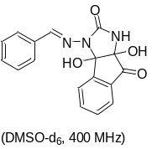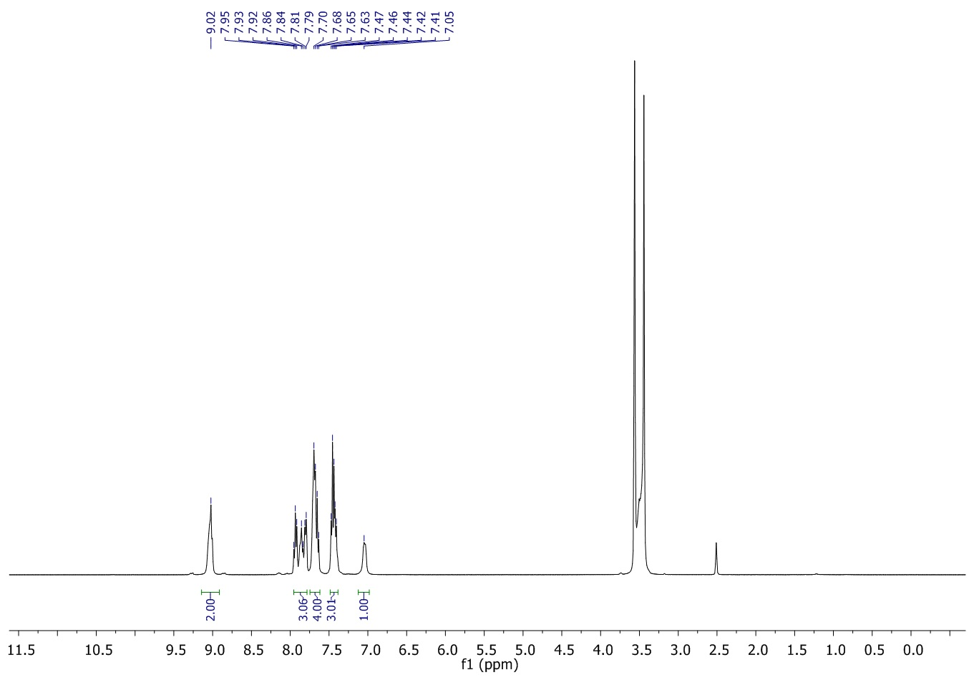

¹³C NMR spectrum of 3-(benzylideneamino)-3a,8a-dihydroxy-1,3,3a,8a-tetrahydroindeno[1,2-d]imidazole-2,8-dione (8i)
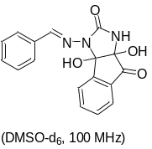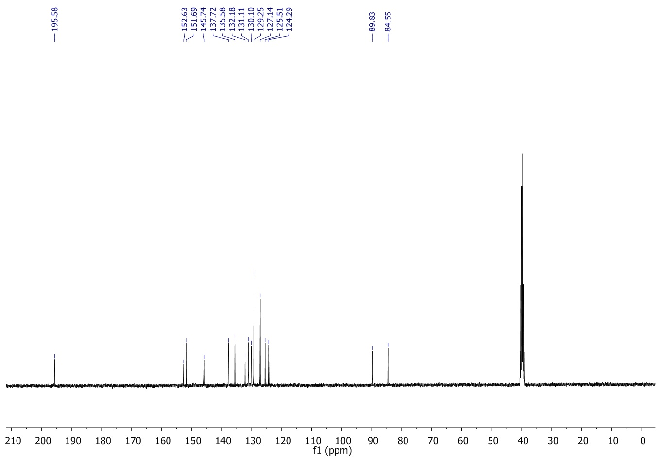

¹H NMR spectrum of 3a,8a-dihydroxy-3-((2-hydroxbenzylidene)amino)-1,3,3a,8a-tetrahydroindeno[1,2-d]imidazole-2,8-dione (8ii)
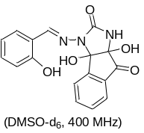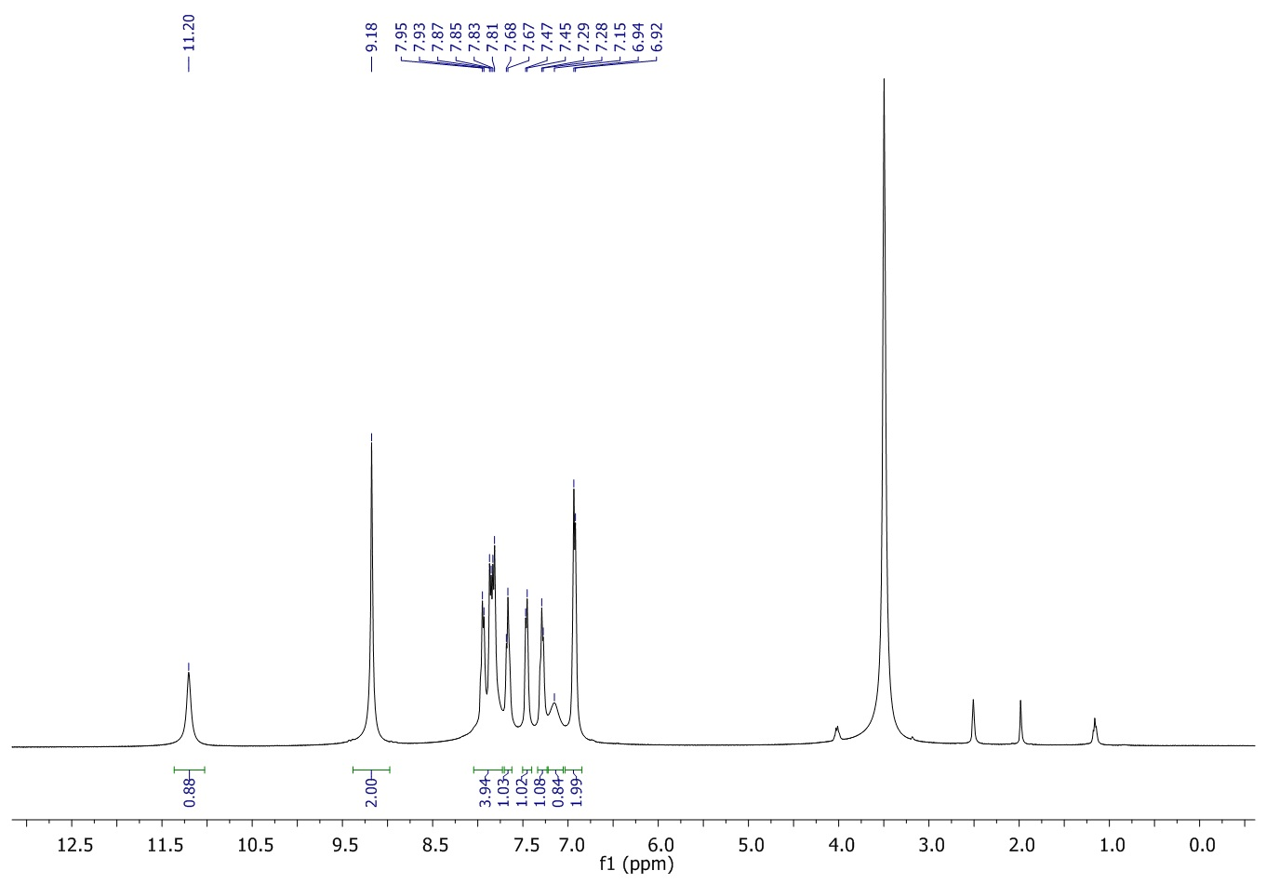

¹³C NMR spectrum of 3a,8a-dihydroxy-3-((2-hydroxbenzylidene)amino)-1,3,3a,8a-tetrahydroindeno[1,2-d]imidazole-2,8-dione (8ii)
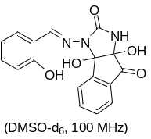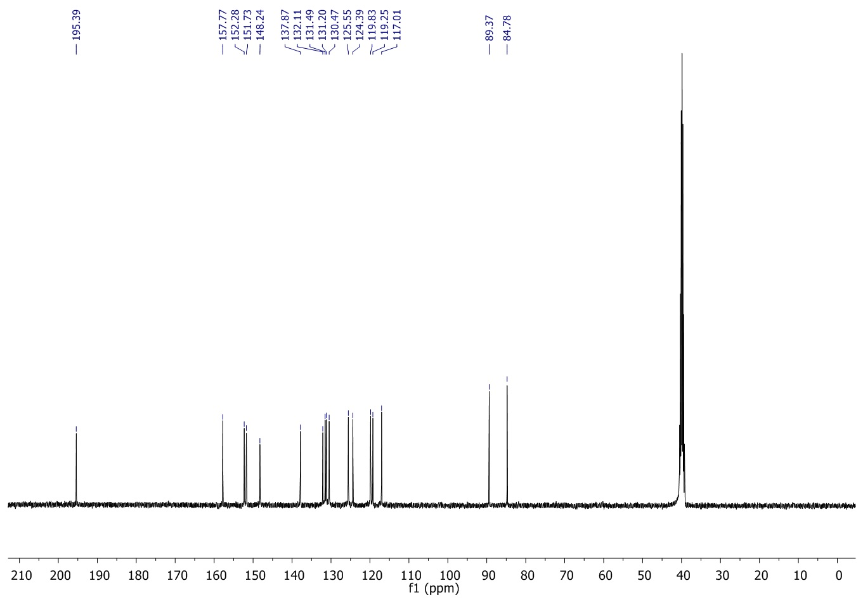

¹H NMR spectrum of 3a,8a-dihydroxy-3-((4-methylbenzylidene)amino)-1,3,3a,8a-tetrahydroindeno[1,2-d]imidazole-2,8-dione (8iii)
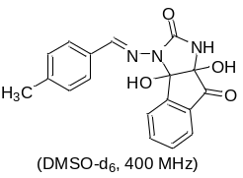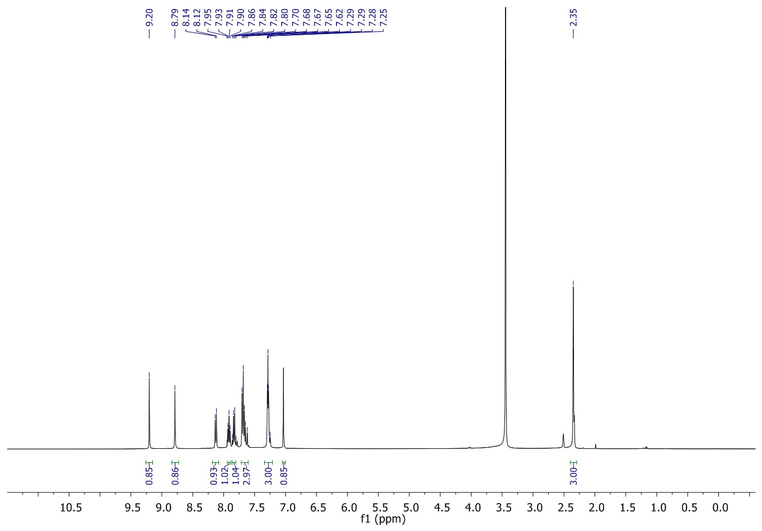

¹³C NMR spectrum of 3a,8a-dihydroxy-3-((4-methylbenzylidene)amino)-1,3,3a,8a-tetrahydroindeno[1,2-d]imidazole-2,8-dione (8iii)
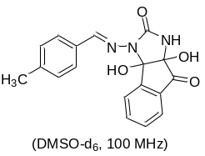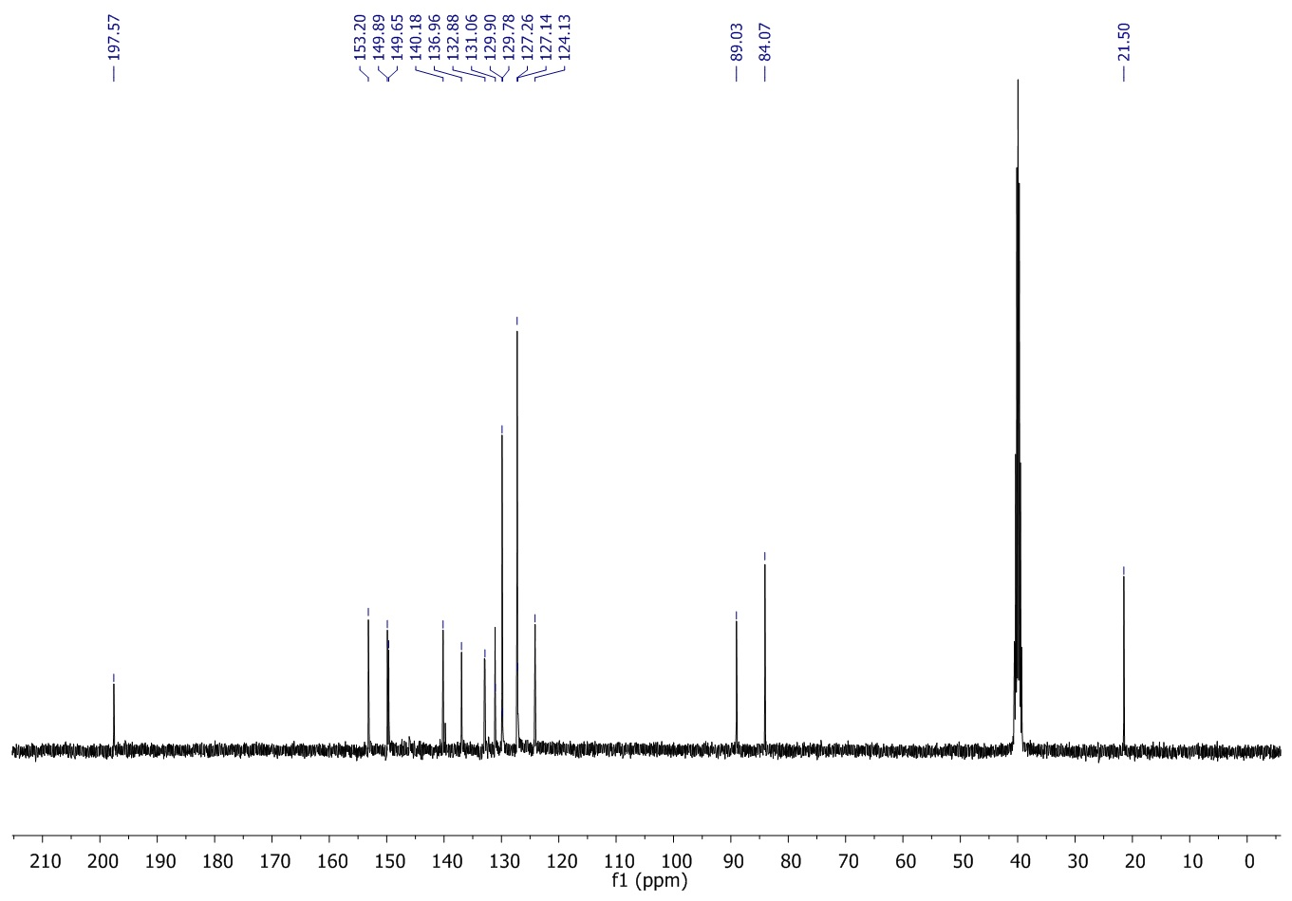
¹H NMR spectrum of3a,8a-dihydroxy-3-((4-methoxybenzylidene)amino)-1,3,3a,8a-tetrahydroindeno[1,2-d]imidazole-2,8-dione (8iv)
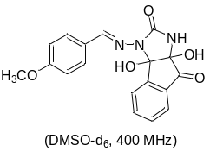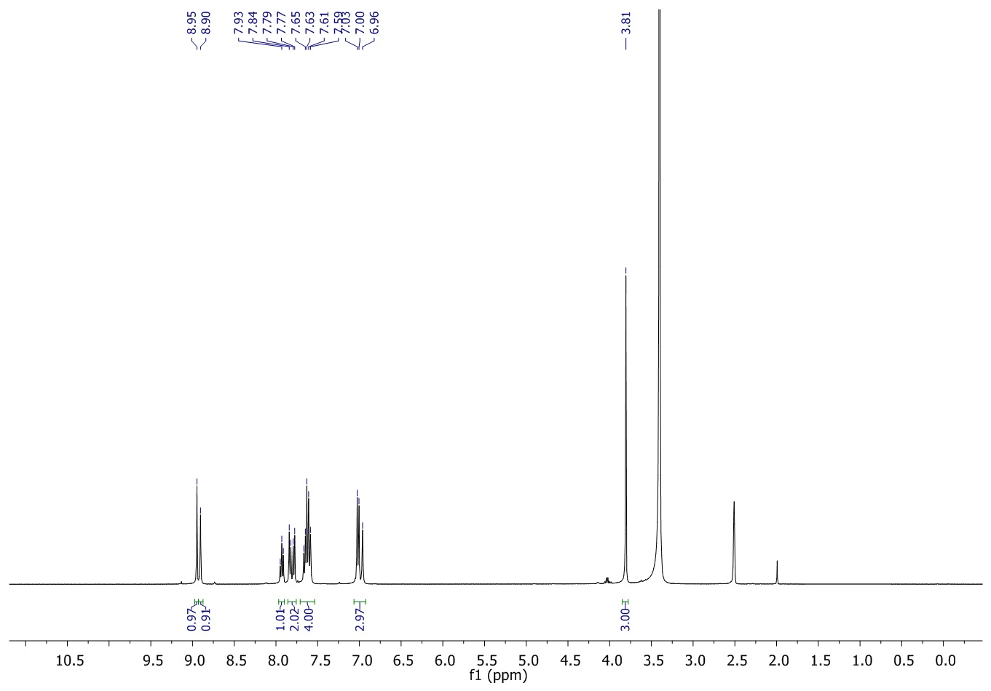

¹³C NMR spectrum of3a,8a-dihydroxy-3-((4-methoxybenzylidene)amino)-1,3,3a,8a-tetrahydroindeno[1,2-d]imidazole-2,8-dione (8iv)
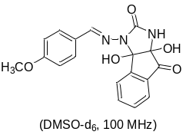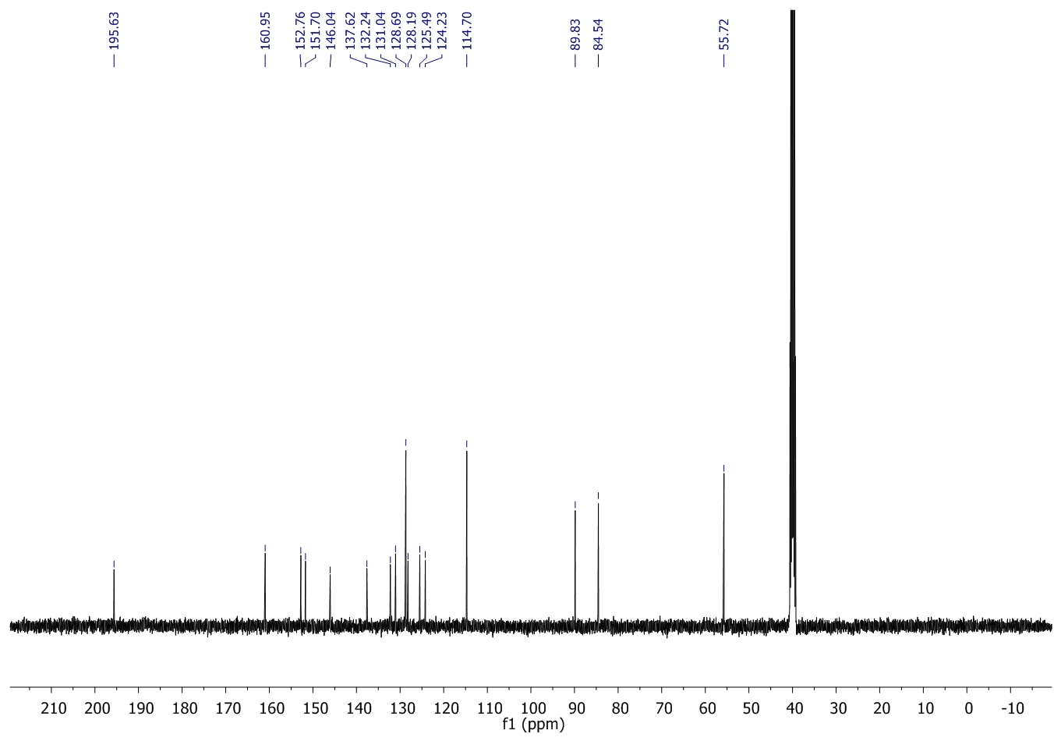

¹H NMR spectrum of 3a,8a-dihydroxy-3-((3-methoxybenzylidene)amino)-1,3,3a,8a-tetrahydroindeno[1,2-d]imidazole-2,8-dione (8v)
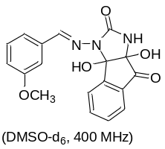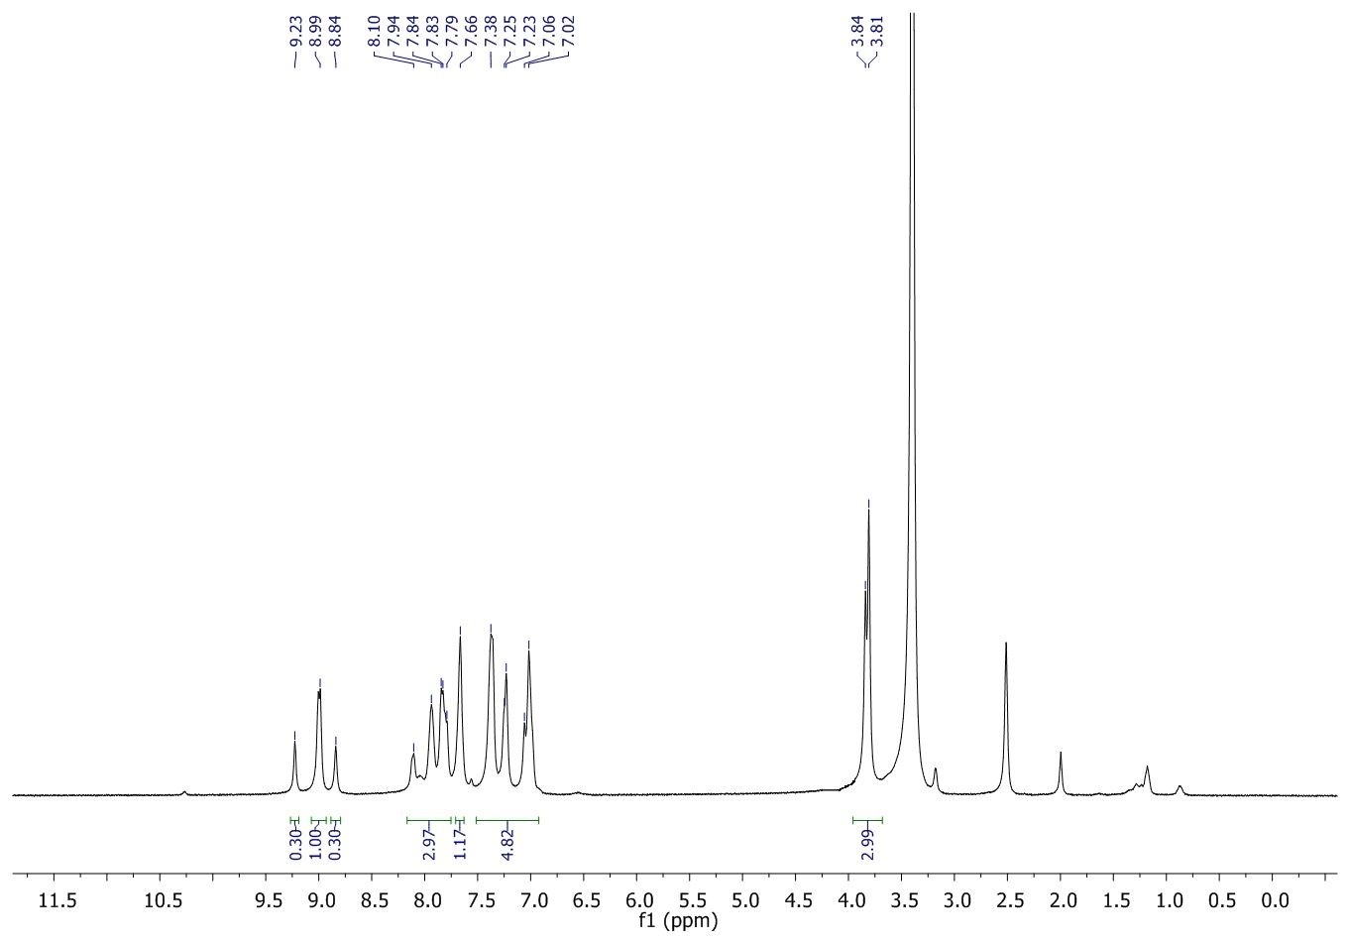

¹³C NMR spectrum of 3a,8a-dihydroxy-3-((3-methoxybenzylidene)amino)-1,3,3a,8a-tetrahydroindeno[1,2-d]imidazole-2,8-dione (8v)
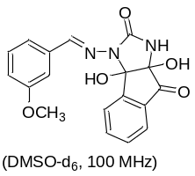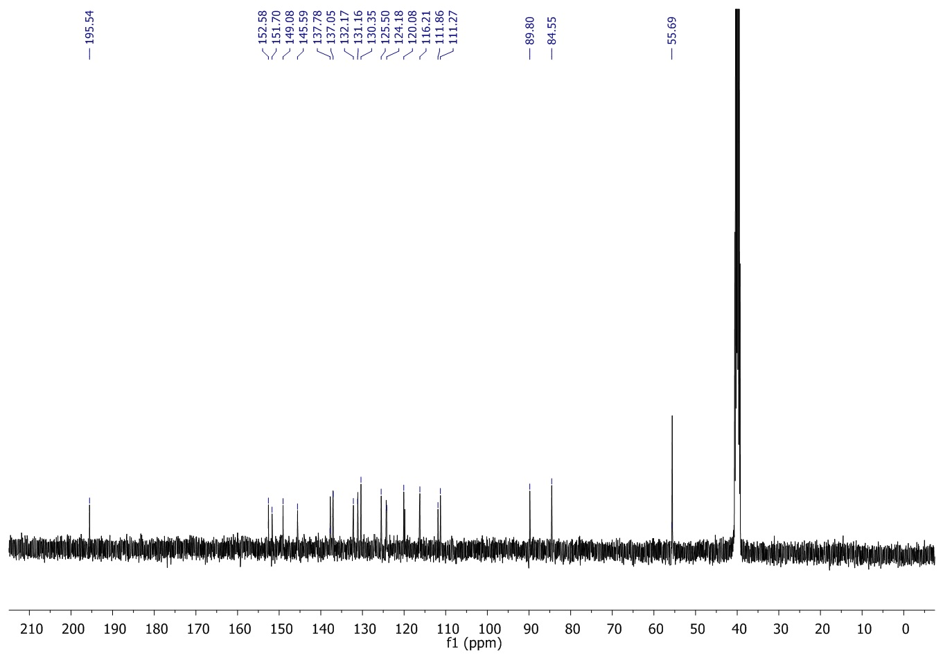

¹H NMR spectrum of 3-((4-chlorobenzylidene)amino)-3a,8a-dihydroxy-1,3,3a,8a-tetrahydroindeno[1,2-d]imidazole-2,8-dione (8vi)

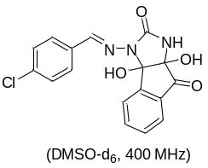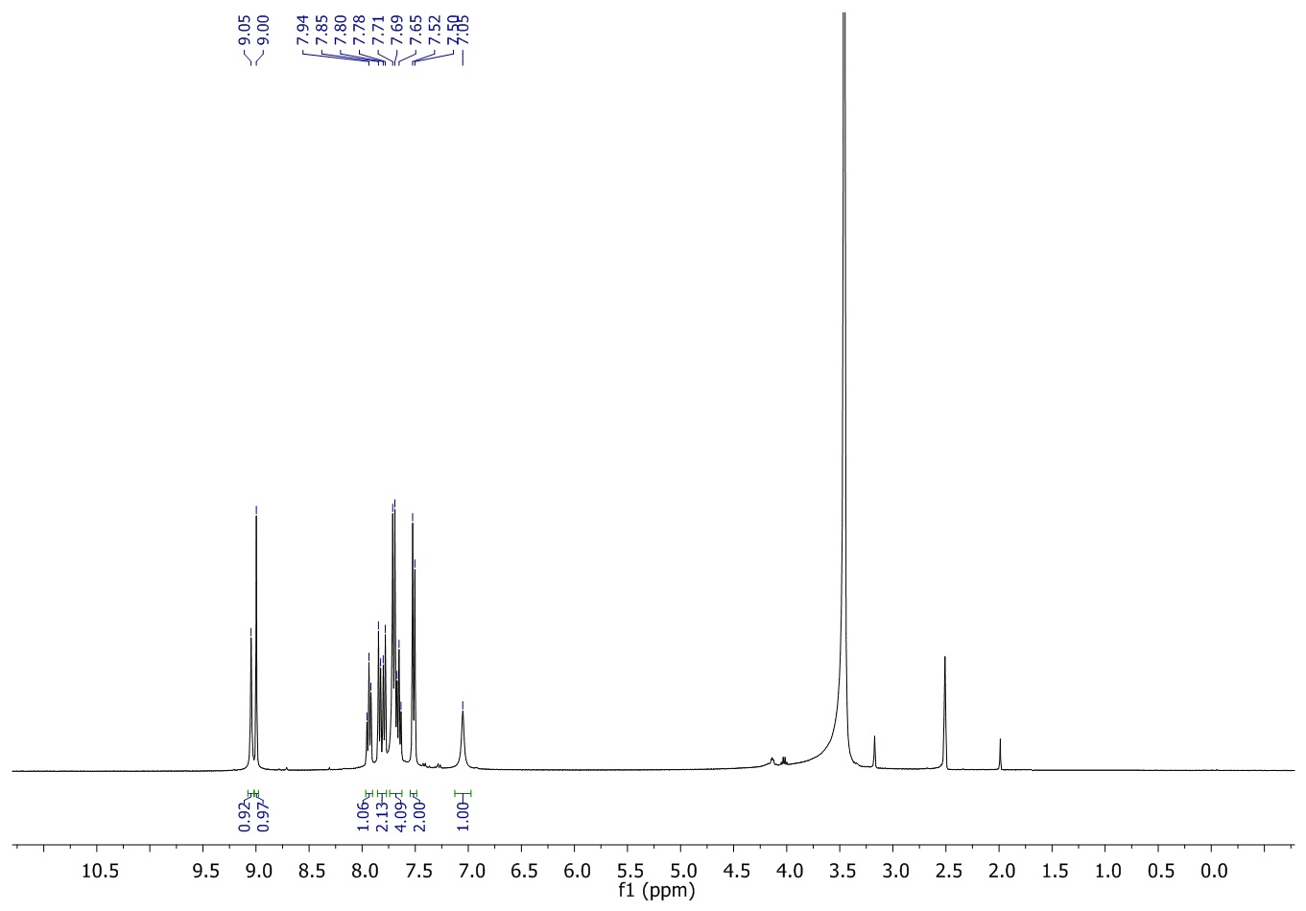

¹³C NMR spectrum of 3-((4-chlorobenzylidene)amino)-3a,8a-dihydroxy-1,3,3a,8a-tetrahydroindeno[1,2-d]imidazole-2,8-dione (8vi)
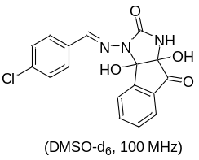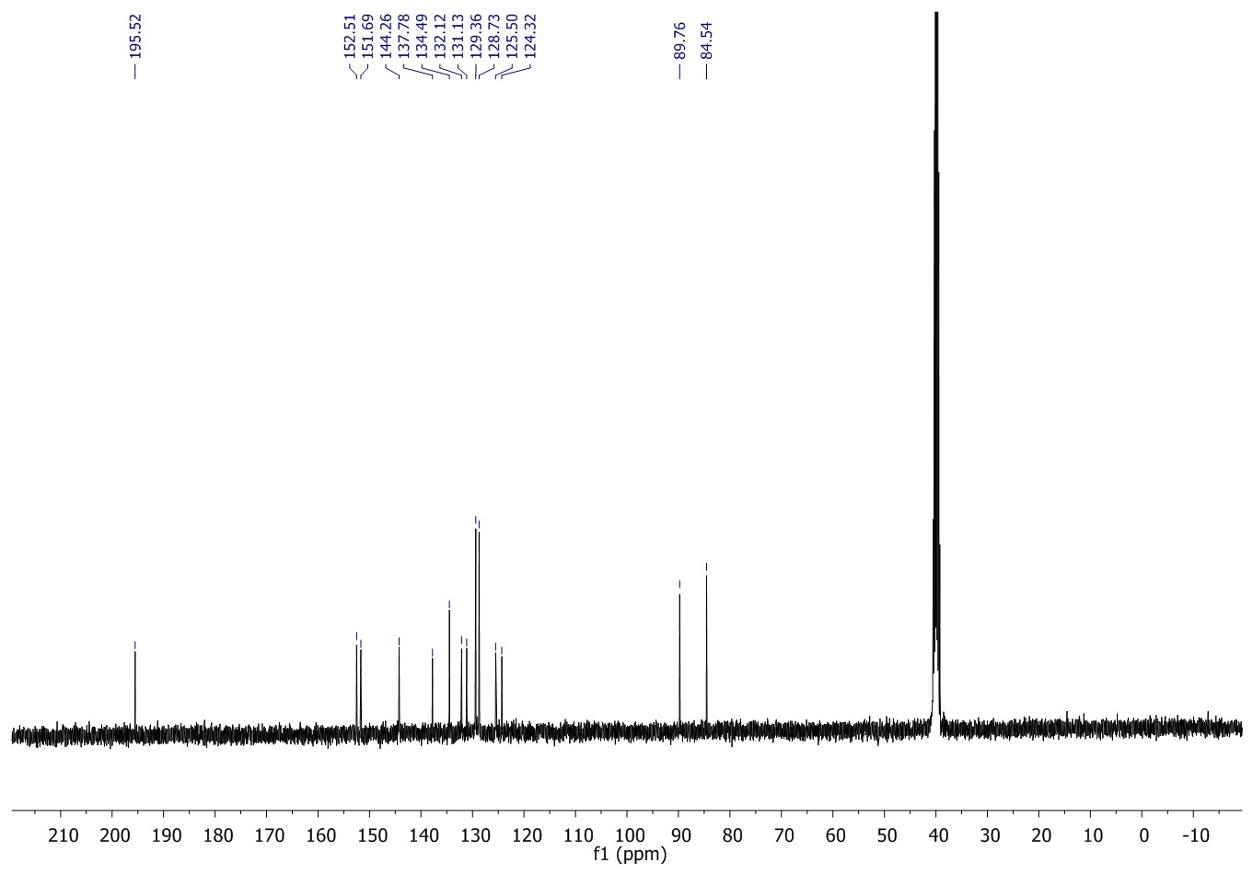

¹H NMR spectrum of 3-((2-chlorobenzylidene)amino)-3a,8a-dihydroxy-1,3,3a,8a-tetrahydroindeno[1,2-d]imidazole-2,8-dione (8vii)
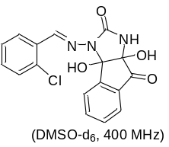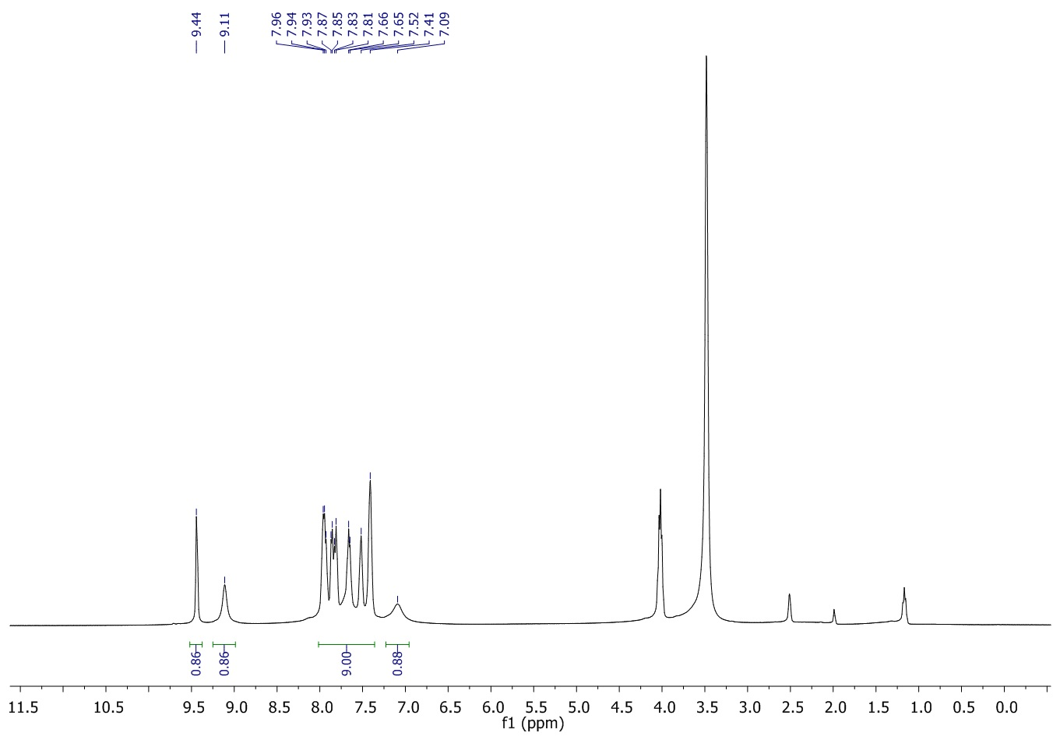

¹³C NMR spectrum of 3-((2-chlorobenzylidene)amino)-3a,8a-dihydroxy-1,3,3a,8a-tetrahydroindeno[1,2-d]imidazole-2,8-dione (8vii)
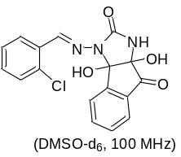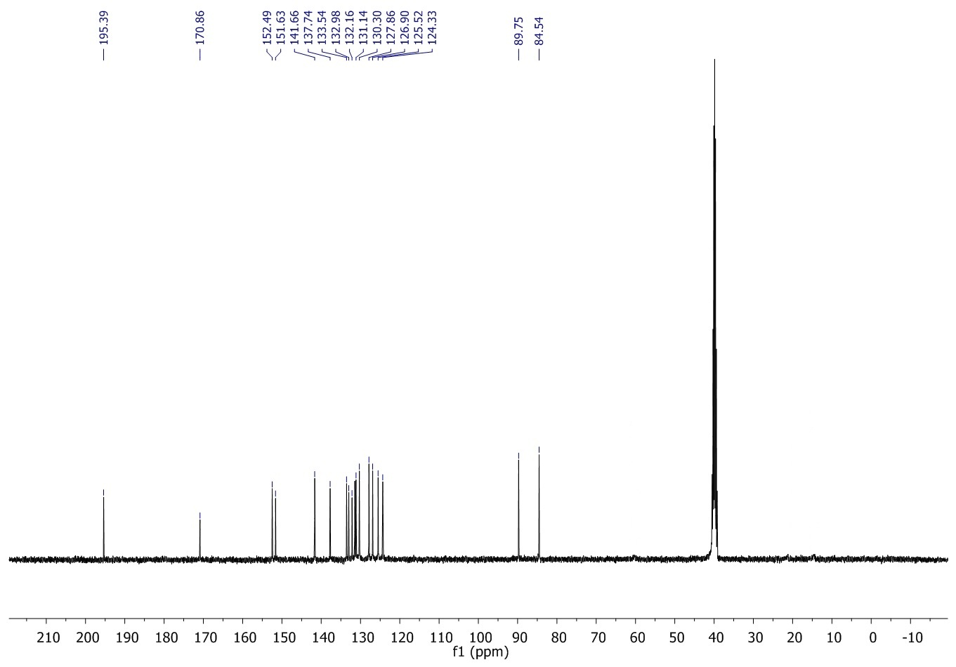
¹H NMR spectrum of 3-((4-bromobenzylidene)amino)-3a,8a-dihydroxy-1,3,3a,8a-tetrahydroindeno[1,2-d]imidazole-2,8-dione (8viii)
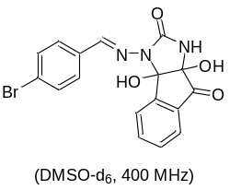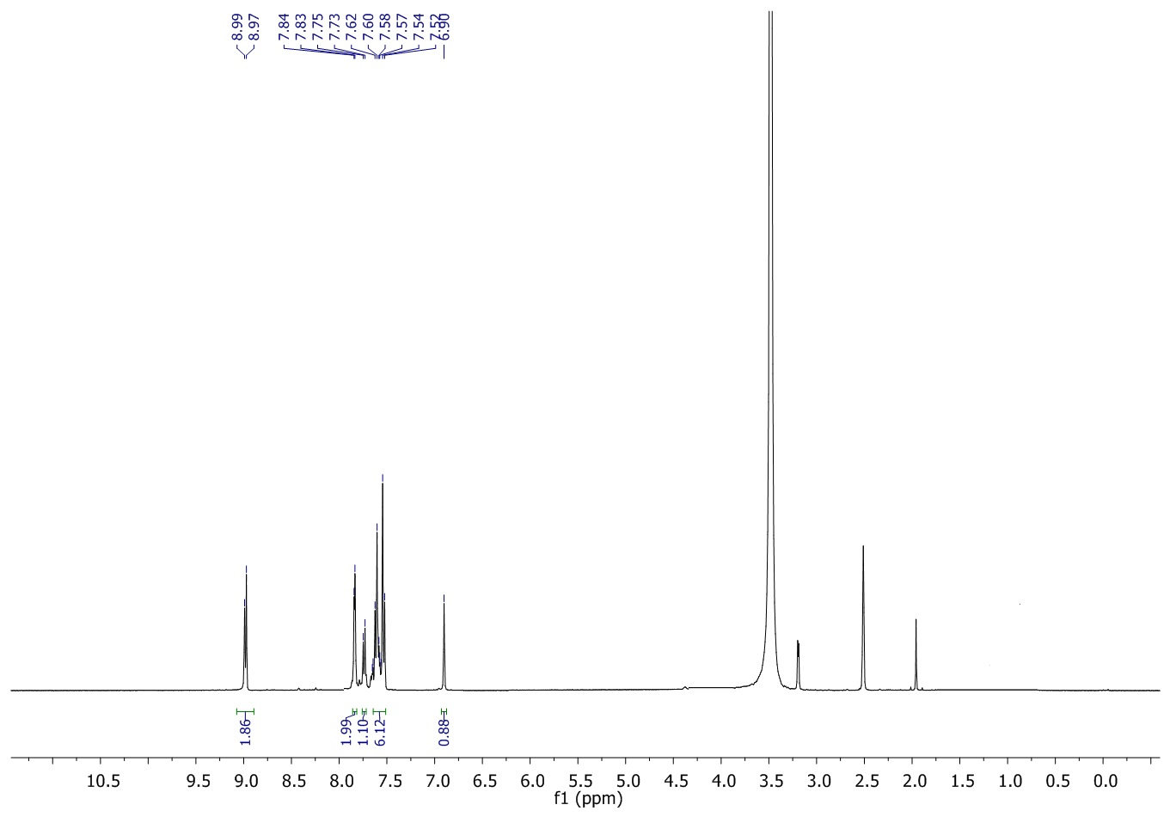

¹³C NMR spectrum of 3-((4-bromobenzylidene)amino)-3a,8a-dihydroxy-1,3,3a,8a-tetrahydroindeno[1,2-d]imidazole-2,8-dione (8viii)
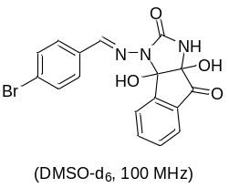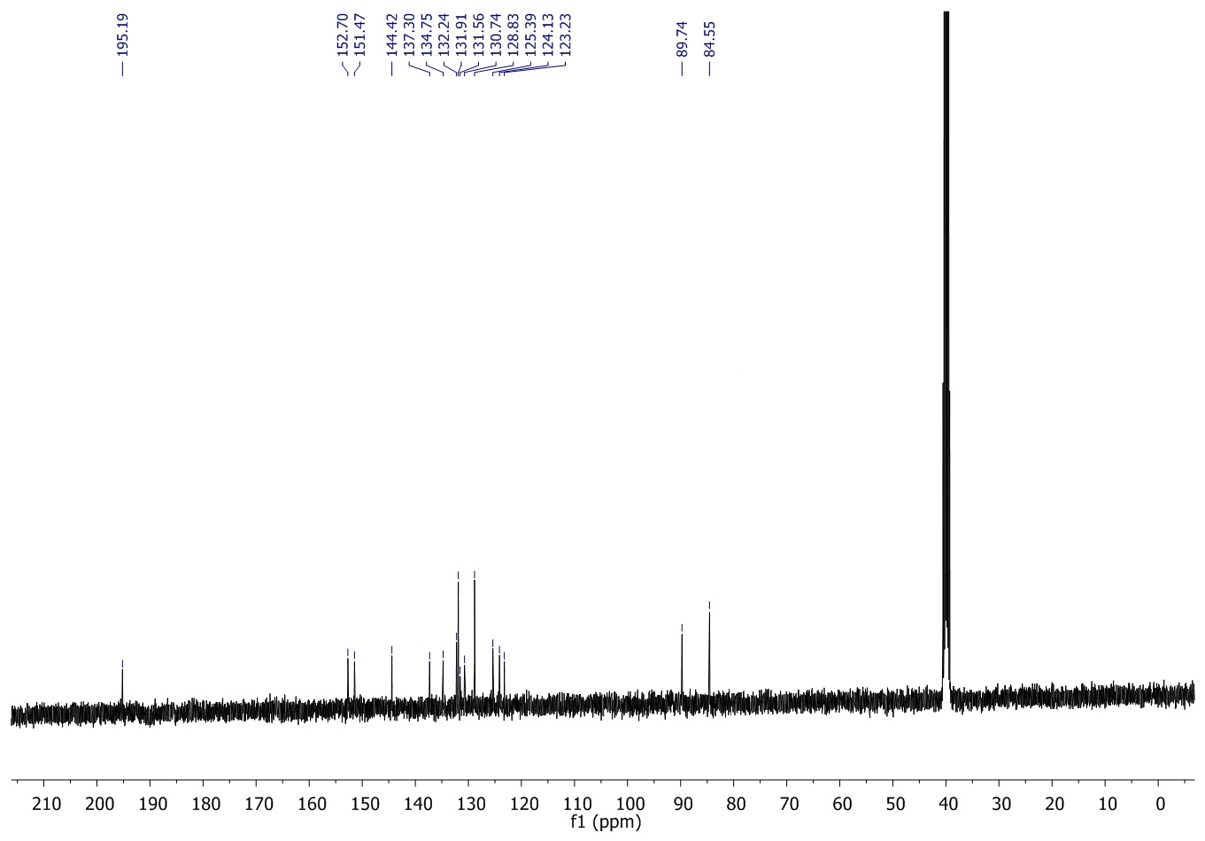
¹H NMR spectrum of3a,8a-dihydroxy-3-((4-nitrobenzylidene)amino)-1,3,3a,8a-tetrahydroindeno[1,2-d]imidazole-2,8-dione (8ix)
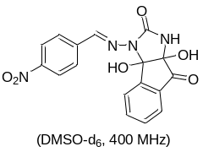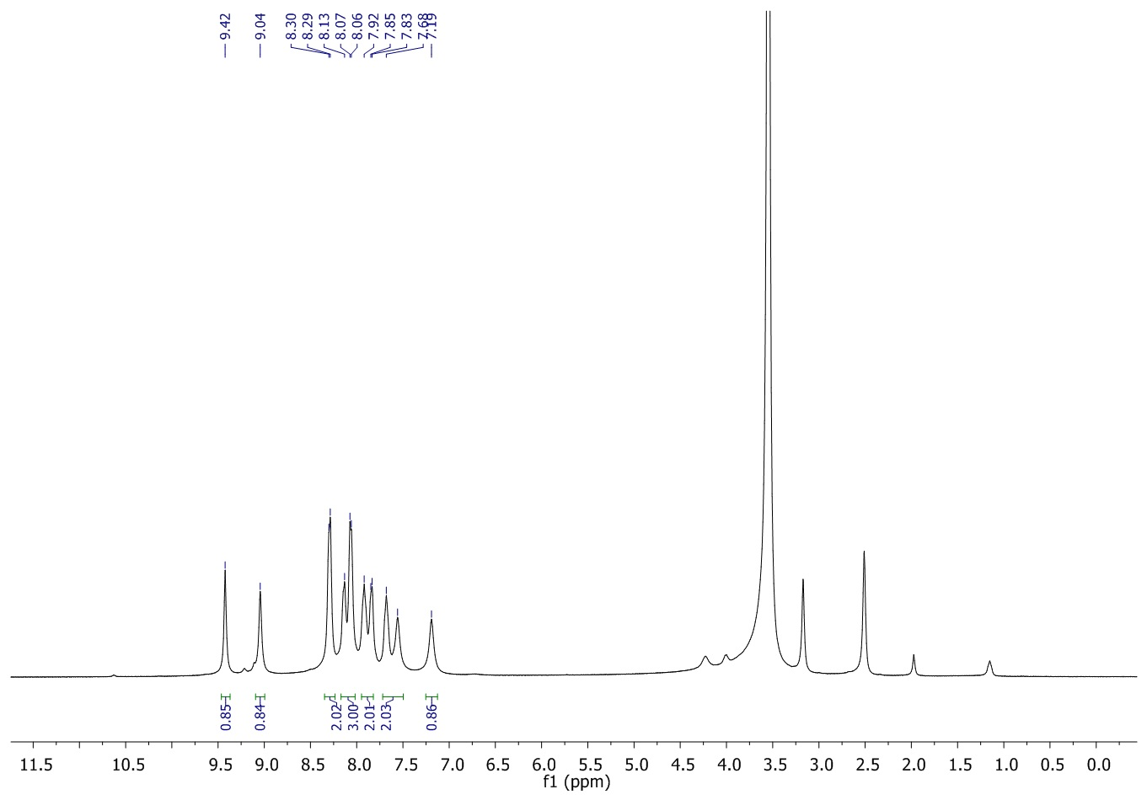

¹³C NMR spectrum of3a,8a-dihydroxy-3-((4-nitrobenzylidene)amino)-1,3,3a,8a-tetrahydroindeno[1,2-d]imidazole-2,8-dione (8ix)
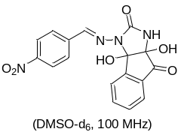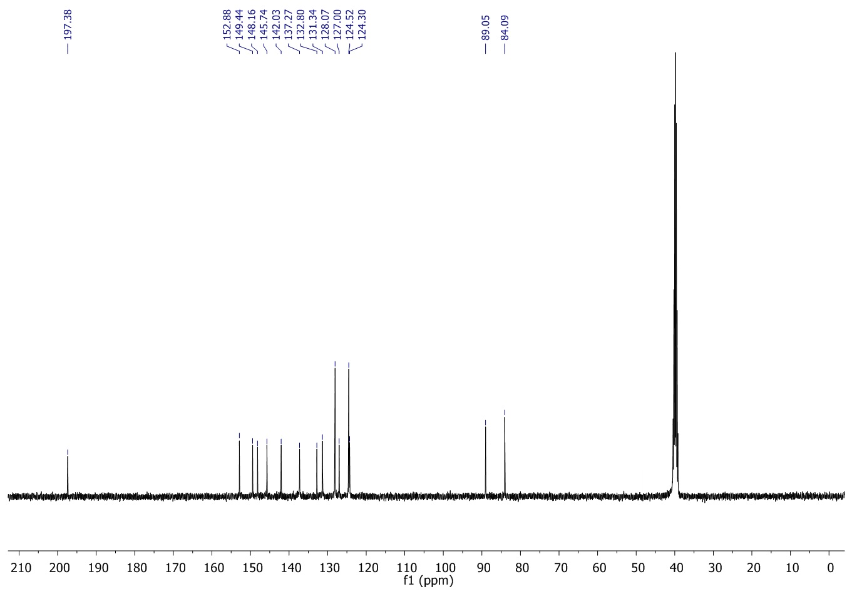

¹H NMR spectrum of3a,8a-dihydroxy-3-((3-nitrobenzylidene)amino)-1,3,3a,8a-tetrahydroindeno[1,2-d]imidazole-2,8-dione (8x)
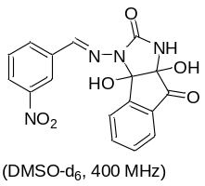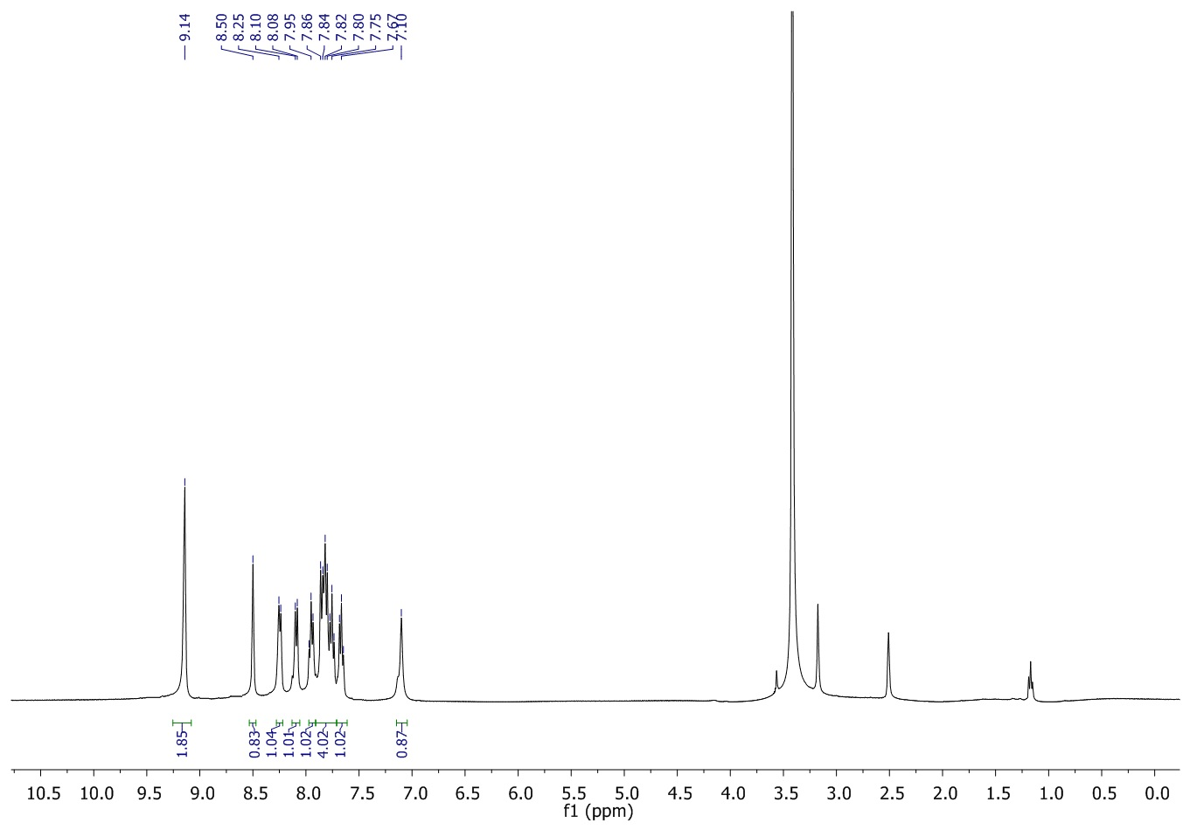

¹³C NMR spectrum of3a,8a-dihydroxy-3-((3-nitrobenzylidene)amino)-1,3,3a,8a-tetrahydroindeno[1,2-d]imidazole-2,8-dione (8x)
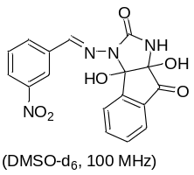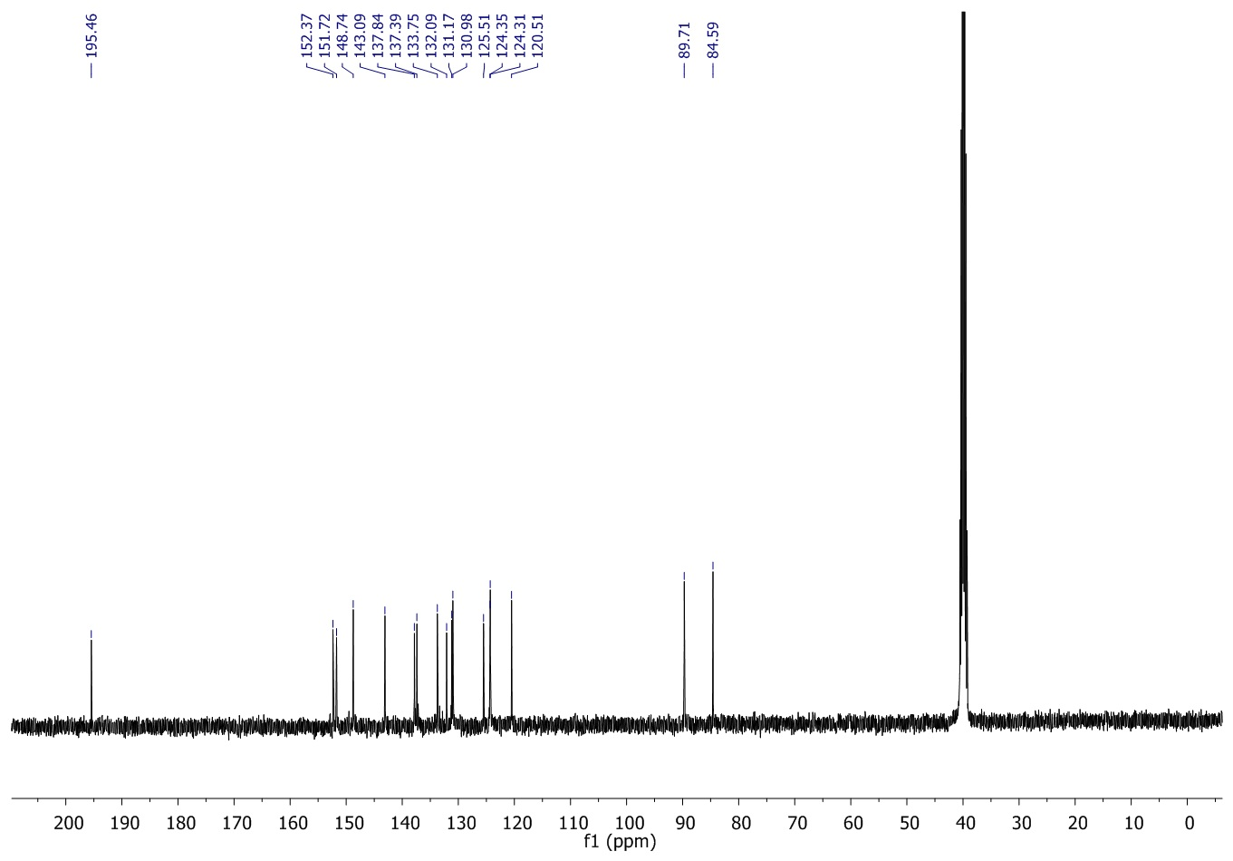

¹H NMR spectrum of 3a,8a-dihydroxy-3-((3,4,5-trimethoxybenzylidene)amino)-1,3,3a,8a-tetrahydroindeno[1,2-d]imidazole-2,8-dione (8xi)
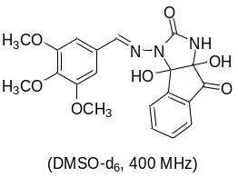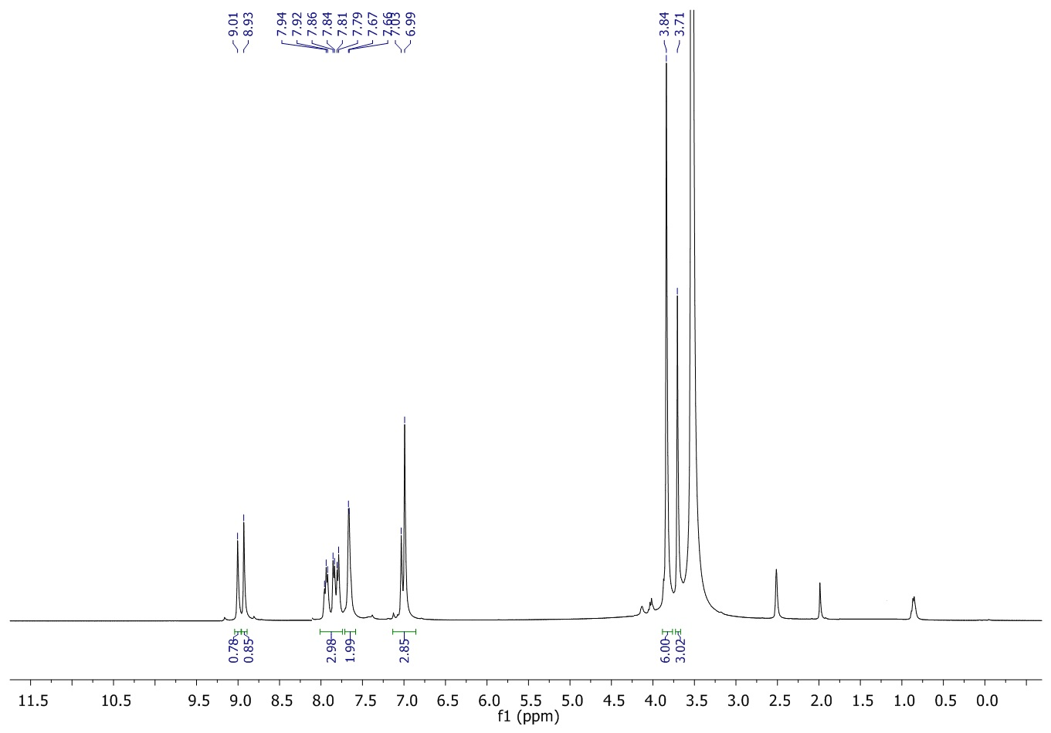

¹³C NMR spectrum of3a,8a-dihydroxy-3-((3,4,5-trimethoxybenzylidene)amino)-1,3,3a,8a-tetrahydroindeno[1,2-d]imidazole-2,8-dione(8xi)

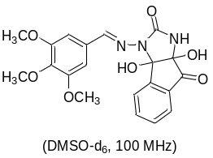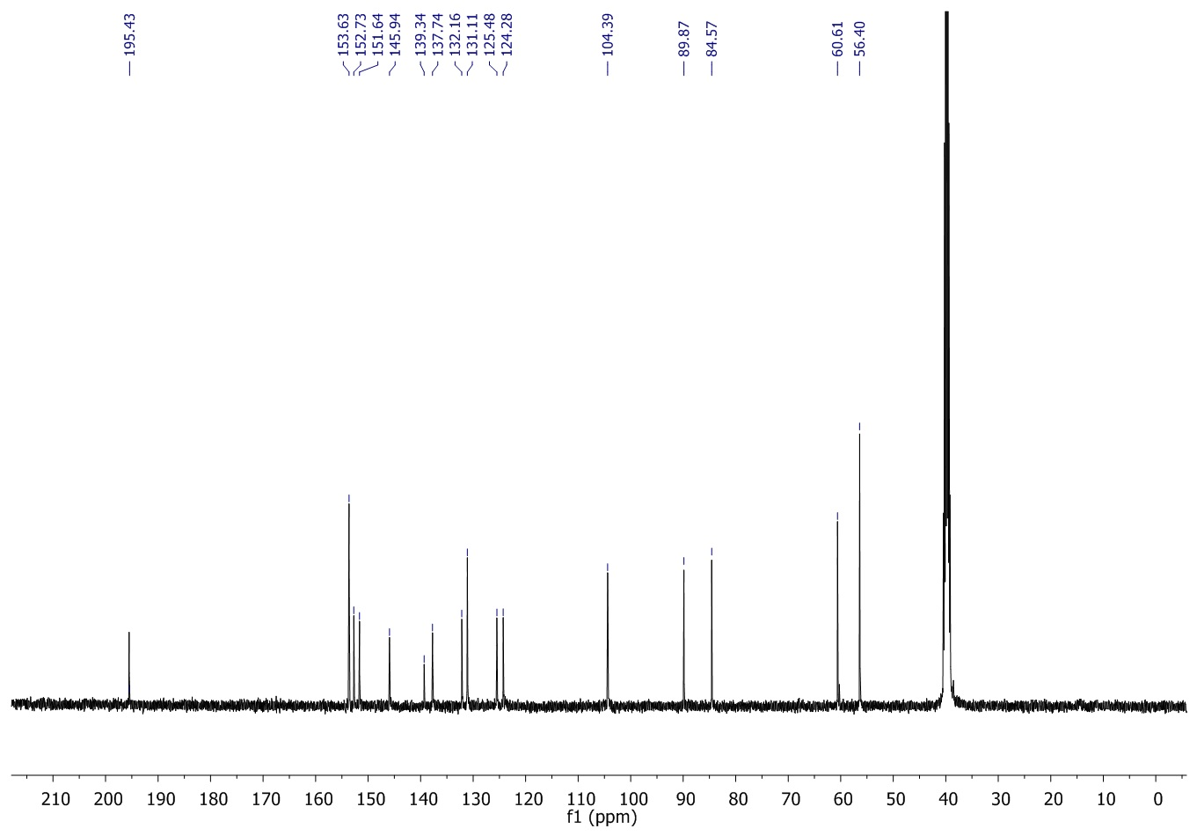
¹H NMR spectrum of3a,8a-dihydroxy-3-((napthalen-1-ylmethylene)amino)-1,3,3a,8a-tetrahydroindeno[1,2-d]imidazole-2,8-dione(8xii)
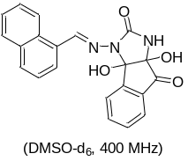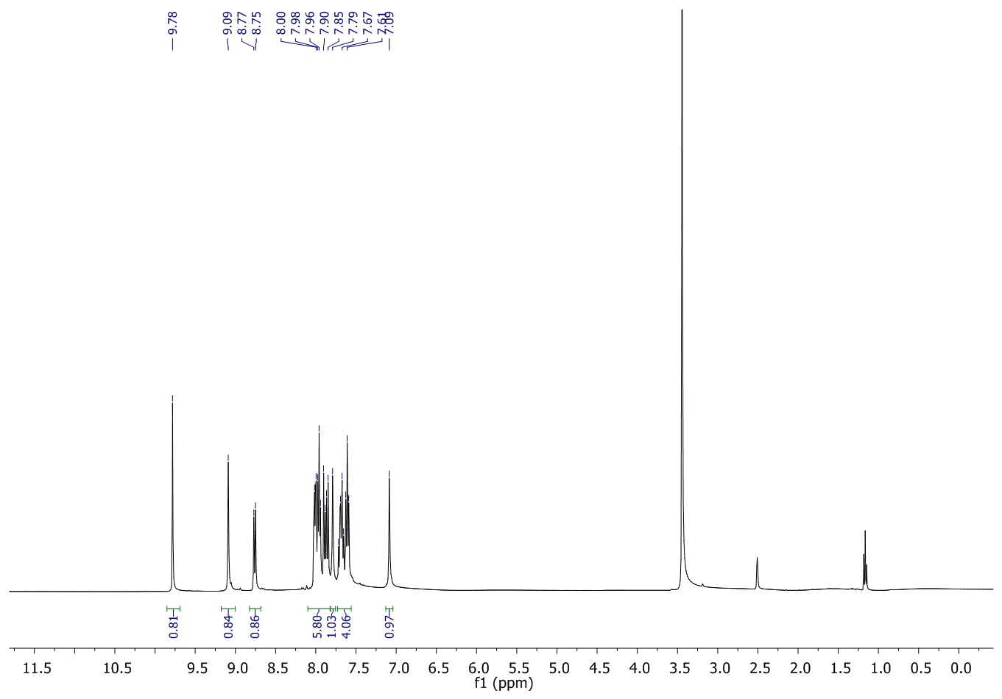

¹³C NMRspectrum of3a,8a-dihydroxy-3-((napthalen-1-ylmethylene)amino)-1,3,3a,8a-tetrahydroindeno[1,2-d]imidazole-2,8-dione(8xii)
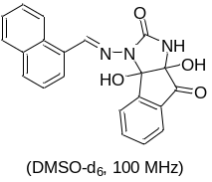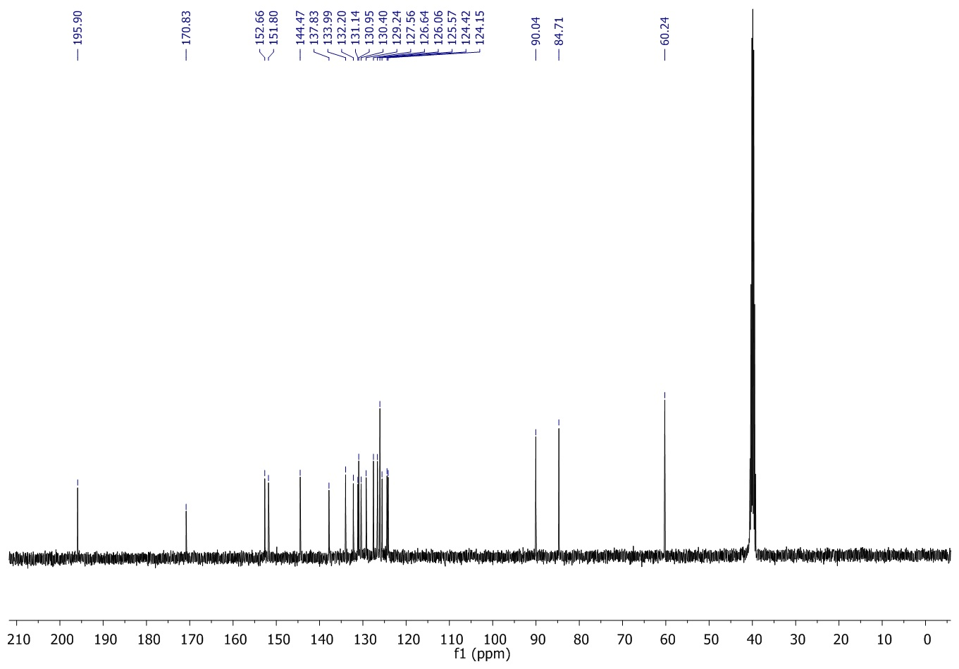

¹H NMR spectrum of3-((furan-2-ylmethylene)amino)-3a,8a-dihydroxy -1,3,3a,8a-tetrahydroindeno [1,2-d]imidazole-2,8-dione (8xiii)
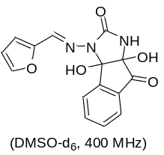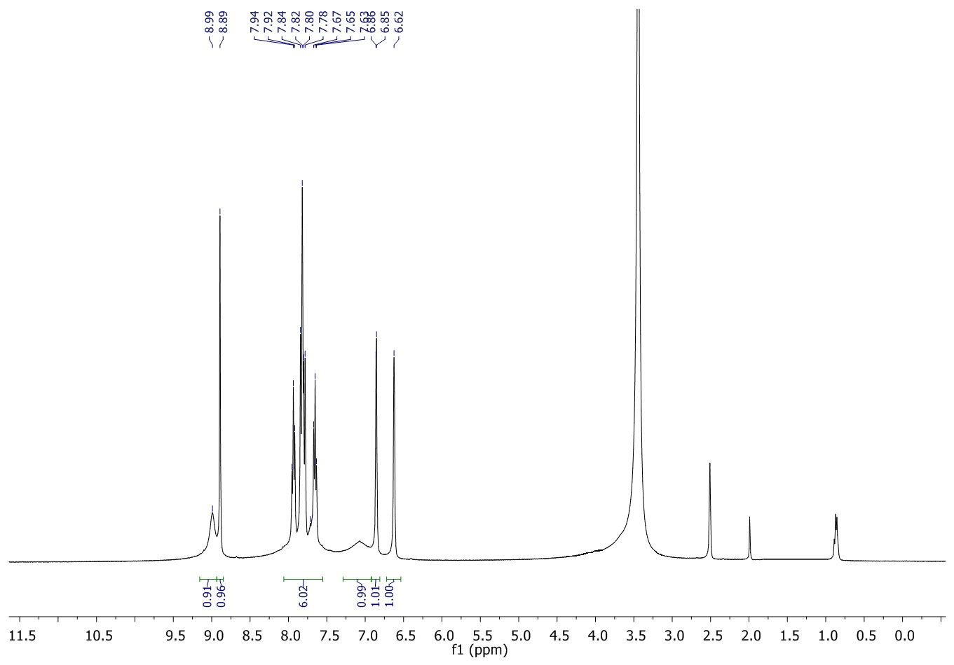

¹³C NMRspectrum of3-((furan-2-ylmethylene)amino)-3a,8a-dihydroxy -1,3,3a,8a-tetrahydroindeno [1,2-d]imidazole-2,8-dione (8xiii)
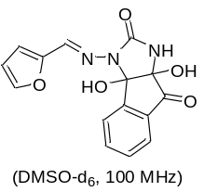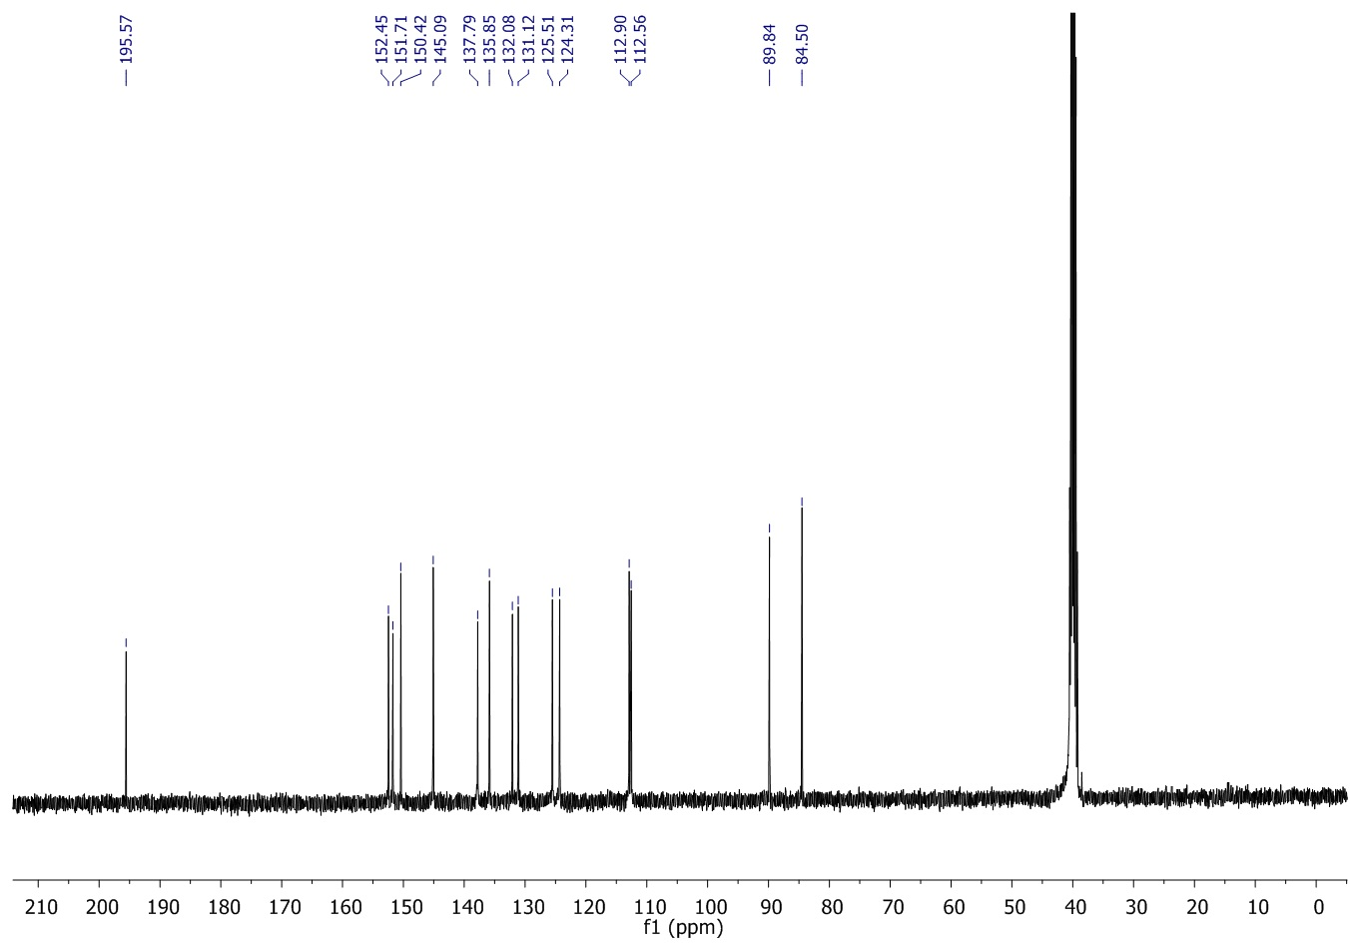

¹H NMR spectrum of 3-(((6-bromobenzo[d][1,3]dioxol-5-yl)methylene)amino)-3a,8a-dihydroxy-1,3,3a,8a-tetrahydroindeno[1,2-d]imidazole-2,8-dion(8xiv)
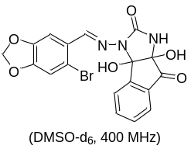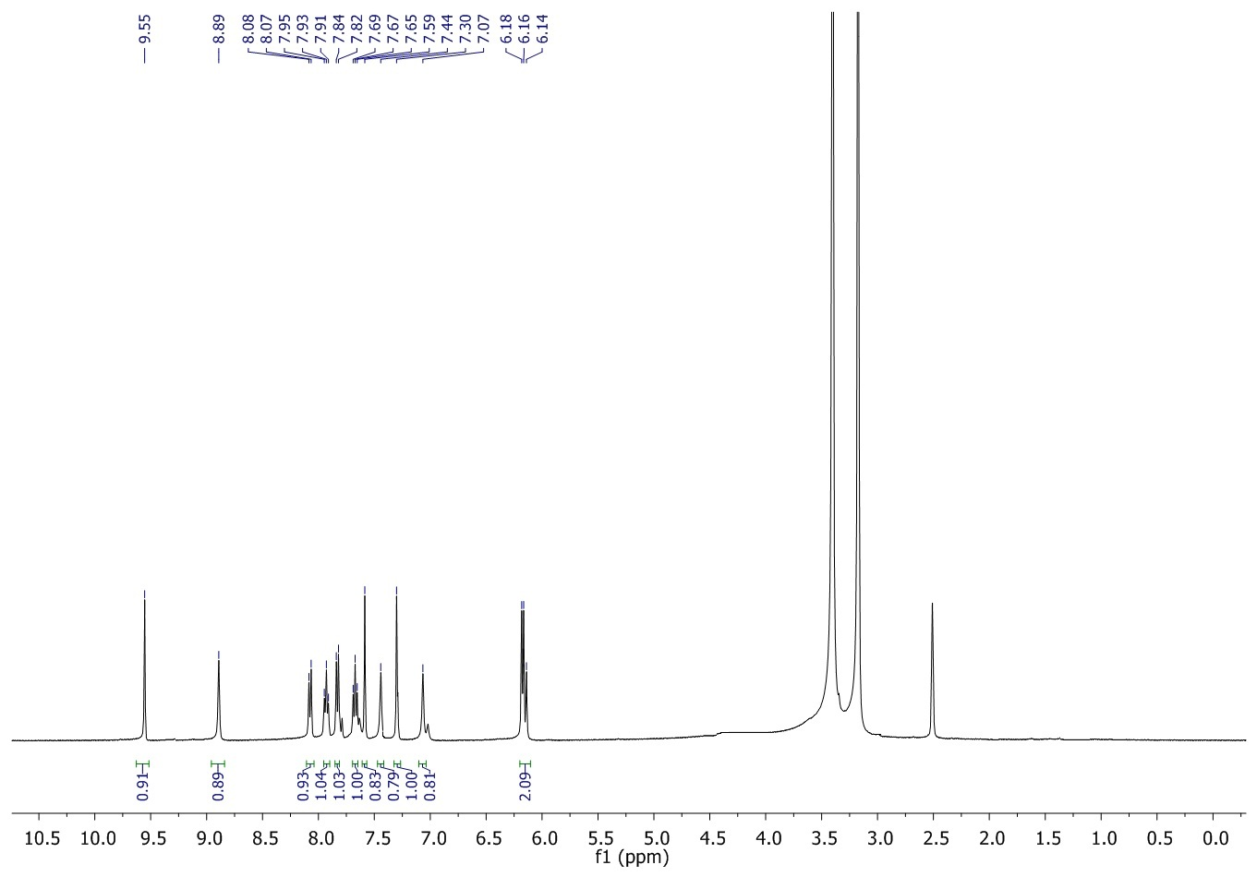

¹³C NMR spectrum of 3-(((6-bromobenzo[d][1,3]dioxol-5-yl)methylene)amino)-3a,8a-dihydroxy-1,3,3a,8a-tetrahydroindeno[1,2-d]imidazole-2,8-dion(8xiv)
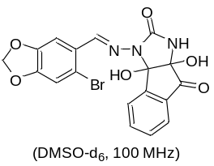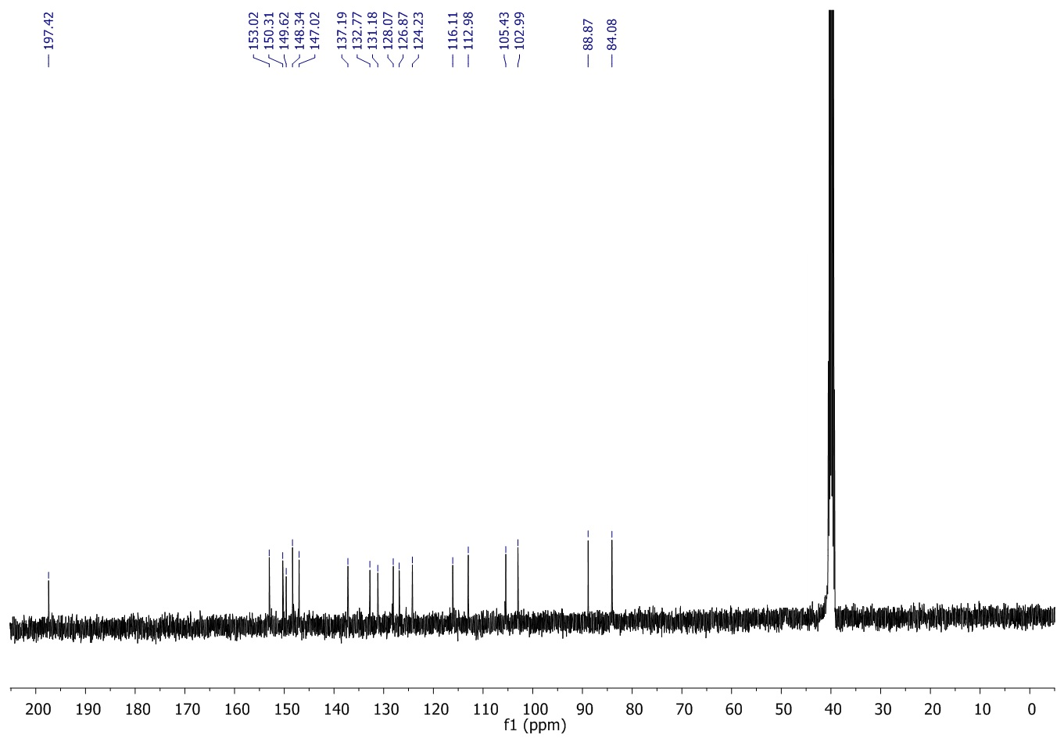

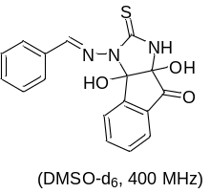¹H NMR spectrum of 3-(benzylideneamino)-3a,8a-dihydroxy-2-thioxo-1,3,3a,8a-tetrahydroindeno[1,2-d]imidazol-8(2H)-one (9i)
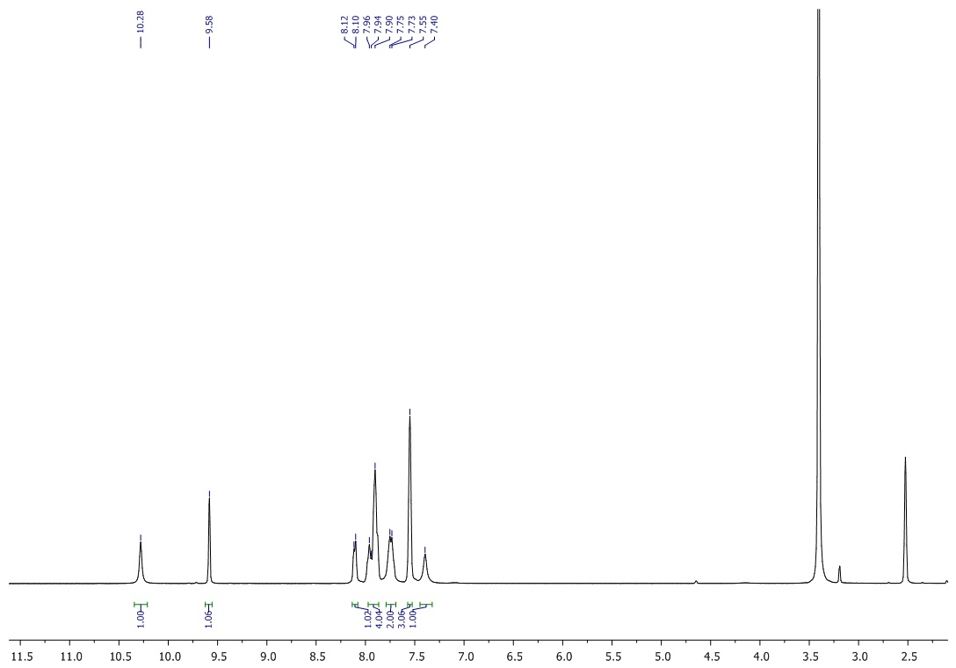

¹³C NMR spectrum of 3-(benzylideneamino)-3a,8a-dihydroxy-2-thioxo-1,3,3a,8a-tetrahydroindeno[1,2-d]imidazol-8(2H)-one (9i)
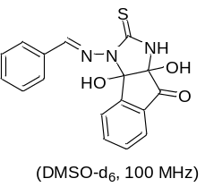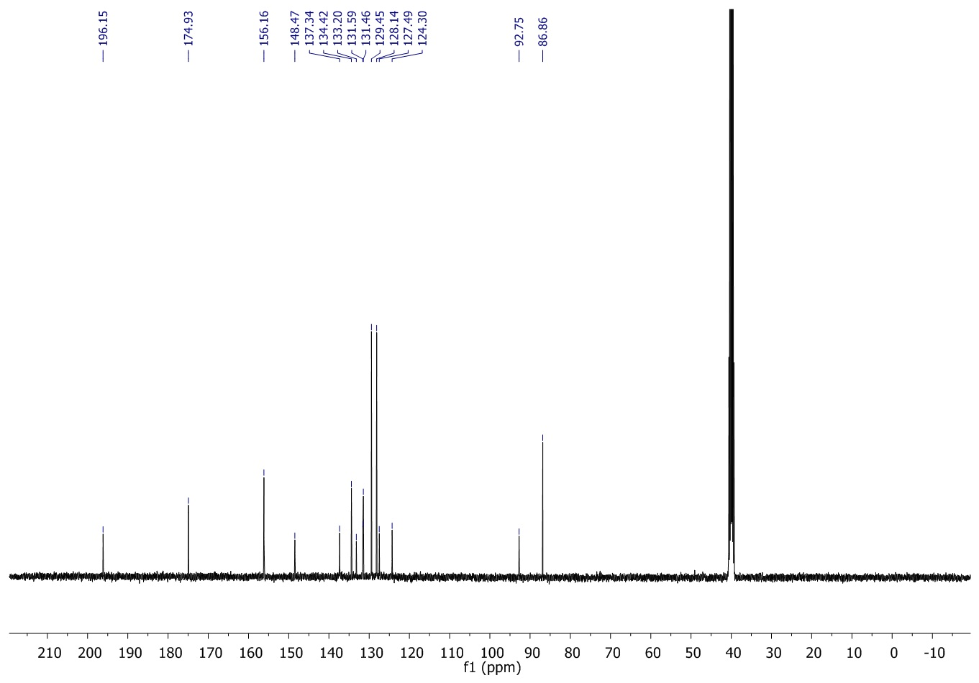
¹H NMR spectrum of 3a,8a-dihydroxy-3-((2-hydroxybenzylidene)amino)-2-thioxo-1,3,3a,8a-tetrahydroindeno[1,2-d]imidazol-8(2H)-one (9ii)
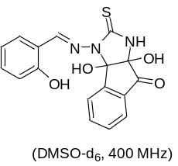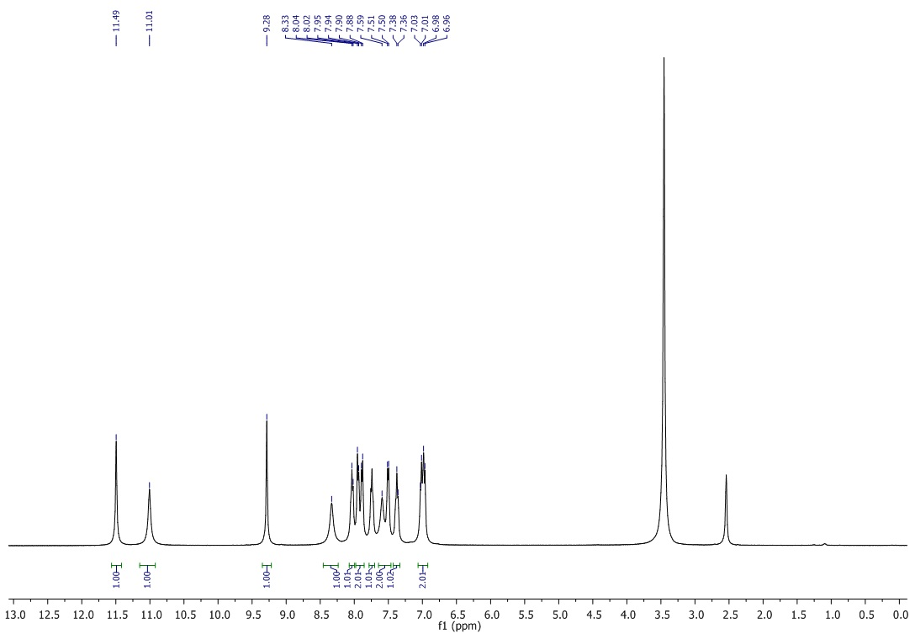

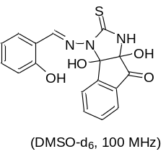¹³C NMR spectrum of 3a,8a-dihydroxy-3-((2-hydroxybenzylidene)amino)-2-thioxo-1,3,3a,8a-tetrahydroindeno[1,2-d]imidazol-8(2H)-one (9ii)
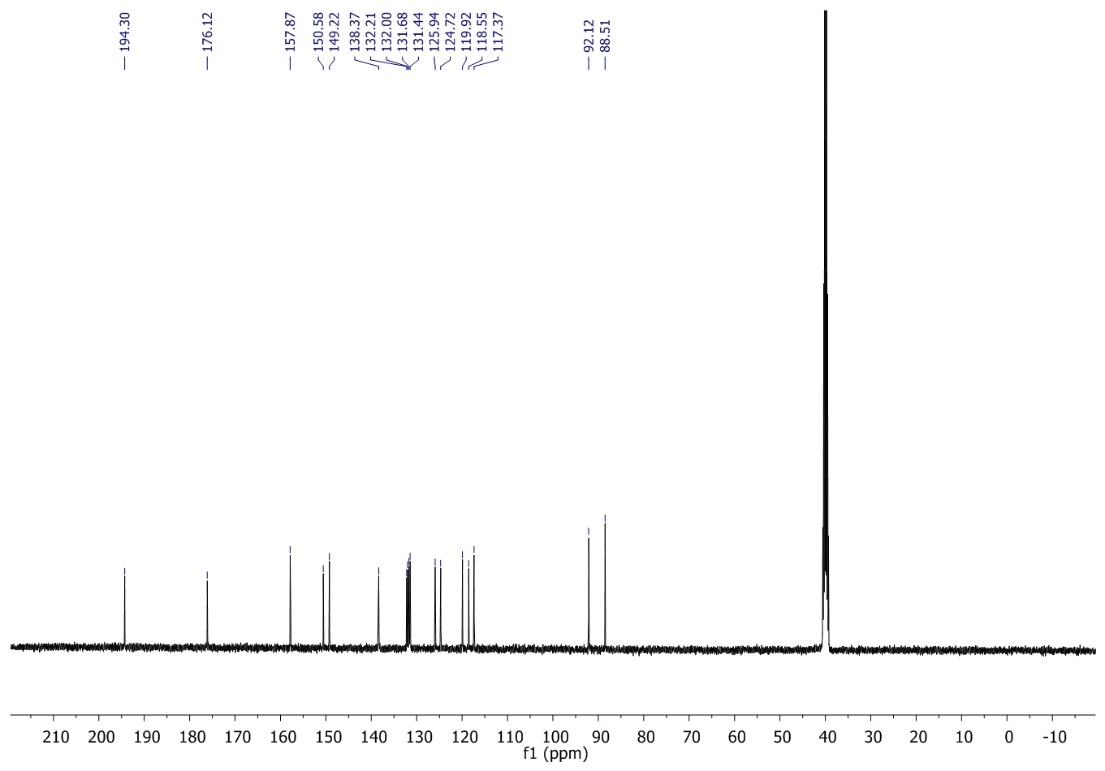

¹H NMR spectrum of 3a,8a-dihydroxy-3-((4-methylbenzylidene)amino)-2-thioxo-1,3,3a,8a-tetrahydroindeno [1,2-d]imidazol-8(2H)-one (9iii)
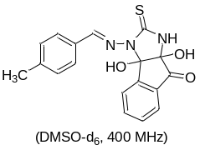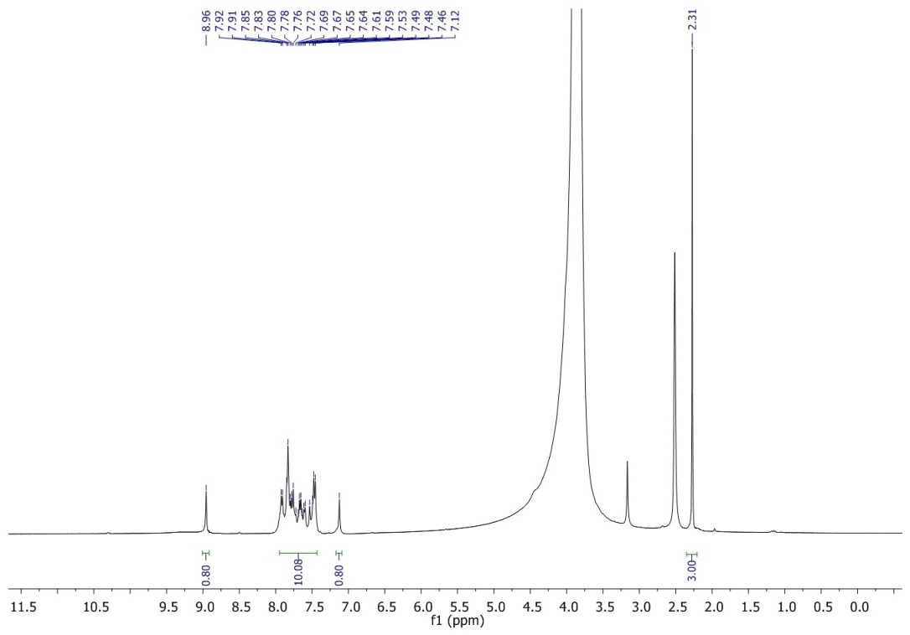

¹³C NMR spectrum of 3a,8a-dihydroxy-3-((4-methylbenzylidene)amino)-2-thioxo-1,3,3a,8a-tetrahydroindeno[1,2-d]imidazol-8(2H)-one (9iii)
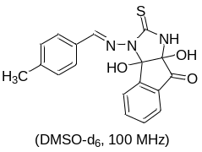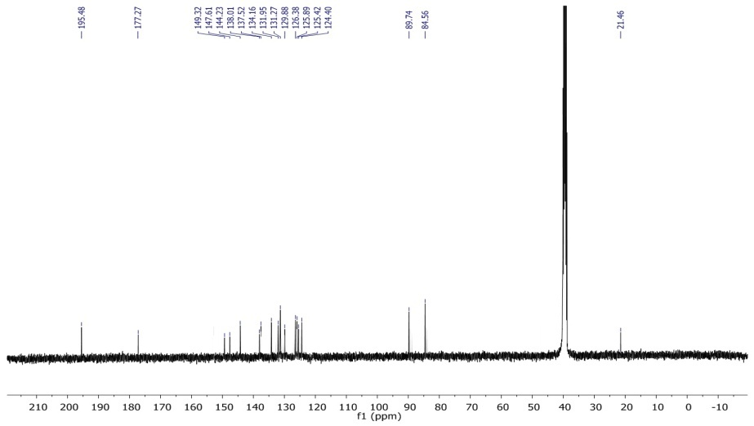

¹H NMR spectrum of 3a,8a-dihydroxy-3-((4-methoxybenzylidene)amino)-2-thioxo-1,3,3a,8a-tetrahydroindeno [1,2-d]imidazol-8(2H)-one (9iv)
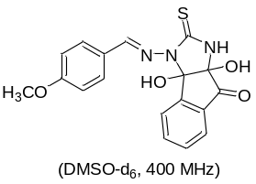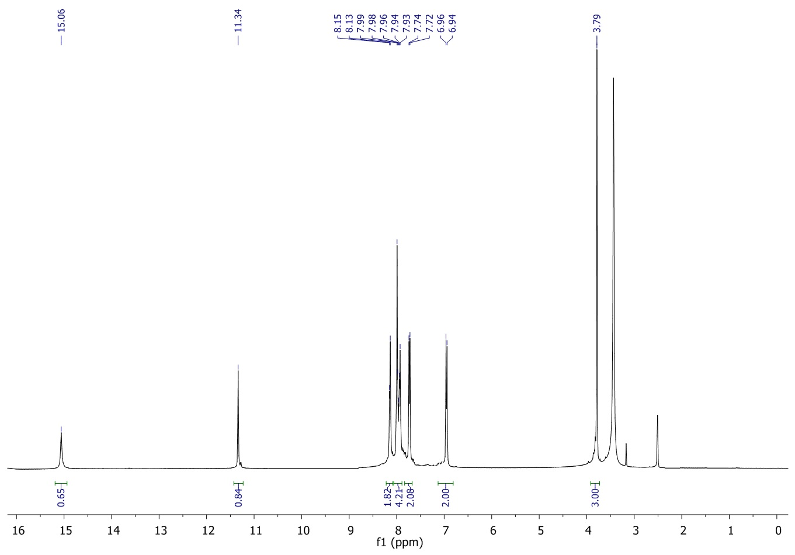

¹³C NMR spectrum of 3a,8a-dihydroxy-3-((4-methoxybenzylidene)amino)-2-thioxo-1,3,3a,8a-tetrahydroindeno[1,2-d]imidazol-8(2H)-one (9iv)
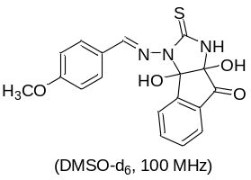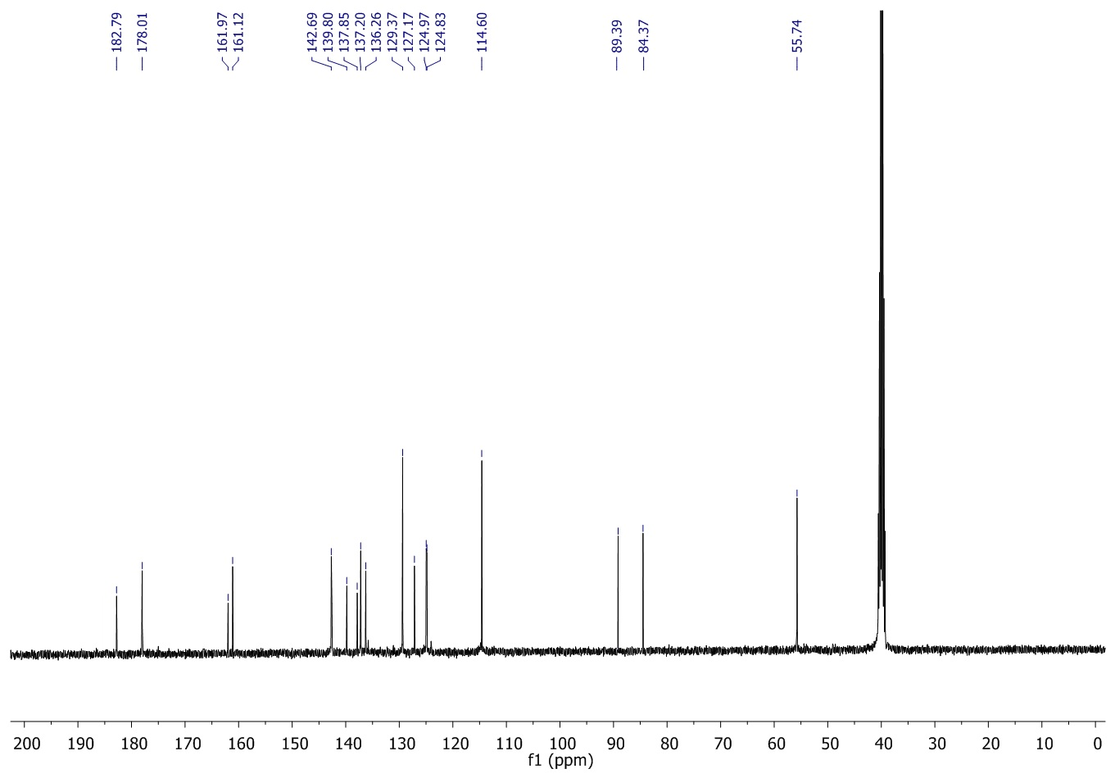
¹H NMR spectrum of 3a,8a-dihydroxy-3-((3-methoxybenzylidene)amino)-2-thioxo-1,3,3a,8a-tetrahydroindeno [1,2-d]imidazol-8(2H)-one (9v)
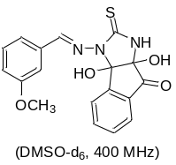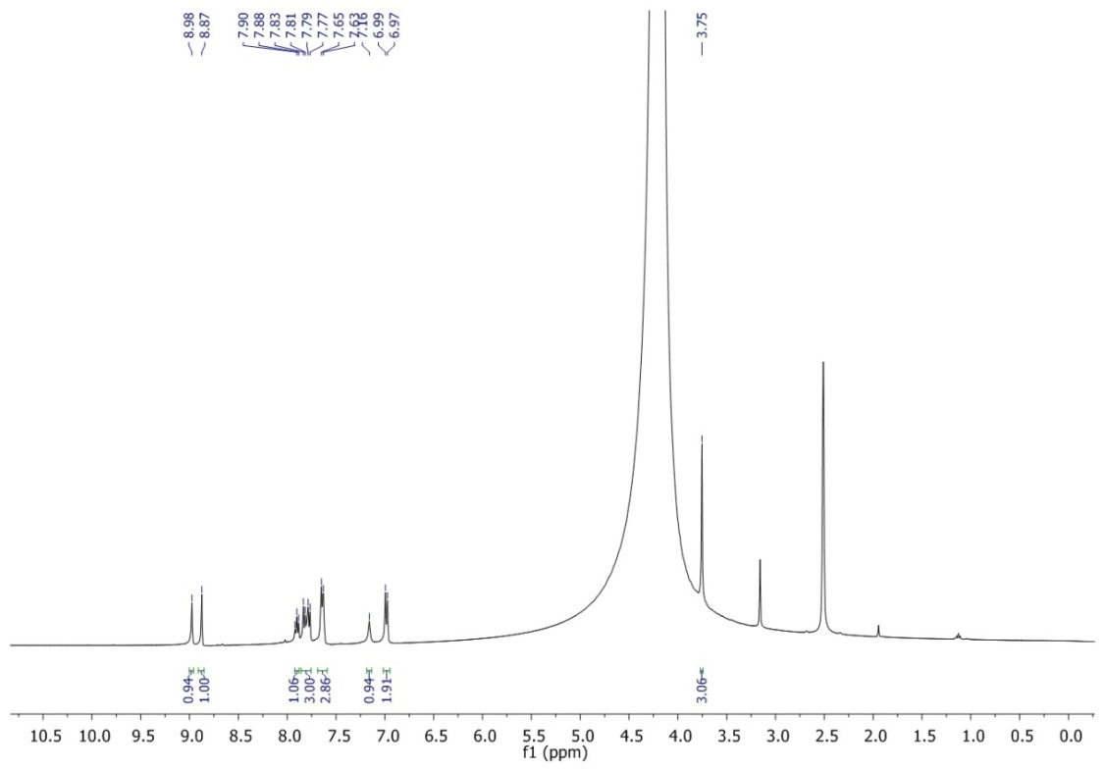

¹³C NMR spectrum of 3a,8a-dihydroxy-3-((3-methoxybenzylidene)amino)-2-thioxo-1,3,3a,8a-tetrahydroindeno[1,2-d]imidazol-8(2H)-one (9v)
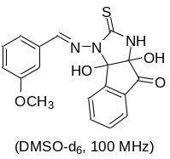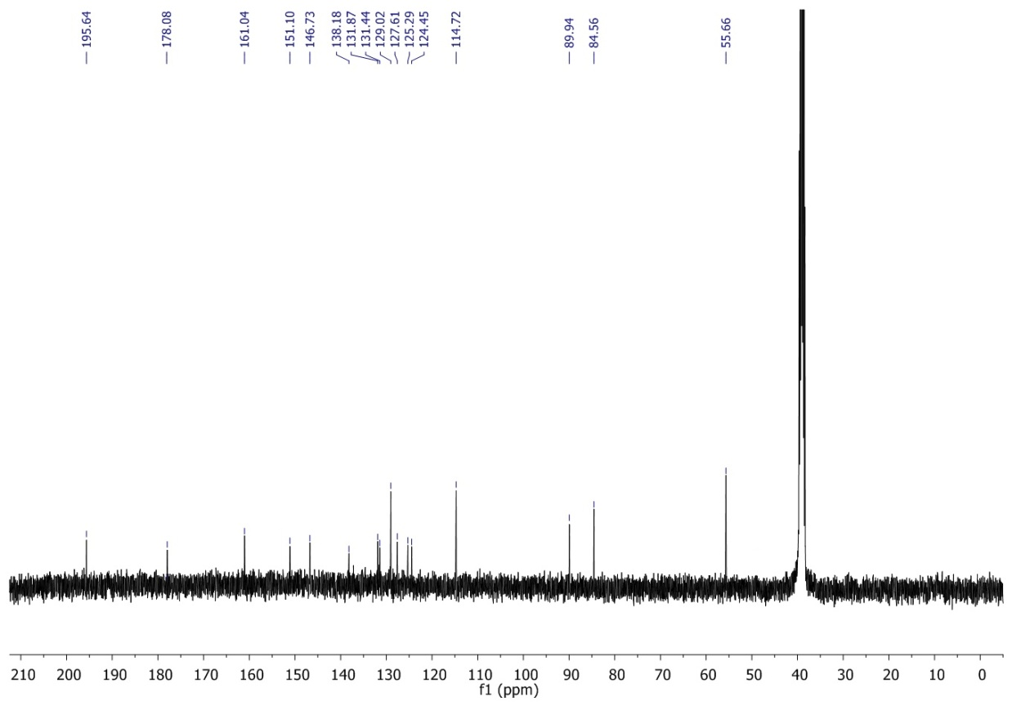

¹H NMR spectrum of 3-((4-chlorobenzylidene)amino)- 3a,8a-dihydroxy-2-thioxo-1,3,3a,8a-tetrahydroindeno [1,2-d]imidazol-8(2H)-one (9vi)
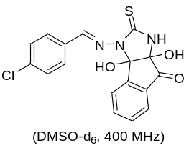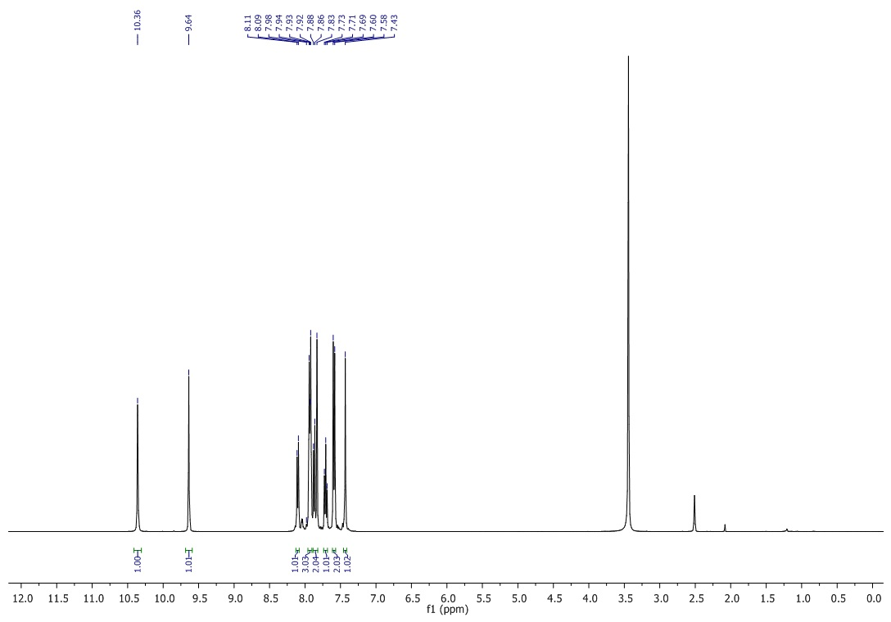

¹³C NMR spectrum of 3-((4-chlorobenzylidene)amino)- 3a,8a-dihydroxy-2-thioxo-1,3,3a,8a-tetrahydroindeno [1,2-d]imidazol-8(2H)-one (9vi)
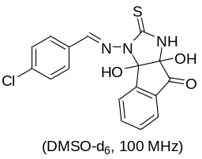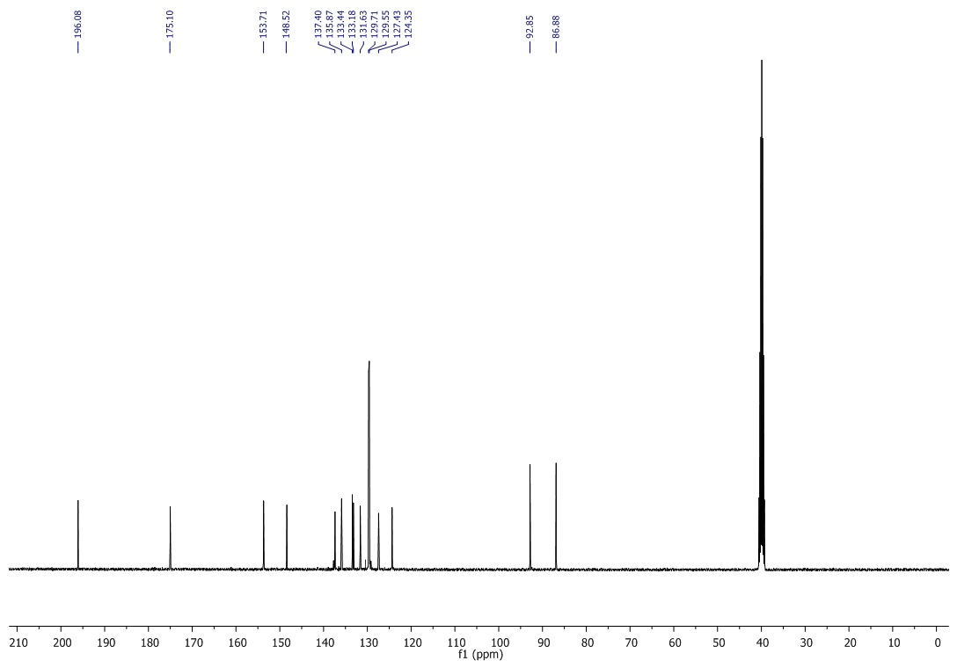

¹H NMR spectrum of 3-((2-chlorobenzylidene)amino)- 3a,8a-dihydroxy-2-thioxo-1,3,3a,8a-tetrahydroindeno [1,2-d]imidazol-8(2H)-one (9vii)
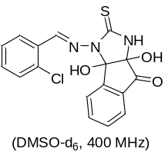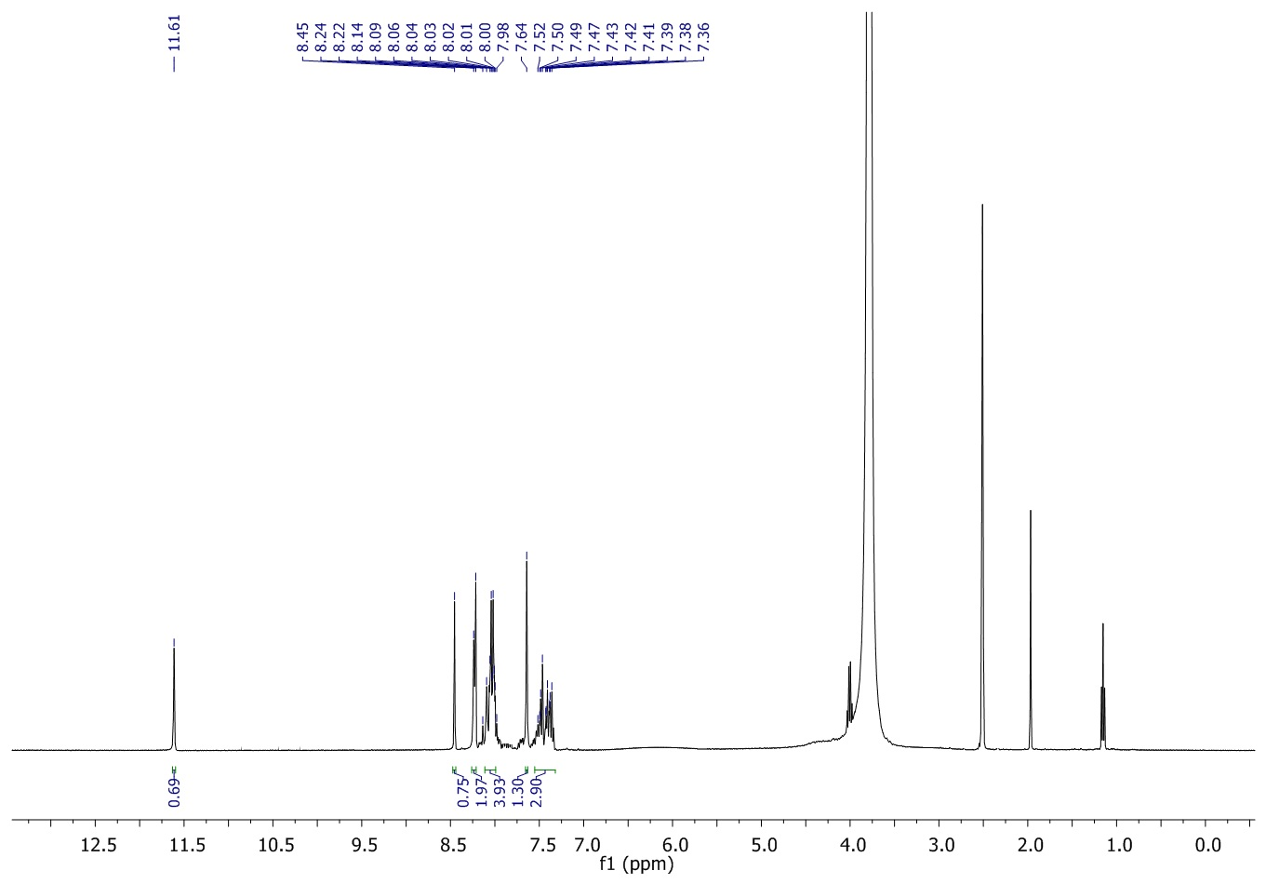

¹³C NMR spectrum of 3-((2-chlorobenzylidene)amino)- 3a,8a-dihydroxy-2-thioxo-1,3,3a,8a-tetrahydroindeno [1,2-d]imidazol-8(2H)-one (9vii)
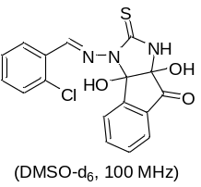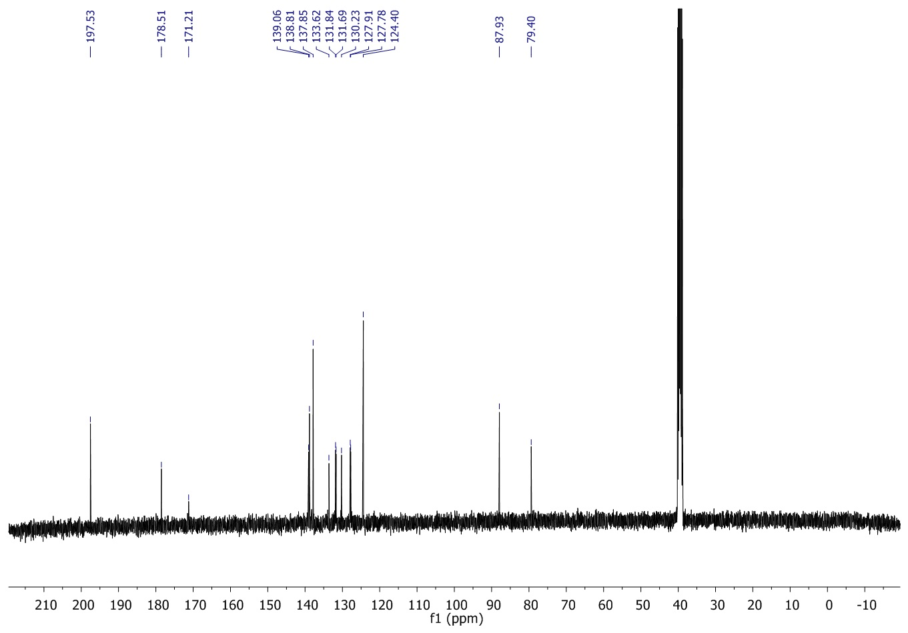

¹H NMR spectrum of 3-((4-bromobenzylidene)amino)- 3a,8a-dihydroxy-2-thioxo-1,3,3a,8a-tetrahydroindeno [1,2-d]imidazol-8(2H)-one(9viii)
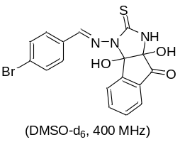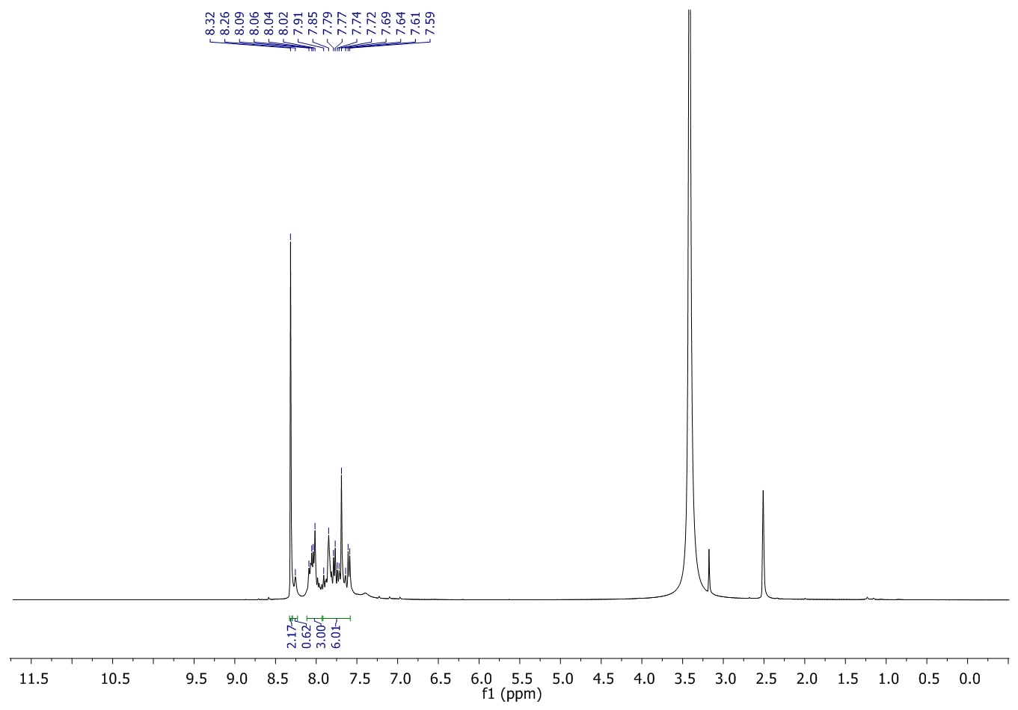

¹³C NMR spectrum of 3-((4-bromobenzylidene)amino)- 3a,8a-dihydroxy-2-thioxo-1,3,3a,8a-tetrahydroindeno [1,2-d]imidazol-8(2H)-one (9viii)
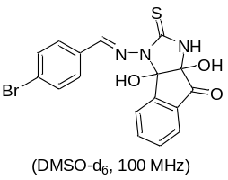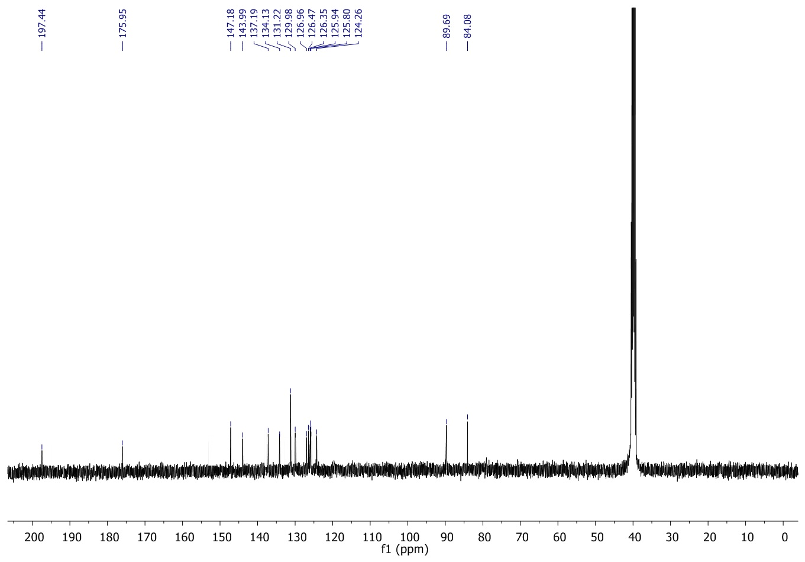

¹H NMR spectrum of 3a, 8a-dihydroxy-3-((4-nitrobenzylidene)amino)-2-thioxo-1,3,3a,8a-tetrahydroindeno[1,2-d]imidazol-8(2H)-one(9ix)
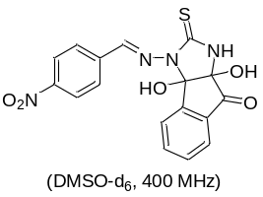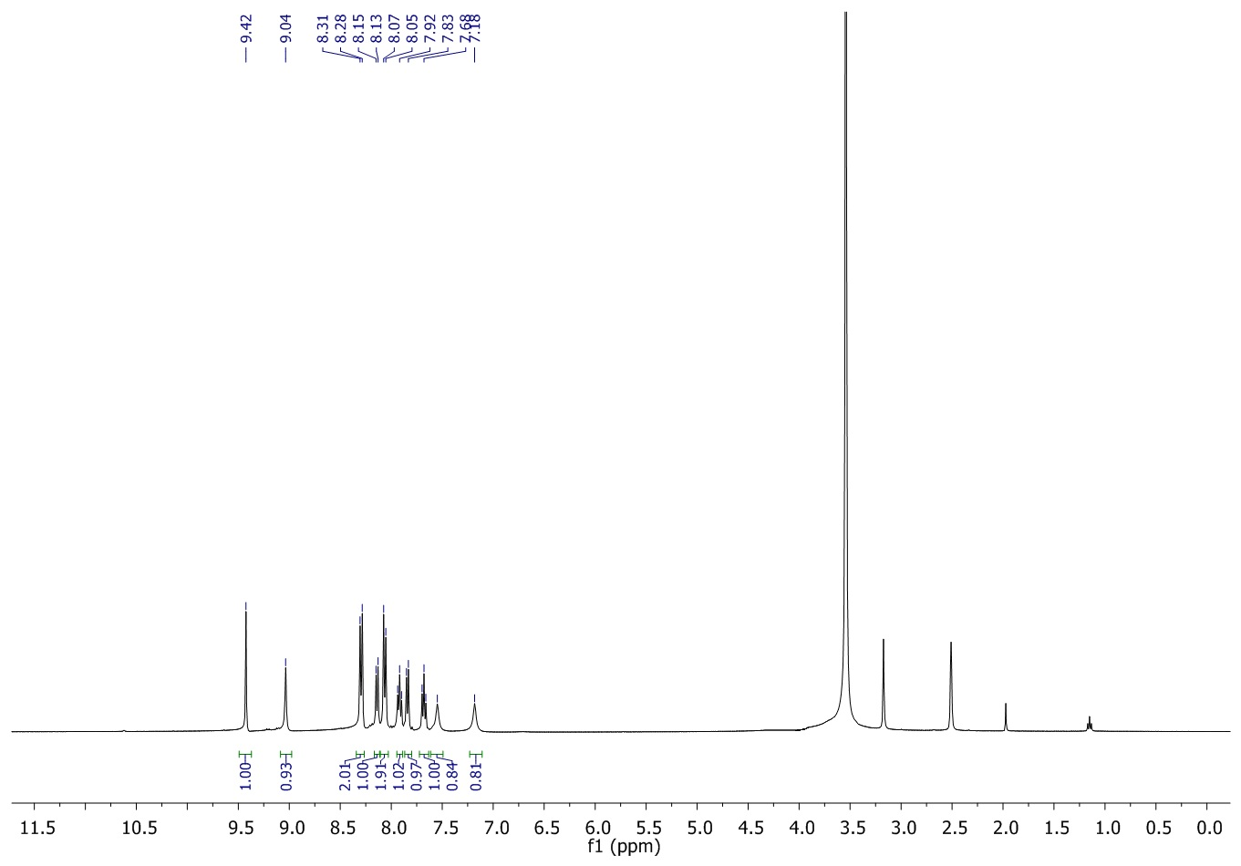

¹³C NMR spectrum of 3a, 8a-dihydroxy-3-((4-nitrobenzylidene)amino)-2-thioxo-1,3,3a,8a-tetrahydroindeno[1,2-d]imidazol-8(2H)-one (9ix)
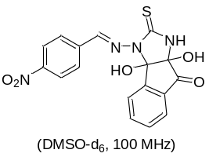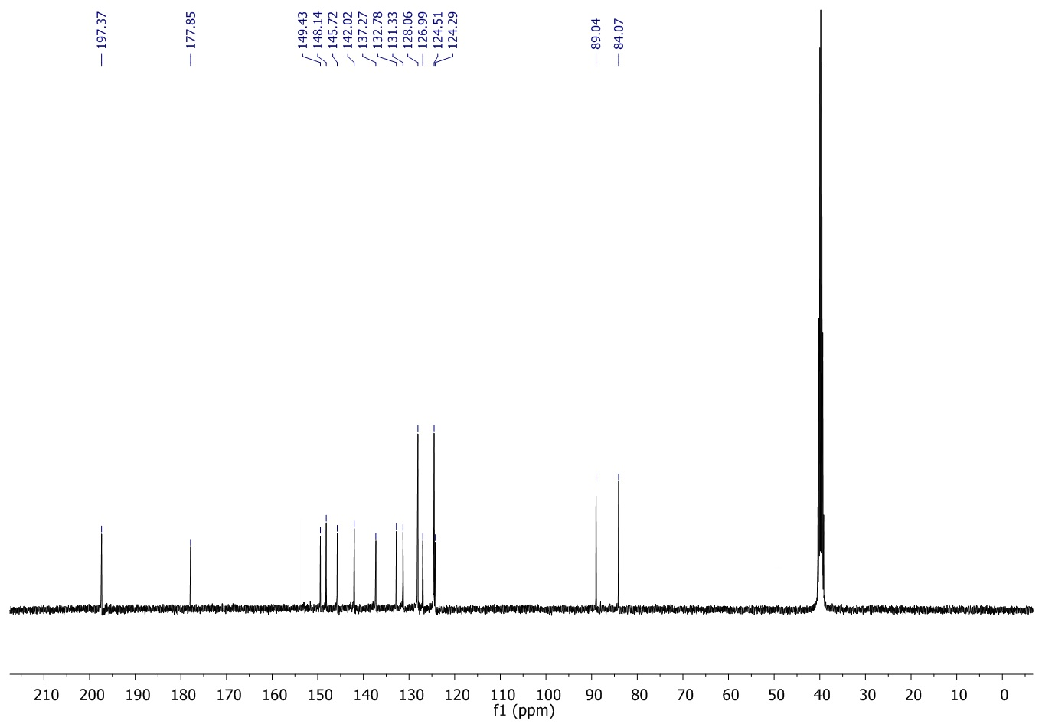

¹H NMR spectrum of 3a, 8a-dihydroxy-3-((3-nitrobenzylidene)amino)-2-thioxo-1,3,3a,8a-tetrahydroindeno[1,2-d]imidazol-8(2H)-one (9x)
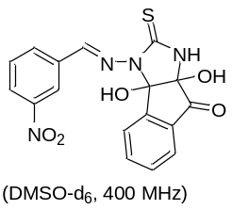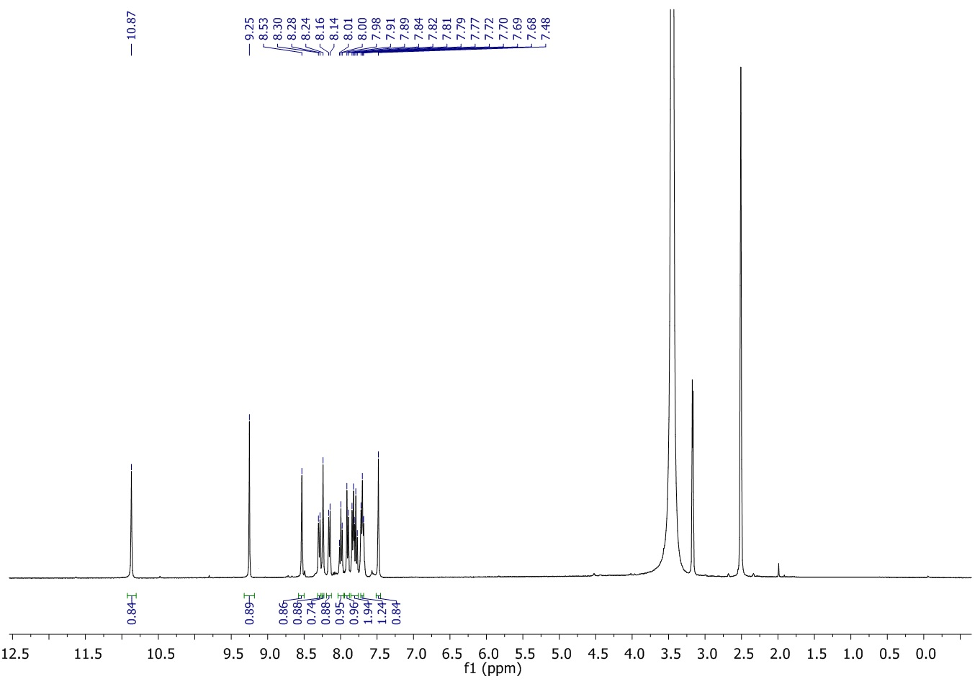

¹³C NMR spectrum of 3a, 8a-dihydroxy-3-((3-nitrobenzylidene)amino)-2-thioxo-1,3,3a,8a-tetrahydroindeno[1,2-d]imidazol-8(2H)-one(9x)
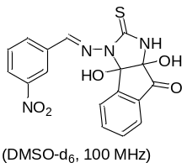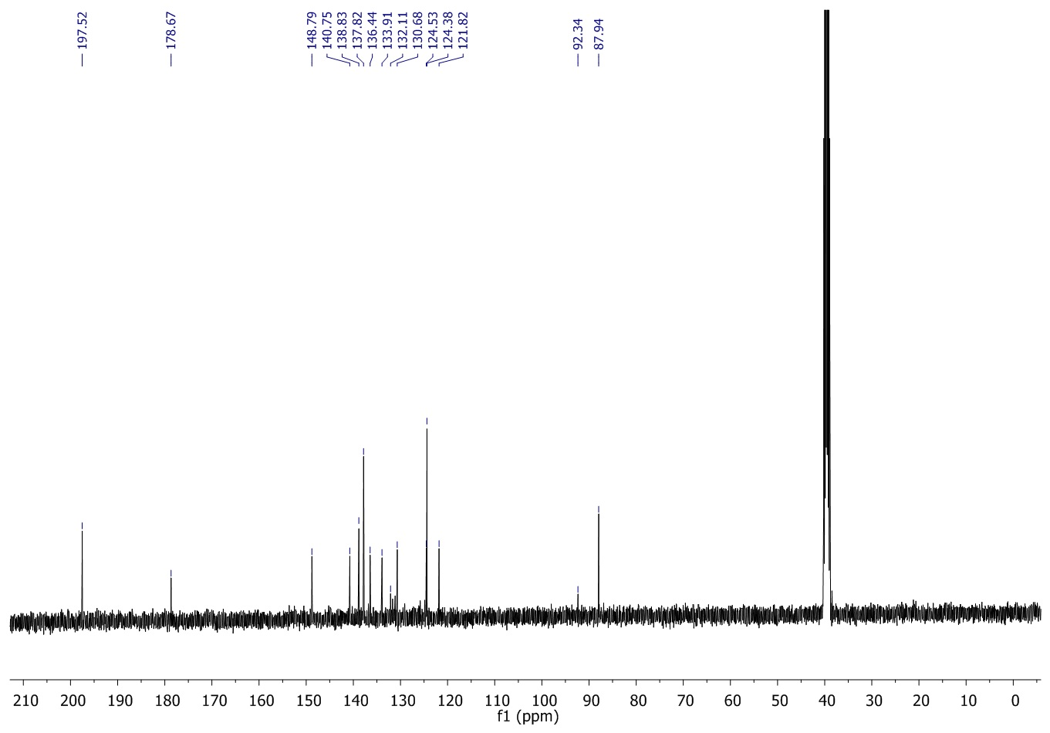
¹H NMR spectrum of 3a,8a-dihydroxy-2-thioxo-3-((3,4,5-trimethoxybenzylidene)amino)-1,3,3a,8a-tetrahydroindeno[1,2-d]imidazol-8(2H)-one (9xi)
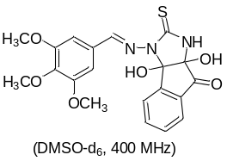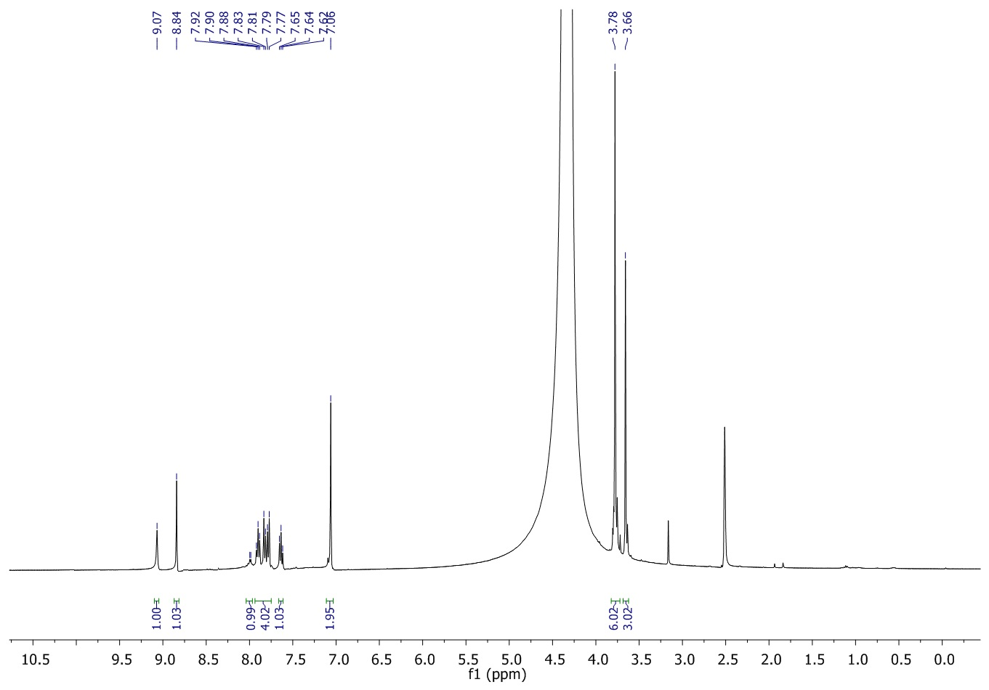

¹³C NMR spectrum of 3a,8a-dihydroxy-2-thioxo-3-((3,4,5-trimethoxybenzylidene)amino)-1,3,3a,8a-tetrahydroindeno[1,2-d]imidazol-8(2H)-one (9xi)
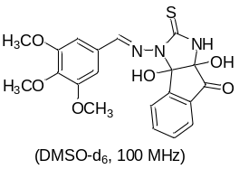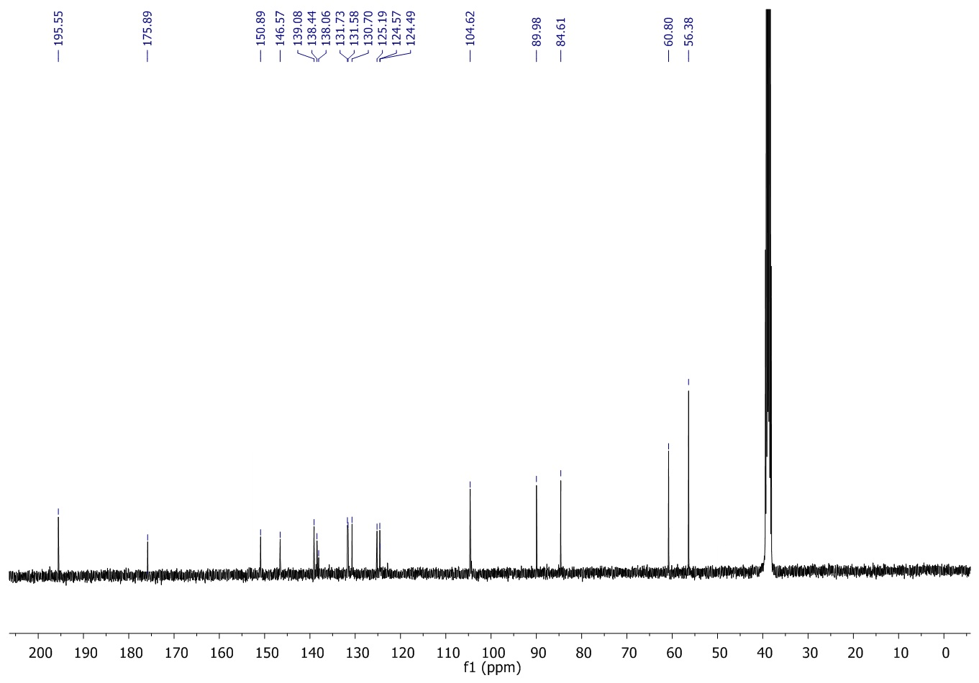

¹H NMR spectrum of 3a,8a-dihydroxy -3-((napthalen-2-ylmethylene)amino) -2-thioxo -1,3,3a,8a-tetrahydroindeno [1,2-d]imidazol-8(2H)-one (9xii)
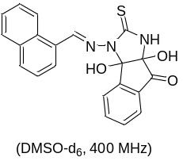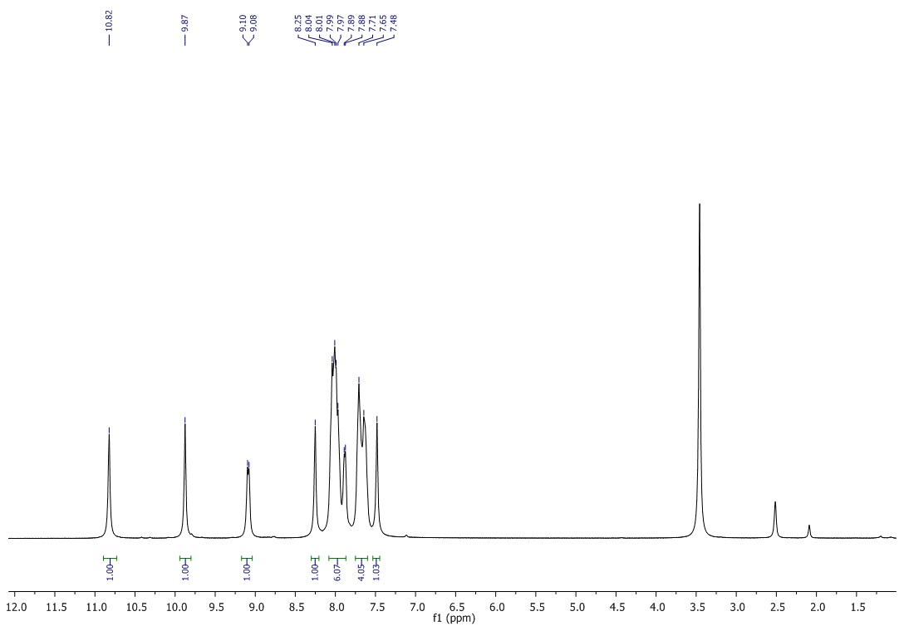

¹³C NMR spectrum of 3a,8a-dihydroxy -3-((napthalen-2-ylmethylene)amino) -2-thioxo -1,3,3a,8a-tetrahydroindeno [1,2-d]imidazol-8(2H)-one (9xii)
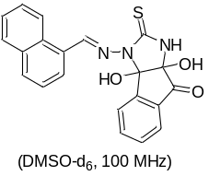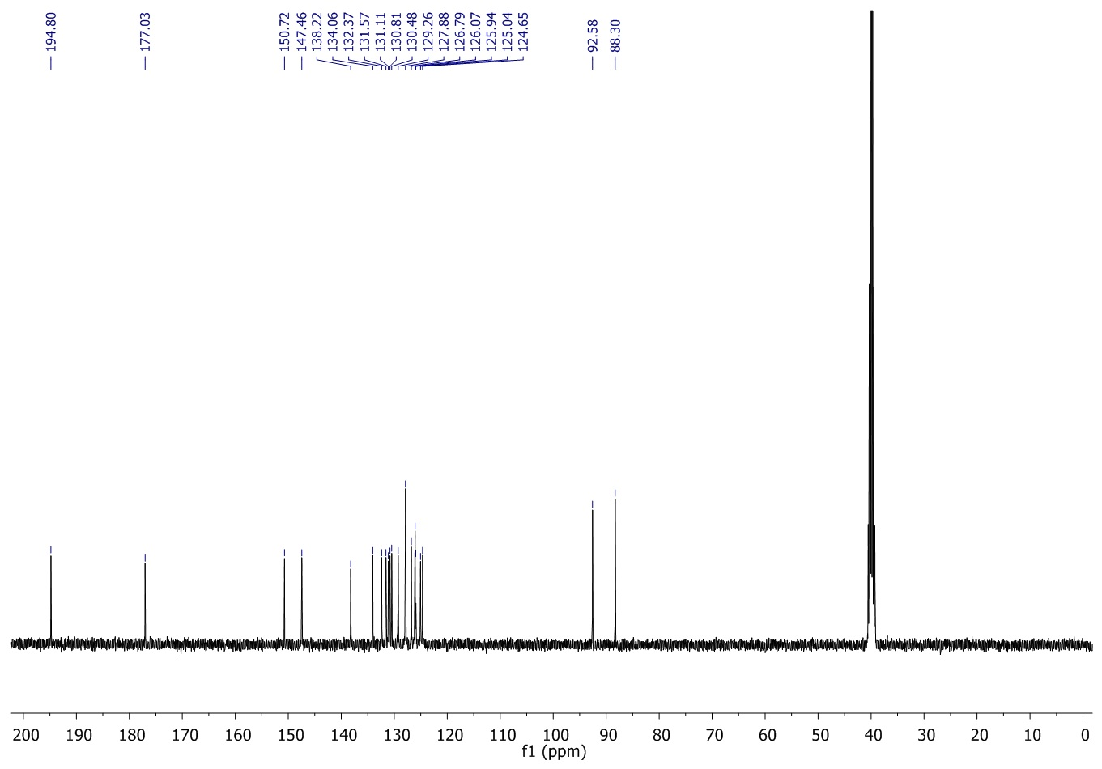

¹H NMR spectrum of 3-((furan-2-ylmethylene)amino)-3a,8a-dihydroxy -2-thioxo -1,3,3a,8a-tetrahydroindeno [1,2-d]imidazol-8(2H)-one (9xiii)
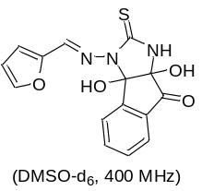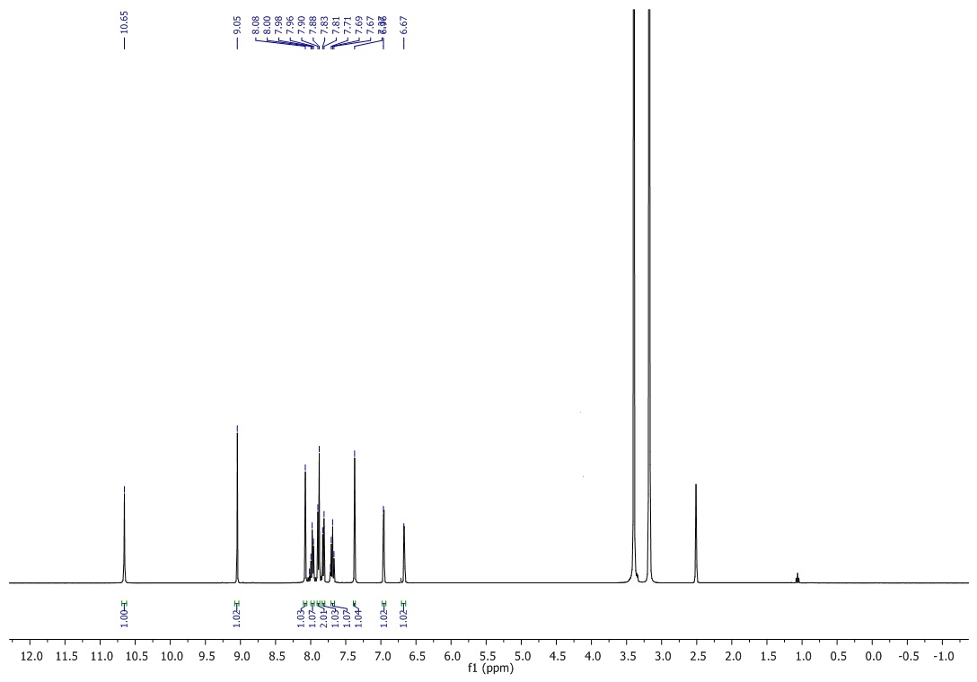

¹³C NMR spectrum of 3-((furan-2-ylmethylene)amino)-3a,8a-dihydroxy -2-thioxo -1,3,3a,8a-tetrahydroindeno [1,2-d]imidazol-8(2H)-one (9xiii)
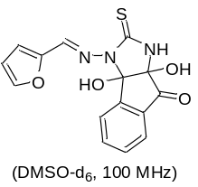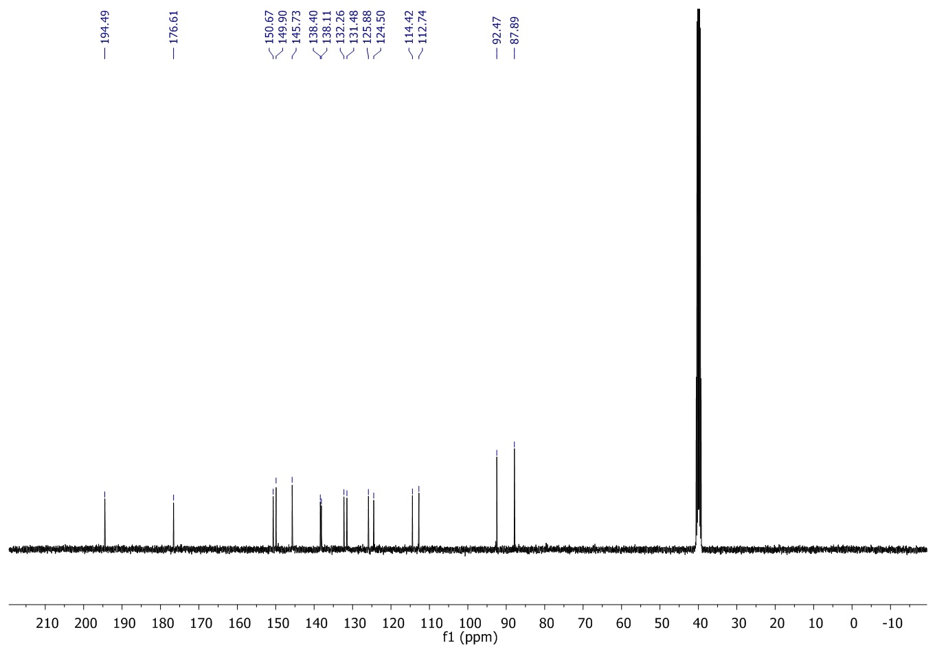
¹H NMR spectrum of 3-(((6-bromobenzo[d][1,3]dioxol-5-yl)methylene)amino)-3a,8a-dihydroxy-2-thioxo-1,3,3a,8a-tetrahydroindeno[1,2-d]imidazol-8(2H)-one (9xiv)
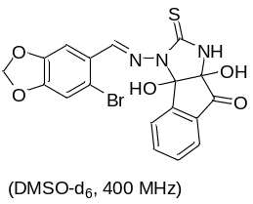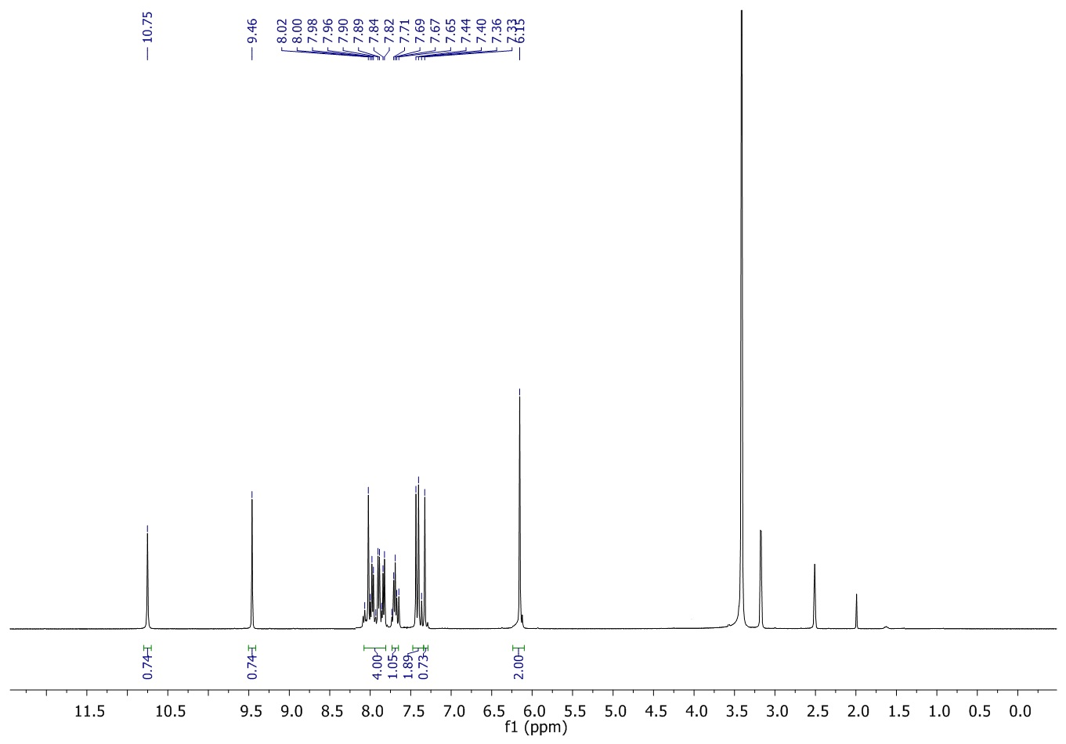

¹³C NMR spectrum of 3-(((6-bromobenzo[d][1,3]dioxol-5-yl)methylene)amino)-3a,8a-dihydroxy-2-thioxo-1,3,3a,8a-tetrahydroindeno[1,2-d]imidazol-8(2H)-one (9xiv)
