Project SP-3 Skills Practice: Handheld Tracking Backward with Moving Subject
Project Handle a camera while walking backwards, shooting someone out walking.
Goals
- Handhold a camera while walking backwards with assistance.
- Shoot three different sizes of someone walking that can be edited together.
- Maintain consistent ‘lead space’ ahead of walker from shot to shot.
- Reduce subject’s self-consciousness.
- Shoot sound coverage of footsteps of the walker.
Steps Production
- Version A: Arrange for a subject to start walking, facing you as in LH diagram below. Camera operator walks backward, guided for safety’s sake by a light touch from assistant or mike operator.
- Frame the subject in a wide shot, and hold that shot for about 15 seconds, then,
- Let subject gain on you until you have a medium shot. Hold this for 15 seconds, then,
- Let subject gain on you again, hold for 15 seconds of big close-up, then,
- Stop camera so subject walks out of shot.
- Version B: Now do the same thing again but this time, as in RH diagram, with the camera shooting at about a 30-degree angle to the subject’s axis. Which works best and why?
Postproduction
- Make the transitions between the three different image sizes as cuts, being very careful to preserve the footstep rhythm. Where you cut in the footstep cycle matters.
Creative Limitations
- You’ll find that people are camera-conscious when you shoot on-axis as in Version A.
- Version B will be more comfortable for subject, gives a better view of background, and allows operator partial sight of what’s behind.
Notes As mental work to lower self-consciousness, ask your subject to mentally reconstruct a recent event in which he or she was involved. Experiment with the framing and background to find the most acceptable shot. Remember to include lead space in the composition in the off-axis framing (more space ahead of a moving subject than there is behind them).

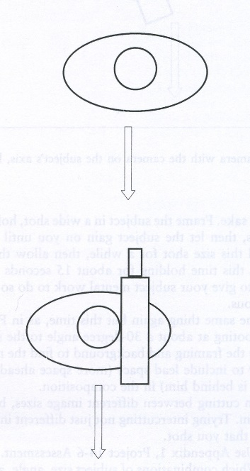
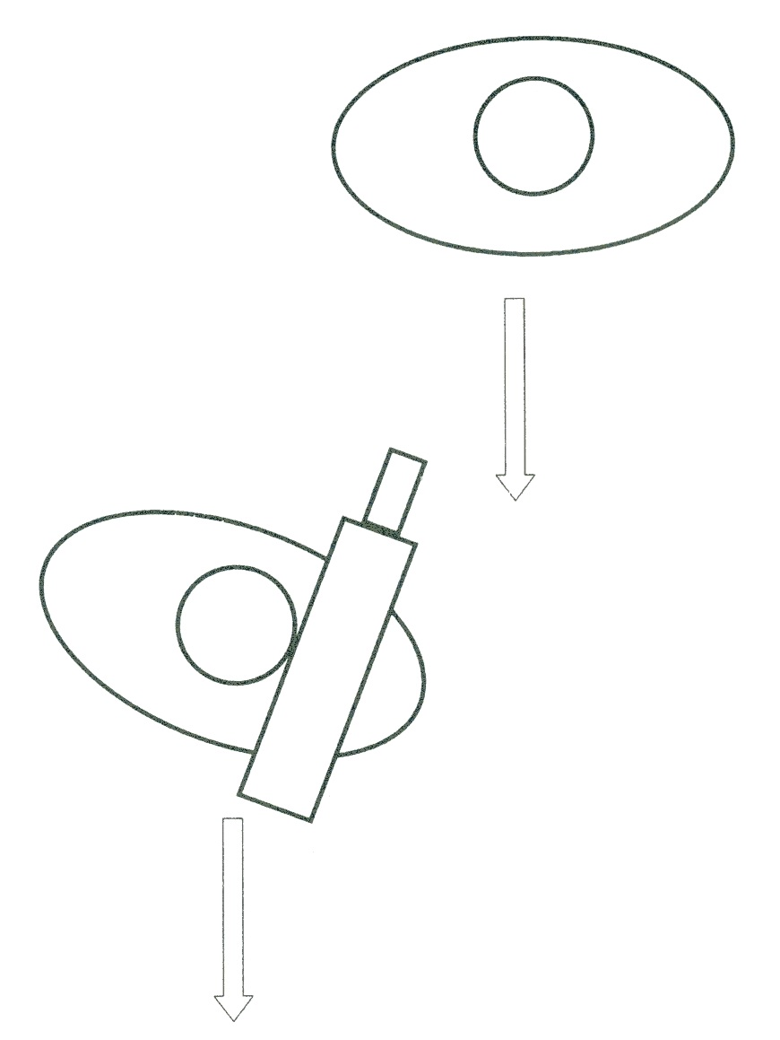

Camera on subject’s axis Camera around 30 deg. off-axis

Which worked best?

ASSESSMENT, PROJECT SP-3 PRACTICE: HANDHELD TRACKING BACKWARD WITH MOVING SUBJECT
Criteria | Rating
- Directing. Person looks relaxed and unselfconscious. | 0 1 2 3 4 5
- Camera glides as if on wheels (no stumbles or lurches). | 0 1 2 3 4 5
- Wide shot (WS) well framed. | 0 1 2 3 4 5
- Medium shot (MS) well framed. | 0 1 2 3 4 5
- BCU well composed. | 0 1 2 3 4 5
- Lead space proportions consistent from shot to shot. | 0 1 2 3 4 5
- Compositional center consistent from shot to shot. | 0 1 2 3 4 5
- Backgrounds (B/Gs) used effectively. | 0 1 2 3 4 5
- Editing: The two cuts look natural. | 0 1 2 3 4 5
- Has tried intercutting different camera-to-subject axes for assessment. | 0 1 2 3 4 5
TOTAL | ______/50

