Chapter 1: Connecting as an Early Years Professional
Workbook
Chapter 1 of the handbook discusses what it means to be an early years educator working with 0-3-year-olds in the UK. It discusses how we see ourselves as professionals and the fragmented nature of the qualification framework in this professional field.
Reflection Point 1: Being an Early Years Professional
- Describe what you think an early childhood professional is.
- Do you think there are any aspects of being an early childhood professional that is different to the usual idea of professionalism?
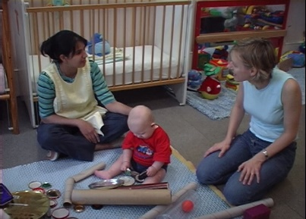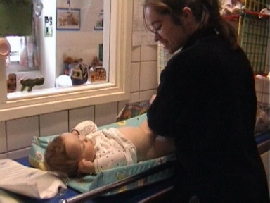
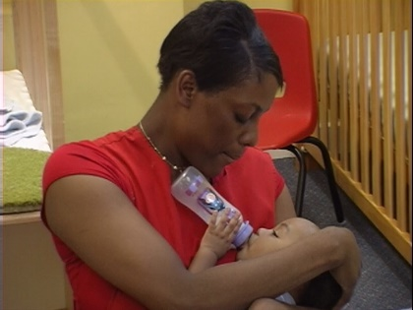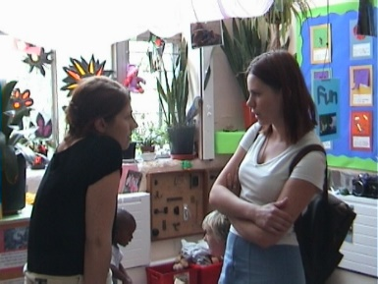

In chapter 1, I quote Bolam et al to suggest that there is a difference between being ‘professional’ and ‘being a professional’, indicating that professionalism includes the way you conduct yourself, your accountability and integrity, not just the qualifications you hold. Therefore, ‘care’ is potentially as professional a pursuit as any.
- Do you consider yourself to be a professional / or professional?
- What do you call the profession you are a member of?
- What are the key events or experiences that have formed your professional identity?
- What attributes of professionalism would you look for when colleagues are interacting with:
  - Children;
  - Parents and carers;
  - Other professional colleagues?

Chapter 1 also explores the motivations that lead us to follow a career in the early years sector and the skills and attributes needed to be an effective early years professional.
Reflection Point 2
Take some time to reflect on your feelings and motivations in your work and how you came to be where you are:
You can write notes in response to this, or draw it as a journey or map if you like, noting significant turnings and maybe barriers or help you received along the way. Think about;
- What led you into the early years field?
- Why did you want to work with young children?
- Why are you working with 0–3-year-olds (if you are)?
- Who has most influenced your work?
- What do you enjoy most about your work?
- What do you find the most challenging?

If possible, join up with a trusted colleagues to share and discuss your responses.

Chapter 1 also suggests that effective communication and teamwork skills are core to being an effective early years professional. You can use the following templates to reflect on your communication skills and work behaviours.
Practice task 1: Thinking further about communication skills
Next time you have a key communication to make, think about: |  | Write your thoughts here
Why am I communicating? | What is the purpose of my communication?
Who do I need to communicate with? | Am I choosing the best person? Am I avoiding anyone?  Am I excluding anyone?
What do I hope to achieve by this communication? | What do I want to happen?  What do people already know / not know?
Where is the best place to communicate? | While working? With others? Alone?  In private?
When is the best time to communicate? | Now? What would be the impact?  Leaving it until later / tomorrow / next week? What would be the impact?
How is the best way of communicating this? | Is this a difficult topic? Prepare  How specific / direct do I need to be to achieve my aim?  How much do I need to listen?

Practice task 2
Use the following questions to identify some elements of group behaviours immediately after the next time you are in a group situation, such as a meeting or discussion group:
Who is / isn’t participating?
Who is / isn’t talking?
What is causing a quiet person to talk or a talkative person to be quiet?
Who is talking to who?
Who keeps the ball rolling?
Who is influencing?
Who is / isn’t listened to when they talk?
Who has high / low influence?
How are decisions being made?

In this situation, how did you?
Observe others | Offer encouragement  Give support
Listen | Show you are paying attention verbally and non-verbally  Create a warm and enabling environment  Show empathy
Communicate clearly | Show honesty and genuineness  Use humour appropriately
Question | Encourage and receive feedback Challenge and confront others assertively

Chapter 1 also emphasises the importance of taking care of your own well-being, as this impacts on your ability to respond well to children.
This includes in your personal life. So, take some time to think about how you look after your own well-being at home. Research suggests that we need regular access to the 5 ‘F’s of well-being: Family, friends, food, fitness and fun!
How do you make sure you get these on a regular basis?
Educators’ well-being also requires good levels of support in the workplace, so take time here to reflect on how your well-being is supported in your workplace.
Reflection Point 3: The well-being of educators
How is your well-being supported in your workplace?
- Who supports you?
- Reflect on what makes you feel good.
- Who can you talk to when you need to think something through?
- How often do you have supervision?

Practice task 3: Journaling for well-being
Keeping a journal is a useful way of reflecting on work issues that cause you worry and so can contribute to your well-being. Try keeping a journal for a month in which you note down things that play on your mind. These are sometimes called critical or significant incidents.
A significant incident might be one where you:
- felt you had done something well
- made the wrong decision
- lacked confidence
- made a mistake
- really enjoyed working with someone / a group
- felt pressured
- felt unsupported
- realised you did not know enough
- were worried about a child, family or colleague

Describe the event | What happened, where and when; what led to the event?  What actually happened, who said or did what?  What were you thinking and feeling at the time of this event and just before / after it?  What took you by surprise or happened in a way you didn't expect?
Reflect on your description | Why did this incident / event stand out?  What was going on?  Did you bring personal bias or a particular mindset to the event?  Could you interpret what happened from a different point of view?  How might the other person(s) think and feel about what happened?  What can you do to resolve any of the issues raised?
If possible, find a colleague to share your account of the episode. Discuss your interpretation, then modify it in the light of their perspective if appropriate.
Reflect on your learning | What were the outcomes of this event for the various participants?  What have you learned about yourself and how you relate to others?  What are your thoughts and feelings now about this event?

Practice check:
You can use the checklist template provided as a tool for identifying what is working well in your setting and what you want or need to develop further in relation to leading and managing and the well-being and professional development of educators.

