MULTIPLE CHOICE QUESTIONS ON CHAPTER 18 - 27
All questions have only one correct answer

1. In the right-angled triangle ABC shown in Figure M2.1, sine A is given by:
(a) b/a (b) c/b (c) b/c (d) a/b
Figure M2.1 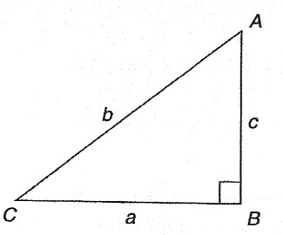

2. In the right-angled triangle ABC shown in Figure M2.1, cosine C is given by:
(a) a/b (b) c/b (c) a/c (d) b/a
3. In the right-angled triangle shown in Figure M2.1, tangent A is given by:
(a) b/c (b) a/c (c) a/b (d) c/a
4. radians is equivalent to: (a) 135° (b) 270° (c) 45° (d) 67.5°
5. In the triangular template ABC shown in Figure M2.2, the length AC is:
(a) 6.17 cm (b) 11.17 cm (c) 9.22 cm (d) 12.40 cm
Figure M2.2 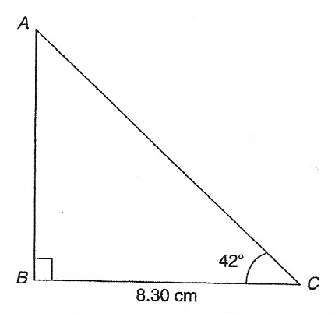

6. (- 4, 3) in polar co-ordinates is:
(a) (5, 2.498 rad) (b) (7, 36.87°) (c) (5, 36.87°) (d) (5, 323.13°)

7. Correct to 3 decimal places, sin(- 2.6 rad) is:
(a) 0.516 (b) -0.045 (c) -0.516 (d) 0.045
8. For the right-angled triangle PQR shown in Figure M2.3, angle R is equal to:
(a) 41.41° (b) 48.59° (c) 36.87° (d) 53.13°
Figure M2.3 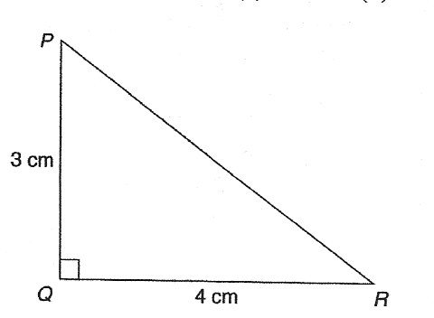

9. A hollow shaft has an outside diameter of 6.0 cm and an inside diameter of 4.0 cm. The cross-
sectional area of the shaft is:
(a) 6283 mm (b) 1257 mm (c) 1571 mm (d) 628 mm
10. If cos A = , then sin A is equal to: (a) (b) (c) (d)
11. The area of triangle XYZ in Figure M2.4 is:
(a) 24.22 cm (b) 19.35 cm (c) 38.72 cm (d) 32.16 cm
Figure M2.4 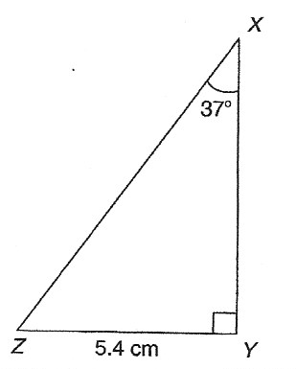

12. The value, correct to 3 decimal places, of cos is:
- 0.999 (b) 0.707 (c) - 0.999 (d) -0.707
13. The speed of a car at 1 second intervals is given in the following table:
Time t (s) 0 1 2 3 4 5 6
Speed v(m/s) 0 2.5 5.0 9.0 15.0 22.0 30.0
The distance travelled in 6 s (i.e. the area under the v/t graph) using the trapezoidal rule is:
(a) 83.5 m (b) 68 m (c) 68.5 m (d) 204 m
14. A triangle has sides a = 9.0 cm, b = 8.0 cm and c = 6.0 cm. Angle A is equal to:
(a) 82.42° (b) 56.49° (c) 78.58° (d) 79.87°
15. An arc of a circle of length 5.0 cm subtends an angle of 2 radians. The circumference of the circle is:
(a) 2.5 cm (b) 10.0 cm (c) 5.0 cm (d) 15.7 cm
16. In the right-angled triangle ABC shown in Figure M2.5, secant C is given by:
(a) (b) (c) (d)
Figure M2.5 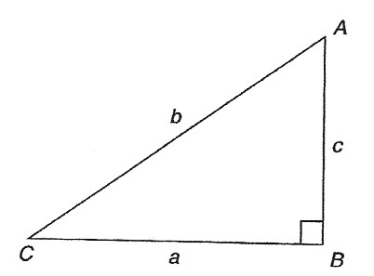

17. In the right-angled triangle ABC shown in Figure M2.5, cotangent C is given by:
(a) (b) (c) (d)
18. In the right-angled triangle ABC shown in Figure M2.5, cosecant A is given by:
(a) (b) (c) (d)
19. The mean value of a sine wave over half a cycle is:
(a) 0.318 × maximum value (b) 0.707 × maximum value
(c) the peak value (d) 0.637 × maximum value
20. Tan 60° is equivalent to: (a) (b) (c) (d)
21. An alternating current is given by: i = 15 sin(100πt – 0.25) amperes. When time t = 5 ms, the current
i has a value of:
(a) 0.35 A (b) 14.53 A (c) 15 A (d) 0.41 A
22. The area of the path shown shaded in Figure M2.6 is:
- 300 m (b) 234 m (c) 124 m (d) 66 m
Figure M2.6 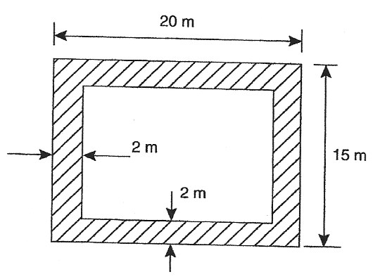

23. Correct to 4 significant figures, the value of sec 161° is:
(a) – 1.058 (b) 0.3256 (c) 3.072 (d) – 0.9455
24. Which of the following trigonometrical identities is true ?
(a) cosec (b) cot (c) (d) sec

25. The displacement x metres of a mass from a fixed point about which it is oscillating is given by
x = 3 cos ωt – 4 sin ωt, where t is the time in seconds. x may be expressed as:
(a) 5 sin(ωt + 2.50) metres (b) 7 sin(ωt – 36.87°) metres
(c) 5 sin ωt metres (d) – sin(ωt – 2.50) metres
26. The solutions of the equation 2 tan x – 7 = 0 for are:
(a) 105.95° and 254.05° (b) 74.05° and 254.05°
(c) 74.05° and 285.95° (d) 254.05° and 285.95°
27. A sinusoidal current is given by: i = R sin(ωt + α). Which of the following statements is incorrect ?
(a) R is the average value of the current (b) frequency = Hz
(c) ω = angular velocity (d) periodic time = s
28. If the circumference of a circle is 100 mm, its area is:
(a) 314.2 cm (b) 7.96 cm (c) 31.83 mm (d) 78.54 cm
29. The trigonometric expression cosθ - sinθ is equivalent to:
(a) 2 sinθ - 1 (b) 1 + 2 sinθ (c) 2 sinθ + 1 (d) 1 – 2 sinθ
30. A vehicle has a mass of 2000 kg. A model of the vehicle is made to a scale of 1 to 100. If the vehicle
and model are made of the same material, the mass of the model is:
(a) 2 g (b) 20 kg (c) 200 g (d) 20 g
31. A vertical tower stands on level ground. At a point 100 m from the foot of the tower the angle of
elevation of the top is 20°. The height of the tower is:
(a) 274.7 m (b) 36.4 m (c) 34.3 m (d) 94.0 m
32. (7, 141°) in Cartesian co-ordinates is:
(a) (5.44, -4.41) (b) (-5.44, -4.41) (c ) (5.44, 4.41) (d) (-5.44, 4.41)
33. If tan A = 1.4276, sec A is equal to:
(a) 0.8190 (b) 0.5737 (c) 0.7005 (d) 1.743
34. An indicator diagram for a steam engine is as shown in Figure M2.7. The base has been divided into
6 equally spaced intervals and the lengths of the 7 ordinates measured, with the results shown in
centimetres. Using Simpson’s rule the area of the indicator diagram is:
(a) 32 cm (b) 17.9 cm (c) 16 cm (d) 96 cm
Figure M2.7 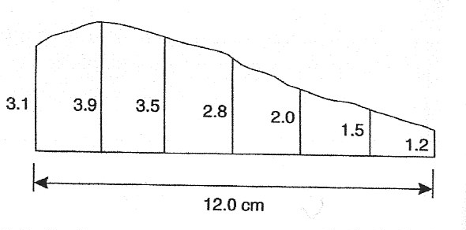

35. The acute angle cot2.562 is equal to:
(a) 67.03° (b) 21.32° (c) 22.97° (d) 68.68°
36. Correct to 4 significant figures, the value of cosec(- 125°) is:
(a) – 1.221 (b) – 1.743 (c) – 0.8192 (d) – 0.5736
37. The equation of a circle is x + y - 2x + 4y – 4 = 0. Which of the following statements is correct?
- The circle has centre (1, - 2) and radius 4
- The circle has centre (- 1, 2) and radius 2
- The circle has centre (- 1, - 2) and radius 4
- The circle has centre (1, - 2) and radius 3
38. Cos 30° is equivalent to: (a) (b) (c) (d)

39. The angles between 0° and 360° whose tangent is –1.7624 are:
(a) 60.43° and 240.43° (b) 119.57° and 299.57°
(c) 119.57° and 240.43° (d) 150.43° and 299.57°
40. The surface area of a sphere of diameter 40 mm is:
(a) 201.06 cm (b) 33.51 cm (c) 268.08 cm (d) 50.27 cm
41. In the triangular template DEF shown in Figure M2.8, angle F is equal to:
(a) 43.5° (b) 28.6° (c) 116.4° (d) 101.5°
Figure M2.8 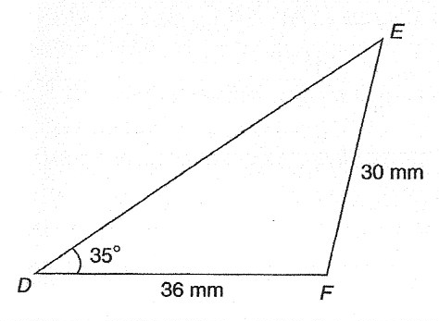

42. The area of the triangular template DEF shown in Figure M2.8 is:
(a) 529.2 mm (b) 258.5 mm (c) 483.7 mm (d) 371.7 mm
43. A water tank is in the shape of a rectangular prism having length 1.5 m, breadth 60 cm and height
300 mm. If 1 litre = 1000 cm, the capacity of the tank is:
(a) 27 l (b) 2.7 l (c) 2700 l (d) 270 l
44. A pendulum of length 1.2 m swings through an angle of 12° in a single swing. The length of arc
traced by the pendulum bob is:
(a) 14.40 cm (b) 25.13 cm (c) 10.00 cm (d) 45.24 cm
45. In the range the solution of the trigonometrical equation 9 tan are:
(a) 33.69°, 146.31°, 213.69° and 326.31° (b) 33.69° and 213.69°
(c) 146.31° and 213.69° (d) 146.69° and 326.31°
46. A wheel on a car has a diameter of 800 mm. If the car travels 5 miles, the number of complete
revolutions the wheel makes (given 1 km = mile) is:
(a) 1989 (b) 1591 (c) 3183 (d) 10000
47. A rectangular building is shown on a building plan having dimensions 20 mm by 10 mm. If the plan
is drawn to a scale of 1 to 300, the true area of the building in m is:
(a) 60000 m (b) 18 m (c) 0.06 m (d) 1800 m
48. An alternating voltage v is given by v = 100 sin volts. When v = 50 volts, the time t is
equal to: (a) 0.093 s (b) – 0.908 ms (c) – 0.833 ms (d) – 0.162 s
49. Using the theorem of Pappus, the position of the centroid of a semicircle of radius r lies on the axis
of symmetry at a distance from the diameter of:
(a) (b) (c) (d)
50. The acute angle cosec1.429 is equal to:
(a) 55.02° (b) 45.59° (c) 44.41° (d) 34.98°
51. The area of triangle PQR is given by:
(a) pr cos Q (b) where s =
(c) rq sin P (d) pq sin Q
52. The values of θ that are true for the equation 5 sin θ + 2 = 0 in the range θ = 0° to θ = 360° are:
(a) 23.58° and 336.42° (b) 23.58° and 203.58°
(c) 156.42° and 336.42° (d) 203.58° and 336.42°
53. (-3, -7) in polar co-ordinates is:
(a) (- 7.62, - 113.20°) (b) (7.62, 246.80°) (c) (7.62, 23.20°) (d) (7.62, 203.20°)
54. In triangle ABC in Figure M2.9, length AC is:
(a) 14.90 cm (b) 18.15 cm (c) 13.16 cm (d) 14.04 cm
Figure M2.9 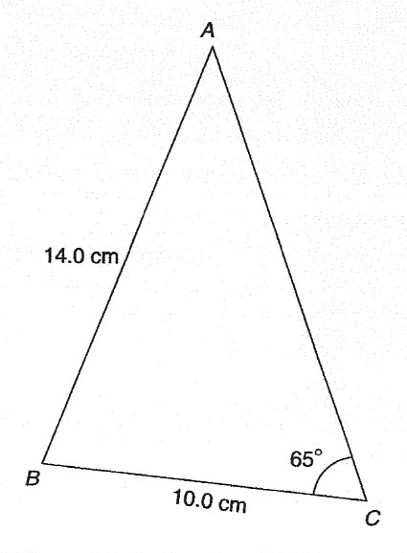

55. The total surface area of a cylinder of length 20 cm and diameter 6 cm is:
(a) 56.55 cm (b) 433.54 cm (c) 980.18 cm (d) 226.19 cm
56. The acute angle sec2.4178 is equal to:
(a) 24.43° (b) 22.47° (c) 0.426 rad (d) 65.57°
57. The solution of the equation 3 – 5 cosA = 0 for values of A in the range are:
(a) 39.23° and 320.77° (b) 39.23°, 140.77°, 219.23° and 320.77°
(c) 140.77° and 219.23° (d) 53.13°, 126.87°, 233.13° and 306.87°
58. An alternating current i has the following values at equal intervals of 2 ms:
Time t (ms) 0 2.0 4.0 6.0 8.0 10.0 12.0
Current I (A) 0 4.6 7.4 10.8 8.5 3.7 0
Charge q (in millicoulombs) is given by q = . Using the trapezoidal rule, the approximate
charge in the 12 ms period is:
(a) 70 mC (b) 72.1 mC (c) 35 mC (d) 216.4 mC

59. In triangle ABC in Figure M2.10, the length AC is:
(a) 18.79 cm (b) 70.89 cm (c) 22.89 cm (d) 16.10 cm
Figure M2.10 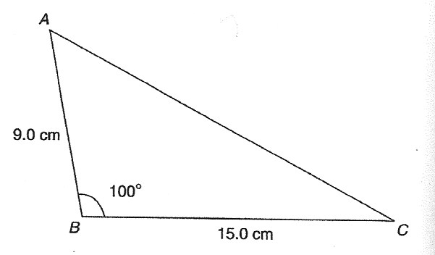

60. The total surface area of a solid hemisphere of diameter 6.0 cm is:
(a) 56.55 cm (b) 339.3 cm (c) 226.2 cm (d) 84.82 cm

