MULTIPLE CHOICE QUESTIONS ON CHAPTERS 28 - 44
All questions have only one correct answer

1. A graph of resistance against voltage for an electrical circuit is shown in Figure M3.1. The equation
relating resistance R and voltage V is:
(a) R = 1.45 V + 40 (b) R = 0.8 V + 20
(c) R = 1.45 V + 20 (d) R = 1.25 V + 20
Figure M3.1 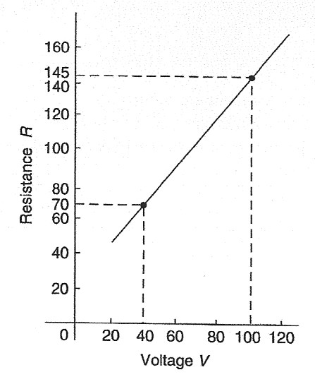

2. is equivalent to: (a) j5 (b) – 5 (c) – j5 (d) 5
3. Two voltage phasors are shown in Figure M3.2. If V = 40 volts and V = 100 volts, the resultant
(i.e. length OA) is:
(a) 131.4 volts at 32.55° to V (b) 105.0 volts at 32.55° to V
(c) 131.4 volts at 68.30° to V (d) 105.0 volts at 42.31° to V
Figure M3.2 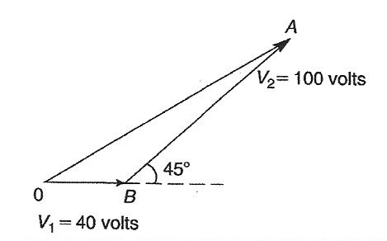

4. Which of the straight lines shown in Figure M3.3 has the equation y + 4 = 2x?
(a) (i) (b) (ii) (c) (iii) (d) (iv)
Figure M3.3 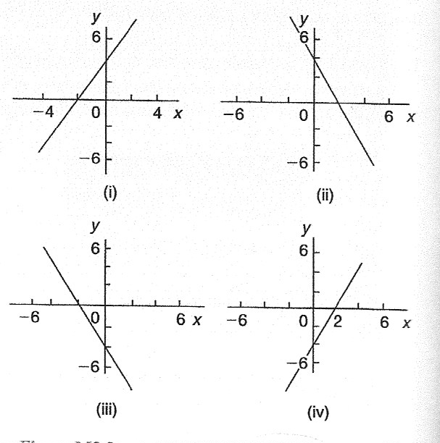

5. A pie diagram is shown in Figure M3.4 where P, Q, R and S represent the salaries of four employees
of a firm. P earns £24000 p.a. Employee S earns:
(a) £40000 (b) £36000 (c) £20000 (d) £24000
Figure M3.4 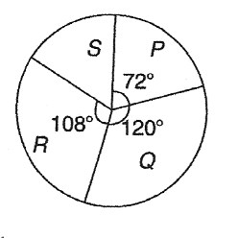

6. A force of 4 N is inclined at an angle of 45° to a second force of 7 N, both forces acting at a point, as
shown in figure M3.5. The magnitude of the resultant of these two forces and the direction of the
resultant with respect to the 7 N force is:
Figure M3.5 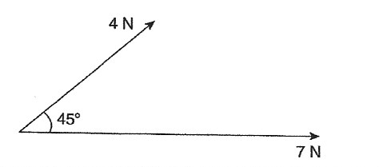
(a) 3 N at 45° (b) 5 N at 146° (c) 11 N at 135° (d) 10.2 N at 16°
Questions 7 to 10 relate to the following information:
The capacitance (in pF) of 6 capacitors is as follows: {5, 6, 8, 5, 10, 2}
7. The median value is: (a) 36 pF (b) 6 pF (c) 5.5 pF (d) 5 pF
8. The modal value is: (a) 36 pF (b) 6 pF (c) 5.5 pF (d) 5 pF
9. The mean value is: (a) 36 pF (b) 6 pF (c) 5.5 pF (d) 5 pF
10. The standard deviation is: (a) 2.66 pF (b) 2.52 pF (c) 2.45 pF (d) 6.33 pF
11. A graph of y against x, two engineering quantities, produces a straight line.
A table of values is shown below:
x 2 - 1 p
y 9 3 5
The value of p is: (a) - (b) - 2 (c) 3 (d) 0
Questions 12 and 13 relate to the following information.
Two voltage phasors V and V are shown in Figure M3.6.
Figure M3.6 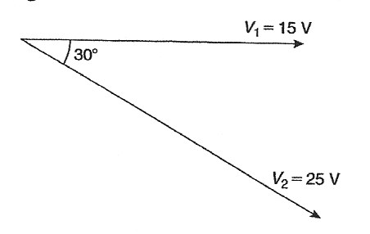

12. The resultant V + V is given by:
(a) 38.72 V at -19° to V (b) 14.16 V at 62° to V
(c) 38.72 V at 161° to V (d) 14.16 V at 118° to V
13. The resultant V - V is given by:
(a) 38.72 V at -19° to V (b) 14.16 V at 62° to V
(c) 38.72 V at 161° to V (d) 14.16 V at 118° to V
14. The curve obtained by joining the co-ordinates of cumulative frequency against upper class
boundary values is called;
(a) a histogram (b) a frequency polygon (c) a tally diagram (d) an ogive
15. A graph relating effort E (plotted vertically) against load L (plotted horizontally) for a set of pulleys
is given by L + 30 = 6E. The gradient of the graph is:
(a) (b) 5 (c) 6 (d)
Questions 16 to 19 relate to the following information:
x and y are two related engineering variables and p and q are constants. For the law y – p = to be verified it is necessary to plot a graph of the variables.

16. On the vertical axis is plotted:
(a) y (b) p (c) q (d) x
17. On the horizontal axis is plotted:
(a) x (b) (c) (d) p
18. The gradient of the graph is:
(a) y (b) p (c) q (d) x
19. The vertical axis intercept is:
(a) y (b) p (c) q (d) x
Questions 20 to 22 relate to the following information:
A box contains 35 brass washers, 40 steel washers and 25 aluminium washers. 3 washers are drawn at
random from the box without replacement.
20. The probability that all three are steel washers is:
(a) 0.0611 (b) 1.200 (c) 0.0640 (d) 1.182
21. The probability that there are no aluminium washers is:
(a) 2.250 (b) 0.418 (c) 0.014 (d) 0.422
22. The probability that there are two brass washers and either a steel or an aluminium washer is:
(a) 0.071 (b) 0.687 (c) 0.239 (d) 0.343
23. (- 4 – j3) in polar form is:
(a) 5∠-143.13° (b) 5∠126.87° (c) 5∠143.13° (d) 5∠- 126.87°
24. The magnitude of the resultant of velocities of 3 m/s at 20° and 7 m/s at 120° when acting
simultaneously at a point is:
(a) 21 m/s (b) 10 m/s (c) 7.12 m/s (d) 4 m/s

25. Here are four equations in x and y. When x is plotted against y, in each case a straight line results.
(i) y + 3 = 3x (ii) y + 3x = 3 (iii) (iv)
Which of these equations are parallel to each other?
(a) (i) and (ii) (b) (i) and (iv) (c) (ii) and (iii) (d) (ii) and (iv)
26. The relationship between two related engineering variables x and y is y – cx = bx where b and c are
constants. To produce a straight line graph it is necessary to plot:
- x vertically against y horizontally
- y vertically against x horizontally
- vertically against x horizontally
- y vertically against x horizontally
27. The number of faults occurring on a production line in a 9-week period are as shown:
32 29 27 26 29 39 33 29 37
The third quartile value is: (a) 29 (b) 35 (c) 31 (d) 28
28. (1 + j) is equivalent to:
(a) 4 (b) – j4 (c) j4 (d) – 4
29. 2% of the components produced by a manufacturer are defective. Using the Poisson distribution the
percentage probability that more than two will be defective in a sample of 100 components is:
(a) 13.5% (b) 32.3% (c) 27.1% (d) 59.4%
30. The equation of the graph shown in Figure M3.7 is:
(a) x(x + 1) = (b) 4x - 4x – 15 = 0 (c) x - 4x – 5 = 0 (d) 4x + 4x – 15 = 0
Figure M3.7 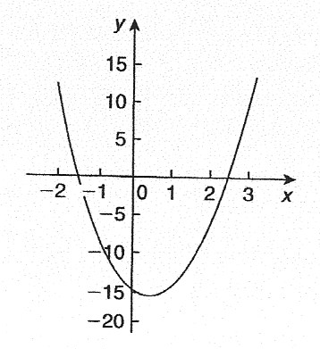

31. In an experiment demonstrating Hooke’s law, the strain in a copper wire was measured for various
stresses. The results included
Stress (megapascals) 18.24 24.00 39.36
Strain 0.00019 0.00025 0.00041
When stress is plotted vertically against strain horizontally a straight line graph results. Young’s
modulus of elasticity for copper, which is given by the gradient of the graph, is:
(a) 96 × 10 Pa (b) 1.04 × 10 Pa (c) 96 Pa (d) 96000 Pa
Questions 32 and 33 relate to the following information:
The frequency distribution for the values of resistance in ohms of 40 transistors is as follows:
15.5 – 15.9 3 16.0 – 16.4 10 16.5 – 16.9 13
17.0 – 17.4 8 17.5 – 17.9 6
32. The mean value of the resistance is:
(a) 16.75 Ω (b) 1.0 Ω (c) 15.85 Ω (d) 16.95 Ω
33. The standard deviation is:
(a) 0.335 Ω (b) 0.251 Ω (c) 0.682 Ω (d) 0.579 Ω

34. To depict a set of values from 0.05 to 275, the minimum number of cycles required on logarithmic
graph paper is:
(a) 2 (b) 3 (c) 4 (d) 5
35. A manufacturer estimates that 4% of components produced are defective. Using the binomial
distribution, the percentage probability that less than two components will be defective in a sample
of 10 components is:
(a) 0.40% (b) 5.19% (c) 0.63% (d) 99.4%
Questions 36 to 39 relate to the following information.
A straight line graph is plotted for the equation y = ax, where y and x are the variables and a and n are constants.

36. On the vertical axis is plotted:
(a) y (b) x (c) lg y (d) a
37. On the horizontal axis is plotted:
(a) lg x (b) x (c) x (d) a
38. The gradient of the graph is given by:
(a) y (b) a (c) x (d) n
39. The vertical axis intercept is given by:
(a) n (b) lg a (c) x (d) lg y
Questions 40 to 42 relate to the following information.
The probability of a component failing in one year due to excessive temperature is , due to excessive vibration is and due to excessive humidity is .

40. The probability that a component fails due to excessive temperature and excessive vibration is:
(a) (b) (c) (d)
41. The probability that a component fails due to excessive vibration or excessive humidity is:
(a) 0.00125 (b) 0.00257 (c) 0.0750 (d) 0.1125
42. The probability that a component will not fail because of both excessive temperature and excessive
humidity is:
(a) 0.914 (b) 1.913 (c) 0.00156 (d) 0.0875
43. Three forces of 2 N, 3 N and 4 N act as shown in Figure M3.8. The magnitude of the resultant force
is: (a) 8.08 N (b) 9 N (c) 7.17 N (d) 1 N
Figure M3.8 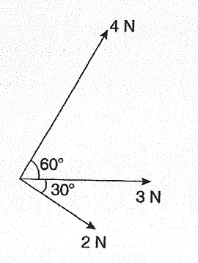

44. in polar form is:
(a) 5 (b) 4.84∠0.84 (c) 6∠0.55 (d) 4.84∠0.73
Questions 45 and 46 relate to the following information.
Two alternating voltages are given by: volts.
45. Which of the phasor diagrams shown in Figure M3.9 represents ?
(a) (i) (b) (ii) (c) (iii) (d) (iv)
Figure M3.9 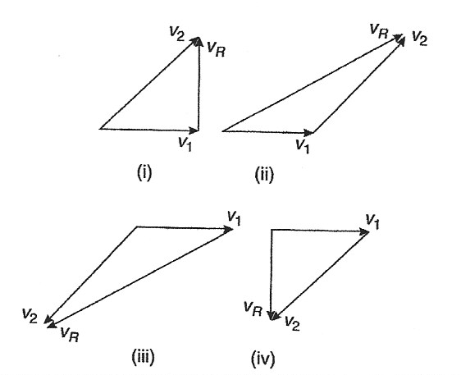

46. Which of the phasor diagrams shown represents ?
(a) (i) (b) (ii) (c) (iii) (d) (iv)
47. The two square roots of (- 3 + j4) are:
(a) ±(1 + j2) (b) ±(0.71 + j2.12) (c) ±(1 – j2) (d) ±(0.71 – j2.12)
Questions 48 and 49 relate to the following information.
A set of measurements (in mm) is as follows:
{4, 5, 2, 11, 7, 6, 5, 1, 5, 8, 12, 6}
48. The median is: (a) 6 mm (b) 5 mm (c) 72 mm (d) 5.5 mm
49. The mean is: (a) 6 mm (b) 5 mm (c) 72 mm (d) 5.5 mm
50. The graph of y = 2 tan 3θ is:
- a continuous, periodic, even function
- a discontinuous, non-periodic, odd function
- a discontinuous, periodic, odd function
- a continuous, non-periodic, even function

Questions 51 to 53 relate to the following information.
The mean height of 400 people is 170 cm and the standard deviation is 8 cm. Assume a normal distribution.

51. The number of people likely to have heights of between 154 cm and 186 cm is:
(a) 390 (b) 380 (c) 190 (d) 185
52. The number of people likely to have heights less than 162 cm is:
(a) 133 (b) 380 (c) 67 (d) 185
53. The number of people likely to have a height of more than 186 cm is:
(a) 10 (b) 67 (c) 137 (d) 20
54. in Cartesian form is:
(a) (0.50 + j0.06) (b) (- 8 + j13.86) (c) (- 4 + j6.93) (d) (13.86 + j8)

