MULTIPLE CHOICE QUESTIONS ON CHAPTERS 45 - 67
All questions have only one correct answer

1. Differentiating y = 4x gives:
(a) (b) (c) (d)
2. is equal to:
(a) 5 - t + c (b) - 3t + c (c) – 6t + c (d) 5t - t + c
3. The gradient of the curve y = - 2x + 3x + 5 at x = 2 is:
(a) – 21 (b) 27 (c) – 16 (d) – 5
4. is equal to:
(a) 5x – ln x + c (b) (c) (d) 5x + + c
5. For the curve shown in Figure M4.1, which of the following statements is incorrect?
(a) P is a turning point (b) Q is a minimum point
(c) R is a maximum value (d) Q is a stationary value
Figure M4.1 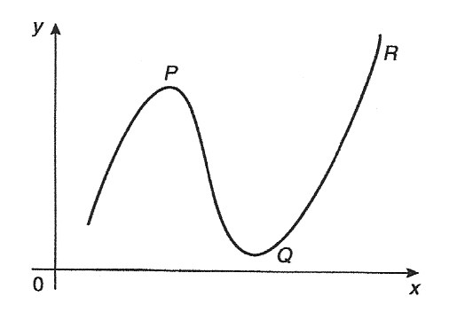

6. The value of , correct to 4 significant figures, is:
(a) – 1.242 (b) – 0.06890 (c) – 2.742 (d) – 1.569
7. If y = 5, is equal to:
(a) (b) (c) (d)
8. is:
(a) (b) 2e + c (c) (d) 2e (x – 2) + c
9. An alternating current is given by i = 4 sin 150t amperes, where t is the time in seconds. The rate of
change of current at t = 0.025 s is:
(a) 3.99 A/s (b) – 492.3 A/s (c) – 3.28 A/s (d) 598.7 A/s
10. A vehicle has a velocity v = (2 + 3t) m/s after t seconds. The distance travelled is equal to the area
under the v/t graph. In the first 3 seconds the vehicle has travelled:
(a) 11 m (b) 33 m (c) 13.5 m (d) 19.5 m
11. Differentiating y = + 2 with respect to x gives:
(a) (b) (c) 2 - (d)
12. The area, in square units, enclosed by the curve y = 2x + 3, the x-axis and ordinates x = 1 and x = 4
is: (a) 28 (b) 2 (c) 24 (d) 39
13. The resistance to motion F of a moving vehicle is given by F = + 100x. The minimum value of
resistance is: (a) – 44.72 (b) 0.2236 (c) 44.72 (d) – 0.2236
14. Differentiating i = 3 sin 2t – 2 cos 3t with respect to t gives:
(a) 3 cos 2t + 2 sin 3t (b) 6(sin 2t – cos 3t)
(c) cos 2t + sin 3t (d) 6(cos 2t + sin 3t)
15. is equal to: (a) + c (b) + c (c) + c (d) + c
16. Given y = is equal to:
(a) (b) (c) (d)
17. is equal to:
(a) (b) (c) (d)
18. The vertical displacement, s, of a prototype model in a tank is given by s = 40 sin 0.1t mm, where t is
the time in seconds. The vertical velocity of the model, in mm/s, is:
(a) – cos 0.1t (b) 400 cos 0.1t (c) – 400 cos 0.1t (d) 4 cos 0.1t
19. Evaluating gives: (a) 2 (b) 1.503 (c) –18 (d) 6
20. The equation of a curve is y = 2x - 6x + 1. The maximum value of the curve is:
(a) – 3 (b) 1 (c) 5 (d) – 6
21. The mean value of y = 2x between x = 1 and x = 3 is:
(a) 2 (b) 4 (c) 4 (d) 8
22. Given f(t) = 3t - 2, f ´(t) is equal to:
(a) 12t - 2 (b) - 2t + c (c) 12t (d) 3t - 2
23. is equal to:
(a) x(ln x – 1) + c (b) + c (c) x ln x – 1 + c (d) + + c
24. The current i in a circuit at time t seconds is given by i = 0.20(1 - e) A.
When time t = 0.1 s, the rate of change of current is:
(a) – 1.022 A/s (b) 0.541 A/s (c) 0.173 A/s (d) 0.373 A/s
25. is equal to: (a) 3 ln 2.5 (b) lg 1.6 (c) ln 40 (d) ln 1.6
26. The gradient of the curve y = 4x - 7x + 3 at the point (1, 0) is
(a) 1 (b) 3 (c) 0 (d) - 7
27. is equal to:
(a) – 5 cos 3t + 3 sin 5t + c (b) 15(cos 3t + sin 3t) + c
(c) (d)
28. The derivative of 2 - 2x is:
(a) (b) - 2 (c) - 2 (d) - 2
29. The velocity of a car (in m/s) is related to time t seconds by the equation v = 4.5 + 18t – 4.5t.
The maximum speed of the car, in km/h, is:
(a) 81 (b) 6.25 (c) 22.5 (d) 77
30. is equal to:
(a) (b) (c) + c (d)
31. An alternating voltage is given by v = 10 sin 300t volts, where t is the time in seconds. The rate of
change of voltage when t = 0.01 s is:
(a) – 2996 V/s (b) 157 V/s (c) – 2970 V/s (d) 0.523 V/s
32. The r.m.s. value of y = x between x = 1 and x = 3, correct to 2 decimal places, is:
(a) 2.08 (b) 4.92 (c) 6.96 (d) 24.2
33. If f(t) = 5t - , f ´(t) is equal to:
- 5 + (b) 5 - 2 (c) (d) 5 +
34. The value of is: (a) 6 (b) (c) – 6 (d)
35. The equation of a curve is y = 2x - 6x + 1. The minimum value of the curve is:
(a) – 6 (b) 1 (c) 5 (d) – 3
36. The volume of the solid of revolution when the curve y = 2x is rotated one revolution about the
x-axis between the limits x = 0 and x = 4 cm is:
(a) 85 cm (b) 8 cm (c) 85 cm (d) 64π cm
37. The length l metres of a certain metal rod at temperature t°C is given by
l = 1 + 4 t + 4 . The rate of change of length, in mm/°C, when the temperature is
400°C, is: (a) 3.6 (b) 1.00036 (c) 0.36 (d) 3.2
38. If y = 3x - ln 5x then is equal to:
(a) 6 + (b) 6x - (c) 6 - (d) 6 +
39. The area enclosed by the curve y = 3 cos 2θ, the ordinates θ = 0 and θ = and the θ axis is:
(a) – 3 (b) 6 (c) 1.5 (d) 3
40. is equal to:
(a) + c (b) x - + c (c) x + (d) x - + c
41. The turning point on the curve y = x - 4x is at:
(a) (2, 0) (b) (0, 4) (c) (- 2, 12) (d) (2, - 4)
42. Evaluating , correct to 4 significant figures, gives:
(a) 2300 (b) 255.6 (c) 766.7 (d) 282.3
43. An alternating current, i amperes, is given by i = 100 sin 2πft amperes, where f is the frequency in
hertz and t is the time in seconds. The rate of change of current when t = 12 ms and f = 50 Hz is:
(a) 31348 A/s (b) – 58.78 A/s (c) 627.0 A/s (d) – 25416 A/s
44. A metal template is bounded by the curve y = x, the x-axis and ordinates x = 0 and x = 2. The x-co-
ordinate of the centroid of the area is:
(a) 1.0 (b) 2.0 (c) 1.5 (d) 2.5
45. If f(t) = eln 2t, f ´(t) is equal to:
(a) (b) (c) (d)
46. The area under a force/distance graph gives the work done. The shaded area shown between p and q
in Figure M4.2 is:
(a) c(ln p – ln q) (b) (c) (ln q – ln p) (d) c ln
Figure M4.2 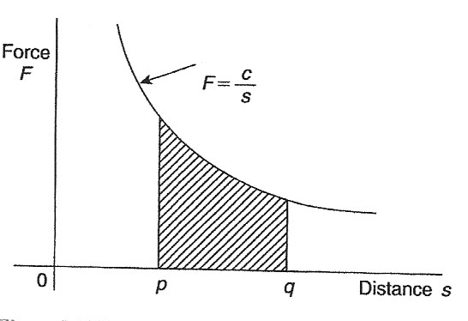

47. Evaluating , correct to e decimal places, gives:
(a) 0.455 (b) 0.070 (c) 0.017 (d) 1.819
48. has a value of: (a) 3 (b) – 8 (c) 2 (d) – 16
49. The value of is:
(a) – 0.1 (b) 3.1 (c) 0.1 (d) – 3.1
50. is equal to: (a) 1.33 (b) – 0.25 (c) – 1.33 (d) 0.25
51. The matrix product is equal to:
(a) (b) (c) (d)
52. The Boolean expression A + is equivalent to:
(a) A (b) B (c) A + B (d) A +
53. The inverse of the matrix is:
(a) (b) (c) (d)
54. For the following simultaneous equations:
3x – 4y + 10 = 0
5y – 2x = 9
the value of x is: (a) – 2 (b) 1 (c) 2 (d) – 1
55. The Boolean expression is equivalent to:
(a) (b) (c) P (d) Q
56. The value of is: (a) 2(1 + j) (b) 2 (c) – j2 (d) 2 + j2
57. The Boolean expression: is equivalent to:
(a) F.G (b) (c) (d)
58. The value of the determinant is: (a) 4 (b) 52 (c) – 56 (d) 8
59. Given x = 3t – 1 and y = 3t(t – 1) then:

(a) (b) (c) (d)
60. is equal to:
(a) (b) (c) (d)

61. If y = then is equal to:

(a) ln 3 + 2x ln x (b) (c) (d)

62. A solution of the differential equation given that x = 1 when y = 2 is:
(a) (b)
(c) (d)

