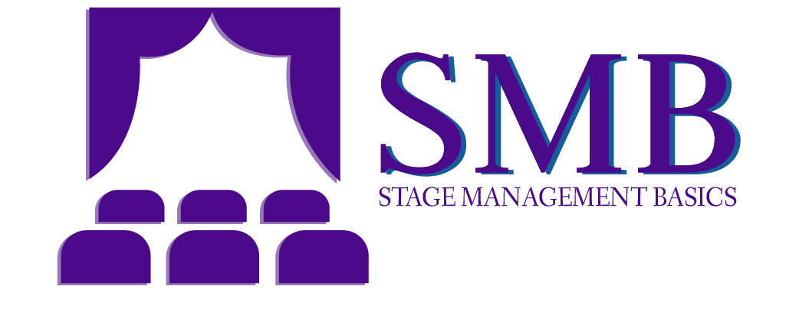

Show Title

Performance Report

Performance #1 Date:
Curtain:

Act I | Intermission | Act 2

Total Run Time:

House Open:
House Count:

Accidents/Injury:

Late/Absent:

Performance Notes:

Technical Notes:

© 2022 Emily Roth, Jonathan Allender-Zivic, and Katy McGlaughlin (2022), Stage Management Basics, 2nd ed., Routledge

