Chapter 2: Introduction
Transmissibility

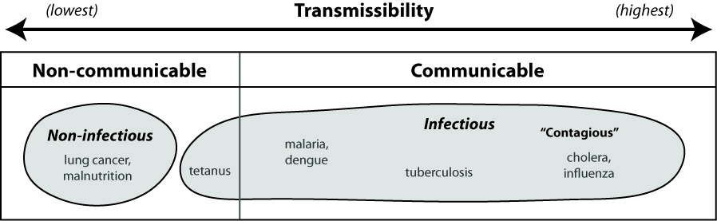

Looking at the figure above, answer the following questions:

- Answer true or false:

A disease can be infectious but not able to be passed directly among individuals.
Only infectious diseases can be described as contagious.
Non-infectious diseases can be transmitted between individuals.
We would probably expect diseases such as cholera and influenza to be more likely to show dramatic peaks in incidence than a disease such as lung cancer.

- From what you know about the following diseases, where would you place them on the transmissibility spectrum: HIV/AIDS, stroke, the common cold, obesity?

- What characteristic of diseases such as malaria and dengue helps to explain their lower transmissibility compared to diseases such as cholera and influenza?

