3. Natural Moral Law

ESSENTIAL TERMINOLOGY

Absolutism

Apparent good

Divine Law

Deontological ethics

Eternal Law

Intrinsically good

Natural Law

Primary precepts

Purpose

Real good

Secondary precepts

WHAT IS NATURAL MORAL LAW?

THE ORIGINS OF NATURAL LAW

THE NATURAL LAW OF THOMAS AQUINAS

THE PURPOSE OF HUMAN BEINGS

NATURAL INCLINATIONS

Primary and secondary precepts

THE DOCTRINE OF DOUBLE EFFECT

THE CATHOLIC CHURCH AND NATURAL LAW

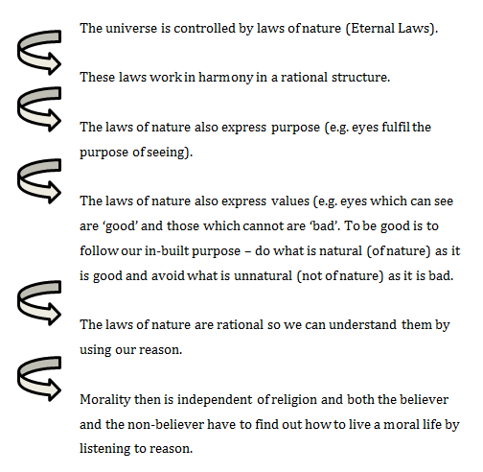

STRENGTHS OF NATURAL LAW

WEAKNESSES OF NATURAL LAW

