Name ✅:
Under the Wave Off Kanagawa Art Criticism Questions
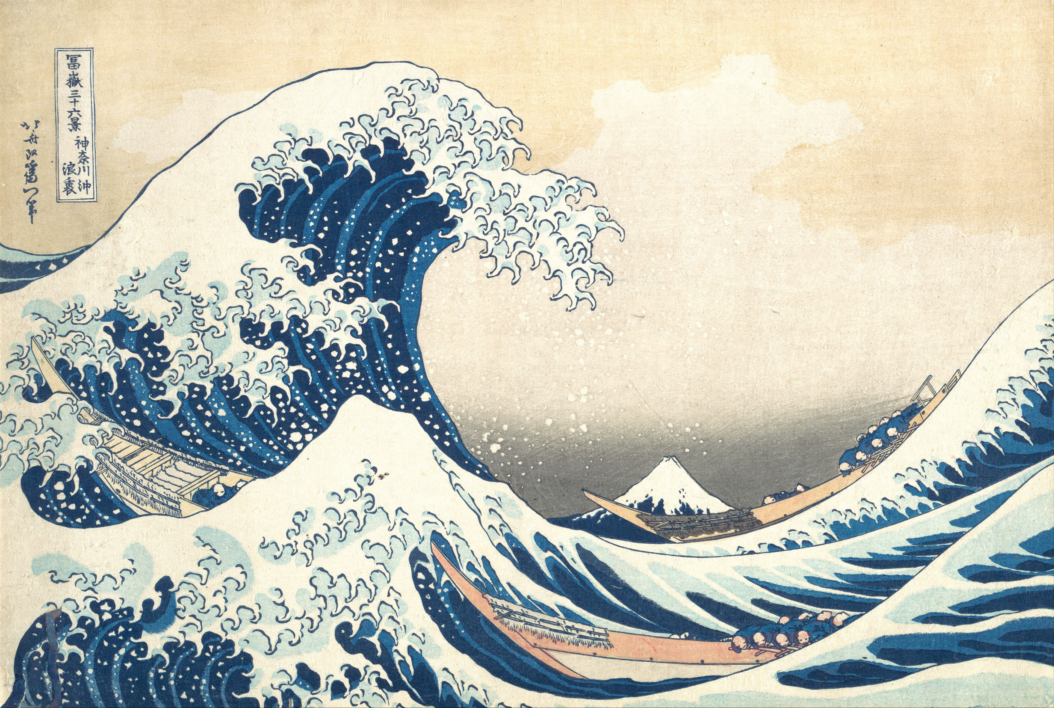
Image: Katsushika Hokusai, Under the Wave off Kanagawa, also known as The Great Wave, from the series Thirty-six Views of Mount Fuji, ca. 1830–32. Woodblock print; ink and color on paper. www.metmuseum.org. (CC0 1.0). Reference: Anderson, T. (1997). A model for art criticism: Talking with kids about art. School Arts, 97(1), 21–24.
Directions: I can answer the following art criticism questions about Under the Wave off Kanagawa using complete sentences. I can prepare to share my answers during a class discussion.
- What are the first things I think and feel when looking at Hokusai’s Under the Wave off Kanagawa? ✅
- How would I describe Under the Wave off Kanagawa to someone who has never seen it? ✅
- What is Under the Wave off Kanagawa’s focal point? What makes me look there? Why do I think that Hokusai chose to emphasize that area? ✅
- How did Hokusai’s technical observational drawing skills and attention to details assist him in capturing the look and feel of Under the Wave off Kanagawa? ✅
- What would I be thinking if I were a passenger on one of the oshiokuri boats? ✅
- What can Under the Wave off Kanagawa teach us about waves? ✅
- Based on my descriptions and interpretations, is Under the Wave at Kanagawa an important artwork? I can explain my answer. ✅



