Climate change and greenhouse gas management
by Al Dharmasasmita, Helen Puntha, Ellie Kennedy and Richard Holmes.

The activities in session 3 – as well as the section of this chapter on How to measure emissions – present three scopes within which emissions can be measured from a business point of view. The open source template below refers to the same three scopes. This template can be easily adapted to record emissions of individuals, households, businesses, or other groups or organisations.
Here are two suggested ways for you to use this template:
- Alongside the activities in session 1, use the template to record the carbon emissions of your household. Then use this information to set targets for reduction and make a plan.
- Use it as a starting point to design a greenhouse gas management plan for an organisation of your choice. You can modify the template to suit your context. You can use the ideas in this chapter to set up a greenhouse gas management plan, or find a more detailed explanation in the Handbook of Carbon Management, chapters 11 to 14 (Molthan-Hill 2023).
Greenhouse gas management plan template (household)

The GHG Protocol recommends dividing your emissions into three Scopes depending on how much influence you have…
- Scope 1: what you own or consume, such as your house or apartment, clothes, a car etc. and you can therefore make decisions on your own. The way you commute or travel on vacation (coach, train, car, plane, bike …).
Any other decisions in your private life that you have control over – including the food you buy.
NB: with regards to cafes and restaurants, for example, you could choose a place serving vegan food, but you could not control the menu. This would therefore not be Scope 1, but would come under Scope 3, where you could potentially engage with them to try to make changes if required….
- Scope 2: the source(s) of energy used in your household, which are not in your own control. That includes electricity or heat sourced from a utility provider.
NB: solar roof panels or the open fire or log burner in your home are Scope 1, as those are in your control.
- Scope 3: not in your control. This includes all the service providers you use, such as the dentist, insurance company, bank, fitness studio, along with your clients and your employers. And even the places where you do not-for-profit service work…
If you rent your home, Scope 3 also includes the source of heating (gas, oil, …) as it is not usually in your control.
NB: it does not included ‘overheating’ your accommodation, that would be Scope 1, as it would be your choice to turn up the thermostat.

SCOPE 1 - please write down all the large assets that you own and/or the items you regularly consume (where you produce significant waste – or store lots of unused/seldom used items):
- E.g. house (currently buying in all energy that is used by the household)
- E.g. car (make, energy consumption)
Can you reduce home-related emissions?
- E.g. installing solar energy panels
- E.g. selling car, or replacing a petrol with an electric vehicle
How much carbon/money would you save? …………………………………………………………….
E.g. cost of installing solar energy divided by current cost of energy per year – when would you start to save money? Could you sign up to a scheme as introduced in week 1, where the installation for solar energy is paid by an investor/community?

SCOPE 2 - please write down your energy provider and their charges:
- E.g. electricity: name of company, costs ………………………………………………………………………
Unless your energy provider is solely using renewables already, could you switch to a different supplier (one that invests exclusively in renewable energy)?
- E.g. name of new company, costs …………………………………………………………..
SCOPE 3 - please write down three key areas where you can save the most greenhouse gas emissions by choosing different products/services:
- E.g. 400 gr beef bought three times per week, reduce to once per week and replace twice with tofu; emissions saved: ……costs saved: ……
- E.g. reduce food waste from current …… % to 0; emissions saved: …… costs saved: ……
- E.g. set temperature on air-conditioning unit four° higher; emissions saved: …… costs saved: …….

SCOPE 3 - please write down three key areas where you could influence others to reduce greenhouse gas emissions
- E.g. change bank account to an ethical bank (more info in week 7 on how to choose one) or engage my bank
- E.g. vote in the next election for a party with good plans on how to reduce greenhouse gas emissions

OVERALL
Emissions saved: ………………… Costs saved: …………………….
Greenhouse Gas Management Plan (household) © Petra Molthan-Hill and Fiona Winfield Nottingham Business School

Additional activities (chapter 15 GHG management)
Optional extension activities for students wanting more challenge and/or critical global perspectives.

Planetary boundaries
Scientist Johann Rockström has identified planetary boundaries: these are nine systems that regulate climate and keep our planet in a suitable state for humanity to prosper. Watch his TED talk here: https://www.youtube.com/watch?v=8Sl28fkrozE and discuss these questions with a classmate:
- Which of the planetary boundaries (there will be more than one) are most likely to be impacted by carbon emissions?
- What does “planetary stewardship” mean to you?
- How might a business manage their carbon reduction while respecting other planetary boundaries in order to take care of the planet as a whole?
- What do you think Rockström means by “a new economic logic”? What might this look like?
Make and record your own TED-style talk (individually or in small groups) to inspire others with your vision for “healthy lifestyles and resilient economies in liveable cities” (Rockström).
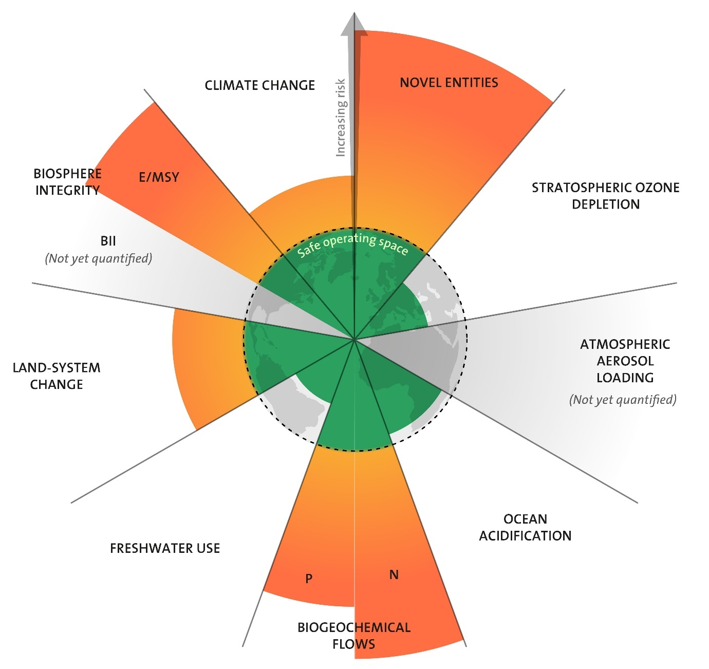

Licenced under CC BY-NC-ND 3.0 Credit: "Azote for Stockholm Resilience Centre, based on analysis in Wang-Erlandsson et al 2022".

Climate justice and national targets
During the United Nations Climate Change COP (Conference of the Parties) the nations make various pledges to address the climate and ecological emergency; these include pledges relating to the reduction and management of carbon emissions.
- Look at the outcomes of the most recent COP to find out what your nation pledged on carbon emissions.
- Then find out more about how your nation’s carbon pledges have impacted/will impact business a) in your country, b) in neighbouring countries, and c) in countries further away.
- Read this UN blog on climate justice: https://www.un.org/sustainabledevelopment/blog/2019/05/climate-justice/ and this feature about a related UN resolution https://www.unep.org/news-and-stories/story/un-resolution-billed-turning-point-climate-justice To what extent do you feel that your nation’s carbon pledges are (or are not) in keeping with ideas of climate justice?
- Pair with a classmate from a different nation, and share your findings and your thinking. Together, make a poster or other visual resource to compare and contrast your two nations’ carbon pledges and their respective impact on climate justice.

Further topics
Research one of the following topics:

- The Degrowth movement (https://degrowth.info/degrowth; Ralph 2021).
- Indigenous approaches to sustainability: https://www.unesco.org/en/links/climate-change
- Women and climate action: https://www.unwomen.org/en/news-stories/explainer/2022/03/explainer-why-women-need-to-be-at-the-heart-of-climate-action

Task: Research and share a two-page brief as if you are a company manager presenting to government and other external stakeholders. Share your ideas on reducing carbon emissions, informed by your particular chosen topic.

References
Degrowth (N.D.). Degrowth. https://degrowth.info/degrowth
Molthan-Hill, P. et al. (2023). The Handbook of Carbon Management. Routledge. https://www.routledge.com/The-Handbook-of-Carbon-Management-A-Step-by-Step-Guide-to-High-Impact-Climate/Molthan-Hill-Winfield-Howarth-Mazhar/p/book/9781032227603
Ralph, N. (2021). A Conceptual Merging of Circular Economy, Degrowth and Conviviality Design Approaches Applied to Renewable Energy Technology, Journal of Cleaner Production, 319, https://doi.org/10.1016/j.jclepro.2021.128549
Rockström, J. (N.D.). 10 years to transform the future of humanity: or destabilize the planet. TED talk. https://www.youtube.com/watch?v=8Sl28fkrozE
Stockholm Resource Centre (2015). The nine planetary boundaries. https://www.stockholmresilience.org/research/planetary-boundaries/the-nine-planetary-boundaries.html
UN Women (2022). Explainer: Why women need to be at the heart of climate action. https://www.unwomen.org/en/news-stories/explainer/2022/03/explainer-why-women-need-to-be-at-the-heart-of-climate-action
UNESCO (2023). Climate Change. https://www.unesco.org/en/links/climate-change
United Nations (2019). Climate Justice. https://www.un.org/sustainabledevelopment/blog/2019/05/climate-justice
Wang-Erlandsson, L., Tobian, A., van der Ent, R., Fetzer, I., te Wierik, S., Porkka, M., Staal, A., Jaramillo, F., Dahlmann, H., Singh, C., Greve, P., Gerten, D., Keys, P., Gleeson, T., Cornell, S., Steffen, W., Bai, X., Rockström, J. 2022. A planetary boundary for green water. Nature Reviews Earth and Environment. http://dx.doi.org/10.1038/s43017-022-00287-8

