Chapter 18: Developing Sustainably Responsible Strategies in Business
by Prof. Dr. phil. Mathias Schüz

Seminar plans
Outcome(s): Students are able to develop sustainably responsible strategies by applying the provided frameworks to the FROG Case in the textbook.
In seminar 1, they can analyse the different internal and external environmental spheres to which a company must respond in order to develop successful business.
In seminar 2, they can develop strategies in order to (a) maximise their strengths, and (b) minimise their weaknesses, in order to exploit opportunities and avoid threats.
In seminar 3, they can assess whether or not such strategies are sustainably responsible.
Resources:
- Student version with worksheets (Students Guide)
- Teachers’ version: with solutions proposals (Teachers Notes)

II Teachers’ Notes

Session 1: External and internal influences (60 minutes)

Worksheet 1: Frog AG’s vision and mission statement
1. Activity : Let the students read Worksheet 1 and formulate a brief vision/mission statement for the new Frog AG. It should give Frog AG a broad direction in which the strategy should lead. It should inspire all stakeholders to invest their relevant resources in the New Frog AG. An example might be:
Background Info: A vision is an image of a desired future. It should be understandable, catchy, ambitious, attractive, motivating, exceptional and trend-setting, and also create enthusiasm. Ideally it gives purpose and identity, and enhances performance. In the 19th century, for example, Gottlieb Daimler had the vision of a motorised humanity moving much faster and more comfortably ‘on land, on water and in the air’. Out of this he derived his mission to build and sell cars. In this sense a mission statement is derived from the vision and defines what purpose an organisation serves, as well as its broader goals, and how its activities should be taken forward. It is ‘the framework or context within which the company’s strategies are formulated’ (Hill and Gareth 2008: 11). With this in mind, formulate a brief vision/mission statement for the new Frog AG. This could be also complemented by a symbol, an image or a picture outlining the desired future:

(1) Vision-Mission-Statement:
“Beautifying our environment. Dedicated to clean households we produce healthy detergents - integrated in the cycles of life and biodegradable. Gaining and retaining our stakeholders’ trust is our highest aim. We foster critical debates about all intended and unintended consequences we create internally and externally.”

(2) Symbol/ Picture:
Let the students creatively draw a picture that symbolizes the words of the Vision-Mission-Statement

Worksheet 2 a/b: Frog AG’s Market and Environments
2. Activity : In the next step, analyse Porter’s five forces and the relevant environmental spheres according to the PESTEL scheme. Focus on the related threats and opportunities for Frog AG with regard to SCR issues (use worksheet 2 a) and b); approximately 30 minutes).

Frog AG operates within the framework of its (a) micro-economic market and (b) macro-environments.
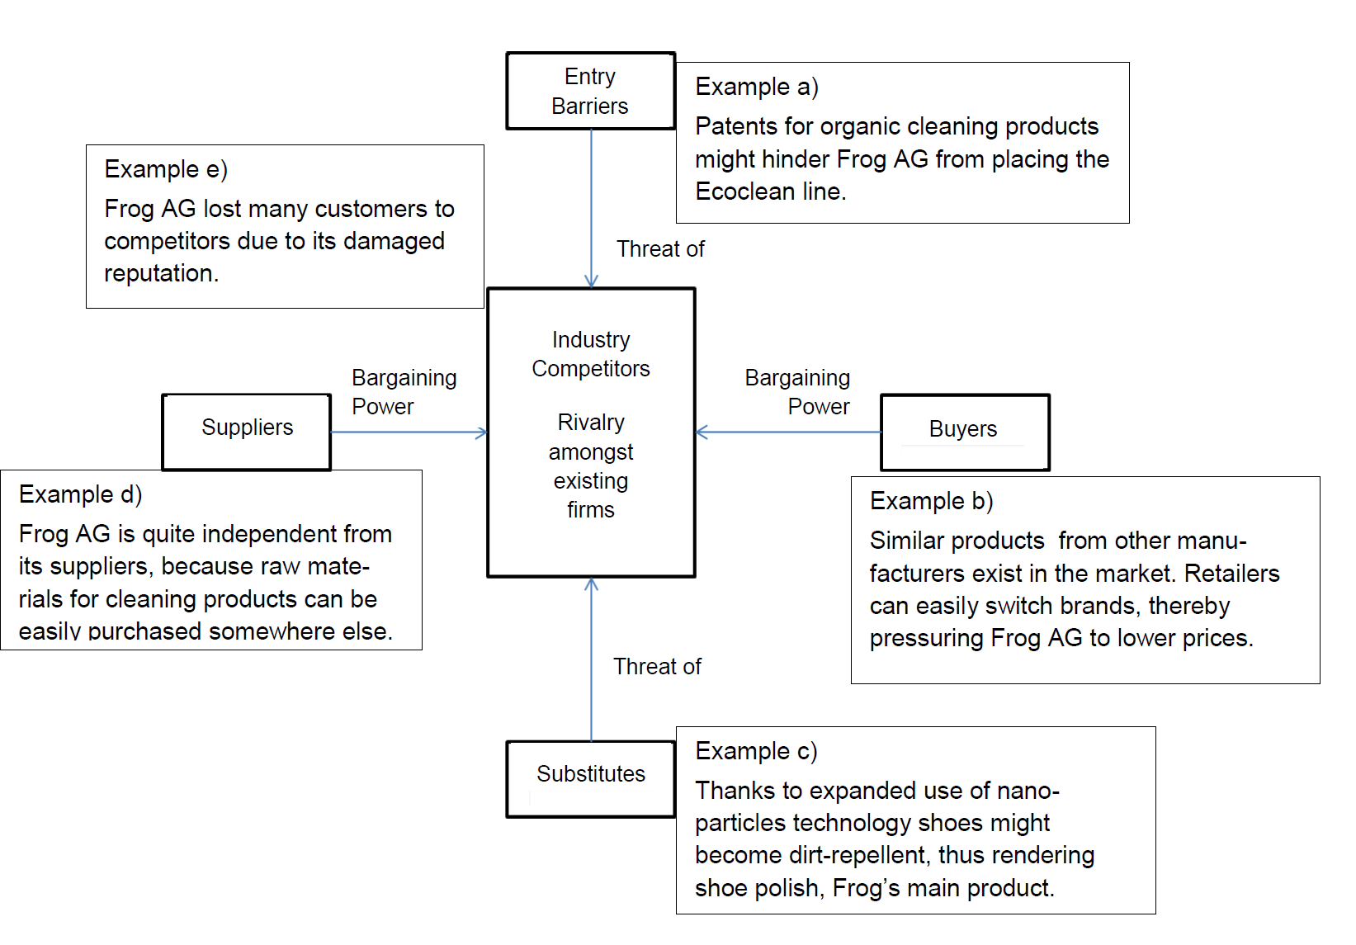
- Analyse Porter’s ‘Five Forces’ for Frog AG: What forces is Frog exposed to after neglected sustainability responsibility reached the media's attention? Fill out the following form (2a) with exemplary issues for the respective fields.

Five Microeconomic Forces | Examples
Substitutes  Which products could substitute Frog’s products and thus pose a threat? | Shoes with dirt-repellant leather due to the deployment of nano particles; retailers could substitute Frog’s chemical cleaning products with biodegradable substances.
Bargaining Power of Customers  Can buyers easily pressure Frog AG to lower prices by turning to other brands? | Low cost of changing products allows retailers to easily press Frog AG for price reductions, because similar products exist in the market from other manufacturers.
Bargaining Power of Suppliers  To what extent is Frog AG dependent on suppliers for raw material, components, labor, and services? | Frog is quite independent from its suppliers, because raw materials for cleaning products can be purchased easily because many manufacturers fight for market shares.
Entry barriers  What obstacles, such as high start-up costs, could prevent new competitors from easily entering Frog’s area of business? | Frog could protect its new organic product line by securing patents.
Intensity of Rivalry  Does Frog AG have many competitors offering similar or alternative products? | High intensity of rivalry, because Frog lost many customers to competitors due to its damaged reputation. Furthermore, many producers offer cleaning products with different components. Particularly, organically produced detergents have begun to penetrate Frog’s market.

- Analyse Frog’s macro-environment using the PESTEL framework.
Note: Consider only those factors which have an impact on Frog AG and cover SCR issues (use worksheet 2 b):

Political Issues | Political parties take on ecological and social issues to address societal demands for more healthy and sustainable products. In this way, they influence jurisdiction.
(Macro-)Economic Issues | Economic recession fosters the average population’s price sensitivity.
Socio-Cultural Issues | The public is sensitized to health-threatening products. LOHAS (Lifestyle for Health and Sustainability) leads to demand for organic products.
Technological Issues | New instruments for material testing allow to analyse even lowest dosages of health-threatening substances. Especially, causes of medical disturbances can be more easily traced back to poisonous substances in products.
Environmental Issues | Treating toxic waste waste produced by cleaning products is costly.
Legal Issues | New laws forbid health-threatening chemicals in cleaning products. Furthermore, increased Directors and Officers (D&O) liability forces managers to produce more healthy products. Law suites. Import-export-regulations

Worksheet 3: Frog AG’s value chain
3. Activity : Work out Frog’s strengths and weaknesses with regard to SCR issues by using Porter’s value chain (use worksheet 3; approximately 20 minutes).

The following diagram (Schüz, 2019: 237) is adapted from Porter and Kramer (2006: 85) and has integrated the role of corporate culture with its lived vices resp. virtues as an important input and output filter for sustainably responsible activities.

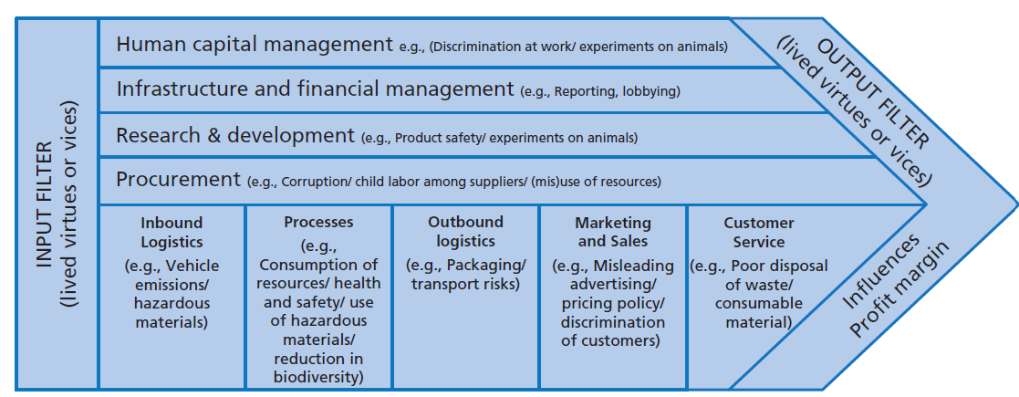
Corporate Culture: lived virtues and/ or vices:
Vices:
- Dishonesty towards the public
- Indecisiveness regarding restructuring
- Lack of empathy for societal demands
- Blind greed for profit
- Fear of exposure
- Hidden envy and ill-will toward outsiders
- Indifference to unintended consequences

Virtues
- Courage of top-management to change course
- Awareness of bad reputation
- Resoluteness to reform obsolete company structures
- Tolerance for deviant research
- Self-discipline to face problems
- Credibility as a traditionally-minded company
- Economic health

The identified corporate vices (to be avoided) and virtues (to be strived for) can be used to formulate corporate principles that might influence Frog’s behaviour to the better. The identified corporate vices (to be avoided) and virtues (to be strived for) can be used to identify the concrete strengths and weaknesses that constitute FROG AG:

(a) The management is economically responsible, but clearly lacks in social and ecological responsibility. Open-minded HR that allows niche research at the same time suppresses bad news threatening profitability in the short-term. HR is not able to protect and foster Ecoclean.
(b) Originally, Frog AG is financially strong but threatened by punitive damages and law suits, thus might be confronted with financial losses, even with bankruptcy. Furthermore, reputational risks loss of customers. Furthermore, an unfriendly takeover threatens Frog’s identity.
(c) Although R&D is focused on traditional chemistry, it allowed niche research on organic cleaning material. Nevertheless, due to psychological prejudices the researches in this field were blocked by all the established researchers.
(d) Main focus was on compliance with shareholder values, neglecting compliance with consumer protection laws, even more ethical values that protect consumers’ health integrity.
(e) Mainly poisonous raw material for cleaning products is purchased and stored, external datas about health problems were ignored, customer and employees complaints suppressed
(f) Operations focused on efficient and effective products that clean effectively but, at the same time, produce non-biodegradable waste that damages the environment, threaten workers’ safety threatened due to toxic materials. Also labor-relations were damaged due to departments’ egotism.
(g) Aerosol gas impacts ozone layer; non-recyclable aerosol containers; transportation impacts not minimized.
(h) Risk suppressing advertising; deficient consumer information; whitewashing communication; selected perception of customer complaints.
(i) No instruction in usage of the products or description of “side-effect”

Session 2: SWOT/TOWS analysis (60 minutes)

Worksheet 4a: SWOT/TOWS
1. Activity : Use the results of session 1 to identify the most challenging threats and opportunities (derived from the Porter’s ‘five forces’ analysis and the PESTEL analysis) and most important strengths and weaknesses (derived from Porter’s value chain analysis and the case study). From this, develop strategic options and recommendations with the help of a SWOT/TOWS analysis (Weihrich, 1982; use worksheet 4a; approximately 50 minutes).
external factors  internal factors | Opportunities  O1: Willingness of the discounter to find a solution for its supplier  O2: Need/ demand for an eco-friendly product- line  O3: Loyalty of co-majority- shareholder  O4: Demand for highly effective cleaning products | Threats  T1: Inquiry of state attorney and media/ legal prosecution  T2: Consumer boycott T3: Product liability and  punitive damages  T4: Damaged image through media, which has received insider information  T5: Unfriendly takeover
Strengths  S1: Established traditional company with high trust image before the crisis  S2: Major-shareholders lead company, therefore enough power for restructuring/ revitalization  S3: Willingness of the CEO and majority shareholder for total restructuring  S4: Eco-friendly product line  S5: Economic health | S1-5/ O1-2:  Restructuring of company and investing in and establishing Ecoclean as eco-friendly product-line.  S2,3,5/ O3:  Convincing shareholders for capital increase to finance the restructuring. | S1,3/ T1-4:  Regaining trust through open and genuine communication with the public by apologi- zing for past transgressions.  S2/ T5:  Convincing shareholders of long- term benefits resulting from new Frog’s strategy and informing of risks of short- termism. Investing in trust building measures such as transparency and  long-term dividends.
Weaknesses  W1: Economic dependence on toxic substances in cleaning agents  W2: Bad internal image of eco-friendly product- line manager  W3: Health-threatening products  W4: Whistle-blowers | W1/ O4:  Keeping up traditional cleaning agents, while  reducing health- threatening substances.  W2/ O2:  Declaring Ecoclean, the product-line on vinegar basis, to Frog’s main strategic product-line. | W1-3/ T1-4:  Selling chemical product line and acquiring niche producer specialized in bio-degradable cleaning agents.  W3/ T1-4:  Compensating payments for health damages, including product liability insurance policy

Worksheet 4b: Selecting strategic options
2. Activity : Prioritise the recommendations according to Frog’s capabilities with regard to its culture, available resources, and market situation as described in the previous case study. Select the two most important and feasible strategic options regarding Frog’s available resources and capabilities (use worksheet 4b; approximately 10 minutes).

Strategic Option 1
Declaring the vinegar-based Ecoclean as the most strategically important product line.

Strategic Option 2
Keeping up traditional cleaning agents, while reducing the amount of toxic substances they contain.

Session 3: SCR compliance (60 minutes)

Worksheet 5: SCR-Checklist

1. Activity : Select the two prioritised strategic options from session 2, and check their acceptability regarding the SCR model. It might be formulated like: ‘Should I invest in more sustainable products such as . . . ?’ Go through the questions of the SCR checklist (worksheet 5). The assessment of the respective scopes and sustainability degrees is made in percentages according to the following scheme: values between 0 and 33.3% can be classified as selfish in the sense that more is taken than given in the exchange relationships involved, that is, it is more a case of robbery than fair exchange; values between 33.3 and 66.6% are in the range of fair exchange; values 66.6–100% represent universal/altruistic action that gives more than it takes. In regard with the sustainability degree, you can also check how far the SDGs (as additional material online available at companion website) are attained.

The strategic sustainability questions are:
(1) 20 mins: To what extent would it be sustainably responsible to declare the vinegar-based Ecoclean as the strategically most important product-line?
(2) 20 mins: Would it be sustainably responsible to keep producing the traditional cleaning agents, while reducing the amount of toxic substances they contain?
Both questions can be discussed in one SCR-Checklist as below demonstrated. This allows a comparison more easily.
(3) 20 mins: Discuss whether and why (1) or (2) is more acceptable according to the results of your SCR-Checklist© or whether both recommendations can be followed. In the last case one should discuss the positive and negative consequences of such a hybrid strategy in regard with functional, social and ecological responsibility.
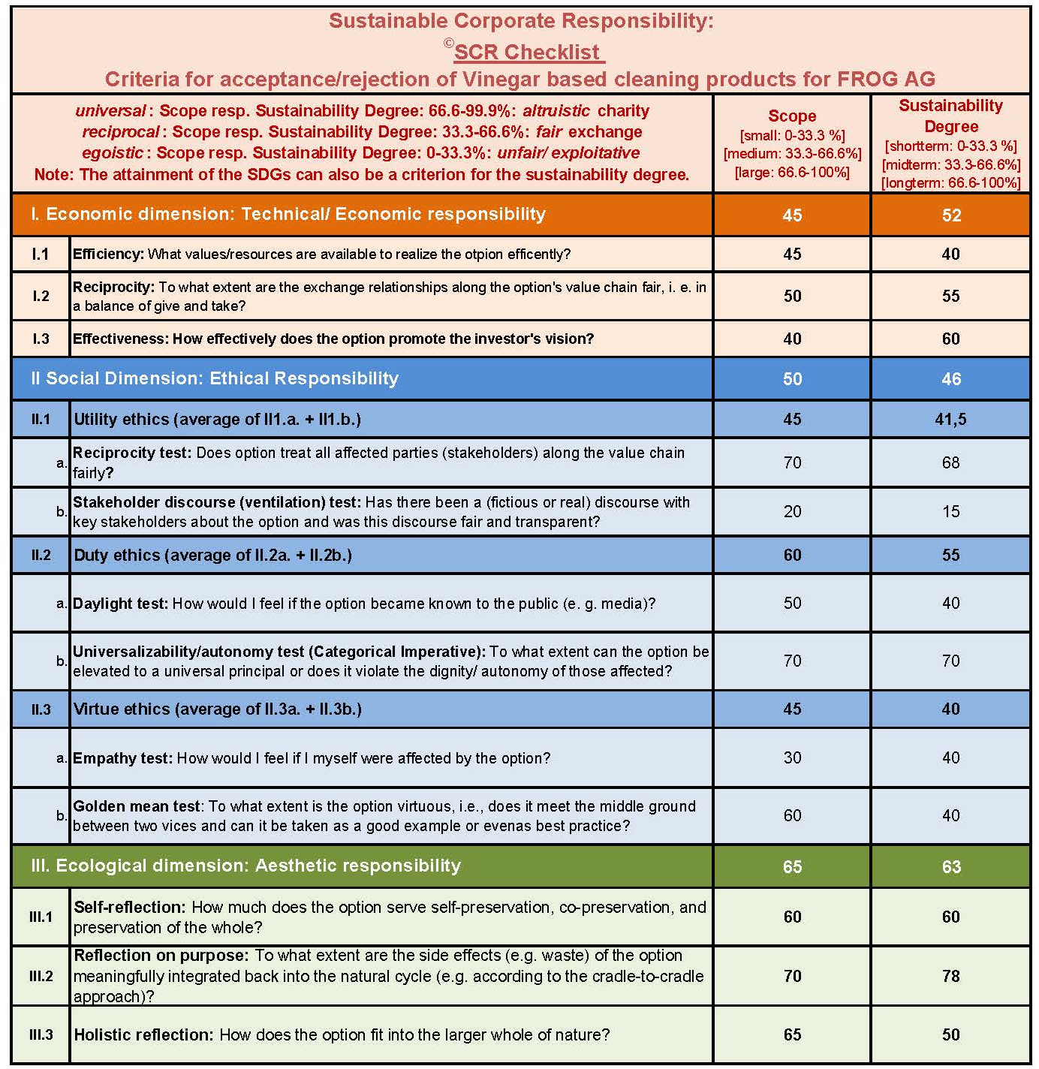
Solution proposal for strategic option 1: "Vinegar based cleaning products" SCR-checklist using the attached Excel-Files (contains one more general and one more specific):
"BSG_chapter 18_SCR-Checklist_Formsheets_online available.xls"

Background Info: The SCR checklist can be used to assess an organization or a strategic option. It consists of test questions that relate to the respective dimensions of responsibility. Their scope as well as sustainability degree can each be entered in the form of a percentage. Afterwards, the average results for the individual dimensions can be entered online in Marcel Fischer's online tool, available at: https://SCR-Schuez.maecefischer.ch/home. The corresponding responsibility profile (SCR-clock) is then automatically displayed and can be downloaded.
Such a checklist referring to the dimensions of SCR helps to verify whether a strategic option complies with the intended SCR standards or not. One can answer the questions and weigh up the positives and negatives, which then serves as a guide to companies in their decision whether to adopt this particular option. Additionally, it is an excellent basis upon which to discuss your own results with those of colleagues. The main aim is to achieve considered and reasoned strategic decisions with better consideration of consequences, duties to be fulfilled and virtues pursued, according to the corporate culture the company has set out to achieve.
Usage for comparisons: When you compare different options, you can compare the resulted profiles easily in regard with strengths and weaknesses in the different dimensions.
Note for assessing the percentages: How the percent figures are selected depends on the individual decision-maker. Since such decisions are rarely made alone in real life, it makes sense to ask all decision-makers to go through the checklist separately and compare and discuss the individual results afterwards. The table raises decision-makers’ awareness of the side-effects, repercussions and long-term effects of an action as well as of a potential evaluation by various entities.
Those using the table must be aware that a negative answer to some of the questions may result in an automatic rejection of the action in question, for instance if question III.2.a is answered negatively and certain requirements, such as the UN Global Compact principles, are taken as absolute. Furthermore, the SDGs (see next figure, online available at: Source: https://www.un.org/fr/sustainable-development-goals ) can also be consulted, to what extent, for example, water life (SDG 14) is positively or negatively affected by the strategic decision. If water is more life-friendly after use than before, the percentage is more likely to be above 66%.

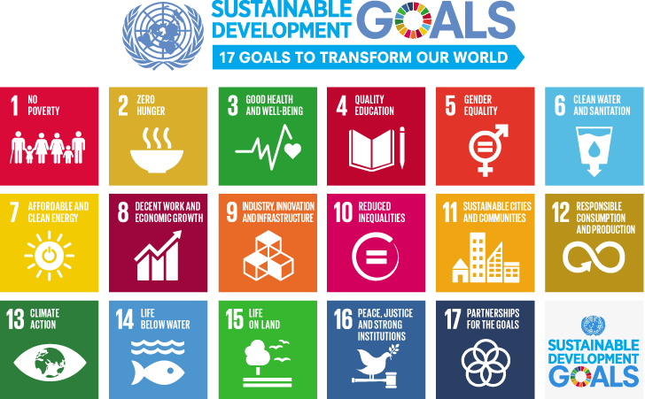

Several questions (such as II.1.a and II.2.b) can also be related to UN Global Compact principles (https://www.globalcompact.ch/ten-principles), which reflect the consequences of an activity for stakeholders such as employees who should never be treated against the human rights (Principle 1, 2; find the declaration of human rights: https://www.un.org/sites/un2.un.org/files/2021/03/udhr.pdf ), or never hindered to join labor unions (Principle 3), or forced to certain labor (Principle 4), or never be substituted by children (Principle 5) or discriminated (Principle 6). Principles 7-9 can be linked with the question 5 of the SCR-checklist. The fight against corruption (Principle 10) has effects that can be calculated as creating more damages than benefits according to utilitarian ethical calculation (Question II.1.a of the SCR-checklist).

How to obtain an SCR profile? Enter percentages in the masks of Fischer's online-tool (https://SCR-Schuez.maecefischer.ch/home) as in the following example:

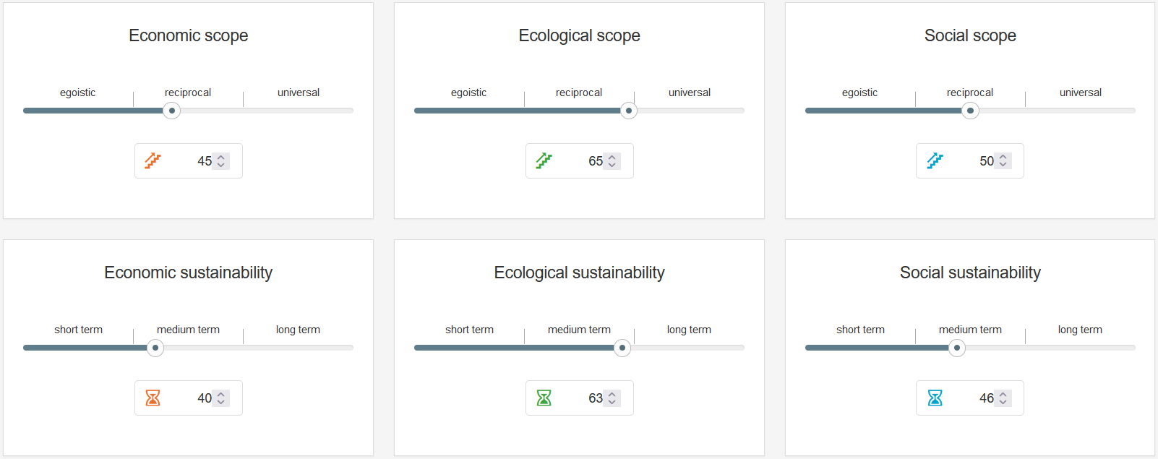
The result of the SCR-profile for strategic option 1 will be in this example:

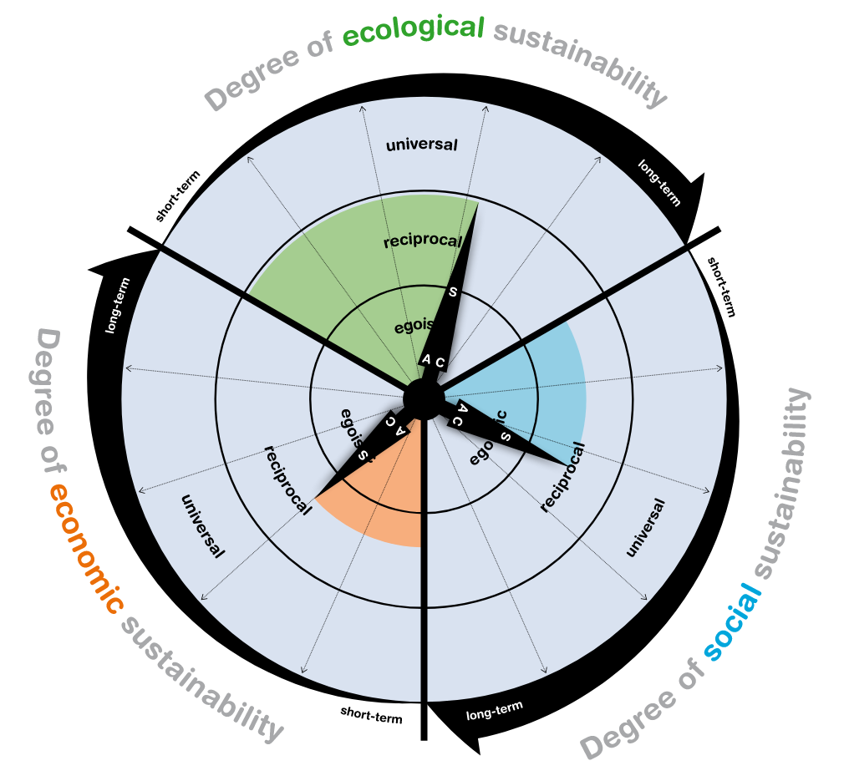

The result of the SCR-profile for strategic 2 might be like this:

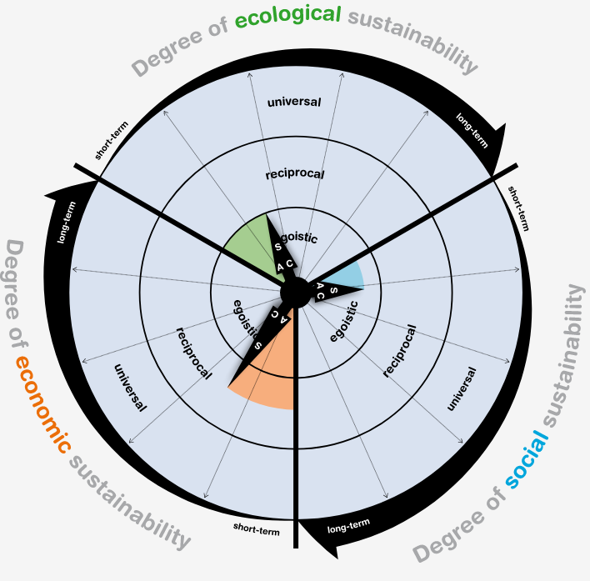

It is clear that the estimation of percentages can never be absolute quantities. So the exercises here are more for awareness and rough comparisons between two or more options. The graphs provide an initial indication of which could be the most sustainably responsible option for a company in a given situation. The checklist is thus a basis for a discussion that takes a wide variety of aspects into account. The purpose of the exercise is to sensitize students to the complex interrelationships of a sustainable economy. The table below gives some examples, how the pros and cons of some aspects of the checklist could be discussed.

Item (Examples) | Option (1) Reasons for aspect | Option (2): Reasons for aspect
I. 1. Efficiency | Frog’s transgression are based on investments that raise costs in the short- and midterm. Additionally, the environmentally unfriendly product line has to be shut down. All this negatively affects Frog’s company-wide efficiency and sustainability in the medium term. | Frog can maintain its established structure, but has to invest in detoxifying its products. This means that costs will increase in the short-term and affect Frog’s efficiency company-wide (mid-term).
I.3.  Effectiveness | Due to stakeholders’ general satisfaction, Frog will gain and retain new customers who will increase profitability company-wide in the long run. | Frog will retain some well-informed customers. It will be difficult to convince new customers about the reduced toxins in its products due to Frog’s bad reputation. Thus it might gain effectiveness only in the short-term. In the long run there is the risk of leftover toxic chemicals. In this case fully biodegradable products in the market might gain a competitive advantage.
II. 1  Integrated Reflection:  Fairness for stakeholder (common good) | Since option (1) delivers not only long-term value for the company and its shareholders but also to society and nature, it serves the common good. | Option (2) serves Frog’s survival but not really the common good, because the leftover chemical substances remain toxic. They are not 100% biodegradable and thus still pose a threat to the environment and public health. Due to the availability of fully biodegradable products the detoxified chemicals cannot be excused as the least bad of all the bad alternatives available. Although it brings a short-term benefit, this action will be considered harmful to the common good in the mid-term.
III.9.b  Universal applicability and dignity | According to Immanuel Kant’s Categorical Imperative option (1) can become a universal law, because all reasonable beings could agree with the deployment of cleaning agents that do not harm human beings. Furthermore it does not harm other living beings, because it is 100% biodegradable in the long run. | Since option (2) still threatens the health of human beings, even if to a lesser degree, the detoxified products harm human beings. In the long run it might even violate human dignity, if the risks are hidden and not clearly disclosed. In this case, customers have no clear choice because they believe in the harmlessness of the products.

