List all the modules, which you teach and where you have integrated the SDGs:

Fill the section below for one module of your choice which you see as the most advanced with regards to the integration of the SDGs:

Mapping the UN Sustainable Development Goals (SDGs)
Please complete form and email to (name)

Details of example
Your name………………………………………………………………………………………………………………


Context (tick or highlight all that are relevant)

Level of study  □ Undergraduate year 1 (level 4)  □ Undergraduate year 2 (level 5)  □ Undergraduate year 3/4 (level 6)  □ Postgraduate (level 7) | Type  □ Case study used in teaching  □ Module content  □ Teaching method/s  □ Module assessment  □ Research or research-informed teaching (see back of page)  □ Continuing Professional Development (CPD) activities  □ Other _______________________________________________
Which of the Sustainable Development Goals does this relate to?

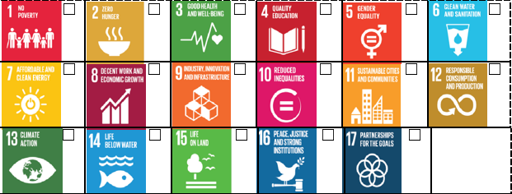
Give a brief description of how you have integrated the SDGs in your module (if not highlighted above, please tell us which module):

We are looking for good practice case studies for the PRME report, can we use yours: Yes/No

Research Focused

If you are doing research, please tick which of the SDGs your research relates to?

Give a brief description of your research.
Thank you

