To succeed in the climate action journey, we must realize that while small actions can seem trivial, individual actions are critical. The Sustainability & Climate Action Plan will provide you an opportunity to create and then demonstrate your personal actions towards sustainability and climate action. The two documents (Sustainability & Climate Action Plan Template and Sticker Book) should be used together to create your individual goals towards these objectives.

Sustainability & Climate Action Plan
For your personal actions to counter climate change
Document created by- Dr. Rajul Singh, Conestoga College, Canada
This document is a template and is divided into five sections. In each section, a sample answer has been put in for guidance. Please replace this with your own selection of stickers based on your professional and personal footprint and actions that you believe will be effective for countering climate change. The white spaces are the areas that should be used to drag and drop-in the stickers from the Sticker Book. This document will also be helpful in reflecting upon, measuring and/or monitoring your progress over time, towards the goals you have set for yourself.
Your role and organization-
Your personal/professional goals-

Date:

Step I- My definition of Sustainability
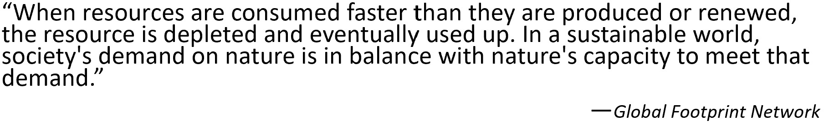

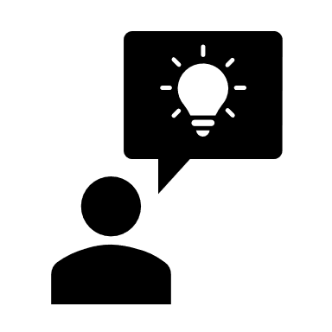

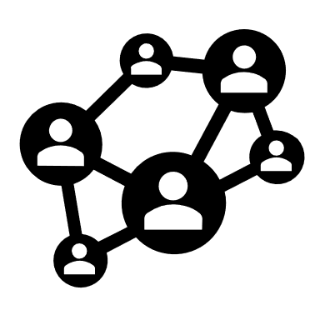
Step 2- Sustainable Development Goals (SDG’s) relevant for my professional role

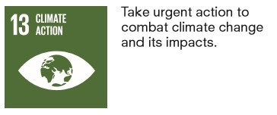

Actions I will take towards the goals I have selected-
1.
2.
3.
4.
5.

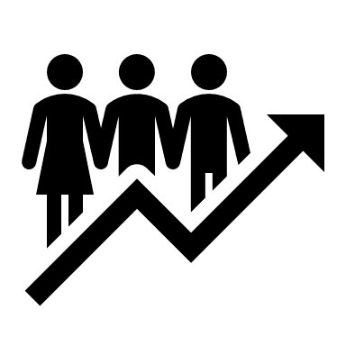
Step 3- Principles for Responsible Management Education relevant for my role

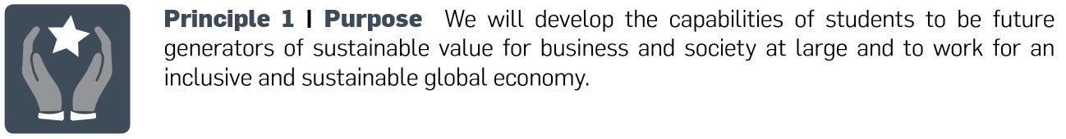

Actions I will take towards the principle(s) I have selected-
1.
2.
3.
4.
5.


Step 4- Good Life Goals relevant for me

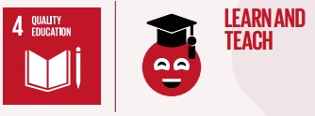

Actions I will take towards the goals I have selected-
1.
2.
3.
4.
5.
6.


Step 5- My Ecological Footprint
Please replace the image below with a screenshot of your ecological footprint
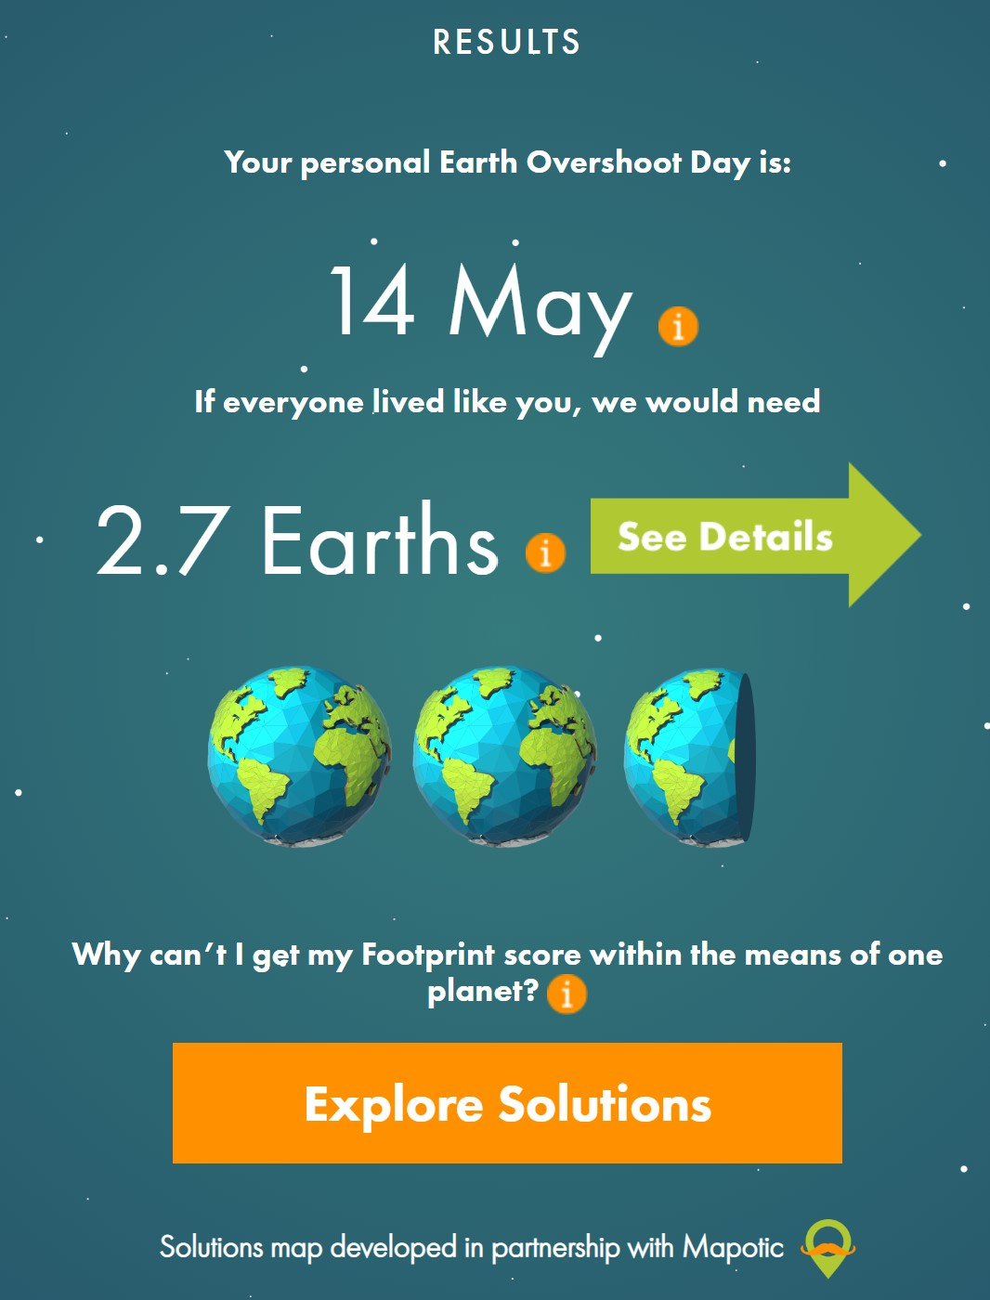

Actions I will take towards reducing my ecological footprint-
1.
2.
3.

Step 6- Congratulations! You have completed your Sustainability & Climate Action Plan.

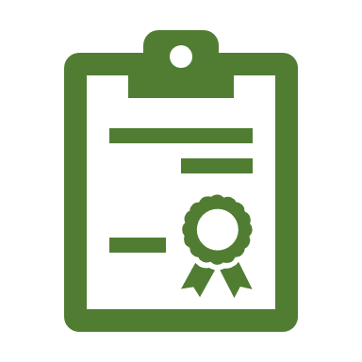

References
- About the Sustainable Development Goals – United Nations Sustainable Development. Retrieved April 10, 2020, from https://www.un.org/sustainabledevelopment/sustainable-development-goals/
- Good Life Goals. (2019, September 26). Retrieved May 25, 2020, from https://sdghub.com/goodlifegoals/
- How many planets does it take to sustain your lifestyle? Retrieved May 25, 2020, from https://www.footprintcalculator.org/signup
- Principles for Responsible Management Education. Background and Policy Documents. Retrieved May 25, 2020, from https://www.unprme.org/resources/display-resources.php?cid=9
- The Good Life Goals by Futerra Sustainability Communications Ltd and 10-Year Framework of Programmes on Sustainable Lifestyles and Education Programme is licenced under CC BY-ND 4.0.

