Chapter 4
Normal Anatomy and Flow

Q1: Which sentence of the followings is correct?
A) Clockwise rotation of the probe will view right-sided structures and anteflexion of the probe will view the cardiac apex
B) Clockwise rotation of the probe will view right-sided structures and anteflexion of the probe will view the heart base
C) Clockwise rotation of the probe will view left-sided structures and anteflexion of the probe will view the cardiac apex
D) Clockwise rotation of the probe will left-sided structures and anteflexion of the probe will view the heart base

Answer: B
Rotation, clockwise to view rightward structures and counterclockwise for leftward structures. Anteflexion and retroflexion of the probe tip, to view structures at the heart base or the apex

Q2: To obtain Transgastric level in TEE, the average distance from the incisors should be:
A) 25–28 cm
B) 29–33 cm
C) 34-37cm
D) 38–42 cm
E) >42 cm

Answer: D
Standard imaging plane levels (with their average distance from the incisors) include upper or high esophageal (25–28 cm), mid-esophageal (ME) (29–33 cm), lower or deep esophageal and gastroesophageal (GE) junction (34–37 cm), transgastric (TG) (38–42 cm), and deep TG (> 42 cm) windows. (See Figure 4.4)

Q3: Which view of the followings is the best to visualize the right atrial appendage (RAA)?
A) Mid-oesophageal 4 chamber view
B) Mid-oesophageal short-axis view
C) Mid-oesophageal 2 chamber view
D) Mid-oesophageal bicaval view
E) Mid-oesophageal 3 chamber view

Answer: D
The RAA appendage is a broad-based outpouching of the RA (Figure 4. 33) Best seen in the far field in the 90°-100° bicaval view.

Q4: Which pulmonary vein lies between the Coumadin ridge and the left atrial appendage (LAA)?
A) Right upper pulmonary vein
B) Right lower pulmonary vein
C) Left upper pulmonary vein
D) Left lower pulmonary vein

Answer: C
The left upper pulmonary vein (LUPV) limbus, pulmonary venous ridge, or “coumadin” ridge, is a wall with a bulbous end containing the vestigium of the left superior vea cava (SVC) or the Marshall ligament that separates the LUPV and LAA. (Figure 4.36)

Q5: What is the best view to visualize the coronary sinus in TEE?
A) Mid-oesophageal (ME) 4 chamber view
B) ME short-axis view
C) Deep-oesophageal (DE) 2 chamber view
D) ME bicaval view

Answer: C
Inserting the TEE probe into a DE position, where a window is available near the coronary sinus ostium, can better visualize the RA (Figure 4. 31).

Q6: What is the structure marked the by the arrow?
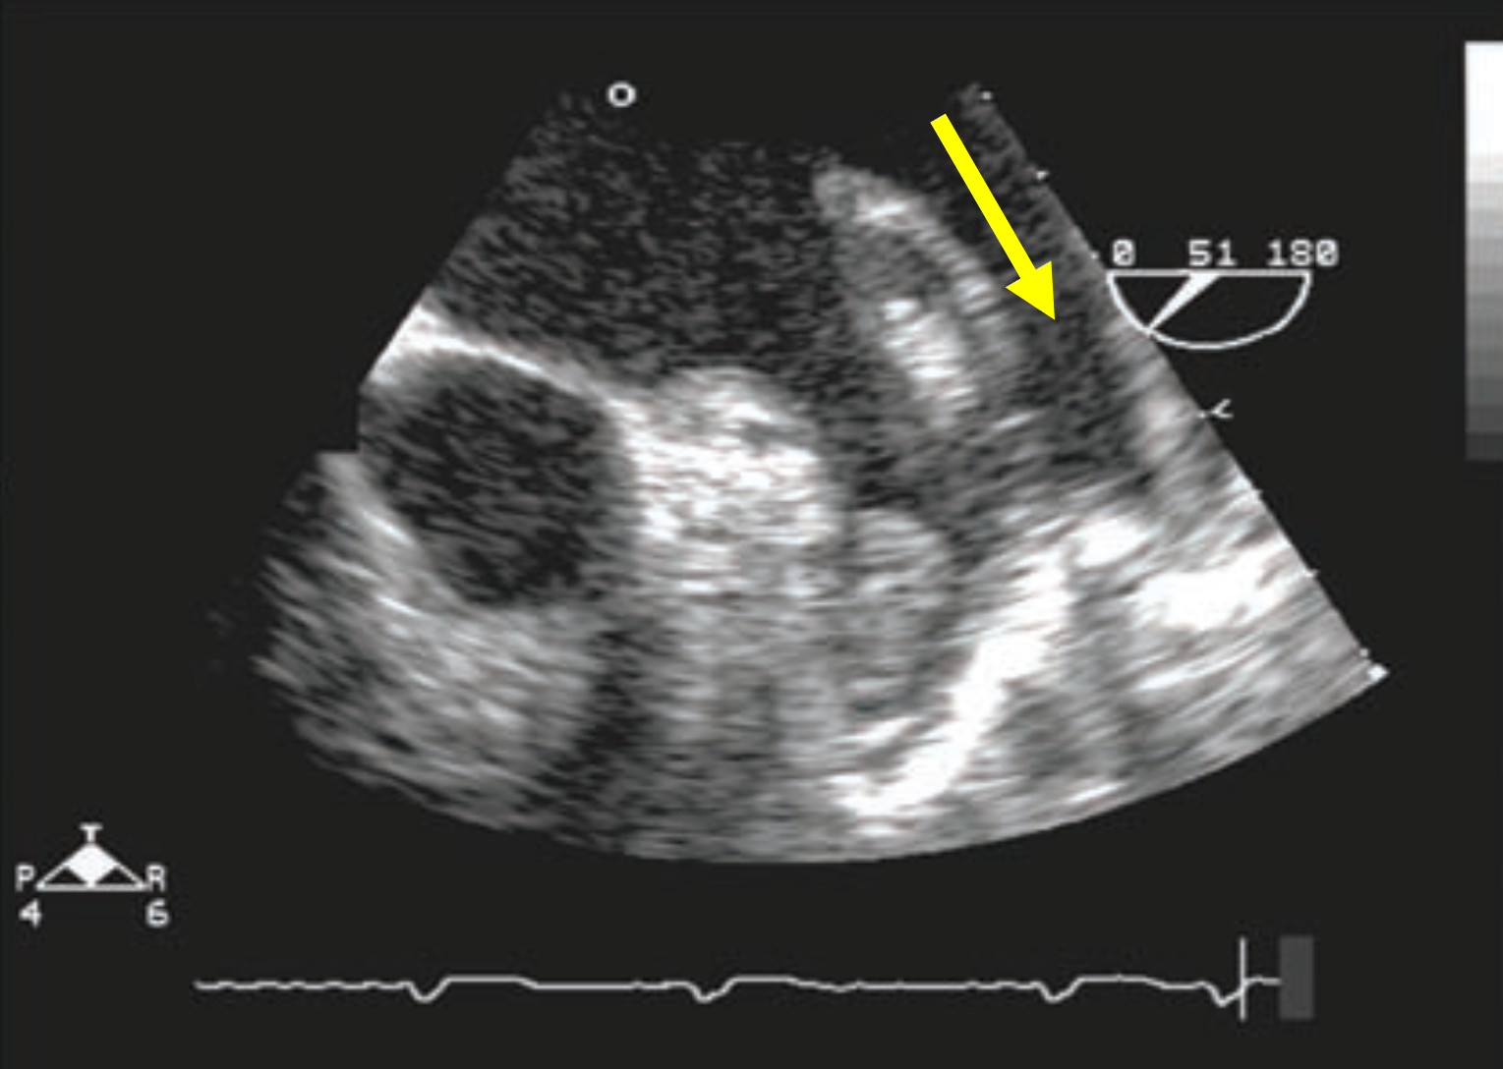
A) Left upper pulmonary vein
B) Left lower pulmonary vein
C) Right upper pulmonary vein
D) Right lower pulmonary vein

Answer: A
(See Figure 4.36)

Q7: What is the structure marked by the arrow?
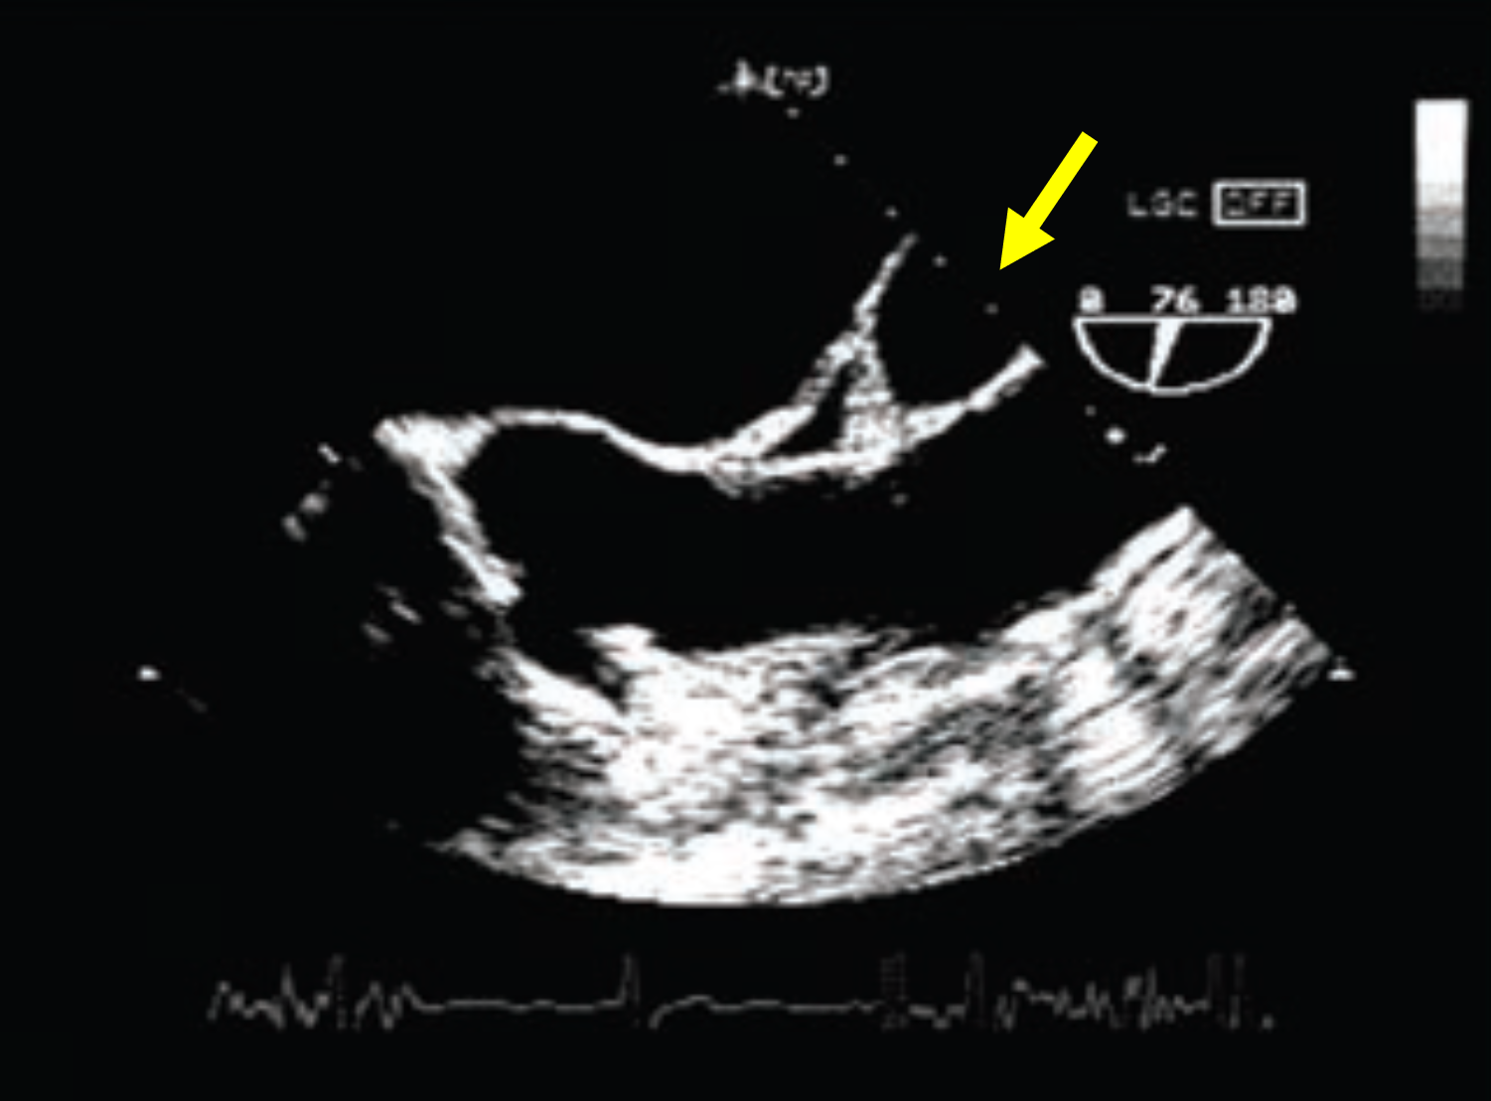
A) Transverse pericardial sinus
B) Oblique pericardial sinus
C) Aortic root abscess
D) Right pulmonary artery

Answer: D
(See Figure 4.14)

Q8: What is the structure marked by the arrow?
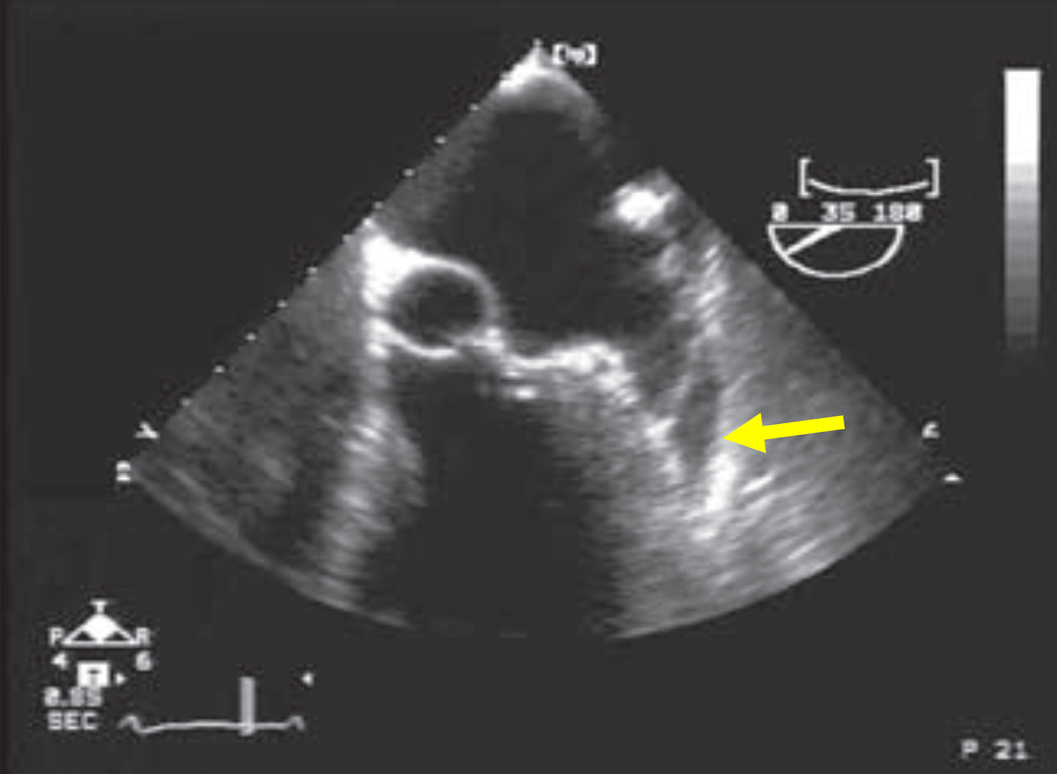
A) Left atrial appendage
B) Oblique pericardial sinus
C) Pericardial effusion
D) Right pulmonary artery

Answer: C.
A small pericardial effusion can accumulate behind the left atrial appendage that communicates with the transverse sinus. (see Figure 12.2)

Q9 What is the structure marked by the arrow?
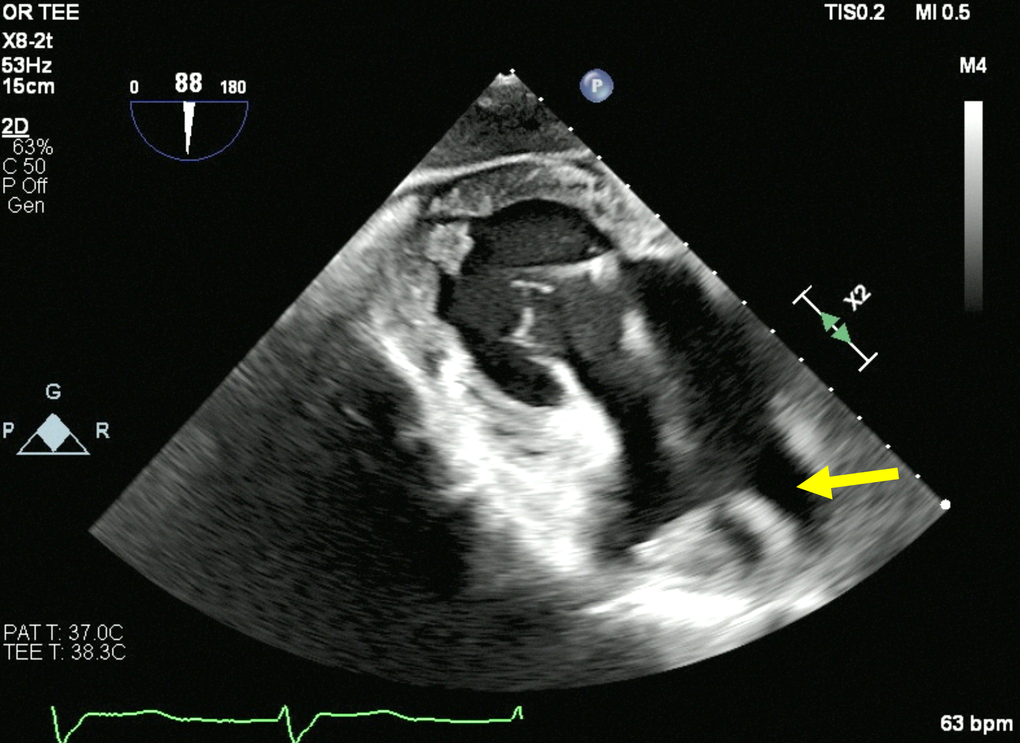
A) Right atrial appendage
B) Right pulmonary vein
C) Superior vena cava
D) Right pulmonary artery

Answer: C
(Figure 4.23)

Question 10: The "*" denotes which structure:
A) Superior vena cava
B) Right pulmonary artery
C) Left atrial appendage
D) Coronary sinus

Answer: A.
Superior vena cavae (Figure 4.15)

