Chapter 5
Quantitative Echo: 2D, 3D and Doppler

Q1: Which sentence of the followings is correct?
A) The leading edge of a structure is defined as the portion of the border closest to the transducer, while the trailing edge is the portion furthest from the transducer
B) The Trailing edge of a structure is defined as the portion of the border closest to the transducer, while the leading edge is the portion furthest from the transducer
C) The outer edge is defined as the portion of the border closest to the center of the structure while the inner edge is the furthest from it.
D) None of the above

Answer: A
The leading edge of a structure is defined as the portion of the border closest to the transducer, while the trailing edge is the portion furthest from the transducer. In two-dimensional (2D) echocardiography, the inner edge is defined as the portion of the border closest to the center of the structure while the outer edge is the furthest from it.

Q2: Which sentence of the followings is correct?
A) The left atrium (LA) is measured at end-systole while the aortic root is measured at end-diastole
B) The LA is measured at end-diastole while the aortic root is measured at end-systole
C) Both LA and aortic root are measured at end-systole
D) Both LA and aortic root are measured at end-diastole

Answer: A
The LA is measured at end-systole and the aortic root at end-diastole.

Q3: What is the cut-off value of LVEDD that defines severe LV dilatation?
A) 6 cm in males
B) 5.9 cm in females
C) 7.5 cm in males
D) 6.2 cm in females

Answer: D
The ASE describes partition values for LV size with severe dilatation in SAX at end-diastole with a left ventricular end-diastolic dimension (LVEDD) in females of ≥ 6.2 cm and males ≥ 6.9 cm (Figure 5. 2).

Q4: All of the following sentences about ejection fraction (EF) is correct except?

A) EF is a measure of myocardial performance and represents the efficiency of the global cardiac pump to eject part of its end-diastolic volume
B) Estimation of LVEF is affected by both cardiac preload and cardiac afterload
C) Estimation of LVEF is affected by myocardial contractility
D) Ejection fraction is the mirror of cardiac output (CO)

Answer: D
Ejection fraction does not necessarily mirror CO. A patient may have a high ejection fraction but a small stroke volume (and CO) as occurs in hypovolemia.

Q5: Which one of the followings is considered correct about wall motion abnormalities?
A) Akinesia is defined as wall thickening <5%
B) Akinesia is defined as wall thickening <10%
C) Hypokinesia is defined as wall thickening <25%
D) Hypokinesia is defined as wall thickening <20%

Answer: B
Wall motion hypokinesia and akinesia are defined as <30% and <10% thickening respectively

Q6: Concentric remodelling is defined as?
A) Normal left ventricular (LV) mass with relative wall thickness (RWT) > 0.42
B) Normal LV mass with relative wall thickness ≤ 0.42
C) Increased LV mass with relative wall thickness > 0.42
D) Increased LV mass with relative wall thickness ≤ 0.42

Answer: A
Patients with normal LV mass can have either concentric remodeling (RWT > 0.42) or normal geometry (RWT ≤ 0.42). Patients with increased LV mass can have either concentric (RWT > 0.42) or eccentric (RWT ≤ 0.42) hypertrophy. (Figure 5.20)

Q7: What is the predicted right atrial pressure (RAP) is the inferior vena cava (IVC) diameter is 2.3cm with 70% collapsibility with sniffing?
A) 5-10mmHg
B) 10-14mmHg
C) 15-20mmHg
D) >20mmHg

Answer: A
If IVC diameter and sniffing do not fit the estimated RAP is 5-10 mmHg.

Q8 Which statement is adequate in this patient with a systolic arterial pressure of 100 mmHg and a right atrial pressure of 10 mmHg? (see video Chap 05_Q8)
A) The right ventricular end-systolic pressure is 70 mmHg
B) The right ventricular end-systolic pressure is 50 mmHg
C) The systolic pulmonary artery pressure is 60 mmHg
D) The systolic pulmonary artery pressure is 70 mmHg

Answer: C
This is a ventricular septal defect with a 40 mmHg pressure gradient. If we assume that the arterial systolic pressure equals the left ventricular end-systolic pressure (LVESP), then the LVESP should be 100 mmHg. As the gradient of 40 mmHg represent the difference between the LVESP and the right ventricular end-systolic pressure (RVESP)
PG = LVESP - RVESP, then the RVESP should be 60 mmHg. As the RVESP is equal to the pulmonary artery systolic pressure (PASP), then the PASP should be also 60 mmHg. (See Figure 5.24)

Q9 A 69 year old patient is undergoing MVR. Intraoperative TEE performed after CPB reveals an ASD with left to right shunt. The surgeon wants to know how significant is the shunt, These measurements are: HR = 90/min, BSA = 1.8 m² , main PA diam. = 2.1 cm, TVI main PA = 15.3 cm, LVOT diameter = 1.9 cm, TVI LVOT = 14.8 cm
A) The shunt is 0.8 and it is not significant
B) The shunt is 1.7 and it is significant
C) The shunt is 1.26 and it is not significant
D) The shunt is 1.0 and it is significant

Answer C
Shunt calculation requires measurement of the right ventricular or pulmonary flow (Qp) and left ventricular stroke volume or systemic flow (Qs) output and their ratio.
Qp = Right ventricular output: (2.1/2)² X 3.14 X 15.3 X 90= 4.76 L/min
Qs = Left ventricular output: (1.9/2)² X 3.14 X 14.8 X 90 = 3,77 L/min
Qp/Qs = 1.26 A significant left-to-right shunt is a Qp:Qs ratio ≥1.5 or that causes dilatation of right-heart chambers.
A simplified approach would be (2.1/1.9)² X (15.3/14.8) = 1.1 X 1.03 = 1.26

Q10 Which statement is true when estimating pulmonary artery pressure in a post-operative patient with a central venous pressure of 11 mmHg

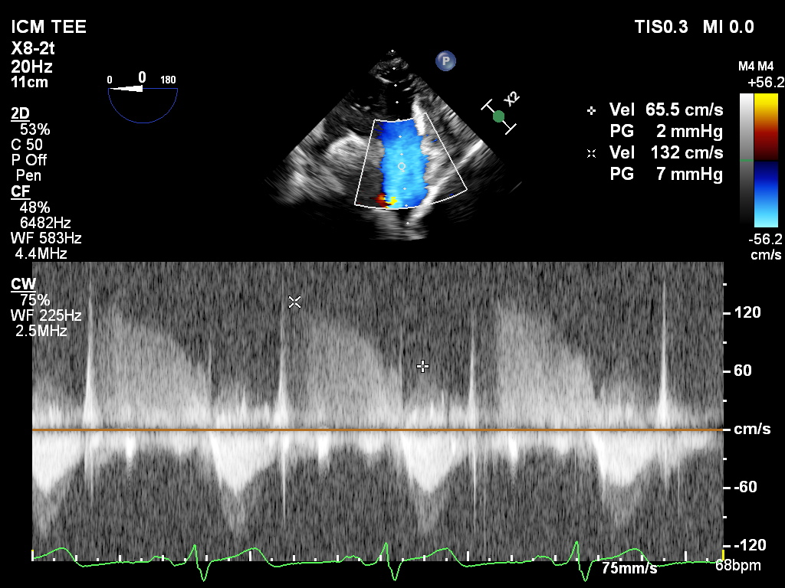

A) Diastolic and mean pulmonary artery pressure of 10 and 16 mmHg
B) Diastolic and mean pulmonary artery pressure of 11 and 14 mmHg
C) Diastolic and mean pulmonary artery pressure of 13 and 18 mmHg
D) Diastolic and mean pulmonary artery pressure of 10 and 21 mmHg

Answer: C.
A pulmonary regurgitation tracing allow estimation of the mean and diastolic pulmonary artery pressure. In this case the end-diastolic pressure gradient was 2 mmHg.

PR gradient: PAEDP – RVEDP
RVEDP = right atrial pressure (RAP)
PAEDP = PR gradient + RVEDP = PR gradient + RAP = 2 + 11 – 13 mmHg

The MPAP can be estimated using the formula
MPAP = 4 (early peak velocity)² + RAP
MPAP = 4 (1.32)² = 7 mmHg + 11 = 18 mmHg

Those values are close from those obtained simultaneously using right heart catheterization. (see video Chap05_Q10)

