Chapter 7
Imaging Artifacts and Pitfalls

Q1: All of the following can help to confirm the presence of an image artifact except?
A) Indistinct boundaries
B) Extension across normal surrounding structures
C) Disappearance with changes in sector depth setting, imaging planes, and transducer position
D) Presence of independent motion

Answer: D
Independent motion favors a real structure. See Table 7.2

Q2: Which kind of artifacts is this?
A) Reverberation artifact
B) Refraction artifact
C) Mirror image artifact
D) Electrocautery artifact

Answer: D
Electrocautery produces a characteristic, fan-shaped interference pattern artifact precluding proper 2D and color flow imaging. This noise artifact appears only during electrocautery use and vanishes instantly when ceasing the electrocautery.

Q3: Which kind of artifacts is this?
A) Reverberation artifacts
B) Side lobe artifact
C) Mirror image artifact
D) Electrocautery artifact

Answer: B
These regions of ultrasound (US) energy, lateral to the main beam in the far field, are the “side lobes”

Q4: Which kind of artifacts is this?
A) Reverberation artifacts
B) Side lobe artifact
C) Comet tail
D) Electrocautery artifact

Answer: C
Comet tails artefact are bright “tails” behind a strong reflector, characterized by multiple parallel bands. The mechanism is based on an acoustic impedance difference between media. It is a reverberation artifact but there are usually two or more reflectors that are very close together, and the process involves multiple round trips
Q5: Which kind of artifacts is this?
A) Ring down artifact
B) Side lobe artifact
C) Comet tail
D) Electrocautery artifact

Answer: A
Ring-down artifacts are another type of bright tail artifact in the axis of the insonated US wave. When US reaches gas bubbles, it excites the liquid trapped between the bubbles, which causes the liquid to resonate. The vibrations cause a continuous sound wave which transmits back to the receiver. There is a clearly identifiable source, and the artefact will “ring-down” as continuous or successive stacks of short horizontal bands to the end of the screen without fading.

Q6: Which kind of artifacts is this?
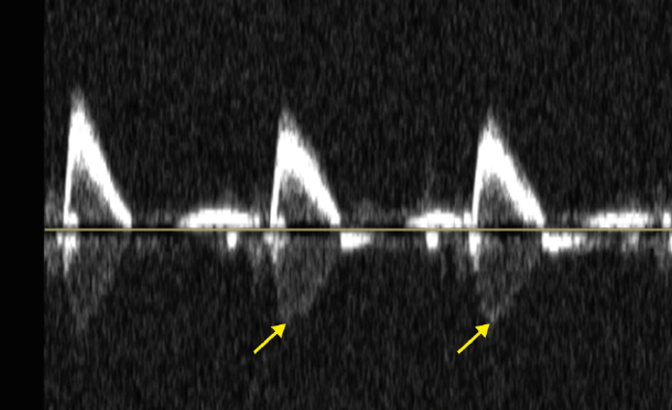

A) Ring down artifacts
B) Side lobe artifact
C) Comet tail
D) Cross-talk artifact

Answer: D
Quadrature channel cross-talk. This mid-esophageal (ME) descending aorta long-axis (LAX) view with pulsed-wave Doppler (PWD) shows this spectral artifact, which looks like a mirror image (arrow) of the initial signal. The phase separation circuits commonly used in echo machines cause it.

Q7: Criteria for diagnosis of this condition include:

A) Atrial septum thickness reaching ≥5 mm
B) Atrial septum thickness reaching ≥10 mm
C) Atrial septum thickness reaching ≥15 mm
D) Atrial septum thickness reaching ≥20 mm

Answer: C
A normal interatrial septum (IAS) can measure up to 7 mm with IAS thickening a common finding. Fatty deposits in the IAS may lead to high echogenicity and severe thickening of its muscular region. Lipomatous hypertrophy of the IAS has a thickness of > 15 mm

Q8 Which 3D structure is shown (see video Chap07_Q8A)

A) Ruptured mitral valve
B) Eustachian valve
C) Flail tricuspid valve
D) Reverberation artifact

Answer: B
(see video Chap07_Q8B) This is the 3D aspect of the Eustachian valve. It is a crescent-shaped ridge on the anterior aspect of the inferior vena cava (IVC) orifice. It may be redundant and appear as a thin mobile membrane undulating in the RA. Unusually large EVs can cause blood flow obstruction from the IVC.

Q9 What is the name of this artifact? (see video Chap07_Q9)
A) Blurring artefact
B) Dropout artefact
C) Blooming artefact
D) Stitching artefact

Answer: D
Stitching artefact are incorrect juxtaposition at the interface of sequential subvolumes. In this case there were 4 volumes. In order to avoid those artifacts, hold respiration and motion and switch to single-beat acquisition.

Q10 What is the abnormality (see video Chap07_Q10)
A) Mitral regurgitation
B) Atrial myxoma
C) Yo-yo artifact
D) Gain, LA smoke

Answer. D
Smoke in the left atrium with unadjusted gain can produce this 3D artifact.

