Chapter 8
Equipment, Complications, Infection Control, and Safety

Q1: Which sentence of the followings is correct about the contraindications for TEE?
A) Oesophageal varices are considered an absolute contraindication for TEE
B) Oesophagitis is considered an absolute contraindication for TEE
C) Relative contraindications may not preclude TEE examination but warrant careful evaluation of the risk-benefit ratio of the procedure
D) None of the above

Answer: C
There are many relative contraindications (Table 8.5). These include various esophageal pathologies, hiatal hernia, previous gastroesophageal surgeries, bleeding diathesis, cervical abnormalities, or anatomical distortion from arthritis or radiation therapy. Relative contraindications may not preclude TEE examination but warrant careful evaluation of the risk-benefit ratio of the procedure.

Q2: Which one of the followings is considered an absolute contraindication for elective TEE?
A) Previous radiation therapy to the mediastinum
B) Neck surgery
C) Perforated viscus
D) Lack of informed consent

Answer: C
Absolute contraindications include esophageal obstruction or interruption, gastric volvulus, active upper gastro-intestinal (GI) bleeding, and perforated viscus (Table 8. 5) Before proceeding with a TEE examination, it is important to inform the patient of the aims, technique, and risks of the procedure and document informed consent in the patients’ medical record. In emergency situation, if no obvious contra indication is present, TEE may be used.

Q3: Which sentence of the followings is correct as regards prophylaxis against infective endocarditis (IE) before TEE?
A) It is recommended to give amoxicillin before TEE
B) It is recommended to give clindamycin before TEE
C) A&B
D) IE prophylaxis is not recommended before TEE in the absence of active infection

Answer: D
The American College of Cardiology/American Heart Association guidelines no longer recommend antibiotic prophylaxis for nondental procedures such as TEE, esophagogastroduodenoscopy and colonoscopy in the absence of active infection.

Q4: What is the appropriate reversal agent for benzodiazepine overdose?
A) Methylene blue
B) Flumazenil
C) Naloxone
D) Protamine sulfate

Answer: B
Reversal agents for benzodiazepine and narcotic overdose, such as flumazenil and naloxone, respectively, should be readily available. Procedural sedation strategies and techniques are beyond the scope of this chapter, but sedation practice guidelines by non-anesthesiologists have addressed this topic.

Q5: What is the Incidence of mechanical complications during the TEE study?
A) Up to 1.5%
B) Up to 2.5%
C) Up to 3.0%
D) Up to 5%

Answer: C
Multiple studies show intraoperative TEE-related major mechanical complications vary between 0.2% and 3%.

Q6: What is the Incidence of complications during an emergency TEE study?
A) Up to 8.6%
B) Up to 10.6%
C) Up to 12.6%
D) Up to 15%

Answer: C
The TEE examination carried out in emergency settings has a higher complication rate of up to 12.6%. Several factors contribute to this situation, including the emergent need for TEE, the hemodynamic status of the patient, the alteration of consciousness, and the risk of aspiration from a full stomach.

Q7: Which sentence of the followings is incorrect about cleaning and disinfection of the TEE probe?
- All TEE and endoscopic equipments must be cleaned between each patient.
- B-Cleaning should be done by properly trained staff
C) Thorough, but gentle, mechanical cleaning under running water with soap or detergent to remove all gross organic material (secretions, saliva, and so on) from the probe.
D) Probe soaking in a bath of 1% glutaraldehyde for 60 min even in HIV patients.

Answer: D
After cleaning, immersing TEE probes in ≥ 2% glutaraldehyde for at least 20 minutes at 20°C achieves disinfection

Q8: Which of the following is not an absolute contraindication to transesophageal echocardiography?
A) Cervical spine instability
B) Esophageal stricture
C) Active upper gastrointestinal bleeding
D) Esophageal varices
E) Esophageal perforation

Answer: D
Patients with liver failure present several relative contraindications such as esophageal varices, esophagitis, and coagulopathy, nevertheless, clinicians may cautiously use TEE during liver transplantation (See Chapter 28).

Q9: What is the incidence of unrecognized esophageal laceration and perforation due to TEE manipulation?
A) 0.03-0.09%
B) 0.2%
C) 0.5%
D) 1%

Answer: A
The incidence of severe upper GI tract laceration has been estimated to be 0.03-0.09% in the cardiac surgical population. Initially unrecognized, esophageal perforation can often lead to mediastinitis and has been associated with a mortality rate of 40%.

Q10 Chest radiograph prior to cardiac surgery in a 72-year-old woman. Select the appropriate statement
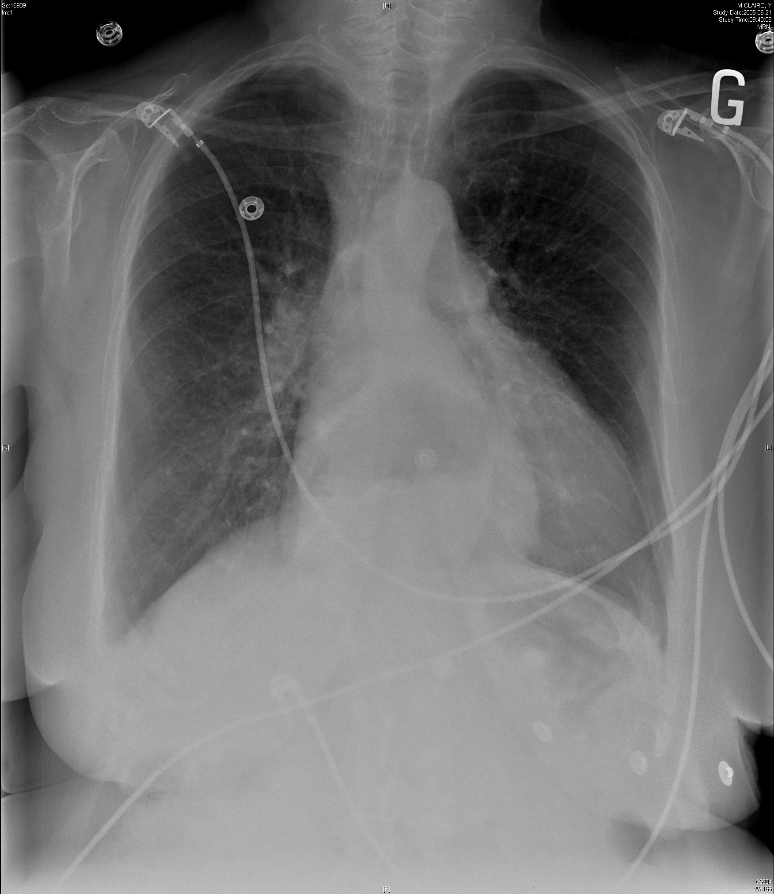

A) The chest radiograph is normal and a transesophageal echocardiography exam can be performed
B) The chest radiograph is abnormal but a transesophageal echocardiography exam can be performed
C) The chest radiograph is abnormal and a transesophageal echocardiography exam cannot be performed
D) The chest radiograph is not useful in determining if a transesophageal echocardiography exam can be performed

Answer: B.
The hyperlucent area (dotted line) corresponds to an hiatal hernia. There are many relative contraindications (Table 8.5). These include various esophageal pathologies, hiatal hernia, previous gastroesophageal surgeries, bleeding diathesis, cervical abnormalities, or anatomic distortion from arthritis or radiation therapy. Relative contraindications may not preclude TEE examination but warrant careful evaluation of the risk-benefit ratio of the procedure. A chest radiograph can identify patients with hiatal hernia.

